3GPP TSG SA WG3 Meeting #98e S3-200236

e-meeting, 2-6 March 2020 revision S3-20abcd

Source: Huawei, Hisilicon

Title: Adding authorization procedures of SEAL system

Document for: Approval
Agenda Item: 3.14

Decision/action requested
Approve this pCR in order to add SEAL authorization procedures of SEAL system.

References
[1] 3GPP TS 33.434: “Service Enabler Architecture Layer for Verticals (SEAL); Security Aspects”, V0.1.0
[2] 3GPP TS 23.434: “Service Enabler Architecture Layer for Verticals (SEAL); Functional architecture and information flows”, V16.2.0

Rational
Several contributions about SEAL skeleton and basic security requirements are defined in TS 33.434 [1] during the last meeting. This contritions proposed to add SEAL server authorization framework to the SEAL TS. The user authorization for VAL service is specified in TS 23.434 clause 12.3.3 [2], including general user service authorization and VAL user interconnection between primary VAL system and partner VAL system. The proposed clause includes detailed descriptions of authorization steps. Additionally, this contribution also proposes to add interconnection procedure to the SEAL TS in order to align with the 23.434 [2].

Detailed proposal
It is proposed to approve the following change:
*************** Start of 1st Change ****************

6.X.y Authorization framework
Authorization framework is shown in Figure 6.X.y-1. A secure HTTP tunnel using HTTPS between VAL UE and VAL server shall be established before SEAL service authorization. Subsequent SEAL service authorization messaging make use of this tunnel. The service clients in the VAL UE present the access tokens to the SEAL service server over HTTP. The SEAL service server authorizes the user for the requested services on if the access token is valid. The procedures may be repeated as necessary to obtain additional SEAL user authorizations.

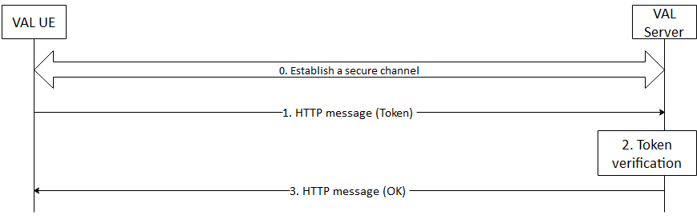
Figure 6.X.y-1: VAL User Service Authorization
After the VAL UE establishing a secure connection with the VAL server, the VAL UE sends an HTTP message containing the access token to the VAL server where service authorization is requested. The VAL server receives the message, validates the access token. If the access token is valid, The VAL server positively acknowledges the request. The VAL server may provide service related information to the VAL UE at this time.

*************** End of 1st Change ****************

