3GPP TSG-SA3 Meeting #115AdHoc-e draft_S3-241343-r4
Electronic meeting, online, 15 - 19 April 2024

Source: Huawei, HiSilicon, Lenovo

Title: Solution for UPU-based provisioning of list of decommissioned systems

Document for: Approval
Agenda Item: 5.6

1 Decision/action requested
Approve the new solution under clause 4 for inclusion in TR 33.701 [1].

2 References
[1] 3GPP TR 33.701: "Study on mitigations against bidding down attacks ".

3 Rationale
The contribution proposes a new solution for key issue #1 of TR 33.701 [1]. The solution proposes to include a new indication on the list of decommissioned systems in the UPU data.

4 Detailed proposal
Approve the following changes for inclusion in TR 33.701 [1].
**** First Changes****

2 References
The following documents contain provisions which, through reference in this text, constitute provisions of the present document.
- References are either specific (identified by date of publication, edition number, version number, etc.) or non-specific.
- For a specific reference, subsequent revisions do not apply.
- For a non-specific reference, the latest version applies. In the case of a reference to a 3GPP document (including a GSM document), a non-specific reference implicitly refers to the latest version of that document in the same Release as the present document.
[1] 3GPP TR 21.905: "Vocabulary for 3GPP Specifications".
[x] 3GPP TS 33.501: "Security architecture and procedures for 5G System".
**** Next Changes****

5.y Solution #y: UPU-based provisioning of decommissioned system list

5.y.1 Introduction
This solution addresses key issue #1: "Bidding down attacks from LTE/NR to decommissioned GERAN/UTRAN". The solution introduces a new IE in the UPU data to signal to the UE the list of decommissioned systems.

5.y.2 Details
It is assumed that the UDM is pre-configured with a list of 3GPP radio technologies that the PLMN does no longer support. Based on this configuration and once a registration procedure is successfully completed, if the UDM invokes the UPU procedure, it can include a new parameter in the UPU data to indicate to the UE which 3GPP access technologies to no longer select as long as the UE is registered in the current PLMN. Since the UPU Data is transported over NAS after successful security establishment, there are no risks that the indication is tampered with. This new parameter which is referred to as the List of Decommissioned 3GPP Access Technologies (LDAT) in the procedure below contains a list of RATs that are decommissioned and hence no longer supported by the serving PLMN. In this context, the LDAT includes GERAN or UTRAN or both.
Figure 5.y.2-1 below illustrates the impact on the current UE parameter update procedure. The step description is included below
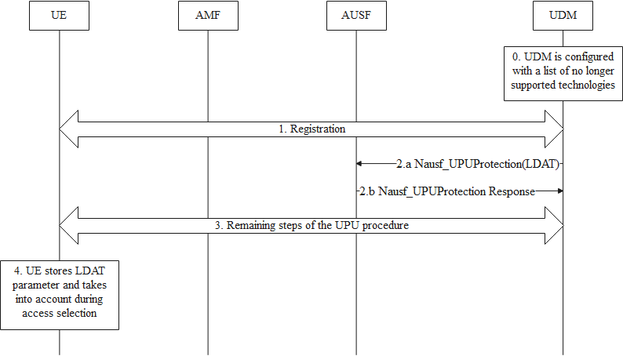
Figure 5.y.2-1: UE parameter update procedure including provisioning of LDAT parameter
- The UDM is preconfigured with a List of Decommissioned 3GPP Access Technologies (LDAT). the details on the LDAT data storage in UDM/UDR are left out of scope of this solution (can be clarified during the normative work or left to stage 2/3 details).

The UE and the network completes a successful registration procedure including Primary authentication and NAS security establishment.
- If the UDM decides to invoke the UE parameter procedure of clause 6.15 of TS 33.501 [x], based on operator policy, the UDM includes the LDAT information in the UPU data, alongside the other parameters.
NOTE: Details of the LDAT parameters such as whether it is a simple list of 3GPP radio access technologies or more granular e.g. a list per tracking area, is left to CT1 group.
- The remaining steps of the UE parameter update procedure are unchanged.
- The UE stores the LDAT information and removes any previously received one (if any). The stored LDAT information is bound to the PLMN. The UE acts on it accordingly during 3GPP access selection as long as the UE is registered over 3GPP access in that PLMN. The UE does not select any RAT that is included in the stored LDAT information when served by that PLMN.

5.y.3 Evaluation
The solution addresses the requirement of key issue #1: "Bidding down attacks from LTE/NR to decommissioned GERAN/UTRAN".
The solution does not provide a mechanism to address backward compatibility issues with UEs not supporting this additional IE.
The solution requires that UPU is deployed which is not necessarily the case on the network side.
The solution is not limited to a specific technology and can achieve the same effect irrespective of the target 3GPP access technology.
Since the LDAT information is under the control of the UDM, the solution works only for non-roaming scenarios.
Depending on the LDAT format (see NOTE in clause 5.y.2), the extent of impact and complexity especially on the UE side may vary considerably.
The solution has impact on UE, AMF and UDM and does not solve the problem for legacy devices.
The solution does not address the issue for EPS.
Editor's Note: Further evaluation is FFS
**** End of Changes****

