3GPP TSG-SA3 Meeting #115AdHoc-e draft_S3-241342-r3
Electronic meeting, online, 15 - 19 April 2024

Source: Huawei, HiSilicon

Title: Solution for registration-based provisioning of list of decommissioned systems

Document for: Approval
Agenda Item: 5.6

1 Decision/action requested
Approve the new solution under clause 4 for inclusion in TR 33.701 [1].

2 References
[1] 3GPP TR 33.701: "Study on mitigations against bidding down attacks ".

3 Rationale
The contribution proposes a new solution for key issue #1 of TR 33.701 [1]. The solution proposes an addition of a new IE in the registration accept message to indicate the list of decommissioned systems.

4 Detailed proposal
Approve the following changes for inclusion in TR 33.701 [1].
**** First Changes****

2 References
The following documents contain provisions which, through reference in this text, constitute provisions of the present document.
- References are either specific (identified by date of publication, edition number, version number, etc.) or non-specific.
- For a specific reference, subsequent revisions do not apply.
- For a non-specific reference, the latest version applies. In the case of a reference to a 3GPP document (including a GSM document), a non-specific reference implicitly refers to the latest version of that document in the same Release as the present document.
[1] 3GPP TR 21.905: "Vocabulary for 3GPP Specifications".
[x] 3GPP TS 23.502: "Procedures for the 5G System (5GS)".
**** Next Changes****

5.y Solution #y: Registration-based provisioning of decommissioned system list

5.y.1 Introduction
This solution addresses key issue #1: "Bidding down attacks from LTE/NR to decommissioned GERAN/UTRAN". The solution introduces a new IE in the registration accept message to signal to the UE the list of decommissioned systems.

5.y.2 Details
It is assumed that the AMF is pre-configured with a list of 3GPP radio technologies that the PLMN does no longer support. Based on this configuration and once a registration procedure is successfully completed, the AMF includes a new parameter in the Registration Accept message to indicate to the UE which 3GPP access technologies to no longer select as long as the UE is registered in the current PLMN. Since the Registration Accept is sent after NAS security establishment, there are no risks that the indication is tampered with. This new parameter which is referred to as the List of Decommissioned 3GPP Access Technologies (LDAT) in the procedure below contains a list of RATs that are decommissioned and hence no longer supported by the serving PLMN. In this context, the LDAT includes GERAN or UTRAN or both.
Figure 5.y.2-1 illustrates the impact on the current registration procedure. The step description is included below
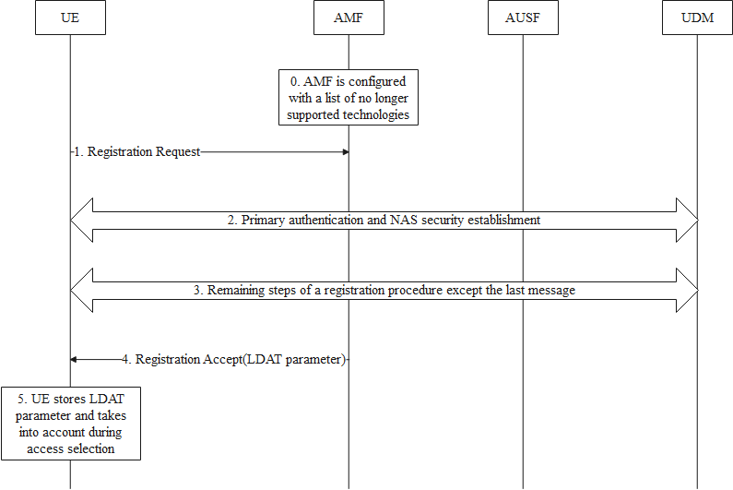
Figure 5.y.2-1: Registration procedure including provisioning of LDAT parameter
- The AMF is preconfigured with a List of Decommissioned 3GPP Access Technologies (LDAT).
- The UE initiates the procedure by sending a Registration Request message.
- The AMF potentially triggers a primary authentication and establishes NAS security with the UE. From this step onwards, all NAS traffic is confidentiality and integrity protected.
- The remaining steps of the registration procedure are performed as specified in TS 23.502 [x] with no changes for this solution except for the last message as described in step 4.
- The AMF concludes the procedure by sending a Registration Accept message including the LDAT information.
NOTE: Details of the LDAT parameters such as whether it is a simple list of 3GPP radio access technologies or more granular e.g. a list per tracking area, is left to CT1 group.
- The UE stores the LDAT information and removes any previously received one (if any). The stored LDAT information is bound to the PLMN. The UE acts on it accordingly during 3GPP access selection as long as the UE is registered over 3GPP access in that PLMN.

5.y.3 Evaluation
The solution addresses the requirement of key issue #1: "Bidding down attacks from LTE/NR to decommissioned GERAN/UTRAN".
The solution does not provide a mechanism to address backward compatibility issues with UEs not supporting this additional NAS IE.
The solution is not limited to a specific technology and can achieve the same effect irrespective of the target 3GPP access technology.
Since the LDAT information is under the control of the AMF, the solution works even in roaming scenarios.
Depending on the LDAT format (see NOTE in clause 5.y.2), the extent of impact and complexity especially on the UE side may vary considerably.
The solution has impact on UE and AMF and does not solve the problem for legacy devices.
Editor's Note: Further evaluation is FFS
**** End of Changes****

