3GPP TSG-SA3 Meeting #115e S3-241244-r1

e-meeting, 15 - 19 April 2024 revision of S3-2xxxx

Source: CMCC

Title: New solution for key issue 1

Document for: Approval
Agenda Item: 5.3

1 Decision/action requested
It is proposed to approve the proposed changes for inclusion in TR 33.757 [1].

2 References
[1] 3GPP TR 33.757: Study of security for PLMN hosting a NPN

3 Rationale
This contribution proposes the solution for N4 interface security of key issue 1. This solution proposes a Security Gateway to securely isolate the secure domain and non-secure domain by providing the security protections such as topology hiding, inspection and control of signaling message etc,. for the traffic through N4 interface over trust boundary.

4 Detailed proposal
It is proposed to approve the following changes for inclusion in TR 33.757 [1].

*************** Start of the changes ***************

2 References
The following documents contain provisions which, through reference in this text, constitute provisions of the present document.
- References are either specific (identified by date of publication, edition number, version number, etc.) or non-specific.
- For a specific reference, subsequent revisions do not apply.
- For a non-specific reference, the latest version applies. In the case of a reference to a 3GPP document (including a GSM document), a non-specific reference implicitly refers to the latest version of that document in the same Release as the present document.
- 3GPP TR 21.905: "Vocabulary for 3GPP Specifications".
[2] 3GPP TS 33.501: "Security architecture and procedures for 5G system"
[3] 3GPP TS 23.502: "Procedures for the 5G System (5GS)"
[4] 3GPP TS 29.244: "Interface between the Control Plane and the User Plane nodes"
[5] 3GPP TS 33.310: "Network Domain Security (NDS); Authentication Framework (AF)"
[6] IETF RFC 4303: "IP Encapsulating Security Payload (ESP)"
[x] <doctype> <#>[ ([up to and including]{yyyy[-mm]|V<a[.b[.c]]>}[onwards])]: "<Title>".

6.X Solution #X: Secure N4 interface with Security Gateway

6.X.1 Introduction
This solution addresses key issue #1.
Considering the nature that the dedicated NF locates outside of operator’s controlled network and interact with PLMN through N4 interface, which leads to the exposure threats to the operator’s core network, this solution proposes to introduce an Security Gateway at the border of operator’s core network to prevent operator’s core network against the attacks through N4 interface. The Security Gateway should be the first contact node when the dedicated UPF interacting with PLMN. All N4 related input/output traffic over the trust boundary should be delegated and protected by Security Gateway.

X.2 Solution details
The assumed architecture with the Security Gateway deployed over the trust boundary for SBA interface is shown in Figure 1.
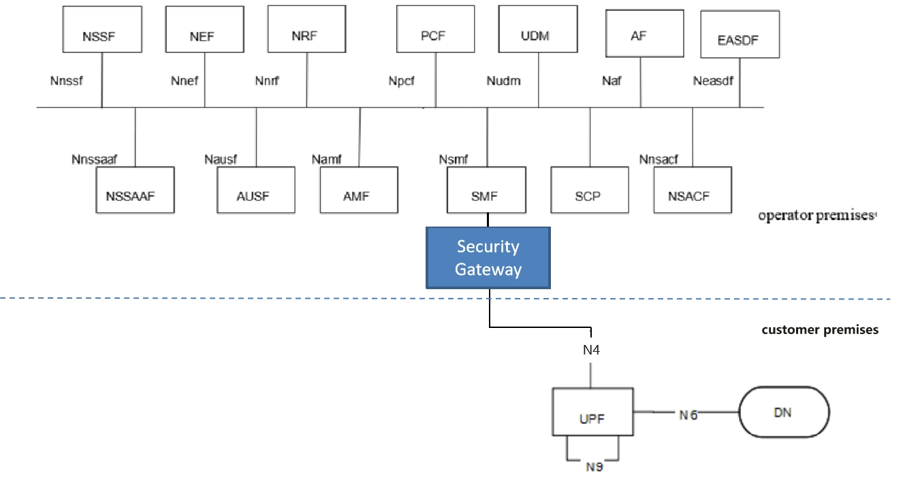
Figure 1: System architecture for Security Gateway

The NFs in the PNI-NPN Customer’s network trust the Security Gateway deployed in the PLMN. Security protections provided by the Security Gateway for the traffic through N4 interface over the trust boundary can be categorized in the following way:
- Topology information hiding of the PLMN and the customer premises network,
- Signaling inspection and message filtration
- Security between the dedicated UPF and the Security Gateway
- Access control etc.

6.x.2.1 Topology information hiding
The Security Gateway delegates every Control Plane message in inter-domain signaling, acting as a service relay between the dedicated UPF and SMF. The Security Gateway can handle topology hiding by limiting the PLMN network topology information visible to the dedicated network in customer premises and vise versa (e.g IP address of SMF/UPF at IP layer, SEID in PFCP message etc.).
Based on the local policy provided by the operator, the appropriate topology hiding mechanisms can be performed based on the security requirements.
Editor's note: It is FFS this solution requires PLMN Operator’s to know the topology information of PNI-NPN Customer’s network.The Security Gateway deployed in the PLMN Operator domain is not intended to protect the NFs in the PNI-NPN Customer’s domain.

6.x.2.2 Signaling inspection and message filtration
The Security Gateway supports to protect the Control Plane messages, it receives all messages through N4 interface over the trust boundary and forwards them to the appropriate NF after verifying security, where present.
Editor's note: It is FFS this solution requires the Security Gateway to interpret all application layer messages passing the trust boundary between PLMN Operator’s domain and the PNI-NPN Customer’s domain.
The Security Gateway supports to discard malformed signaling messages sent from dedicated UPF through N4 interface over the trust boundary according to 3GPP specifications. If an N4 message violates the specified input or output, that message can be considered as malformed message.
NOTE 1: 3GPP specifications specifies N4 message inputs and outputs described in TS 23.502 [x] and TS 29.244 [y] can be considered as normal messages.
NOTE 2: An example for such mechanism is the following: discard PFCP message with unknown/inappropriate message type, discard PFCP message with illegal length, discard the illegal IE which does not belong to the PFCP message, etc.
The Security Gateway supports the means to block messages with wrong NF types sent from NFs in the customer premises or operator premises over the trust boundary according to 3GPP specifications.
The Security Gateway supports anti-spoofing mechanisms that enable cross-layer validation of source and destination address.
NOTE : An example for such an anti-spoofing mechanism is the following: If there is a mismatch between different layers of the message or the destination address does not belong to the Security Gateway’s PLMN, the message is discarded.
The Security Gateway supports the rate-limiting functionalities to defend itself and subsequent NFs against excessive CP signaling.
In addition, as the Security Gateway provides a single point of entry for the signaling messages trough N4 interface, this gives it the global view on all the NFs connecting with it, which makes it be capable to inspect and filter more advanced behavioral and logical attacks against signaling by analyzing the signaling messages received from multiple NFs.

6.x.2.3 Security between the dedicated UPF and the Security Gateway
The Security Gateway is a network function at the border of a security domain of the operator. After successful mutual authentication between the dedicated UPF and the Security Gateway, the Security Gateway connects the dedicated UPF to the operator’s security domain.

6.x.2.3.1 Authentication
The Security Gateway allows the dedicated UPF access to the core network only after successful completion of all required authentications.
Any unauthenticated traffic from the NF in customer premise is filtered out at the Security Gateway.
IKEv2 with certificates or PSK used for authentication is run between the dedicated UPF and the Security Gateway to mutually authenticate the dedicated UPF and the Security Gateway. The certificate handling and profiles adheres to 3GPP TS 33.310 [x].

6.x.2.3.2 Transport protection between the dedicated UPF and the Security Gateway
The Security Gateway uses IKEv2 protocol to set up IPsec tunnel to protect the traffic with the dedicated UPF. All control plane and user plane traffic over the interface between the dedicated UPF and the Security Gateway are sent through an IPsec ESP tunnel that is established as a result of the authentication procedure, which provides the confidentiality, integrity and replay protections. The IPsec ESP adheres to 3GPP TS 33.310 [x] and IETF RFC 4303[z].

6.x.2.4 Access control
The Security Gateway supports access control:
- The ACL (Access Control List) based access control mechanism for the dedicated UPF accessing the SMF in PLMN and vise versa(e.g. based on NF’s address).

6.X.3 Evaluation
Editor's note: evaluation is ffs
**** End of Changes****

