3GPP TSG-SA3 Meeting #109AdHoc-e draft S3-230405-r1

Electronic meeting, 16 - 20 January 2023 Revision of S3-22xxxx

Source: Xiaomi

Title: Remove the Editor's Note of solution #5 in TR 33.893

Document for: Approval
Agenda Item: 5.19

1 Decision/action requested
This contribution proposes to update the solution #5 in the FS_Ranging_SL_Sec study TR 33.893

2 References
[1] 3GPP TR 33.893 v0.4.0: "Study on Security Aspects of Ranging Based Services and Sidelink Positioning"
[2] 3GPP TR 23.700-86 v1.1.0: "Study on Architecture Enhancement to support Ranging based services and sidelink positioning"
[3] 3GPP TS 33.501 v17.4.2: "Security architecture and procedures for 5G system"

3 Rationale
This pCR proposes to address the Editor’s Note of the solution #5 in TR 33.893 [1].
Editor’s Note: The details and necessity of the token are FFS.
Unlike Prose and V2X service, each UE in the Ranging/SL Positioning service has different functionalities. For example, the Server UE is responsible for offering location calculation, and the Reference UE is responsible for transmitting/receiving reference signals for positioning. Therefore, the authorized role is introduced to distinguish UEs with different responsibilities as concluded in the TR 23.700-86 [2]. To ensure that a UE cannot impersonate another UE with different responsibilities, an authorization credential provisioned by the network (e.g. certificate, token, etc.) is needed to be used by a UE to authorize the peer UE. As specified in TS 33.501 [3], the Oauth token is a type of credential for authorization and widely used for the Network Function service access in the 5GC, which can be reused in the Ranging/SL Positioning service. By checking the token, the peer Ranging UEs can authorize each other regardless of whether they are within or out of network coverage.
It is our view that the introduction of token is necessary for the Ranging/SL Positioning service and the details of token can reuse the structure of Oauth 2.0 token. Therefore, it is proposed to address this Editor’s Note by replacing it with a note saying that the token for the Ranging/SL Positioning service is based on the Oauth 2.0 token defined in Clause 13.4.1.1 of TS 33.501 [3], and the details of Ranging/SL Positioning token will be decided during normative phase.
Editor’s Note: Which network function provides authorization token and how the UEs get the public key of token signing entity are FFS.
For the Ranging service triggered by Ranging Application Server, the authorized role is determined by the Ranging Application Server based on the Ranging service code. For the SL Positioning service triggered by 5GC NF, the authorized role is determined by the DDNMF/PKMF. To ensure that peer UEs can check the authorization of each other, the Ranging Application Server or the DDNMF/PKMF can provide the token and the associated public key to UEs.
Therefore, it is proposed to address this Editor’s Note by replacing it with a note saying that for the Ranging service, the token and the associated public key can be provisioned by the Ranging Application Server, and for the SL Positioning service, the token and the associated public key can be provisioned by the DDNMF/PKMF.

4 Detailed proposal
*************** Start of the Change ****************

6.5 Solution #5: Use of authorization tokens at PC5 security establishment

6.5.1 Introduction
The solution addresses Key Issue #2: Authorization for Ranging/SL Positioning Services. It aims to meet one of the potential requirements in Key issue #2 the authorization of the UE as a target UE/reference UE/assistant UE/Located UE in the Ranging/Sidelink Positioning service.
As per TR 23.700-86 [2] KI#5, when a UE is not able to perform Uu based positioning estimation, the UE may use Sidelink Positioning to obtain relative positioning with a Located UE which is in network coverage. Considering the UE may be out of network coverage or in network coverage, the UE shall be able to independently check what SL positioning service the peer UE is authorized to use and what role the peer UE is authorized to act.
In addition, a Target UE may discover a Reference UE/Assistant UE who is out of network coverage to establish the PC5 link and perform the Ranging procedure. In this case, the UE shall be able to independently check what Ranging service the peer UE is authorized to use and what role the peer UE is authorized to act.
This solution proposes a token based method as in OAuth 2.0 to meet the above requirements. The network may provide a token stating what kind of Ranging/Sidelink Positioning service the UE can use and what role it can act in the service.
The token is signed by the network with a private key and can be verified by the UE using the public key. Based on the token, the UE can independently check the authorization of peer UE during the Discovery procedure and the PC5 security establishment procedure.
This solution assumes long term credentials are provisioned into the UE(s) and form the root of the security of the PC5 unicast link as specified in TS 33.536 [5].

Editor’s Note: The details and necessity of the token are FFS.

Note Y: For the Ranging service triggered by Ranging Application Server, the token and the associated public key can be provisioned by the Ranging Application Server. For the SL Positioning service triggered by 5GC NF, the token and the associated public key can be provisioned by the DDNMF/PKMF.
This solution assumes long term credentials are provisioned into the UE(s) and form the root of the security of the PC5 unicast link as specified in TS 33.536 [5].

6.5.2 Solution details

6.5.2.1 Token based authorization for scenario of SL positioning services

6.5.2.1.1 Security for network assisted Sidelink Positioning with full network coverage
0. The Target UE/Located UE are provisioned with discovery security materials and authorization tokens when they are in coverage. If the Target UE/Located UE is authorized to use the SL Positioning service under the specific role, the network provides a token claiming the specific SL positioning service it can use and what role it can act in the service. The token is signed by the network and can be verified by the UE.
This step can be perform at any step before step #4.
1. The AMF receives a Sidelink positioning request from any 5GC NF or AF.
2. The AMF sends the Sidelink positioning request to the selected LMF.
3. The LMF decides to use the network assisted Sidelink positioning for Target UE. The LMF triggers the discovery of a Located UE for positioning assistance or performs Sidelink positioning capability negotiation with Target UE.
NOTE: Whether or not located UE ID is provided by the LMF is to be aligned with SA2.
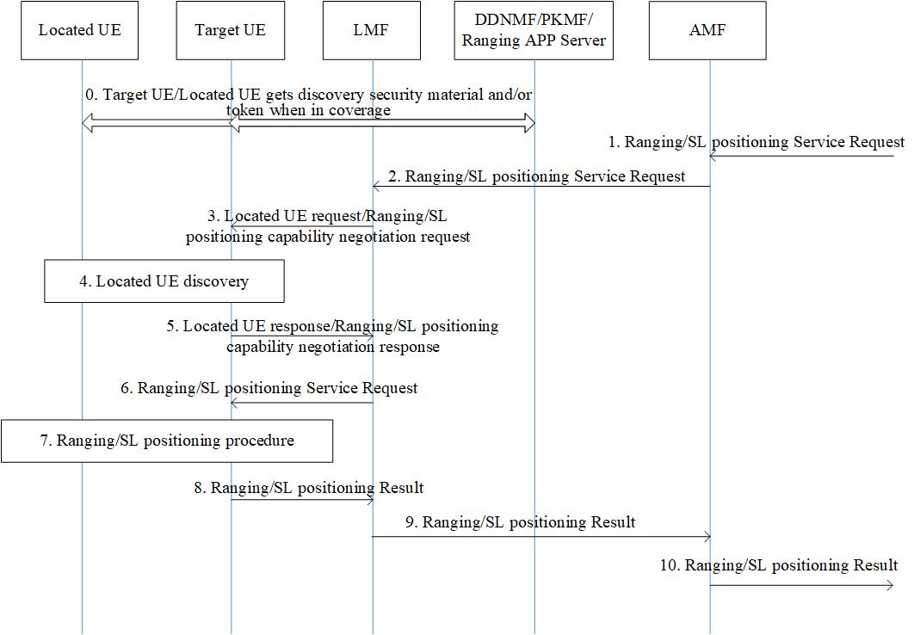
Figure 6.5.2-1: Security for Network Assisted Sidelink Positioning with Full Network Coverage
4. If the Located UE ID is provided by the LMF, Target UE performs Model B discovery with the selected Located UE. If no located UE ID is provided, Target UE performs Model A discovery by listening to announcement message send by the Located UE.
The Located UE provides the Service Code and its token in the discovery message. Once receiving the discovery messages, the Target UE verifies the discovery message and the token.
5. If the authorization checking is successful, the Target UE responds to LMF with the Located UE ID. If required, the Target UE also responds with the Target UE/Located UE’s Sidelink positioning capability.
6. The LMF determines the Sidelink positioning result calculation mode and the requested info. After that, the LMF sends the Sidelink positioning request to the Target UE
7. The Target UE establishes a PC5 link with the located UE for the SL positioning measurement as defined in TS 33.503 [6]. The Located UE and Target UE also exchange their tokens during the PC5 link establishment procedure for role authorization of each other. The Target UE performs Sidelink positioning procedure with the Located UE, and obtains the Sidelink positioning measurement data.
8~10. The rest of the procedure Sidelink Positioning service is performed between the Target UE and the network.

6.5.2.1.2 Security for network assisted Sidelink Positioning with partial network coverage
Steps #0~#1 are the same as steps #0~#1 in clause 6.5.2.1.
2. The AMF sends the SL positioning service request to the selected LMF which includes Target UE ID and one or multiple Located UE ID(s)
3. When both Target UE ID and one or multiple Located UE ID(s) are received in the LCS service request, the LMF sends the Sidelink positioning request to one or multiple Located UE(s) to trigger the Sidelink positioning procedure.
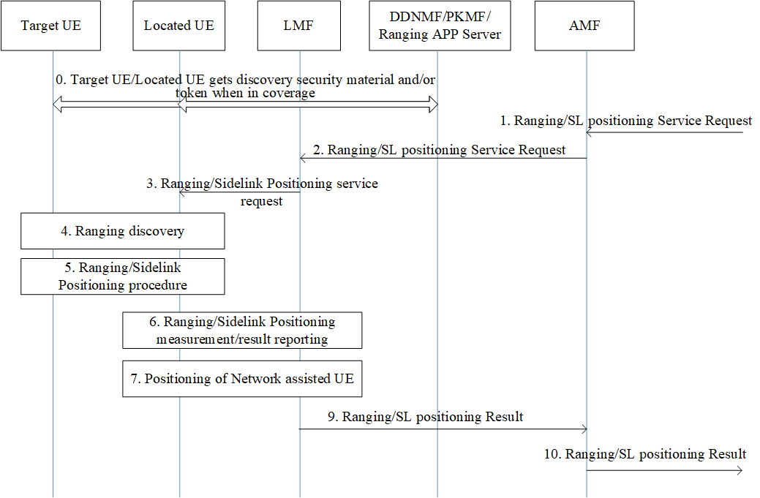
Figure 6.5.2-2: Security for Network Assisted Sidelink Positioning with Partial Network Coverage
4. The selected Located UE(s) performs the Discovery procedure (i.e. Model B discovery) to discover the Target UE which may move out of network coverage, and provides the Service Code and its token to the Target UE. Once receiving the discovery messages, the Target UE verifies the integrity of discovery message and the token.
5. If the authorization checking is successful, the Target UE establishes a PC5 link with the located UE for the SL positioning measurement as defined in TS 33.503 [6]. The Located UE and Target UE also exchange their tokens during the PC5 link establishment procedure for role authorization of each other.
6~9. The rest of the procedure of Sidelink Positioning service is performed between the Located UE and the network.

6.5.2.2 Token based authorization for scenario of Ranging services

6.5.2.2.1 Security for Ranging procedure between Reference UE and Target UE
0. The Reference UE and the Target UE are provisioned with the discovery security materials and request authorization tokens when they are in 3GPP coverage.
1. The direct discovery procedure is performed by the Reference UE in order to discover the Target UE using the discovery parameters and discovery security material, based on the Ranging Service Code for the Ranging service.
2. If discovery result indicates the Target UE supports the Ranging service, the Reference UE sends a Direct Communication Request (DCR) that contains the Ranging Service Code (RSC) of the Ranging service and the authorization token of Reference UE which is retrieved from step #0, and also the Key_Est_Info used for direct authentication and key establishment. Protection of authorization token and RSC in DCR can be done in a similar way as described in TS33.503 [6].
3. Direct Auth and Key Establish procedure as specified in TS 33.536 [5] is performed.
4. The Target UE uses the public key provided by the network to verify the token1 of the Reference UE that the Reference UE is authorized to act as a Reference UE.
Figure 6.5.2-3: High-level Procedure of PC5 Security between Reference UE and Target UE
5. The Target UE derives KNRP and other security material as specified in TS 33.536 [5]. The Target UE sends a Direct Security Mode Command message to the Reference UE including the authorization token2 of the Target UE which is retrieved from step #0. The confidentiality protection is applied to the authorization token2.
6. The Reference UE uses the public key provided by the network to verify the token2 of the Target UE that the Target UE is authorized to act as a Target UE in the Ranging service. The Reference UE derives KNRP and other security material similar as the Target UE in step #5.
7. The Reference UE sends the Direct Security Mode Complete message to the Target UE.
8. The Reference UE and Target UE continue with the rest of procedure for the Ranging service over the secure PC5 link.

6.5.2.2.2 Security for Ranging procedure between Reference UE/Target UE and Assistant UE
0. The Reference UE, the Assistant UE and Target UE are provisioned with the discovery security materials and request authorization tokens when they are in 3GPP coverage.
1. The direct discovery procedure is performed by the Reference UE in order to discover the Assistant UE using the discovery parameters and discovery security material, based on the Ranging Service Code for the Ranging service.
Figure 6.5.2-4: High-level Procedure of PC5 Security between Reference UE/Target UE and Assistant UE
2. If discovery result indicates the Assistant UE supports the Ranging service, the Reference UE sends a Direct Communication Request (DCR) that contains the Ranging Service Code (RSC) of the Ranging service and the authorization token1 of Reference UE which is retrieved from step #0, and also the Key_Est_Info used for direct authentication and key establishment. Protection of authorization token and RSC in DCR can be done in a similar way as described in TS33.503 [6].
3. Direct Auth and Key Establish procedure as specified in TS 33.536 [5] is performed.
4. The Assistant UE uses the public key provided by the network to verify the token1 of the Reference UE that the Reference UE is authorized to act as a Reference UE.
5. The Assistant UE derives KNRP and other security material as specified in TS 33.536 [5]. The Assistant UE sends a Direct Security Mode Command message to the Reference UE including the authorization token2 of the Assistant UE which is retrieved from step #0. The confidentiality protection is applied to the authorization token.
6. The Reference UE uses the public key provided by the network to verify the token2 of the Assistant UE that the Assistant UE is authorized to act as a Assistant UE in the Ranging service. The Reference UE derives KNRP and other security material similar as the Assistant UE in step #5.
7. The Reference UE sends the Direct Security Mode Complete message to the Assistant UE.
8. The Reference UE and Assistant UE continue with the rest of procedure for the Ranging service over the secure PC5 link.
9. Steps #1-#8 are repeated for PC5 security establishment between the Assistant UE and Target UE.

6.5.3 Evaluation
This solution, based on multiple solutions for KI#2 and KI#5 of TR 23.700-86 [2], addresses the first requirement in KI#2 on the authorization of the UE as a Target UE/Reference UE/Assistant UE/Located UE in the Ranging/Sidelink Positioning service.
This solution ensures that the peer UE can authorize the role of each other during Discovery procedure and PC5 link establishment procedure, covering both cases where they are in network coverage and out of network coverage.
The solution requires the network to provide the authorization token to the UE.
This solution requires the UEs to exchange their authorization tokens during Discovery procedure and PC5 link establishment procedure and verify the role.
*************** End of the Change ****************

