3GPP TSG-SA3 Meeting #109AdHoc-e draft S3-230398-r2

Electronic meeting, 16 - 20 January 2023 Revision of S3-22xxxx

Source: Xiaomi

Title: Evaluation of solution #30 in TR 33.740

Document for: Approval
Agenda Item: 5.3

1 Decision/action requested
This contribution proposes to evaluate the solution #30 in the FS_5G_ProSe_Ph2 study TR 33.740

2 References
[1] 3GPP TR 33.740 v0.4.0: "Study on security aspects of Proximity Based Services (ProSe) in 5G System (5GS) phase 2"

3 Rationale
This pCR proposes to evaluate solution #30 in TR 33.740 [1].

4 Detailed proposal
*************** Start of the Change ****************

6.30 Solution #30: Security for discovery integrated into PC5 link establishment

6.30.1 Introduction
The solution addresses Key Issue #1: Security for UE-to-UE Relay discovery and Key Issue #2: Security of UE-to-UE Relay. It largely reuses the mechanism of Restricted Discovery procedure and Direct Security Establishment procedure defined in TS 33.503 [6]
In addition to the Model A discovery and Model B discovery, discovery integrated into PC5 unicast link establishment procedure is supported in the U2U Relay scenario, which is concluded by SA2. By broadcasting the DCR message, the Source UE and Target UE can discover and select one U2U Relay to establish the PC5 link. However, the broadcast UE identity (i.e. User Info ID) may compromise the user’s privacy information and the missing of discovery procedure may introduce additional security threats, e.g. the unauthorized UE-to-UE Relay can arbitrarily initiate to establish the PC5 link with peer UE.
This solution uses the code security parameters to protect the privacy-sensitive information in the DCR message and uses the security materials (i.e. the long term credential) to secure the link establishment. To obtain the code security parameters, the peer UE and UE-to-UE Relay need to send the Discovery Request. Once receiving the Discovery Request, the network can check the authorization of peer UE and U2U Relay, which reuses the Restricted Discovery procedure specified in TS 33.503 [6]. By authorization checking and direct authentication, the hop-by-hop security can be provided between the Source UE and Target UE via 5G ProSe Layer-3 UE-to-UE Relay.

6.30.2 Solution details
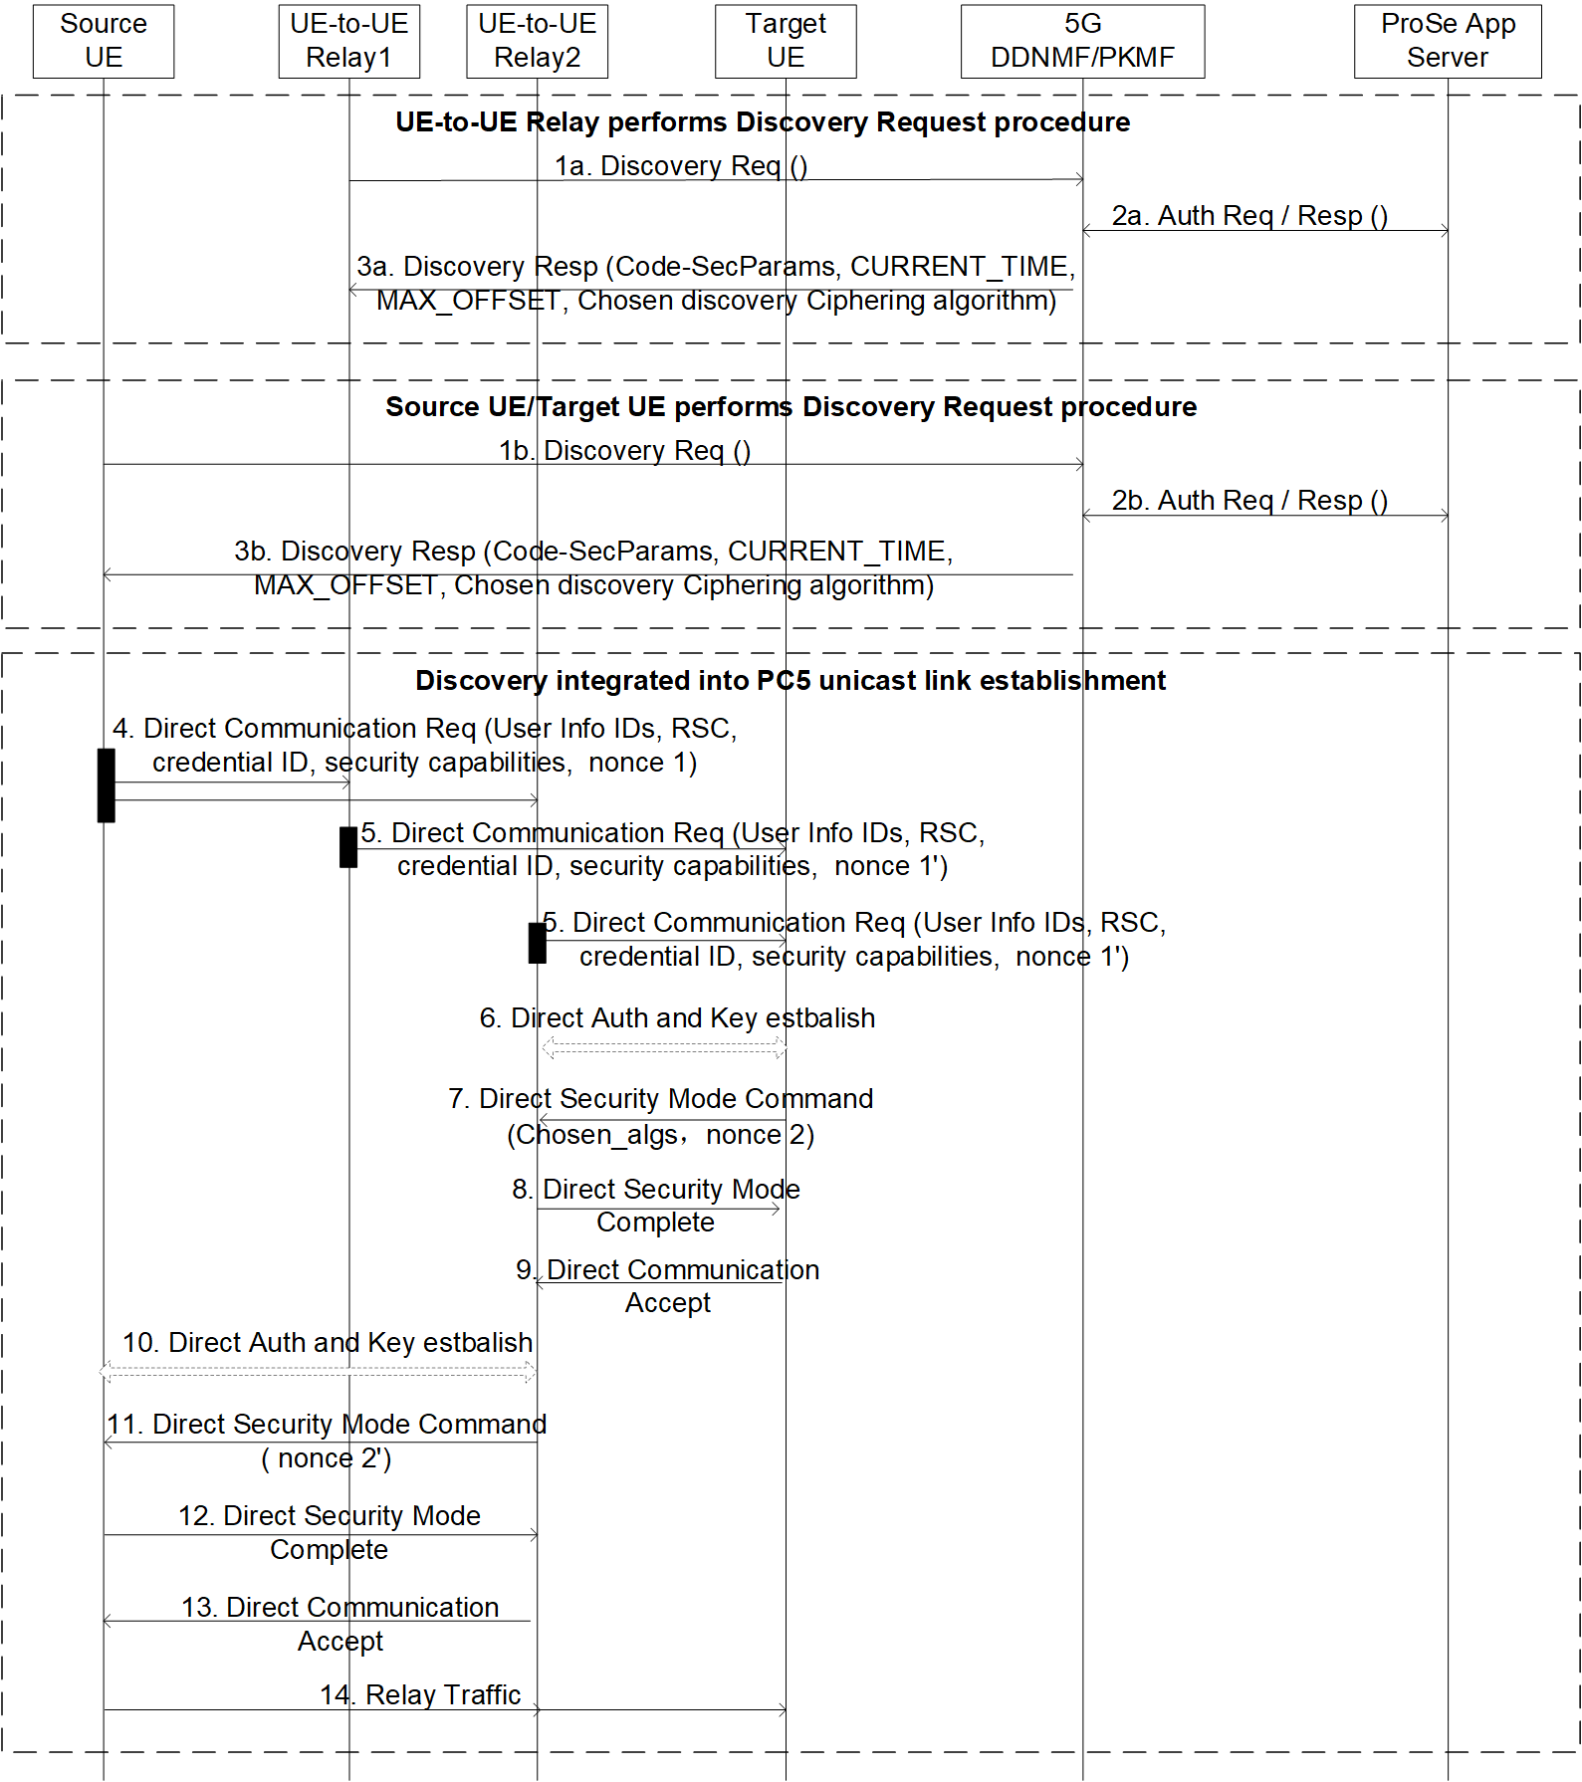
Figure 6.30.2-1: Security for discovery integrated into PC5 link establishment
Note 1: When the user-plane based security procedure for the UE-to-UE Relay is used, the 5G PKMF takes the role of the 5G DDNMF.
Steps 1a-3a refer to the Discovery Key Request procedure of UE-to-UE Relay.
1a. UE-to-UE Relay sends a Discovery Request message containing its User Info ID, the Relay Service Code (RSC) to the 5G DDNMF in order to get the associated security parameters. In addition, the U2U Relay shall include its PC5 UE security capability that contains the list of supported ciphering algorithms by the UE in the Discovery Request message.
2a. The 5G DDNMF may check for the authorization with the ProSe Application Server based on the User Info ID and RSC.
3a. The 5G DDNMF of the U2U Relay returns the corresponding code security parameters, along with the CURRENT_TIME and MAX_OFFSET parameters. The code security parameters provide the necessary information for the UE-to-UE Relay to protect the information in the DCR message and are stored with the RSC. The 5G DDNMF of the U2U Relay may include the chosen discovery ciphering algorithm in the Discovery Response message. The 5G DDNMF determines the chosen discovery ciphering algorithm based on the RSC and the received security capability in step 1a. The UE-to-UE Relay stores the chosen discovery ciphering algorithm together with the RSC.
Steps 1b-3b refer to the Discovery Key Request procedure of Source UE/Target UE.
1b. The Source UE/Target UE sends a Discovery Request message containing the User Info ID and its PC5 UE security capability to the 5G DDNMF in order to get the associated security parameters.
2b. The 5G DDNMF of Source UE/Target UE sends an authorization request to the ProSe Application Server. If, based on the permission settings, the user Info ID is allowed to access U2U relay service, the ProSe Application Server returns an authorization response.
3b. If the Discovery Request is authorized and the PC5 UE security capability in step 1b includes the chosen discovery ciphering algorithm, the 5G DDNMF responds with the Discovery Response message including the corresponding Code Security Parameters and the chosen discovery ciphering algorithm (based on the information/keys stored in step 3a).Steps 4-14 refer to the discovery integrated into PC5 unicast link establishment procedure.
4. The Source UE wants to establish unicast communication with the Target UE via a UE-to-UE relay. Then the Source UE broadcasts Direct Communication Request containing User Info ID of Source UE and User Info ID of Target UE, RSC, long term credential ID, nonce 1 and its security capabilities. The message will be received by U2U relay-1, U2U relay-2. The User Info ID of Source UE/Target UE are protected by the code security parameters as defined in the TS 33.503 [6].
Note 2: The long term credential and long term credential ID could be pre-configured on the 5G ProSe UE (incl. Source UE, Target UE and UE-to-UE Relay) or provisioned by the network e.g. during Service Authorization and Provisioning procedure before the U2U discovery integrated into PC5 unicast link establishment procedure.
5. The U2U Relay-1 and U2U Relay-2 receive the DCR message and check the RSC. If they are authorized to provide the Relay service associated with RSC, then broadcast a new Direct Communication Request message. When a U2U Relay broadcasts the Direct Communication Request message, it includes User info ID of Source UE, User info ID of Target UE and User info ID of U2U Relay, long term credential ID, its nonce 1’ and its security capabilities in the message.
6. The Target UE receives the Direct Communication Requests from U2U Relay-1 and U2U Relay-2. The Target UE verifies the DCR message by using the code security parameters and chooses one U2U relay (e.g. U2U Relay-2). The Target UE may initiate a Direct Auth and Key Establish procedure with U2U Relay-2 to generate the K_{NRP}.
7. The Target UE derives the session key (K_{NRP-SESS}) from K_{NRP} and then derive the confidentiality key (NRPEK) (if applicable) and integrity key (NRPIK) based on the PC5 security policies. The Target UE sends a Direct Security Mode Command message to the U2U Relay-2. This message includes the chosen PC5 security algorithm, nonce 2’, and is protected as specified in TS 33.536 [9].
8. The U2U Relay-2 responds with a Direct Security Mode Complete message to the Target UE.
9. Once receiving the Direct Security Mode Complete message from the U2U relay-2, the Target UE sends the Direct Communication Accept message to the U2U Relay-2.
10. The U2U Relay-2 may initiate a Direct Auth and Key Establish procedure with Source UE to generate the K_{NRP}’.
11. The U2U Relay-2 derives the session key (K_{NRP-SESS}’) from KNRP’ and then derives the confidentiality key (NRPEK’) (if applicable) and integrity key (NRPIK’) based on the PC5 security policies. The U2U Relay-2 sends a Direct Security Mode Command message to the Source UE. This message includes the chosen PC5 security algorithm, the nonce 2.
12. The Source UE responds with a Direct Security Mode Complete message to the U2U Relay-2.
13. The U2U Relay-2 sends the Direct Communication Accept message to the Source UE.
14. The secure L3 PC5 link between the Source UE and the Target UE via the U2U Relay-2 is established. The U2U Relay-2 can relay the traffic between the peer UEs.

6.30.3 Evaluation

This solution addresses KI#1 and KI#2 by largely reusing the mechanisms defined for Restricted Discovery in TS 33.503 [6].
This solution addresses how the 5G Prose UEs retrieve their discovery materials associated with RSC to protect its privacy sensitive information in the case that UE-to-UE Relay Discovery is integrated into PC5 link establishment.
This solution also addresses how the 5G Prose UEs securely establish the ProSe Communication via UE-to-UE Relay with Discovery integrated into PC5 unicast link establishment procedure.
This solution is aligned with the SA2’s procedure defined in TS 23.304 [8].
For discovery integrated into PC5 link establishment, 5G Prose UEs use the discovery materials associated with RSC to protect the information in DCR messages. The provisioning of discovery materials reuses the discovery request procedure defined in clause 6.1.3.2 of TS 33.503 [6].
The discovery request in sol can be seen as the relay discovery key request in the U2N discovery.

Editor’s Note: Further evaluation is FFS.
*************** End of the Change ****************

