3GPP TSG-SA3 Meeting #109AdHoc-e S3-230123

Electronic meeting, 16 - 20 January 2023

Source: China Telecom

Title: New solution to KI#5

Document for: Approval
Agenda Item: 5.8

1 Decision/action requested
This contribution proposes to add new solution to KI#5.

2 References

3 Rationale
The contribution proposes to add new solution to KI#5.

4 Detailed proposal
It is suggested to approve the following change.

*************** Start of the change ****************

6.Y Solution #Y: Access control for user plane data

6.Y.1 Introduction
The solution addresses KI#5 on security for NWDAF-assisted application detection.
When NWDAF provides NWDAF-assisted PFD Determination analytics, it needs to use data extracted from the inspected user plane packets in the flow. This solution proposes a user plane data access control method, where application service provider (ASP) provides a user-plane-data-access-control list of data/data type that should not be provided to NWDAF for each application identifier maintained by the ASP.
Editor’s Note: Whether it is the ASP’s responsibility to control access to the user data is ffs.

6.Y.2 Solution details
In this solution, ASP defines the user-plane-data-access-control list of data/data type that should not be provided to NWDAF for an application. NWDAF and UPF both check the user-plane-data-access-control list to make sure data that matches the user-plane-data-access-control list will not be collected.
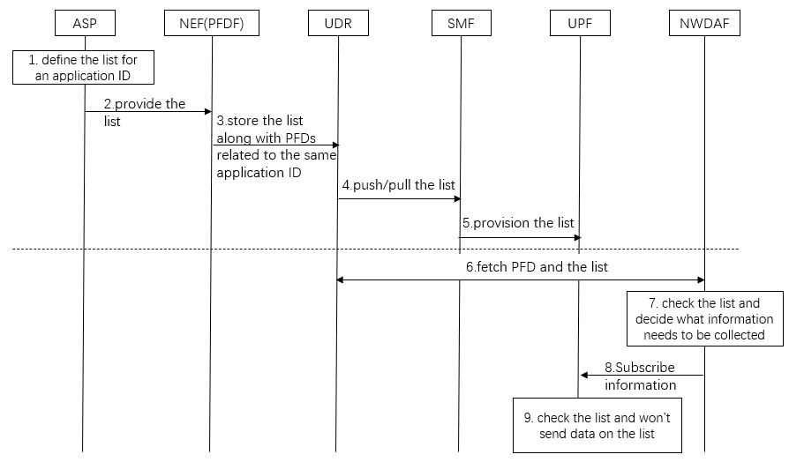
Step 1: ASP defines the user-plane-data-access-control list of data/data type that should not be provided to NWDAF for an application identifier maintained by the ASP.
Step 2: ASP provides the user-plane-data-access-control list to NEF (PFDF).
Step 3: NEF (PFDF) stores the user-plane-data-access-control list along with PFDs related to the same application identifier in UDR.
Step 4: The user-plane-data-access-control list may be retrieved by SMF from NEF (PFDF) in "pull" mode or may be provisioned from NEF (PFDF) to the SMF in "push" mode.
When the "push" mode is used, the NEF (PFDF) retrieves from the UDR the user-plane-data-access-control list for each application identifier and distributes them to those SMFs that enable access to those applications. There are three methods to provision the user-plane-data-access-control list from the NEF (PFDF) to the SMF:
a) Push of whole user-plane-data-access-control lists and PFD(s) that can be accessed by the NEF (PFDF) according to operator configuration in NEF (PFDF) (e.g. provision per day according to operator configuration);
b) Selective push of an ASP change in the user-plane-data-access-control list (i.e. ASP changes the list while operator configuration defines when to push);
c) Selective push of an ASP change in the user-plane-data-access-control list according to ASP request (i.e. ASP indicates to push changes in the list).
When the "pull" mode is used, at the time a PCC Rule with an application identifier for which PFDs are not available is activated or provisioned, the SMF requests all PFDs and the user-plane-data-access-control list for that application identifier from the NEF (PFDF), and NEF (PFDF) retrieves them from the UDR.
Step 5: If there's any user-plane-data-access-control list received and there are still active application detection rules in the UPF for the application identifier, the SMF shall provision the user-plane-data-access-control list corresponding to the application identifier to the UPF.
Step 6: When NWDAF does NWDAF-assisted PFD Determination analytics, it fetches currently stored PFD information in use and user-plane-data-access-control list from UDR via NEF(PFDF).
Step 7: NWDAF checks user-plane-data-access-control list and decides what information needs to be collected. Information that matches the user-plane-data-access-control list will not be collected.
Step 8: NWDAF subscribes PFD Determination related information.
Step 9: UPF checks user-plane-data-access-control list. UPF will not send information that matches the user-plane-data-access-control list to NWDAF.

6.Y.3 Evaluation
TBD
*************** End of the change ****************

