3GPP TSG-SA3 Meeting #109AdHoc-e S3-230102

Electronic meeting, 16 - 20 January 2023

Source: China Telecom

Title: New solution to KI#2

Document for: Approval
Agenda Item: 5.8

1 Decision/action requested
This contribution proposes to add new solution to KI#2.

2 References

3 Rationale
The contribution proposes to add new solution to KI#2.

4 Detailed proposal
It is suggested to approve the following change.

*************** Start of the change ****************

6.Y Solution #Y: Authorization of selection of participant NWDAF instances in the FL group

6.Y.1 Introduction
The solution addresses KI#2 on authorization of selection of participant NWDAF instances in the Federated Learning group.
For the client NWDAF’s authorization to join a FL group, as per TR 23.700-81’s conclusion to KI#8: supporting federated learning in 5GC, server NWDAF selects client NWDAFs from NRF and client NWDAF cannot request to join a FL group. Since client NWDAF joins a FL group only when it is selected by server NWDAF, client NWDAF is authorized to join the FL group by server NWDAF at the same time.
For the server NWDAF’s authorization to include a client NWDAF into a FL group, this solution proposes that client NWDAF registers to NRF with the permitted-server-NWDAF list for each supporting Analytics ID. When a server NWDAF discovers client NWDAFs for an Analytics ID from NRF, NRF only returns client NWDAFs whose permitted-server-NWDAF list for this Analytics ID includes the server NWDAF. When server NWDAF requests access token, NRF also checks if the server NWDAF is on the permitted-server-NWDAF list.
NOTE: When new permitted server NWDAFs are introduced, the client NWDAF needs to update its permitted-server-NWDAF list.

6.Y.2 Solution details
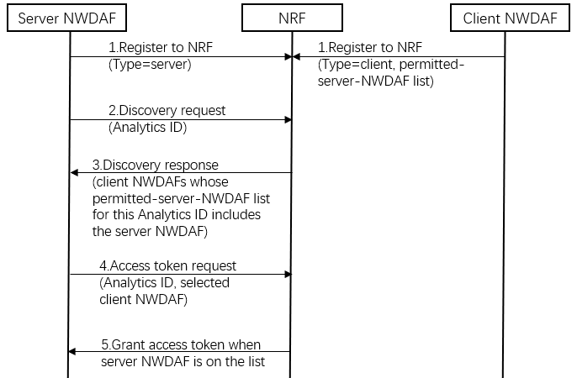
Step 1: NWDAF registers to NRF with its FL related information including Analytics ID(s), FL capability type (i.e. FL server or FL clients), permitted-server-NWDAF list for each Analytics ID when this NWDAF serves as a FL client, etc.
Step 2: Server NWDAF sends discovery request to NRF to find client NWDAFs for an Analytics ID.
Step 3: NRF returns candidate client NWDAFs whose permitted-server-NWDAF list for this Analytics ID includes the server NWDAF.
Step 4: Server NWDAF sends access token requests to NRF for each selected client NWDAFs of the Analytics ID.
Step 5: When the server NWDAF is on the selected client NWDAF’s permitted-server-NWDAF list for this Analytics ID, NRF grants access token to the server NWDAF.

6.Y.3 Evaluation
TBD
*************** End of the change ****************

