3GPP TSG-SA3 Meeting #108e S3-222246

e-meeting, 22 - 26 August 2022

Source: NTT DOCOMO, Nokia, Nokia Shanghai Bell, BSI (DE), Deutsche Telekom

Title: pCR to TR 33.875 new solution on PRINS for roaming hubs

Document for: Approval
Agenda Item: 5.24 study on enhanced security aspects of the 5G service based architecture

1 Decision/action requested
It is proposed to approve the pCR below

2 References
[1] 3GPP TR 33.875 v1.2.0 Study on enhanced security aspects of the 5G Service Based Architecture (SBA)

3 Rationale
Roaming hubs were not considered originally during the design of PRINS. This pCR introduces a possibility to use PRINS to support roaming hub functionality.

4 Detailed proposal
It is proposed to approve the following pCR:
+++++++++++++++++++++++++++++++++ First change ++++++++++++++++++++++++++++++++++++++

3.1 Terms
For the purposes of the present document, the terms given in 3GPP TR 21.905 [1] and the following apply. A term defined in the present document takes precedence over the definition of the same term, if any, in 3GPP TR 21.905 [1].

traffic shaper: a network device that is used to limit the throughput for individual connections by delaying or dropping packets.

+++++++++++++++++++++++++++++++++ Next change ++++++++++++++++++++++++++++++++++++++

2 References
The following documents contain provisions which, through reference in this text, constitute provisions of the present document.
- References are either specific (identified by date of publication, edition number, version number, etc.) or non-specific.
- For a specific reference, subsequent revisions do not apply.
- For a non-specific reference, the latest version applies. In the case of a reference to a 3GPP document (including a GSM document), a non-specific reference implicitly refers to the latest version of that document in the same Release as the present document.
[1] 3GPP TR 21.905: "Vocabulary for 3GPP Specifications".
[2] 3GPP TS 33.501: "Security architecture and procedures for 5G System".
[3] 3GPP TS 23.501: "System architecture for the 5G System (5GS); Stage 2".
[4] 3GPP TS 33.220: "Generic Authentication Architecture (GAA); Generic Bootstrapping Architecture (GBA)".
[5] 3GPP TS 29.500: "5G System; Technical Realization of Service Based Architecture; Stage 3"
[6] 3GPP TS 29.510: "5G System; Network function repository services; Stage 3"
[xx] 3GPP TS 29.573: "5G System; Public Land Mobile Network (PLMN) Interconnection; Stage 3"

+++++++++++++++++++++++++++++++++ Next change ++++++++++++++++++++++++++++++++++++++

6.Y Solution #Y: PRINS for Roaming Hubs

6.Y.1 Introduction
There may be one or two roaming hubs involved in the communication between two PMNs (cf. KI XYZ). The roaming hubs require the ability to allow roaming relations between these PMNs via these roaming hubs. Furthermore, roaming hubs with financial liability require the ability to shape roaming traffic between the PMNs.
PRINS can be used to achieve this, allowing and disallowing establishment of N32c through standard HTTP proxy functionality. PRINS can also be used to dynamically introduce a traffic shaper under control of the RH into the data plane.

6.Y.2 Solution details
Figure 6.Y.2-1: Establishment of N32c via roaming hubs
0: The cSEPP is configured to make use of RH1
1: After receiving an initial request, the cSEPP may set up a TLS connection with RH1's proxy. The cSEPP then sends a CONNECT command to RH1's proxy indicating the destination to be pSEPP.
Editor's Note: whether additional methods to determine pSEPP name other than its well known FQDN are required is FFS
2: RH1's proxy shall verify that cSEPP is allowed to set up a roaming relation with pSEPP. If not, the flow continues with the error message of step 6. Otherwise, it continues with step 3.
3: If pSEPP requires another roaming hub to be reached, RH1's proxy sets up a TLS connection with RH2's proxy. R1's proxy then sends a CONNECT command to RH2's proxy indicating the destination to be pSEPP. RH2's proxy shall verify that RH1 is allowed to set up a roaming relation with pSEPP. If not, the flow continues with the error message of step 5. Otherwise, it continues with step 4.
4: If RH2 is present, RH2's proxy, otherwise RH1's proxy shall set up a TCP connection to pSEPP. This connection may be protected by TLS.
5: If successful, if RH2 is present, RH2 shall return success with code 200.
6: If successful, RH1 shall return success with code 200.
If successful, pSEPP and cSEPP shall establish a TLS connection via the proxy/proxies for N32c and establish an N32f context, selecting PRINS as the protection mechanism.

Figure 6.Y.2-2: N32f via roaming hubs
1: cSEPP may either intiate a new TLS connection to RH1's proxy, or reuse the TLS connection from setting up N32c. In any case, communication between cSEPP and RH1's proxy shall be TLS protected.
2: After receiving a request from an NF, the cSEPP shall encapsulate the request as defined in TS29.573 [xx] subclause 5.3.2.3 and send the reformatted message to RH1's proxy. The URL to send the request to shall be located on RH1's proxy, thus RH1's proxy is able to read the request.
3: If another RH is present, RH1's proxy shall forward the message to RH2's proxy, including a via header and an asserted identity header asserting the identity of the cSEPPs PMN. If RH2 is not present, then this request shall be sent directly to pSEPP.
4: If another RH is present, RH2's proxy shall forward the request to pSEPP, including a via header giving both RH proxies. An asserted identity header is not necessary as pSEPP can identify the source PMN from the N32f context.
5: pSEPP shall decapsulate the request, forward it to the pNF and receive the response.
6: pSEPP shall reformat the response and forward to RH2 (if present) or to RH1 (if RH1 is not present).
7: If RH2 is present, then RH2's proxy shall forward the response to RH1's proxy.
8: RH1's proxy shall forward the response to cSEPP.
9: cSEPP shall decapsulate the response, forward it to the pNF
All communication shall be TLS protected on the hops between cSEPP and RH1's proxy, RH1's proxy and RH2's proxy, RH2's proxy and pSEPP.
RH1's proxy and RH2's proxy both may include modifications, or return errors in case of roaming policy violations.
The following two messages sequence charts give examples:
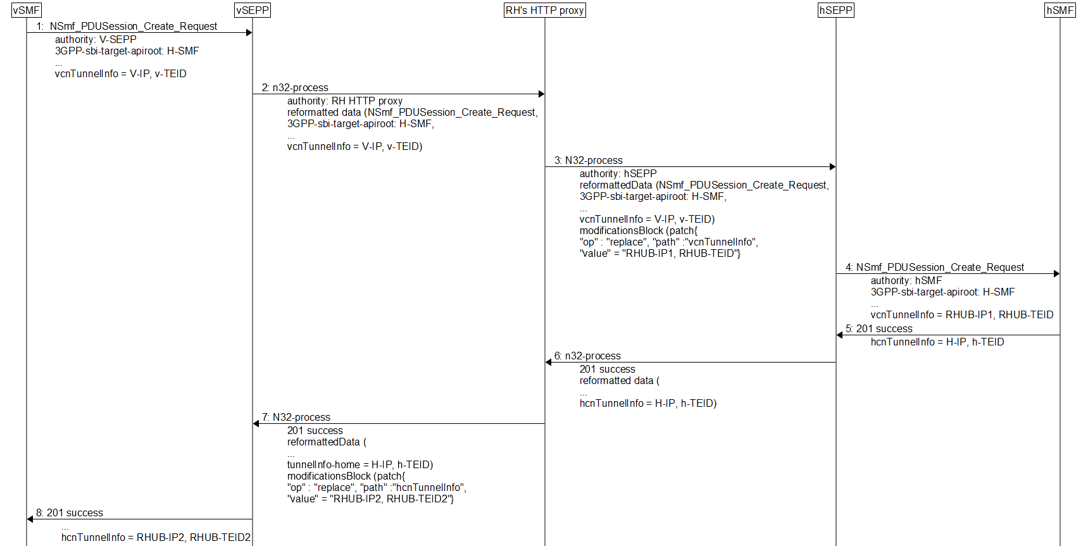
Figure 6.Y.2-3: Roaming hub inserting a traffic shaper
To insert a traffic shaper into the roaming user data plane, the RH may include a modifications block that rewrites the N9 endpoints IP address and TEID for the visited networks UPF in message 3, and another modifications block that rewrites the N9 endpoints IP address and TEID for the visited networks UPF in message 7. As these modifications blocks are signed, the modifications are attributable.
Figure 6.Y.2-4: Roaming rejecting a session creation request
A roaming hub may also reject a PDU session setup request by returning an error in message 3. This error is forwarded to the vSMF in message 4. This may be triggered by some information in the request visible to the RH. If different SUPIs require different handling, then of course, SUPI shall not be encrypted in the request.
The examples can be extended to include two roaming hubs and potentially even two traffic shapers.

6.Y.3 Evaluation
The solution allows a RH to allow or deny roaming traffic between operators based on the contractual relations with the RH. In addition, it allows traffic shaping of the user plane roaming traffic between two PMNs making use of roaming hubs by dynamically introducing a traffic shaper.
The solution exposes user plane traffic to roaming hub's traffic shapers (when present). However, at both PMNs, the presence of the traffic shapers is visible in the modifications blocks. Furthermore, modifications performed by the roaming hubs are attributable.
Editor's Note: further evaluation is FFS.

+++++++++++++++++++++++++++++++++ End of changes ++++++++++++++++++++++++++++++++++++

