3GPP TSG-SA3 Meeting #108e S3-222175

e-meeting, 22 - 26 August 2022

Source: China Mobile

Title: Adding description about methodology of security requirements to clause 5.2 in TR 33.936

Document for: Approval
Agenda Item: 4.2

1 Decision/action requested
This contribution proposes to add description about methodology of security requirements to clause 5.2

2 References
[1] 3GPP TR 21.905: "Vocabulary for 3GPP Specifications".
[2] 3GPP TR 33.916 Security Assurance Methodology (SECAM) for 3GPP network products
[3] 3GPP TR 33.818 Security Assurance Methodology (SECAM) and Security Assurance Specification (SCAS)
for 3GPP virtualised network products (Release 17).

3 Rationale
This contribution proposes to add the description about description about methodology of security requirements to clause 5.2 based on the TR 33.818 that includes process for deriving security requirements in a SCAS document, handling of security requirements, guidelines for writing test cases, etc..

4 Detailed proposal
It is suggested to approve the following changes.

********************Start of the change ***************************

5.2 SCAS documents structure and content

5.2.a Security Requirements

5.2.a.1 Introduction
According to the scope of a SECAM SCAS in clause 4.2, a SCAS contains security requirements and associated test cases, and may contain environmental assumptions which will be validated during product deployment. So, like GNP in TR 33.916 [2], the countermeasures deemed relevant to threat mitigation will also take the form of either:
- security requirements on the network product with associated test cases; or
- operational environment security assumptions for a given product class.
For GVNP, the operational environment security assumptions among different product classes vary greatly, for example some sensitive 3GPP functions may need to be run from special security domain or may need to implement hardware (See clause 4.9 in TR 33.916 [2]) with special security requirement that make it difficult, if not impossible to be realized in a GVNP implementation or the protection of certain data may require higher level of protection due to the extreme sensitive nature of the data (e.g. lawful interception target lists). It may also be necessary to consider such assumptions during testing so that stringent security requirements can be met. Any such consideration should be well-documented as part of both the testing environment so that the validation during product deployment can be carried out and duplicated.
The Security Requirements clauses within the pertinent TS contain the security requirements identified according to the threats (see figure 5.2.a.1-1).

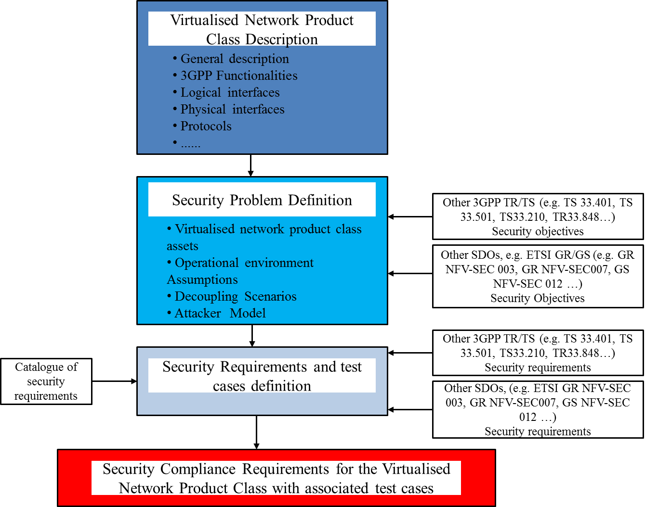
Figure 5.2.a.1-1: Process for deriving security requirements in a SCAS document
The security requirements include security functional requirements and hardening requirements. Since SECAM tasks include Basic Vulnerability Testing, basic vulnerability testing requirements are also included in security requirements of a SCAS. The types of the security requirements are same as in TR 33.916 [2].
The three types of the levels of detail for security requirements in clause 5.2.3.1.1 of TR 33.916 [2] and the relationship between these levels are generic and are also applicable to describe the level of detail of security requirements for a GVNP.

5.2.a.2 Incorporation of security requirements from existing 3GPP and ETSI specifications in current releases
According to GVNP model and threat analysis, the categories of potential security functional requirements can also include the following category extension to the three categories in clause 5.2.3.2 of TR 33.916 [2]:
- Security functional requirements related to virtualization layer, hardware and resource isolation, among others, which may be identified in ETSI specifications etc..
The security functional requirements in this category are within scope of SCAS and related test cases will be proposed.

5.2.a.3 Handling of security requirements
A SECAM Catalogue of General Security Assurance Requirements and associated test cases is proposed in clause 5.2.3.3 of TR 33.916 [2] to prevent from writing the same security requirements from scratch several times in different network product class SCAS. This generic way is also applied to SECAM of virtualized network product class.
Since SECAM and SCAS of physical network product class are bases for SECAM and SCAS of virtualized network product class, the security requirements of a virtualized network product class will refer to the security requirements already available in the current SECAM catalogue if possible otherwise select the new ones from the agreed sources and update the Catalogue. The template for a security requirement description of virtualized network product also uses the template in current SECAM which is described in TR 33.916 [2].

5.2.a.4 Guidelines for writing test cases
Some general guidelines for writing test cases (e.g. describing test case, verifiability and repeatability of test case etc.) are described in clause 5.2.3.4 of TR 33.916 [2]. These general guidelines are also used to guide writing test case of virtualized network product class.
NOTE: All the test cases in the present document do not apply to the scenarios where the tested interfaces are not standard compliant, e.g. when the VNF and VNFM are provided by the same vendor who has proprietary implementation on the interface between them.
********************End of the change ***************************

