3GPP TSG-SA3 Meeting #108e-AdHoc S3-222876-r2

e-meeting, 10 - 14 October 2022 Revision of S3-22xxxx

Source: Xiaomi

Title: New solution on Security Establishment Procedure for 5G ProSe Layer-2 UE-to-UE Relay

Document for: Approval
Agenda Item: 5.3

1 Decision/action requested
This contribution proposes to add a new solution in the FS_5G_ProSe_Ph2 study TR 33.740

2 References
[1] 3GPP TR 33.740 v0.2.0: "Study on security aspects of Proximity Based Services (ProSe) in 5G System (5GS) phase 2"
[2] 3GPP TR 23.700-33 v1.0.0: "Study on system enhancement for Proximity based Services (ProSe) in the 5G System (5GS); Phase 2"
[3] 3GPP TS 33.503 v17.0.1: "Security Aspects of Proximity based Services (ProSe) in the 5G System (5GS)"

3 Rationale
Key issue #2 in TR 33.740 [1] addresses the security for UE-to-UE Relay. As per TR 23.700-33 [2], two options (Layer-2 UE-to-UE Relay and Layer-3 UE-to-UE Relay) are under consideration. For Layer-2 UE-to-UE Relay, full security for PC5 one-to-one communication between the Source UE and the Target UE needs to be ensured. The peer UEs need to exchange their security materials and associate the end-to-end PC5 keys with the assistance of Layer-2 UE-to-UE Relay.
Therefore, this pCR proposes a solution to address Key issue #2 Security for UE-to-UE Relay in TR 33.740 [1] by using the IKEv2 protocol and the mechanism of Direct Security Establishment procedure defined in TS 33.503 [3].

4 Detailed proposal
*************** Start of the Change ****************

6.Y Solution #Y: E2E Security Establishment Procedure for 5G ProSe Layer-3 UE-to-UE Relay

6.Y.1 Introduction
The solution addresses Key Issue #2: Security of UE-to-UE Relay. It largely reuses the IKEv2 protocol and the mechanism of Direct Security Establishment procedure defined in TS 33.503 [6] to ensure the end-to-end security between the Source UE and Target UE.
After the per-hop links (i.e. the PC5 link between Source UE and UE-to-UE Relay, as well as the PC5 link between UE-to-UE Relay and Target UE) are established, the peer UEs may exchange their security materials and associate the end-to-end security keys to establish E2E security. The Source UE and Target UE perform the IKEv2 protocol, which enables the end-to-end security in the UE-to-UE relay communication.

6.Y.2 Solution details
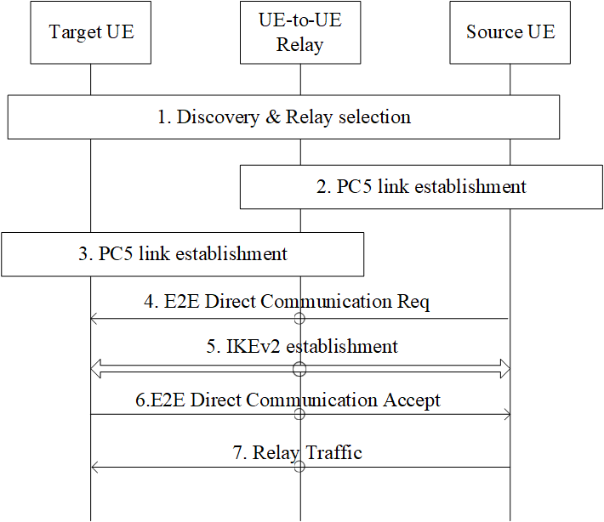
Figure 6.Y.2-1: PC5 link security establishment procedure for 5G ProSe Layer-3 UE-to-UE Relay
1. The Discovery & Relay Selection procedure is performed between the peer UEs and the UE-to-UE Relay.
2. The Source UE initiates the PC5 link setup with UE-to-UE Relay by performing the Direct Communication procedures specified in TS 33.503 [6].
3. After the PC5 link between the Source UE and UE-to-UE Relay is established, the UE-to-UE Relay initiates the PC5 link setup with the Target UE based on the Direct Communication procedure specified in TS 33.503 [6].
4. The Source UE sends E2E Direct Communication Request to the Target UE, which is forwarded by the Layer-3 U2U relay. The E2E Direct Communication Request is protected by the NRPIK/NRPEK of each hop (i.e the link between Source UE and Layer-3 U2U Relay and the link between Layer-3 U2U Relay and Target UE).
5. [Optional]The Target UE initiates the security negotiation procedure with the Source UE to establish an end-to-end IPSec connection by performing IKEv2 authentication procedure. After the IKEv2 authentication, the Source UE and the Target UE generate the E2E security keys. The details of IKEv2 protocol is out of the scope of 3GPP.
Note: The detail of IKEv2 protocol is out of the scope of 3GPP.
6. The Target UE responds with the E2E Direct Communication Accept forwarded by the Layer-3 U2U Relay. The E2E Direct Communication Accept is protected by the E2E security keys generated in step5.
7. The End-to-End PC5 link between the Source UE and the Target UE via the UE-to-UE Relay is established. The UE-to-UE Relay can forward the traffic between the peer UEs.

6.Y.3 Evaluation
TBD
*************** End of the Change ****************

