3GPP TSG-SA3 Meeting #108e-AdHoc S3-222750-r2

e-meeting, 10 - 14 October 2022

Source: Nokia, Nokia Shanghai Bell

Title: Proposal for an evaluation to solution #1.

Document for: Approval
Agenda Item: 5.18

1 Decision/action requested
It is requested to approve this proposal

2 References

3 Rationale
This contribution proposes an evaluation to solution #1.

4 Detailed proposal
************ START OF CHANGES ************

6.1 Solution #1: Provide additional authentication information to enhance URSP policy enforcement.

6.1.1 Introduction
The solution provides a UE platform agnostic method to provide additional authentication information which can be used to enhance URSP policy enforcement. The solution provides a method to add additional authentication information to a URSP policy and update the policy in the UE. The solution reuses existing methods to input the additional authentication information and update the policy. The content of the additional authentication information could as an example be token but is out of scope of this specification.

6.1.2 Solution details
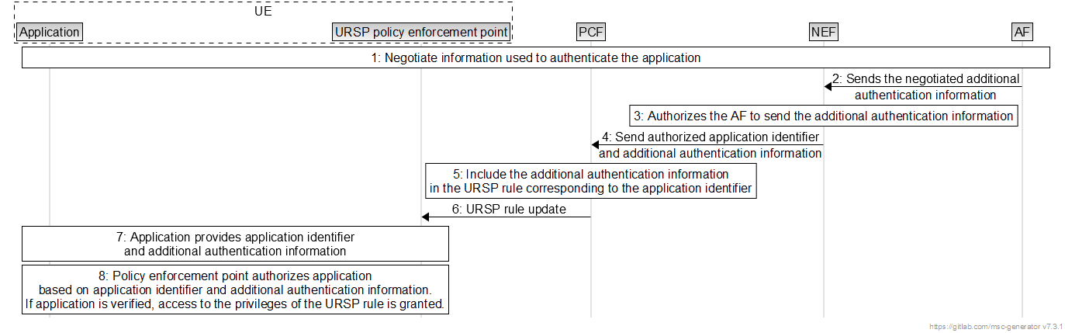
- UE application and backend application function negotiates authentication data. This can be a token, signature etc. The negotiation protocol is out of scope of this specification. The step can be omitted if data is already pre-provisioned or negotiation is unnecessary for the proprietary application verification method.
- The AF sends the application authentication information to the NEF to be included in the URSP rule.
- NEF authorises the AF to update the URSP rule with the additional authentication information.
- NEF provides the application ID together with additional authentication information. The interaction between NEF and PCF is described in TS 23.503 section 5.3.10 [2]
- The PCF includes the application identifier and additional authentication information in the policy as described in TS 23.503 section 6.2.1.2 [2].
- The PCF triggers a policy update using existing methods.
- Application provides additional authentication information along application identifier. The interaction between URSP enforcement point and application is out of scope of this specification.
- The policy enforcement point authenticates the application using the provided additional authentication information.

6.1.3 Evaluation
The solution proposes a UE platform independent exchange of additional authentication information which enables a scalable method which can be used across platforms. The solution extends the URSP policy with an additional field containing the additional authentication information and reused already existing methods to inject information into the policy and update the policy enforced in the UE. The solution leaves the enforcement of the policy and hereby the usage of the additional authentication information to the application function and UE platform.
System impact:
- Additional field added to the URSP.
- PCF: Injection of additional authentication data into the field.
- UE: Parsing and collecting the additional authentication data from the URSP.

Editor’s Note: It is ffs to show that additional authentication information can be used to mitigate the threat.
Editor’s Note: usage of URSP procedures for provisioning of security material is FFS
************ END OF CHANGES ************

