3GPP TSG-SA3 Meeting #108adhoc-e S3-222661

e-meeting, 10 – 14 Oct 2022

Source: Apple

Title: New solution on Authentication and Authorization between EEC and ECS in roaming

Document for: Approval
Agenda Item: 5.9

1 Decision/action requested
This contribution proposes a new solution for key issue#2.1 in TR 33.739

2 References
[1] TS 33.739 v020

3 Rationale
Null

4 Detailed proposal
It is suggested to approve the following changes.

***************************Start of Change ****************************

6.x Solution #x: Authentication and authorization of the EEC/UE by the ECS/EES in roaming scenario

6.x.1 Solution overview
This contribution addresses key issue #2.1 “Authentication and authorization of the EEC/UE by the ECS/EES”.

6.x.2 Solution details
The authentication procedure is based on primary authentication. The procedure is as following:
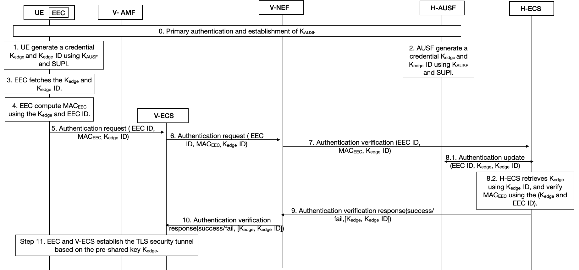
Figure 6.x.2-1: Authentication Procedure for the Authentication and Authorization between EEC and ECS in roaming
Step 0: Primary authentication is performed as defined in TS 33.501. After this step, UE is successfully registered into the 5GS network. Then K_{AUSF} is shared between UE and AUSF in Home network.
Step 1: UE generates a credential K_{edge} and K_{edge} ID using K_{AUSF} and SUPI and stored securely.
Step 2: AUSF generates a credential K_{edge} and K_{edge} ID using K_{AUSF} and SUPI and stored securely.
Step 3: EEC fetches the K_{edge} and K_{edge} ID. This requires UE to provide secure interface to transmit K_{edge} and K_{edge} ID.
Step 4: EEC computes MAC_{EEC} using the K_{edge} and EEC ID.
Step 5: UE sends Authentication request (EEC ID, MACEEC, K_{edge} ID) to V-ECS. Whether this message is send using NAS or user plane is based on SA2’s decision.
Step 6: ECS sends Authentication verification (EEC ID, MAC_{EEC}, K_{edge} ID) to NEF.
Step 7: NEF forward the Authentication verification directly to H-ECS.
Editor’s Note: It is FFS how V-NEF locate the H-ECS.

Step 8.1: H-ECS send request the credentials request to AUSF using EEC ID, and fetched the latest (K_{edge}, K_{edge} ID).
Step 8.2: H-ECS retrieves K_{edge} using K_{edge} ID and verify MAC_{EEC} using the (K_{edge} and EEC ID).
Step 9: If H-ECS verification success, then H-ECS sends Authentication verification response(success) back to V-NEF, otherwise, H-ECS sends Authentication verification response(fail) to V-NEF.
Step 10: V-NEF sends Authentication verification response(success/fail) to V-ECS.
Step 11: Based on the verification results, ECS decides whether to accept or reject the authentication request and sends Authentication Request accept/rejection to EEC in the UE. If ECS accepts the authentication request, then they will establish the security tunnel based on the shared K_{edge}

6.x.3 Solution evaluation
TBA

***************************End of change****************************

