3GPP TSG-SA3 Meeting #108-Adhoc S3-222610r1

e-meeting, 10 – 14 October 2022

Source: OPPO

Title: New Solution on security negotiation of U2U relay protection of remote UE traffic

Document for: Approval

Agenda Item: 5.3

1 Decision/action requested
This pCR proposes to add a solution to address Key Issue #X in companion contribution S3-22XXXX

2 References
[1] 3GPP TR 33.740 " Study on security aspects of Proximity Based Services (ProSe) in 5G System (5GS) phase 2".
[2] S3-22XXXX New KI on U2U relay protection of remote UE traffic

3 Rationale
This contribution addresses the security requirements for key issue #X in the companion contribution S3-222609.

4 Detailed proposal
SA3 is kindly requested to agree to the below pCR to TR 33.740 [1].
**** START OF CHANGE ****

6.X Security of remote UE communication via U2U Relay

6.X.1 Introduction
This solution addresses security requirement for the U2U relay and the remote UEs to negotiate a common security protection scheme in key issue #X.
The solution reuses existing provisioning, discovery, authentication, and authorization procedures as much as possible. Once Source and Target UEs and U2U relay have been authenticated and authorized, a protection scheme is negotiated among Source UE, Target UE, and U2U relay so that the communication between Source UE and Target is protected either using hop-by-hop via the U2U relay or end-to-end between the Remote UEs.

6.X.2 Solution details

6.X.2.1 Remote UE protection scheme negotiation via UE-to-UE relay
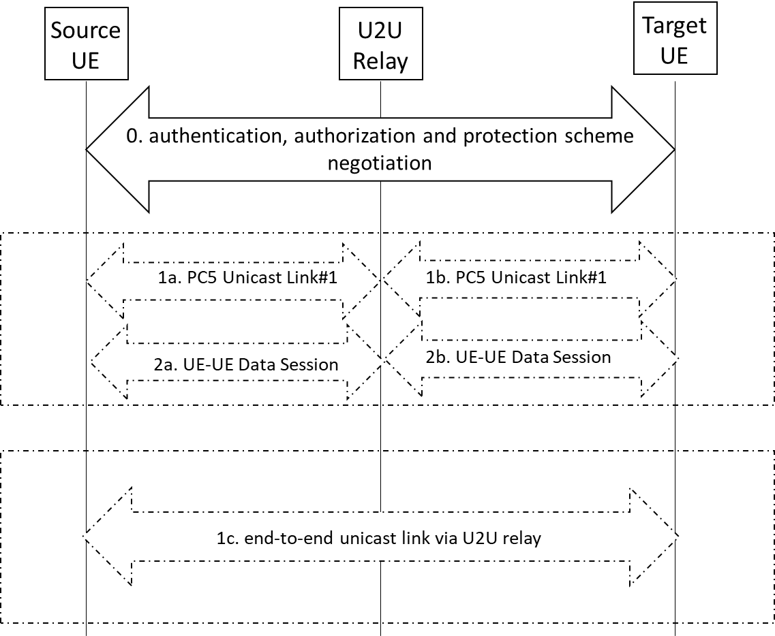
Figure 6.X.2.1: End to end security establishment for UE-to-UE relay
It is assumed that Source UE, Target UE, and U2U relay have discovered each other via existing discovery procedure(s) as specified in TS 33.503. Source UE, Target UE, and U2U relay have also been provisioned with the necessary security credentials as well as security policies (e.g., PC5 unicast security policy) while in network coverage.
0. During the authentication, authorization and UE communication protection scheme negotiation, Source UE and U2U relay， Target UE and U2U relay， and Source UE and Target UE are mutually authenticated respectively via provisioned credentials. Based on security policies that are provisioned, U2U relay negotiates the protection scheme between the Source and Target UEs are to be either hop-by-hop protection where individual PC5 links are established between Source UE and U2U relay and between U2U relay and Target UE respectively.
Based on protection negotiated protection, either Steps 1a, 1b, 2a, 2b are executed or Step 1c is executed.
1a and 1b. A PC5 unicast link is established between Source UE and the UE-to-UE Relay. Another PC5 unicast link is established between the UE-to-UE Relay and Target UE. If there are multiple relay sessions between more than one set of Source and Target UEs, the U2U relay may need to maintain a session state for each set of Source and Target UEs. Each unicast link is secured based on the credential provisioned between the Source or Target UE and the U2U relay.
2a and 2b. Source UE and Target UE communicate securely via the U2U relay. For each of the PC5 unicast link between Source or Target UE and the U2U relay, the U2U relay uncovers the security protection applied by Source or Target UE and re-applies security to protect the link that is being relayed to the Target or Source UE respectively
1c. An end-to-end secure unicast link via U2U relay is established that carries the traffic between Source UE and Target UE.

6.X.3 Evaluation
TBD
**** END OF CHANGE ****

