3GPP TSG-SA3 Meeting #108e AdHoc draft_S3-222528-r2

e-meeting, 10 Oct - 14 Oct 2022

Source: CMCC

Title: New solution for key issue 1

Document for: Approval
Agenda Item: 5.4

1 Decision/action requested
It is proposed to approve the proposed changes for inclusion in TR 33.870 [1].

2 References
[1] 3GPP TR 33.870: Study of privacy of identifiers over radio access

3 Rationale
This contribution proposes a new solution to key issue 1. The solution proposes an empirical method which relies on the rational selection of the SUPI length based on the length distribution model to avoid the privacy issue caused by the length of SUPIs in NAI format(e.g. extreme short or long variable length SUPIs). The use of this mechanism allows the operator to have better control of SUCI length distribution. Compared to the padding mechanism, this un-padding mechanism can effectively improve the system performance and also protect the privacy of variable length SUPIs in NAI format.

4 Detailed proposal
It is proposed to approve the following changes for inclusion in TR 33.870 [1].
**** Start of Changes****

6.X Solution #X: Limited length of SUPIs in NAI format

6.X.1 Introduction
Editor’s Note: This solution may need to be updated to align with the KI once the ENs in the KI is resolved.
Editor's Note: The k-anonymity analysis in the context of an IMSI catcher is FFS.

The solution addresses key issue 1. It is based on the control of the length limit of SUPIs in NAI format that can provide k-anonymity (for a given k) for the SUPI/SUCI if chosen carefully.

X.2 Solution details
Assume a typical distribution of the SUPIs in function of the length as shown in Figure 6.x.2 below. A fixed k value (for a desired k-anonymity level) gives two length limits shown as l_{min} and l_{max}. The middle parts of distributions between l_{min} and l_{max} typically have much higher frequencies and no privacy disclosure issue in length.

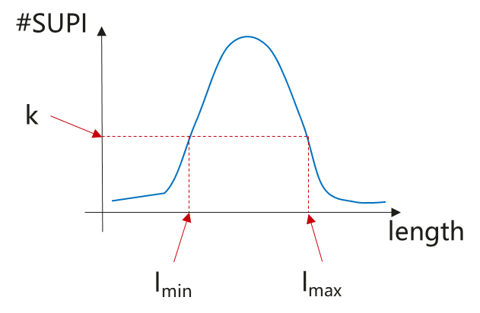
Figure 6.x.2 Example of SUPI distribution
One straightforward way to guarantee k-anonymity is to limit the length of SUPIs in NAI type between l_{min} and l_{max}, which can be allocated and managed by the operators based on the subscribers distribution in a specific realm, i.e. 6-16 characters limit for username, to ensure the SUPIs can not only be chosen to be unique so that they do not collide with each other, and also the desired k-anonymity level for any given k can be guaranteed.
Note: How to analyze and choose l_{min} and l_{max} could be left to implementation.

6.X.3 Evaluation
Editor's note: evaluation is ffs
**** End of Changes****

