3GPP TSG-SA3 Meeting #108e-AdHoc draft_S3-222506-r1

e-meeting, 10 - 14 October 2022

Source: Huawei

Title: New solution for key issue x

Document for: Approval
Agenda Item: 5.4

1 Decision/action requested
Approve the changes in clause 4 for inclusion in TR 33.870 [1].

2 References
[1] 3GPP TR 33.870: Study of privacy of identifiers over radio access

3 Rationale
This contribution proposes a new solution to key issue 1. The solution relies on pre-provisioned pseudonyms to be used, only if present, instead of the SUPI for the SUCI calculation.

4 Detailed proposal
It is proposed to approve the following solution for inclusion in TR 33.870 [1].
**** Start of Changes****

3.1 Terms
For the purposes of the present document, the terms given in 3GPP TR 21.905 [1] and the following apply. A term defined in the present document takes precedence over the definition of the same term, if any, in 3GPP TR 21.905 [1].
k-anonymity: is a property of anonymized data. The release of such data is said to have the k-anonymity property if the information for each subject contained in the release cannot be distinguished from at least k - 1 subjects whose information also appear in the release.
**** Next Changes****

6.A Solution #A: Pseudonym based solution for k-anonymity of SUPI/SUCI

6.A.1 Introduction
Editor's Note: The solution may need to be updated to align with the KI once the ENs in the KI is resolved.
The solution addresses key issue 1. It is based on the use of pre-provisioned pseudonyms that when chosen carefully can guarantee k-anonymity (for a given k) for the SUPI/SUCI.

6.A.2 Solution details

6.A.2.1 General
It is assumed that the UE can be pre-provisioned with a pseudonym for the SUPI. The pseudonym is allocated and managed by the operator. It is stored alongside the SUPI. The pseudonym is chosen to be unique to avoid collision with other pseudonyms or SUPIs. Clause 6.A.2.2 describes how such pseudonyms are used. Clause 6.A.2.3 describes how they can be allocated in order to guarantee a desired k-anonymity level for any given k.
The UE uses the pseudonym only if present and only instead of the SUPI when calculating a SUCI with a non-null encryption scheme. To signal the use of pseudonyms, the solution relies on the introduction of new protection scheme identifies. For example: 0x3 for Profile <C> where Profile C is identical to Profile <A> except that the pseudonym is used instead of the SUPI.

6.A.2.2 Procedure
It is assumed that the UE can be preconfigured with a pseudonym and that the SIDF is preconfigured with a map from pseudonyms to SUPIs.
- If the UE is preconfigured with a pseudonym and the UE is required to calculate a SUCI with other than the null encryption scheme, for example for an initial registration procedure, then the UE calculates the SUCI using the pseudonym and includes the corresponding new scheme identifier to indicate that SUCI was calculated using a pseudonym.
- If the SIDF receives a SUCI including a scheme identifier signalling the use of a pseudonym, then after decryption of the SUCI, the SIDF uses the preconfigured map to recover the corresponding SUPI. If the included scheme identifier does not signal the use of pseudonym then the SIDF obtains the SUPI directly after decryption. In both cases, normal network operations can continue using the SUPI.
The need of a preconfigured map on the network side depends on how the pseudonyms are generated. For methods that require keeping an association such as hashing, random generation, etc, then such a map is needed. For other methods such as padding, the use of special delimiters or padding characters would suffice, in which case a preconfigured map is not needed and the SIDF can simply recover the SUPI from the decrypted pseudonym by stripping the padding characters.

6.A.2.3 Guidance on pseudonym allocation
Assume a bell-like shaped distribution of the SUPIs in function of the length as shown in Figure 6.A.2.3-1 below. A fixed k value (for a desired k-anonymity level) gives two length limits shown as l_{min} and l_{max}. All subscribers whose SUPI's length is less than l_{min} or greater than l_{max} are allocated pseudonyms.
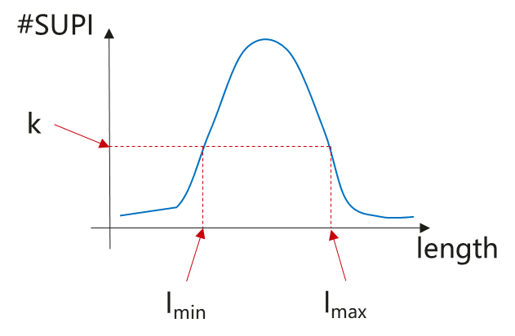
Figure 6.A.2.3-1 Example of SUPI distribution
One straightforward way to guarantee k-anonymity is that SUPIs that are shorter than l_{min} or longer than l_{max} all allocated pseudonyms of length between l_{min} and l_{max}. Observe that this is sufficient but not necessary because for example, if the total number of subscribers with short SUPIs (less than l_{min}) is greater than k, then it is enough if they are allocated pseudonyms of the same length, irrespective of l_{min}. That group will be of size greater than k and hence k-anonymity is realized. The same reasoning applies to longer SUPIs (longer than l_{max}).
Observe also that the pseudonym value is irrelevant for anonymity. Only the length is decisive. The only requirement on the value is that it is unique to avoid collisions and to enable efficient recovery of the original SUPI on the network side. For the pseudonym value itself, there are many ways it can be generated: padded SUPI, truncated SUPI, hash of SUPI, random fixed length value, fixed length counter, etc. This could be left to implementation as well.

6.A.3 Evaluation
Editor's Note: Impact on the UE, the SIDF, and the UDM is FFS.

**** End of Changes****

