3GPP TSG-SA3 Meeting #108Adhoc-e S3-222499-r2

e-meeting, 10th – 14th October, 2022 revision S3-221382-r1

Source: Huawei, HiSilicon

Title: New solution for KI #6 Relation between certificate management lifecycle and NF management lifecycle

Document for: Approval
Agenda Item: 5.5

Decision/action requested
This contribution proposes a new solution in TR 33.876

Rational
This pCR is proposes a new solution to KI#6. Compared to the previous submission in SA3#107Adhoc, few updates were made to address the comments raised.

Detailed proposal
*************** Start of 1st Change ****************

2 References
[14] 3GPP TS 33.502: " Procedures for the 5G System (5GS)".
*************** End of 1st Change ****************

*************** Start of 2nd Change ****************

6.Y Solution #Y: Certificates revocation query procedure based on NRF

6.Y.1 Introduction
This solution addresses KI#6.
After a certificate expires or is revoked, the NF may still be discovered by the NRF during the NF service discovery procedure. In which case, when the NF consumer setups a TLS connection with the NF producer, the connection between the NF consumer and the NF producer may fail because the certificate of the NF producer is no longer valid. This impact network efficiency.

6.Y.2 Solution details

6.Y.2.1 General
Based on an existing service discovery procedure, this solution combines the certificate revocation status query with the service discovery procedure, thereby optimizing the efficiency of certificate revocation status query.
This solution also prevents the NRF from providing an NF producer to an NF consumer after the NF producer’s certificate expires or is revoked, that may cause connection setup failures.

6.Y.2.2 NF service Registration procedure
An NF carries its own certificate during registration. The NRF stores the certificate information as the NF context. In addition, when the certificate of the NF is renewed, this certificate needs to be updated in the NRF
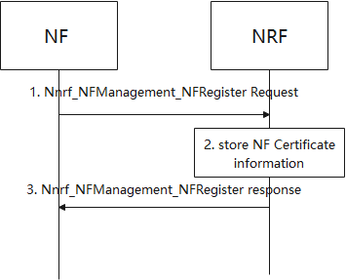
Figure 6.Y.2.2-1 NRF store the certificate validity during NF registration
1. NF sends Nnrf_NFManagement_NFRegister Request message to NRF with all certificates of NF.
2. NRF stores the certificate information of certificates from NF. The certificate information can be certificate ID, certificate type and certificate validity information.
3. NRF acknowledge NF Registration is accepted via Nnrf_NFManagement_NFRegister response.

6.Y.2.3 NF/NF service discovery in the same PLMN
In the service discovery procedure, the NRF determines whether to provide the NF producer to the NF consumer based on the certificate status of the NF producer.
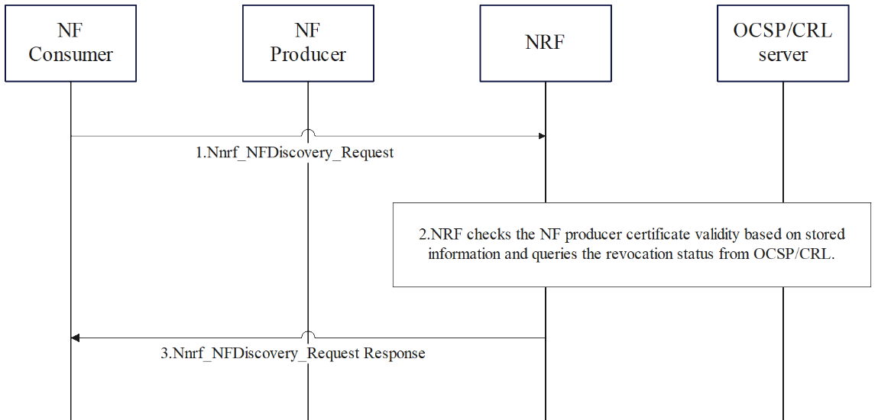
Figure 6.Y.2.2-2 NRF queries NF producer certificate when NFDiscovery_request
1. NF consumer initiates service discover procedure. The NF consumer sends the Nnrf_NFDiscovery_Request message to discover an NF producer for the service. NRF determines a required candidate NF producer list as specified in 3GPP TS 23.501 [5].
2. After determining the candidate NF producer list, the NRF checks the NF producers’ certificate validities based on store information in 6.Y.2.2 and queries the certificate revocation status from the CRL or the OCSP server. The NRF can interact with the CRL/OCSP server directly or through a proxy depending on the implantation of the CRL/OCSP server. Certificate validity is the information preconfigured by CA/RA. The revocation status is to indicate whether the certificate is revoked. There are some cases that leads to the revocation (e.g., private key leak, the re-orchestration of NF, etc.)
3. NRF sends Nnrf_NFDiscovery_Request Response message to NF consumer.
If multiple NRFs are required to discovery a NF producer, NRF can forward the request to other NRFs as specified in 3GPP TS 23.502[14].

6.Y.3 Evaluation
TBD
*************** End of 2nd Change ****************

