**3GPP TSG-SA3 Meeting #108Adhoc-e draft_S3-222474-r2**

**e-meeting, 10th – 14th October, 2022**

**Source:**  **Huawei, HiSilicon**

**Title:** **solutions on privacy protection for UEs in ranging**

**Document for: Approval**

**Agenda Item: 5.19**

# 1 Decision/action requested

***It is proposed to approve the change described in this document.***

# 2 References

N/A.

# 3 Rationale

In the ranging procedure, the target UE’s distance, direction and/or position is measured with the support from one or multiple Reference UEs. As the information of almost all Ranging/Sidelink Positioning services is related to location, all the UEs participating in Ranging/Sidelink Positioning, the authorization is needed before performing ranging positioning.

In addition, the ranging positioning result should be only exposed to the limited parties to protect the user privacy. The entity who is responsible for result calculation also needs negotiation.

# 4 Detailed proposal

*** 1st CHANGE ***

## 6.Y Solution #Y: privacy protection for UEs in ranging

### 6.Y.1 Introduction

This solution resolves Key Issue #1 for Privacy protection for Ranging/SL Positioning services. In particular, this solution tries to acquire the UE’s authorization. In addition, configuration information is exchanged between the UEs to decide the entity for result calculation.

### 6.Y.2 Solution details

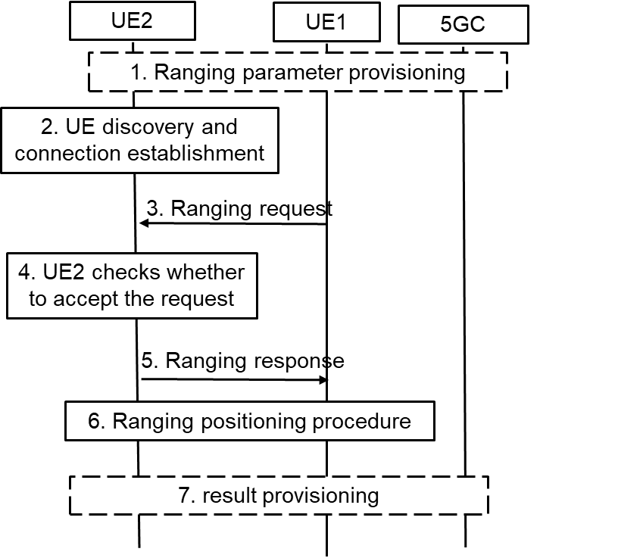

Figure 6.Y.2-1: high-level procedure for Ranging operation control

The high-level procedure as shown in Figure 6.Y.2-1 is based on the procedure descripted in solution 3 of TR 23.700-86[2].

1. UE1 and UE2 may get the ranging parameters from 5GC during registration. UE1 gets the ranging request from the application layer, UE3 or 5GC NF. The ranging request includes the consumer info and/or the purpose of ranging positioning. For example, if the AF wants to acquire the distance between UE1 and UE2 for V2X service. The AF ID and purpose for V2X are included.

2. Discovery and the connection establishment procedure are performed between UE1 and UE2.

NOTE: The solution assumes that Ranging authorization is not performed during discovery and comminucation establishement procedures.

3. UE1 sends the ranging request to the UE2 to check the authorization and negotiate the ranging parameters. The ranging request includes the ranging parameters, e.g. the Ranging role (Reference UE or Target UE), consumer info, purpose, result calculation entity. For example, UE1 decides to calculate the result and not share with UE2, then the result calculation entity means that “UE1 will calculate the ranging result”. If it is implied by the ranging role, the result calculation entity is not needed.

4. UE2 checks whether to accept the ranging request in step 3. For example, UE2 checks whether to allow the ranging result to be provided to the consumer for the claimed purpose based on local policy. UE2 decides whether to accept the ranging role as assigned by UE1. Based on received result calculation entity info, UE2 confirms whether the result can be acquired by UE1 or not.

Editor’s Note: What and how the information for privacy protection is configured in UE side are FFS.

Editor’s Note: Whether and how UE1 and UE2 can trust the authorization operation/result of each other is FFS.

5. UE2 sends the ranging response to the UE1. For example, If UE2 does not authorize the ranging positioning for the purpose or the consumer, the reject message with cause will be responsed. If UE2 wants to change the Ranging role or result calculation entity, for example due to its privacy consideration, a new Ranging role or result calculation entity is included.

6. Ranging positioning procedure is preformed. The ranging result is calculated based on the negociation result in step 5.

7. The ranging results may not be shared between the UEs accordingly to the negociation result. The result calculation entity will provide the result to the application layer, UE3 or 5GC NF.

Editor’s Note: Inter-layer communication regarding the parameter configuration and negotiation for authorizing the UE is pending on SA2 conclusion.

### 6.Y.3 Evaluation

TBA

*** END OF 1st CHANGE***