3GPP TSG-SA3 Meeting #108Ad Hoc-e S3-222559-r1

e-meeting, 10th – 14th October 2022

Source: Nokia, Nokia Shanghai Bell

Title: New solution for privacy prevention of SUPI in NAI format

Document for: Approval, Information, Discussion
Agenda Item: 5.4

1 Decision/action requested
Request for approval of solution for privacy preservation of SUPI in NAI format

2 References
[1] 3GPP TR 33.870 Study of privacy of identifiers over radio access.
[2] 3GPP TS 23.003 “Numbering, addressing and identification”.

3 Rationale
This solution proposal prevents the attacker from identifying the user and tracking them. Privacy issue in SUCI using NAI format is addressed with this proposal.

4 Detailed proposal
****************************** Start of changes **************************

6.1.x Solution #x: Solution for Privacy aspects of variable length user identifiers

6.1.x.1 Introduction
According to clause 2.2A of TS 23.003[2], the 5G standard allows the use of Network Specific Identifiers (NSI) as SUPI. An NSI will take the form of a Network Access Identifier (NAI) as defined in clause 28.7.2 of TS 23.003 [2]. The NAI for SUPI can have the form username@realm. Username in NAI format is encrypted during SUCI generation for privacy reasons. Usually the username part of NAI is created based on real-world names. Hence any encoding of the realworld names can lead to predictable outcomes which could also be guessed. This may lead to same privacy issues.
Key Issue #1 identified in [1] describes the privacy concern due to variable length SUPIs in NAI format.
Editor’s Note: This solution may need to be updated to align with the KI once the ENs in the KI is resolved

6.1.x.2 Solution details

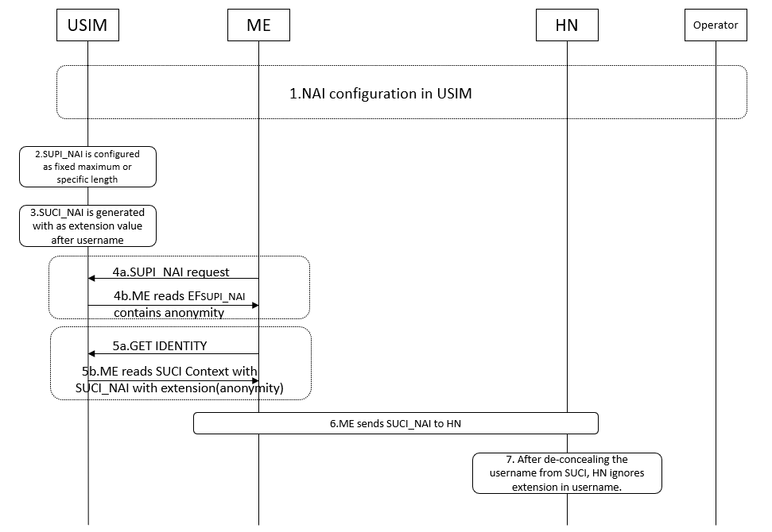

Figure 1: Message flow detailing the solution
Figure 1 illustrates the system level message sequence detailing this solution. The steps are described as follows:
- NAI configuration is performed by HN or Operator in USIM.
- Extension/padding of SUPI NAI is configured by the operator.
Note 1: Operators may have their own specific extension length (fixed or variable according to the USIM).
As part of this solution, an extension/padding after a configurable delimiter, for example, “!”, in username can be used in SUPI_NAI. This padding can ensure that the length of each username for a specific Operator adds up to a fixed number of octets. This also ensures that for any given length of SUPI_NAI, the input to SUCI generation is always having a fixed length. Also, the delimiter can be used to extract the actual SUPI_NAI after de-concealing the username from SUCI at the home network.
Operator can ensure that the choice of delimiter and maximum SUPI_NIA length configurations are also made in UDM.
- SUCI NAI is generated as described in Annex C.3.2 of TS 33.501.

- After ME requests for SUPI_NAI request, it reads the EF file of SUPI_NAI which has anonymity configured username from USIM as described in Step 4.

- ME requests for SUCI_NAI and USIM shares the generated SUCI.

- ME sends the SUCI_NAI to HN.

- After de-concealment of SUCI_NAI, UDM will retrieve the SUPI_NAI as “username!any_non_null_string@realm”. UDM ignores the content after “!” (configurable delimiter) and considers only the username part in both fixed or variable NAI cases.

Note 2: Each user within same operator can have pre-defined or configured maximum length of username part. This will make a uniformity between different users of same operator. Operators can configure different delimiters and maximum lengths.

6.1.x.3 Evaluation

******************************* End of changes ***********************

