3GPP TSG-SA3 Meeting #104-e draft_S3-213021-r1

e-meeting, 16th - 28th August 2021

CR-Form-v12.0
CHANGE REQUEST
 | 33.203 | CR | draft | rev | - | Current version: | 16.1.0
For HELP on using this form: comprehensive instructions can be found at
http://www.3gpp.org/Change-Requests.

Proposed change affects: | UICC apps |  | ME |  | Radio Access Network |  | Core Network | X

Title: | Security updates for algorithms and protocols in 33.203
3
Source to WG: | Ericsson
Source to TSG: | S3
Work item code: | eCryptPr |  |  |  |  |  | Date: |  |  | 2021-08-09
Category: | B |  |  |  |  |  | Release: |  |  | Rel-17
 | Use one of the following categories:  F (correction)  A (mirror corresponding to a change in an earlier release)  B (addition of feature),  C (functional modification of feature)  D (editorial modification)  Detailed explanations of the above categories can  be found in 3GPP TR 21.900. |  |  |  |  |  |  |  | Use one of the following releases:  Rel-8 (Release 8)  Rel-9 (Release 9)  Rel-10 (Release 10)  Rel-11 (Release 11)  Rel-12 (Release 12)  Rel-13 (Release 13)  Rel-14 (Release 14)  Rel-15 (Release 15)  Rel-16 (Release 16)
Reason for change: |  | IMS authentication in 3G, 4G, and 5G uses “AKAv1-MD5” which has several significant security weaknesses.  - MD5 is much weaker than the weak SHA-1 algorithm and should be phased-out and long-term be forbidden to use everywhere, especially in critical infrastructure like 5G.  - AKAv1 is vulnerable to "man-in-the-middle" attacks.  AKAv2-SHA-256 addresses both problems and is already used in other parts of TS 33.203.
Summary of change: |  | AKAv2-SHA-256 is introduced as mandatory to support. AKAv1-MD5 is still supported to maintain backwards compatibility with pre Rel-17 releases.
Consequences if not approved: |  | IMS, VoLTE, and VoNR continue to rely on the very weak AKAv1-MD5 algorithm.
Clauses affected: |  | 6.1.1
 |  | Y | N
Other specs |  |  | X | Other core specifications |  |  |  | TS/TR ... CR ...
affected: |  |  | X | Test specifications |  |  |  | TS/TR ... CR ...
(show related CRs) |  |  | X | O&M Specifications |  |  |  | TS/TR ... CR ...
Other comments:
This CR's revision history:

*** BEGIN CHANGES ***

6.1.1 Authentication of an IM-subscriber
Before a user can get access to the IM services at least one IMPU needs to be registered and the IMPI authenticated in the IMS at application level. In order to get registered the UE sends a SIP REGISTER message towards the SIP registrar server i.e. the S-CSCF, cf. figure 1, which will perform the authentication of the user. The message flows are the same regardless of whether the user has an IMPU already registered or not.
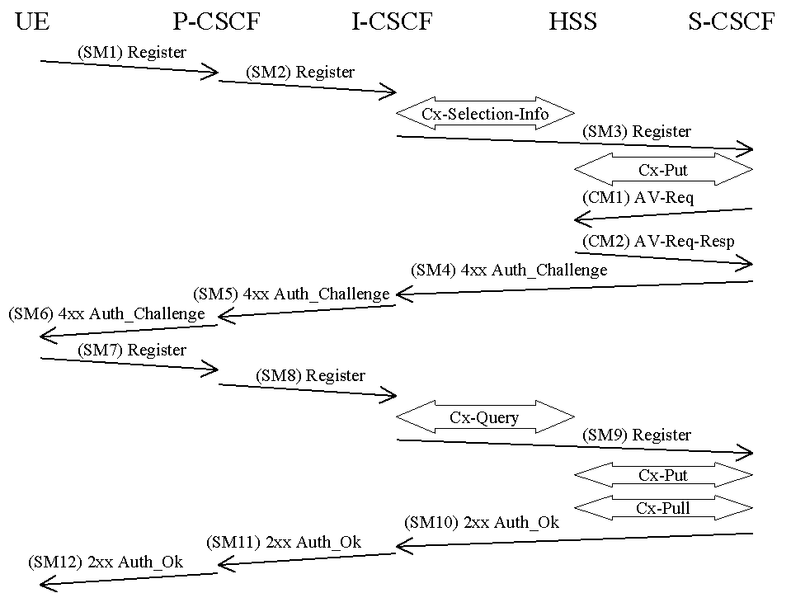
Figure 4: The IMS Authentication and Key Agreement for an unregistered IM subscriber and successful mutual authentication with no synchronization error
The detailed requirements and complete registration flows are defined in TS 24.229 [8] and TS 24.228 [11].
SMn stands for SIP Message n and CMm stands for Cx message m which has a relation to the authentication process:

SM1:
REGISTER(IMPI, IMPU)

In SM2 and SM3 the P-CSCF and the I-CSCF respectively forwards the SIP REGISTER towards the S-CSCF.
After receiving SM3, if the IMPU is not currently registered at the S-CSCF, the S-CSCF needs to set the registration flag at the HSS to initial registration pending. This is done in order to handle UE terminated calls while the initial registration is in progress and not successfully completed. The registration flag is stored in the HSS together with the S-CSCF name and user identity, and is used to indicate whether a particular IMPU of the user is unregistered or registered at a particular S-CSCF or if the initial registration at a particular S-CSCF is pending. The registration flag is set by the S-CSCF sending a Cx-Put to the HSS. If the IMPU is currently registered, the S-CSCF shall leave the registration flag set to registered. At this stage the HSS has performed a check that the IMPI and the IMPU belong to the same user.
Upon receiving the SIP REGISTER the S-CSCF CSCF shall use an Authentication Vector (AV) for authenticating and agreeing a key with the user. If the S-CSCF has no valid AV then the S-CSCF shall send a request for AV(s) to the HSS in CM1 together with the number m of AVs wanted where m is at least one.

CM1:
Cx-AV-Req(IMPI, m)

Upon receipt of a request from the S-CSCF, the HSS sends an ordered array of n authentication vectors to the S-CSCF using CM2. The authentication vectors are ordered based on sequence number. Each authentication vector consists of the following components: a random number RAND, an expected response XRES, a cipher key CK, an integrity key IK and an authentication token AUTN. Each authentication vector is good for one authentication and key agreement between the S-CSCF and the IMS user.

CM2:
Cx-AV-Req-Resp(IMPI, RAND1||AUTN1||XRES1||CK1||IK1,….,RANDn||AUTNn||XRESn||CKn||IKn)

When the S-CSCF needs to send an authentication challenge to the user, it selects the next authentication vector from the ordered array, i.e. authentication vectors in a particular S-CSCF are used on a first-in / first-out basis.
The S-CSCF sends a SIP 4xx Auth_Challenge i.e. an authentication challenge towards the UE including the challenge RAND, the authentication token AUTN in SM4. It also includes the integrity key IK and the cipher key CK for the P-CSCF. RFC 3310 [17] and RFC 4169 [65] specifies how to populate the parameters of an authentication challenge. The S-CSCF shall offer both "AKAv2-SHA-256" [65] and "AKAv1-MD5" [17] starting with "AKAv2-SHA-256" as most preferred. The S-CSCF also stores the RAND sent to the UE for use in case of a synchronization failure. To maintain backwards compatibility with pre Rel-17 releases, "AKAv1-MD5" is supported but not recommended to use.
The verification of the SQN by the USIM and ISIM will cause the UE to reject an attempt by the S-CSCF to re-use a AV. Therefore no AV shall be sent more than once.
NOTE: This does not preclude the use of the normal SIP transaction layer re-transmission procedures.

SM4:
4xx Auth_Challenge(IMPI, RAND, AUTN, IK, CK)

When the P-CSCF receives SM5 it shall store the key(s) and remove that information and forward the rest of the message to the UE i.e.

SM6:
4xx Auth_Challenge(IMPI, RAND, AUTN)

Upon receiving the challenge, SM6, the UE takes the AUTN, which includes a MAC and the SQN. The UE calculates the XMAC and checks that XMAC=MAC and that the SQN is in the correct range as in TS 33.102 [1]. If both these checks are successful the UE selects the first algorithm it supports and uses RES and some other parameters to calculate an authentication response. The UE should support "AKAv2-SHA-256". This response is put into the Authorization header and sent back to the registrar in SM7. RFC 4169 [65] and RFC 3310 [17] specify how to populate the parameters of the response for "AKAv2-SHA-256" and "AKAv1-MD5" respectively. It should be noted that the UE at this stage also computes the session keys CK and IK. To maintain backwards compatibility with pre Rel-17 releases, "AKAv1-MD5" is supported but not recommended to use.

SM7:
REGISTER(IMPI, Authentication response)

The P-CSCF forwards the authentication response in SM8 to the I-CSCF, which queries the HSS to find the address of the S-CSCF. In SM9 the I-CSCF forwards the authentication response to the S-CSCF.
Upon receiving SM9 containing the response, the S-CSCF retrieves the active XRES for that user and uses this to check the authentication response sent by the UE as described in RFC 3310 [17] and RFC 4169 [65]. If the check is successful then the user has been authenticated and the IMPU is registered in the S-CSCF. If the IMPU was not currently registered, the S-CSCF shall send a Cx-Put to update the registration-flag to registered. If the IMPU was currently registered the registration-flag is not altered.
It shall be possible to implicitly register IMPU(s). (see clause 4.3.3.4 in TS 23.228 [3]). All the IMPU(s) being implicitly registered shall be delivered by the HSS to the S-CSCF and subsequently to the P-CSCF. The S-CSCF shall regard all implicitly registered IMPU(s) as registered IMPU(s).
When an IMPU has been registered this registration will be valid for some period of time. Both the UE and the S-CSCF will keep track on a timer for this purpose but the expiration time in the UE is smaller than the one in the S-CSCF in order to make it possible for the UE to be registered and reachable without interruptions. A successful registration of a previously registered IMPU (including implicitly registered IMPUs) means the expiry time of the registration is refreshed.
If the user has been successfully authenticated, the S-CSCF sends a SM10 SIP 2xx Auth_OK message to the I-CSCF indicating that the registration was successful. In SM11 and SM12 the I-CSCF and the P-CSCF respectively forward the SIP 2xx Auth_OK towards the UE.
It should be noted that the UE initiated re-registration opens up a potential denial-of-service attack. That is, an attacker could try to register an already registered IMPU and respond with an incorrect authentication response in order to make the HN de-register the IMPU. For this reason a subscriber, when registered, shall not be de-registered if it fails an authentication.
The lengths of the IMS AKA parameters are specified in clause 6.3.7 of TS 33.102 [1].
*** END OF CHANGES ***

