3GPP TSG SA WG3 Meeting #104-e S3-212709

e-meeting, 16 – 27 August 2021 revision S3-21abcd

Source: Huawei, HiSilicon

Title: Solution Update and Evaluation for Solution 3

Document for: Approval
Agenda Item: 5.14

Decision/action requested
This contribution proposes an evaluation for solution 3 in TR 33.867

References

Rational
This contribution proposes update and evaluation for solution 3 in TR 33.867.

Detailed proposal
*************** Start of 1st Change ****************

7.3 Solution #3: User Consent for UE Related Analytics of NWDAF

7.3.1 Solution overview
The solution addresses key issue #2.
The solution gives an overview for user consent on services provided by NWDAF.

7.3.2 Solution details

7.3.2.1 NF Authorization based on User Consent

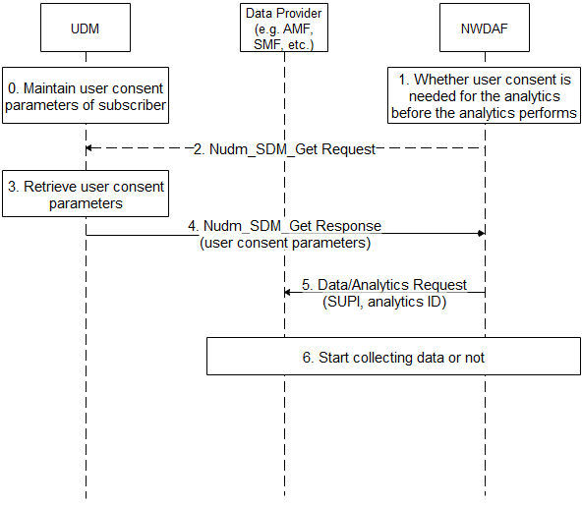
Figure 7.3.2.1-1 NF Authorization based on User Consent for NWDAF
- The UDM maintains user consent for the subscriber.
- If the NWDAF receives request for specific analytics from Data Consumer, e.g. it may collect UE’s information for UE related analytics, the NWDAF checks whether user consent is needed for the analytics according to local policy, e.g. regulation.
- If there is no user consent paramters in the NWDAF’s UE context, the NWDAF sends Nudm_SDM_Get Request message to the UDM. The input “Subscription data type(s)” shall be set to “user consent subscription data”, the input “Key for each Subscription data type(s)” shall be set to “SUPI”, the input “Data Sub Key(s)” shall be set to “data processor ID” and/or “purpose of data process”.
- The UDM retrieves user consent parameters.
- The UDM sends Nudm_SDM_Get Response message to the Data Provider. The message includes the user consent parameters. The NWDAF stores the user consent parameters in the NWDAF’s UE context.
- Based on the user consent parameters, the NWDAF sends Data/Analytics Request to Data Provider, the request includes the SUPI and the analytics ID.
- The Data Provider starts to collect the requested data based on the result.

7.3.2.2 User Consent Format
The UDM maintains the following user consent parameters for services provided by NWDAF:
- UE ID: refers to a subscriber, can be SUPI.
- Data Processor ID: refers to a service provider who provides data analytics service for the UE, can be PLMN ID.
- Purpose of Data Processing: refers to a data analytics service, can be service operation name (e.g. Nnwdaf_AnalyticsSubscription_Subscribe), with specific analytics ID input.
- User Consent Result: whether there is consent for data processor to process the data according to purpose of data processing.
Editor’s Note: whether purpose of data processing is sufficient is ffs.
Those parameters are combined to indicate that a specific subscriber has user consent to consume specific network analytics service provided by the specific service provider.

7.3.2.3 Obtain of User Consent
The subscriber may give its consent to operator when the subscriber signs service contract with the operator.
The subscriber may change or add consent to operator when the subscriber changes its subscription with the operator.

7.3.3 Solution evaluation

TBD
*************** End of 1st Change ****************

