3GPP TSG SA WG3 Meeting #104-e draft_S3-212708-r1

e-meeting, 16 – 27 August 2021 revision of S3-abcd

Source: Huawei, HiSilicon

Title: Solution for user consent revocation

Document for: Approval
Agenda Item: 5.14

Decision/action requested
This contribution proposes to add one new solution in TR 33.867

References

Rational
There is a newly added security requirement about the revocation of user consent of KI #3.
This proposal provides a solution to address this security requirement.

Detailed proposal
*************** Start of 1st Change ****************

7.X Solution #X: Revocation for user consent

7.X.1 Solution overview
The solution addresses key issue 3.
The solution gives an overview for revoking user consent due to some regulatory requirements.

7.X.2 Solution details
Figure 7.X.2-1 illustrates the general procedure for user consent revocation.
The overall assumption is that user consent is part of subscription of the UE stored in UDM. If there is revocation or modification requirement on user consent, UDM shall initiate the subsequent procedures in the network. There are several means for a UE to trigger the user consent revocation, for example, out-of-band way, i.e. the user can revoke a contract.

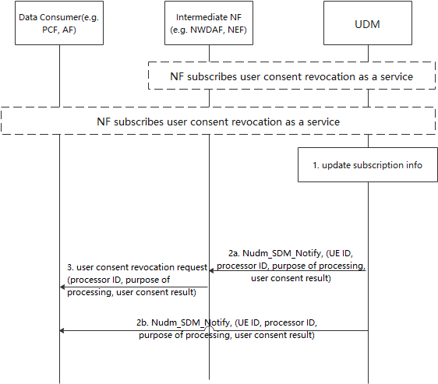
Figure 7.X.2-1 user consent revocation procedure
The pre-condition is that, a data consumer or an intermediate NF (e.g. including NWDAF/NEF) has already subscribed to the user consent revocation as a service at UDM, reusing the subscription notification procedure, e.g. Nudm_SDM_notification service. To be detailed, the inputs shall be set as: “Subscription data type(s)” is set to “user consent subscription data”, the “Key for each Subscription data type(s)” is set to “SUPI”.
Another precondition is that any NF acquiring user consent from the UDM has to register to this revocation service.
Step1: UDM updates subscription information which aims to revoke the user consent due to the request from user. User can request to withdraw its specific user consent corresponding the user data, e.g. location, identity through the demand on network. How does the user require the revocation is not captured in this solution.
Editor’s Note: How does the UDM decide whether a data consumer is allowed to subscribe to the service is ffs
Step2a: UDM sends out the Nudm_SDM_Notify message which includes UE ID, processor ID, purpose of processing, user consent result to the Intermediate NF. UE ID is relevant to the subscriber ID, e.g. SUPI, GPSI, processor ID refers to a data processor who processes data for the UE, can be PLMN ID, AF ID, or more generic, e.g. “3rd party” or “all”. Purpose of processing is linked to the revoked services. User consent result refers to consent for data processor to process the data according to purpose of data processing, e.g. allowed or not allowed.
Once receiving the request, the intermediate NF shall delete the data subject to the consent, if the intermediate NF has the processing data functionalities, such as analysis, collection functionalities, intermediate NF shall stop processing the data subject to the consent.
Step 3: If the Data Consumer accesses the Data Provide via intermediate NF, the intermediate NF additionally sends user consent revocation request message to the Data Consumer. Upon receiving the request, the Data Consumer shall delete the data subject to the consent, if the intermediate NF has the processing data functionalities, such as analysis, collection functionalities, intermediate NF shall stop processing the data subject to the consent.
Step2b: UDM sends out the Nudm_SDM_Notify message to Data Consumer directly. The message is the same as provided to the intermediate NF.
Once receiving the request, the Data Consumer shall delete the data subject to the consent, if the intermediate NF has the processing data functionalities, such as analysis, collection functionalities, intermediate NF shall stop processing the data subject to the consent.
Editor’s Note: How to handle scenarios where the target NF is not available is FFS.

7.X.3 Solution evaluation
This solution fulfills the requirement of Key issue #3.
There is no impact on UE side.
*************** End of 1st Change ****************

