3GPP TSG SA WG3 Meeting #104-e S3-212701

e-meeting, 16 – 27 August 2021 revision S3-21abcd

Source: Huawei, HiSilicon

Title: New Solution for Check of User Consent for 3GPP service Exposure

Document for: Approval
Agenda Item: 5.14

Decision/action requested
This contribution proposes a new solution in TR 33.867

References

Rational
The contribution proposes a new solution for check of user consent for 3GPP service exposure.

Detailed proposal
*************** Start of 1st Change ****************

7.X Solution #1: Check of User Consent for 3GPP Service Exposure

7.X.1 Solution overview
The solution addresses key issue #1 “User Consent for Exposure of information to Edge Applications”.

7.X.2 Solution details

7.X.2.1 Check of user consent on NEF/CAPIF
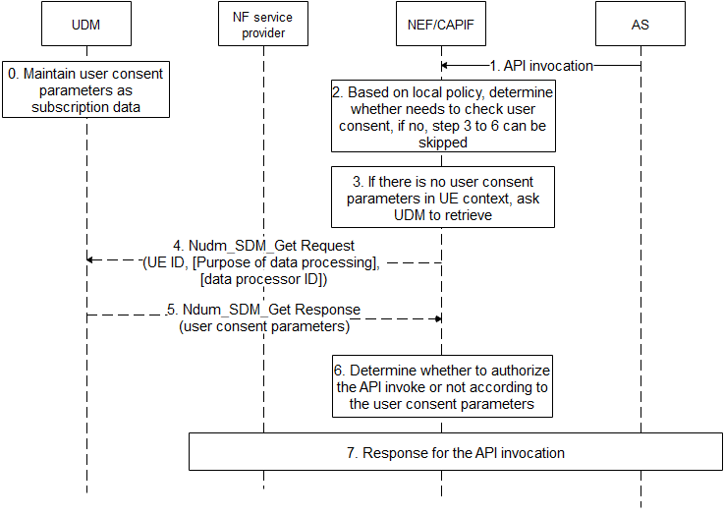
Figure 7.X.2.1 Check of User Consent on NEF/CAPIF
- UDM maintains user consent parameters as subscription data as depicted in 7.X.2.2.
- AS sends API invocation to NEF/CAPIF, requesting for processing user’s data, e.g. if the invocated service is “Nnef_Location_LocationUpdateNotify” with inputs with AF ID, and GPSI, it means that the AF asks NEF/CAPIF to retrieve location of UE identified by the GPSI.
- The NEF/CAPIF determines whether the invocated service needs to check user consent based on operator’s local policy, e.g. whether regulation is required, whether the invocated service is to process user’s personal information, etc.. If there is no need to check user consent, step 3-6 can be skipped.
Editor’s note: how does the NEF know the purpose from API invocation is ffs.
- If there is no related user consent parameters in UE context, the NEF/CAIPF invokes Nudm_SDM_Get Request service to retrieve related user consent parameters. Otherwise, step 4-5 can be skipped.
Editor’s note: how to ensure user consent parameters are current / not outdated is ffs.
- The NEF/CAPIF sends Nudm_SDM_Get Request message to the UDM, the message shall include UE ID, and may include purpose of data processing, data processor ID. The UE ID can be SUPI which is resolved with the GPSI by NEF/CAPIF using existing mechanism. The purpose of data processing is format combined with service operation name and some of specific inputs which are derived from the API invocation, The data processor ID can be AF ID or more generic which is resolved from the AF ID in the API invocation.
Editor’s note: how does the NEF know the purpose from API invocation is ffs.
- The UDM returns requested user consent parameters, which includes user consent result.
- The NEF/CAPIF determines whether to authorize the API invocation or not according to the user consent parameters. If the user consent result of the purpose of data process is not allowed, the NEF/CAPIF rejects the AF’s request with specific cause. If the user consent result of the purpose of data process is allowed, the NEF/CAPIF accepts the AF’s request. If there is no explicit user consent results, the NEF/CAPIF can decide to reject or accept the AF’s request based on operator’s local policy.
- The NEF/CAIPF response for the API invocation based on determination in step 6.

7.X.2.2 User Consent Parameter
The UDM maintains the following user consent parameters:
- UE ID: can be SUPI.
- Data Processor ID: refers to a data processor who process data for the UE, can be AF ID, or more generic, e.g. “3rd party” or “all”.
- Purpose of data processing: combined with service operation name and some of specific inputs, e.g. Nnef_AnalyticsExposure_Subscriber with Analytic ID set to “UE communication analytics”, which means to allow AF to ask for UE’s communication analytics information.
- Editor’s Note: Further information elements to uniquely define a purpose are FFS.
- User Consent Result: whether there is consent for data processor to process the data according to purpose of data processing.

7.X.3 Solution evaluation
TBA.
*************** End of 1st Change ****************

