**3GPP TSG-SA3 Meeting #104-e *draft_S3-212618-r1***

**e-meeting, 16 - 27 August 2021** Revision of S3-20xxxx

**Source: Huawei, HiSilicon**

**Title: Location Information Veracity and Location Tracking Authorisation procedures**

**Document for: Approval**

**Agenda Item: 4.20 ID_UAS**

# 1 Decision/action requested

***Approve the proposed pCR as normative text***

# 2 References

[1] TS 33.256

# 3 Rationale

This contribution proposes to add the location information veracity and location tracking authorization procedures to the UAV TS 33.256 [1].

Merger of S3-212837.

# 4 Detailed proposal

*** BEGINNING OF CHANGES (all text new) ***

### X.Y Location Information Veracity and Location Tracking Authorisation

### X.Y.1 General

There are three UAV tracking modes as follows (see TS 23.256 [aa] for more details):

- UAV location reporting mode;

- UAV presence monitoring mode; and

- Unknown UAV tracking mode.

The first two relate to obtaining location information about a particular UE while the latter one is about obtaining information about all the UEs in a particular geographic region.

For the first two mode before proceeding with the request for information about the particular UE, the UAS NF shall ensure that the requesting USS is the one that authorised the UE.

For the latter mode, a USS is authorised to receive the CAA level ID of all UAVs in a geographic area indicated by the USS. In addition, if the USS performed the UUAA of the UAV, or the UAS NF is configured to know the USS is authorized to receive such information, then the 3GPP UAV ID of such UAVs is also included.

X.Y.2 Location information veracity and location tracking authorization in 5GS

USS may receive the location information which is reported by UAV via the application layer. The USS may decide to check and verify the location information in order to prevent spoofed and forged location information. The location result from 5GS helps to verify the location information reported from UAV side. 5GS provides network-based location information by utilising the Location Services (LCS) supported by AMF or GMLC as specified in TS 23.273 [xx] and 23.502 [yy], and the detailed procedures of location information veracity and location tracking authorisation are described below.

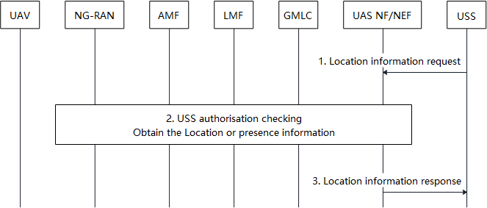

**Figure X.Y.1-1: location information veracity and location tracking authorisation in 5GS**

Step 1-3 shows the procedure for the USS to obtain a network-based location for UAV(s).

1. The USS sends the location request to UAS NF/NEF to request the UAV location or presence from network. The location request includes the GPSI of the UAV to request the location information or presence about an individual UE, or a geographic area when trying to find the information of all UAVs in an area. The LCS request also indicates the 5GS to select the positioning method with high reliability.

2. The UAS NF/NEF first verifies the request in step 1 is authorised by checking whether the identifier of the USS sending the request matches the previously associated mapping between the GPSI and the USS identifier. The UAS NF/NEF gets the relevant UAV(s) location information or presence from AMF or GMLC by the current location services supported by AMF or GMLC if passes the above authorisation check. On the condition of the location services provided by GMLC, the GMLC indicates LMF to select Network Assisted Positioning method which relies on the location measurement from NG-RAN nodes.

Editor’s Note: Details of the location authorization for unknown UAV tracking mode are FFS.

NOTE: The USS may be authorized by UAS NF/NEF by means not specified in this release of the specification.

3. The UAS NF/NEF provides the UAV(s) location information or presence to the USS. USS may make decisions to control the UAV based on the result output received from UAS NF/NEF.

*** END OF the 1st CHANGE ***

*** START OF 2nd CHANGE (all text new) ***

# 2 References

The following documents contain provisions which, through reference in this text, constitute provisions of the present document.

- References are either specific (identified by date of publication, edition number, version number, etc.) or non‑specific.

- For a specific reference, subsequent revisions do not apply.

- For a non-specific reference, the latest version applies. In the case of a reference to a 3GPP document (including a GSM document), a non-specific reference implicitly refers to the latest version of that document *in the same Release as the present document*.

[xx] 3GPP TS 23.273: "5G System (5GS) Location Services (LCS); Stage 2".

[yy] 3GPP TS 23.502: "Procedures for the 5G System (5GS)".

[aa] 3GPP TS 33.256: "Support of Uncrewed Aerial Systems (UAS) connectivity, identification and tracking; Stage 2".

*** END OF CHANGES ***