3GPP TSG-SA3 Meeting #104-e draft_S3-212556-r1

e-meeting, 16 - 27 August 2021 Revision of S3-20xxxx

Source: ZTE

Title: Update the solution #6

Document for: Approval
Agenda Item: 5.11

1 Decision/action requested
This contribution proposes to update the solution #6.

2 References
[1] 3GPP TR 33.850 "Study on Security Aspects of Enhancements for 5G Multicast-Broadcast Services (MBS)".

3 Rationale
This contribution proposes to update the solution #6. This contribution try to resolve the ENs in the solution.

4 Detailed proposal
**** 1st CHANGE ****

6.6 Solution #6: Authentication and authorization for multicast communication service based on AKMA

6.6.1 Solution overview
This solution, which is based on AKMA, addresses the key issue #1 Security of authentication and authorization for multicast communication service.

6.2 Solution details

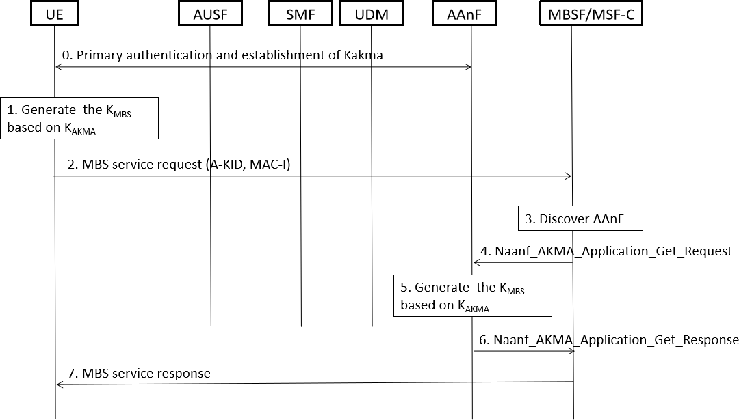
Figure 6.6.2-1 Authentication between the MBSF/MSF-C and UE based AKMA
- UE shall generate the AKMA Anchor Key (K_{AKMA}) and the A-KID from the K_{AUSF} before initiating communication with an AKMA Application Function, i.e MBSF/MSF-C, as specified in TS 33.535 [5].
- UE derive a key K_{MBS} for authentication with the MBSF/MSF-C .
- When UE try to join the multicast service, UE computes MAC-I and then UE sends a MBS service request to MBSF/MSF-C. The service request include A-KID and MAC-I.
Editor’s Note: How to derive the MAC-I is FFS.
3-6. Upon receiving the request, the MBSF/MSF-U discovers the AAnF, then AAnF generates K_{MBS} and sends the K_{MBS} to MBSF/MSF-C. The AAnF discovery and selection is specified in the TS 33.535[5] clause 6.7. The MBSF/ MSF-C computes the MAC-I using K_{MBS}, and check if it is the same with the received MAC-I from UE. If so, it means that the UE is authenticated and authorized to use the service.

Editor’s Note: How MBSF/MSF-C obtains authorization information is FFS.

7. The MBSF/MSF-C verifies the MAC-I using the K_{MBS}, when the verification is succeed, and if the UE is authorized to perform the operation,Then the MBSF/MSF-C sends a service response to the UE.

6.6.3 Solution evaluation
TBD
**** END OF CHANGES ****

