3GPP TSG-SA3 Meeting #103-e draft_S3-211695-r1

e-meeting, 17 - 28 May 2021 Revision of S3-21xxxx

Source: Nokia, Nokia Shanghai Bell

Title: EN resolution on solution privacy preservation of transmitted data

Document for: Approval
Agenda Item: 5.16

1 Decision/action requested
Resolution on solution privacy preservation of transmitted data

2 References
[1] 33.866

3 Rationale
The following ed. notes are resolved:
Editor's Note: Definition on policies/rules to be added. Clarification needed how to specify them in our TR/TS.
Editor's Note: Clarification needed on what is privacy local policy of a specific geographical region.
Editor's Note: Clarification needed on "DataPurposeID" in relation with privacy.

Editor's Note: Definition on policies/rules to be added. Clarification needed how to specify them in our TR/TS.
A privacy policy describes what an analytics function is allowed to provide to another analytics function in line with privacy rules set by a subscriber or the network operator.
Details on such privacy policies and associated rules would need to be detailed in stage 3.
In the following some rules are given as example:
- If purpose of request is 'Advertisement', exposing user identity allowed (yes/no), or only when anonymized
- If purpose of request is 'Advertisement', exposing user location allowed (yes/no), or only in the home network, with or without identity.
Privacy rules could also hold per policy for all the subscribers of a network for which an analytics data has data stored, for example:
- If purpose of request is 'Advertisement', exposing call records allowed (yes/no)
- If purpose of request is 'Advertisement', exposing of Internet access records allowed (yes/no), but only anonymized

Editor's Note: Clarification needed on what is privacy local policy of a specific geographical region.
Policies can be bound to geographical locations (area, country). They can also be bound to regulatory environments, i.e. whether data protection laws allow exposure or not.
NOTE: Privacy policies bound to regulatory environments are independent of whether a subscriber has given user consent.

Editor's Note: Clarification needed on "DataPurposeID" in relation with privacy.
Text on definition is already existing:
NOTE: DataPurposeID specifies the purpose of the user data request corresponding to an analytics ID. For instance, the DataPurposeID can be 'Advertisement' corresponding to the user data request of analytics ID 'location'.

The following text has been added addition to provide explanation for relation with privacy:
A privacy policy describes what an analytics function is allowed to provide to another analytics function in line with privacy rules set by a subscriber or the network operator.
The privacy framework proposes to store these privacy rules in the home network in
- UDM/UDR if privacy is configured per subscriber, or
- NRF if privacy is generic for all the subscribers of one or several NFs.
Privacy rules are useful, e.g., if an analytics function requests from another analytics function UE data about users currently in a certain location area (e.g. shopping center) with a specific purpose for usage given by the requesting analytics function. This can be indicated by a 'DataPurposeID', e.g. 'Advertisement' if the requesting analytics function would like to analyse data for, e.g., sending promotion messages. If the request is related to category 'User data', further narrowing down the intention of usage could be useful, e.g. indicated by providing sub-categories (identity, location, anonymization). The data holding analytics function is obliged to follow, which data and under which conditions data can be provided to the requesting analytics function, e.g. only anonymized data are allowed to be provided. For this, privacy policies are implemented.

4 Detailed proposal

************** START OF CHANGES

6.8.2 Solution details
To protect the sensitive and private information of the user, a privacy framework is introduced. By this, different privacy rules can be applied by different operators/vendors based upon specific policies and requirements, e.g. by local policy in line with regulatory requirements.
A privacy policy describes what an analytics function is allowed to provide to another analytics function in line with privacy rules set by a subscriber or the network operator.
The privacy framework proposes to store these privacy rules in the home network in
- UDM/UDR if privacy is configured per subscriber, or
- NRF if privacy is generic for all the subscribers of one or several NFs.
Privacy rules are useful, e.g., if an analytics function requests from another analytics function UE data about users currently in a certain location area (e.g. shopping center) with a specific purpose for usage given by the requesting analytics function. This can be indicated by a 'DataPurposeID', e.g. 'Advertisement' if the requesting analytics function would like to analyse data for, e.g., sending promotion messages. If the request is related to category 'User data', further narrowing down the intention of usage could be useful, e.g. indicated by providing sub-categories (identity, location, anonymization). The data holding analytics function is obliged to follow, which data and under which conditions data can be provided to the requesting analytics function, e.g. only anonymized data are allowed to be provided. For this, privacy policies are implemented.
In the following some rules are given as example:
- If purpose of request is 'Advertisement', exposing user identity allowed (yes/no), or only when anonymized
- If purpose of request is 'Advertisement', exposing user location allowed (yes/no), or only in the home network, with or without identity.
Privacy rules could also hold per policy for all the subscribers of a network for which an analytics data has data stored, for example:
- If purpose of request is 'Advertisement', exposing call records allowed (yes/no)
- If purpose of request is 'Advertisement', exposing of Internet access records allowed (yes/no), but only anonymized
Policies can be bound to geographical locations (area, country). They can also be bound to regulatory environments, i.e. whether data protection laws allow exposure or not.
NOTE: Privacy policies bound to regulatory or regional environments are independent of whether a subscriber has given user consent.
NOTE: Details on such privacy policies and associated rules could be based on local policy.
User privacy policies and rules can be retrieved from UDM. NRF can also push this information to NFs. In any case, the analytics function requested to provide analytics data to another analytics function for a specific purpose, need to check these privacy policies first.

Service requests related to User data can be indicated, e.g. by an IE 'DataPurposeID'. The NF Service Consumer (i.e. requester NWDAF1 NF) needs to send this 'DataPurposeID' along with the request to the NF Service Producer (e.g. NWDAF2). Based on this IE, the NWDAF2 will process privacy related data accordingly to the specific policy or requirement valid in this operator network, before sending a service response to the requester NWDAF1.

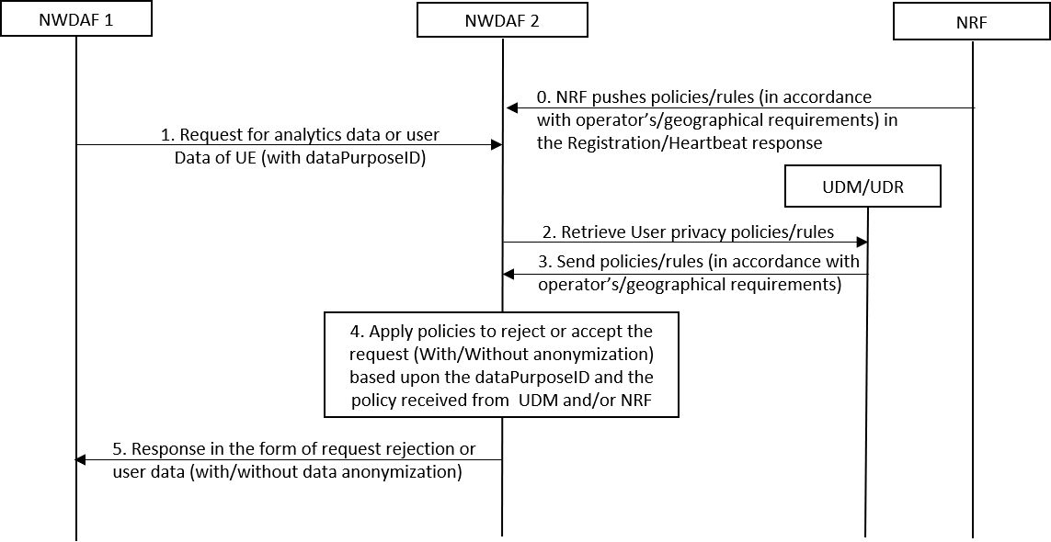
Figure 6.8.2-1: Generic Procedure to preserve user privacy based upon the predefined policies
Step 0: If an operator configures the privacy rules in the NRF (generic for all subscribers), then the NRF can push the policy/rules to NF in the response of registration/heartbeat. A heartbeat message is sent by NFs every some seconds (i.e. 10-20 seconds). Therefore, whenever the privacy rule is changed in the NRF, the NRF can push updated rules to the NFs.

Step 1: NWDAF1 sends a user data request to NWDAF 2 (Sending NWDAF Instance) with an additional IE DataPurposeID indicating the purpose.
NOTE: DataPurposeID specifies the purpose of the user data request corresponding to an analytics ID. For instance, the DataPurposeID can be 'Advertisement' corresponding to the user data request of analytics ID 'location'.
Step 2: NWDAF2 sends a request to retrieve the user privacy policies for a specific subscriber from the UDM/UDR. Or it can use the locally configured policies based upon the operator's or geographical requirements.
NOTE: Step 2 and 3 are further addressed in the UC3S study.

Step 3: UDM/UDR sends the privacy policies configured for the subscriber either by the operator or by the user or based upon the privacy local policy enforced by regulation.

Step 4: NWDAF2, after receiving the policies, applies them to the requested user data for the DataPurposeID. For instance, because of the privacy policy it can either reject the request completely or it sends the data without or with anonymization. The latter preserves the sensitive information of the user. Policies received in Step 0 are also applied along with policy received in Step 3.

Step 5: NWDAF2 sends the processed data to NWDAF1 as a response to the initial request.

************** ENF OF CHANGES

