3GPP TSG-SA3 Meeting #103-e draft_S3-211627-r3

e-meeting, 17 – 28 May 2021 Revision of S3-20xxxx

Source: Huawei, HiSilicon

Title: Evaluation of solution 14

Document for: Approval, Information, Discussion
Agenda Item: 5.9

1 Decision/action requested
In this box give a very clear / short /concise statement of what is wanted.

2 References
[1] 3GPP TR 33.847 "Study on Security Aspects of Enhancement for Proximity Based Services in 5GS".

3 Rationale
This document proposes an evaluation of Solution #15.

4 Detailed proposal
*************** Start of the Change ****************

6.15 Solution #15: Key management in UE-to-Network Relay based on primary authentication

6.15.1 Introduction
This solution addresses the KI #3, KI#4 and KI#9. This solution provides a mechanism setup a PC5 link security between a remote UE and UE-to-network relay based on primary authentication.
NOTE: Remote UE needs to be in coverage to request relay key from AUSF (i.e. NAS messages step1-6).

6.15.2 Solution details

6.15.2.1 Procedure
The procedure for key management in UE-to-Network relay using primary authentication is depicted in Figure 6.15.2-1.
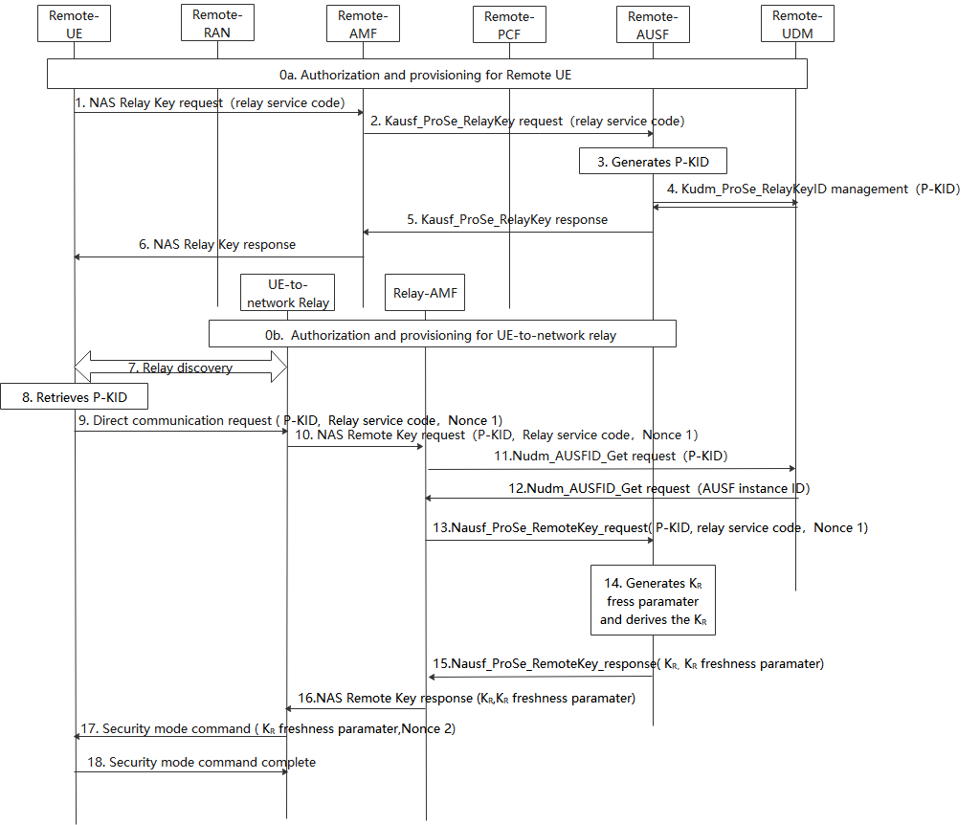
Figure 6.15.2-1: Procedures for key management in ProSe UE-to-Network Relay based on primary authentication
0. During Registration procedure, authorization and provisioning is performed for the Remote UE (0a) and ProSe UE-to-NW relay (0b).
1. The Remote UE sends a NAS relay Key request message with relay service code for PC5 communication with a UE-to-network relay.
2. After receiving the NAS relay key request from UE, the Remote AMF that serves the remote UE first checks whether the UE is authorized to be as a remote UE. If it is authorized, the Remote AMF further sends Nausf_ProSe_RelayKey request with relay service code.
3. The Remote AUSF that serves the remote UE generates P-KID for the relay service code in the Nausf_ProSe_RelayKey request.
P-KID is in NAI format as specified in clause 2.2 of IETF RFC 7542 [6], i.e. username@realm. The username part includes the Routing Identifier and the P-TID (ProSe Temporary UE Identifier), and the realm part includes Home Network Identifier.
The P-TID is derived from K_{AUSF} as specified in 6.15.2.2.
4. The Remote AUSF further stores P-KID in UDM via Kudm_ProSe_RelayKey service.
5. The Remote AUSF sends Nausf_ProSe_RelayKey response to the AMF.
6. The Remote AMF sends NAS relay Key response to the UE.
Note: If the Kausf changes, the UE initiates step 1~6 to trigger the AUSF to derive the new P-KID and stores the new P-KID in the UDM.
7. The Remote UE discovers the UE-to-network Relay using either model A or model B discovery.
8. The Remote UE derives P-KID based on the relay service code the Remote UE would like to access using the same method as the remote AUSF.
9. The Remote UE sends a Direct Communication Request. The Direct Communication Request contains the Relay Service Code, P-KID and Nonce1.
10. The UE-to-Network relay triggers the PC5 root key (i.e PC5 root key for communicating with the remote UE) retrival procedure. The Relay sends NAS remote Key request with P-KID, Relay service code, Nonce 1.
11. The relay AMF that serves the relay UE first check whether the relay UE is authorized to be a relay. If authorized, The AMF discovers the UDM based on the P-KID, the relay AMF sends Nudm_AUSFID_Get request with P-KID to the UDM.
12. UDM response to relay AMF via Nudm_AUSFID_Get with AUSF instance ID of the AUSF serving remote UE.
13. AMF further sends Nausf_ProSe_RemoteKey request with P-KID, Relay service code, Nonce 1 to the remote AUSF.
14. The remote AUSF generates K_{R} freshness parameter and derives K_{R} using at least Kausf, relay service code,K_{R} freshness parameter and Nonce 1 as input.
15. The remote AUSF sends Nausf_ProSe_RemoteKey response with K_{R}, K_{R} freshness parameter to the relay AMF.
16. The relay AMF sends NAS remote Key response K_{R}, K_{R} freshness parameter to the UE-to-network relay.
NOTE: This solution requires the integrity and confidentiality protected NAS messages.
17. The UE-to-network relay sends a Direct Security Mode Command message to the Remote UE, K_{R} freshness parameter and Nonce 2 are included in the message.
18. The Remote UE derives K_{R} key in the same way as the remote AUSF in step 14. The DSMC message is integrity and confidentiality protected as in TS 33.536[8].

6.15.2.2 Derivation of P-TID
When deriving the P-TID from K_{AUSF}, the following parameters are used to form the input S to the KDF:
- FC = xxxx(to be allocated by 3GPP);
- P0 = SUPI;
- L0 = length of SUPI.
- P1 = relay service code;
- L1 = length of relay service code.
The input key KEY is K_{AUSF}.
SUPI has the same value as parameter P0 in Annex A.7.0 of TS 33.501 [2].

6.15.3 Solution Evaluation

This solution#15 addresses the requirements in KI#3, KI#4 and KI#9. The remote UE triggers the 5GC network to derive the P-KID per service relay code and the remote UE derives the PKID locally. The remote UE sends the P-KID to Relay UE for retrieving the shared key from the AUSF that serving remote UE, and the remote UE derives the shared key locally based on the primary authentication key kausf. During the shared key obtaining procedure, the 5GC check whether the relay UE is authorized to be a relay UE. After the remote UE and relay UE retrieves the share key, they can establish the PC5 security based on existing mechanism defined in TS33.536.
This solution requires Remote UE to be in coverage to request relay key from AUSF.
The AUSF is responsible for ProSe key management function in this solution. This solution requires AMF to support new NAS procedures.
Editor’s Note: Futher evaluation is FFS.
*************** End of the Change ****************

