3GPP TR 33.867 V0.4.0 (2021-3)
Technical Report

3rd Generation Partnership Project;
Technical Specification Group Services and System Aspects;
Study on User Consent for 3GPP services
(Release 17)
 | 
The present document has been developed within the 3rd Generation Partnership Project (3GPP TM) and may be further elaborated for the purposes of 3GPP.
The present document has not been subject to any approval process by the 3GPP Organizational Partners and shall not be implemented.
This Specification is provided for future development work within 3GPP only. The Organizational Partners accept no liability for any use of this Specification.
Specifications and Reports for implementation of the 3GPP TM system should be obtained via the 3GPP Organizational Partners' Publications Offices.

3GPP
Postal address

3GPP support office address
650 Route des Lucioles - Sophia Antipolis
Valbonne - FRANCE
Tel.: +33 4 92 94 42 00 Fax: +33 4 93 65 47 16
Internet
http://www.3gpp.org

Copyright Notification
No part may be reproduced except as authorized by written permission.
The copyright and the foregoing restriction extend to reproduction in all media.

© 2020, 3GPP Organizational Partners (ARIB, ATIS, CCSA, ETSI, TSDSI, TTA, TTC).
All rights reserved.

UMTS™ is a Trade Mark of ETSI registered for the benefit of its members
3GPP™ is a Trade Mark of ETSI registered for the benefit of its Members and of the 3GPP Organizational Partners
LTE™ is a Trade Mark of ETSI registered for the benefit of its Members and of the 3GPP Organizational Partners
GSM® and the GSM logo are registered and owned by the GSM Association

Contents
Foreword 5
Introduction 6
1 Scope 7
2 References 7
3 Definitions of terms, symbols and abbreviations 8
3.1 Terms 8
3.2 Symbols 8
3.3 Abbreviations 8
4 User consent background, analysis 8
4.1 Background 8
4.2 Analysis 8
5A Use Cases 9
5A.1 Use Cases #1: UE Related Analytics of NWDAF 9
5A.1.1 Use Case details 9
5A.1.2 Individual Architecture 9
5.2 Use Cases #2: UE Information Exposure for Mobile Edge Computing 10
5.2.1 Use Case details 10
5.2.2 Individual Architecture 11
5A.X Use case #X 11
5A.X.1 Use Case details 11
5A.X.2 Individual architecture 11
5B Common architecture 11
6 Key issues 12
6.3 Key Issue #3: Modification or revocation of user consent 13
6.3.1 Introduction 13
6.3.2 Security threats 13
6.3.3 Potential security requirements 13
6.4 Key Issue #4: KI on relationship between the subscriber and the end-users 13
6.4.1 Key issue details 13
6.4.2 Security Threats 14
6.4.3 Potential Requirements 14
6.X Key issue #X: <Key issue name> 14
6.X.0 Use case mapping 14
6.X.1 Key issue details 14
6.X.2 Security threats 14
6.X.3 Potential security requirements 14
7 Potential solutions 14
7.0 Mapping of solutions to key issues 14
7.1 Solution #1: User Consent for Exposure of information to Edge Applications in Real Time 15
7.1.1 Solution overview 15
7.1.2 Solution details 15
7.1.3 Solution evaluation 16
7.2 Solution #2: User Consent for UE Related Analytics of NWDAF 16
7.2.2.1 NF Authorization based on User Consent 16
7.2.2.2 User Consent Format 17
7.2.2.3 Obtain of User Consent 17
TBA. 17
7.Y Solution #Y: <Solution name> 17
7.Y.1 Solution overview 17
7.Y.2 Solution details 17
7.Y.3 Solution evaluation 17
8 Conclusions 18
8.1 Conclusion on KI #4 18
Annex A (Informative): Observations related to regulations 18
Annex <A>: <Informative annex title for a Technical Report> 19
Annex <X> (informative): Change history 20

Foreword
This Technical Report has been produced by the 3rd Generation Partnership Project (3GPP).
The contents of the present document are subject to continuing work within the TSG and may change following formal TSG approval. Should the TSG modify the contents of the present document, it will be re-released by the TSG with an identifying change of release date and an increase in version number as follows:
Version x.y.z
where:
x the first digit:
1 presented to TSG for information;
2 presented to TSG for approval;
3 or greater indicates TSG approved document under change control.
y the second digit is incremented for all changes of substance, i.e. technical enhancements, corrections, updates, etc.
z the third digit is incremented when editorial only changes have been incorporated in the document.
In the present document, modal verbs have the following meanings:
shall indicates a mandatory requirement to do something
shall not indicates an interdiction (prohibition) to do something
The constructions "shall" and "shall not" are confined to the context of normative provisions, and do not appear in Technical Reports.
The constructions "must" and "must not" are not used as substitutes for "shall" and "shall not". Their use is avoided insofar as possible, and they are not used in a normative context except in a direct citation from an external, referenced, non-3GPP document, or so as to maintain continuity of style when extending or modifying the provisions of such a referenced document.
should indicates a recommendation to do something
should not indicates a recommendation not to do something
may indicates permission to do something
need not indicates permission not to do something
The construction "may not" is ambiguous and is not used in normative elements. The unambiguous constructions "might not" or "shall not" are used instead, depending upon the meaning intended.
can indicates that something is possible
cannot indicates that something is impossible
The constructions "can" and "cannot" are not substitutes for "may" and "need not".
will indicates that something is certain or expected to happen as a result of action taken by an agency the behaviour of which is outside the scope of the present document
will not indicates that something is certain or expected not to happen as a result of action taken by an agency the behaviour of which is outside the scope of the present document
might indicates a likelihood that something will happen as a result of action taken by some agency the behaviour of which is outside the scope of the present document
might not indicates a likelihood that something will not happen as a result of action taken by some agency the behaviour of which is outside the scope of the present document
In addition:
is (or any other verb in the indicative mood) indicates a statement of fact
is not (or any other negative verb in the indicative mood) indicates a statement of fact
The constructions "is" and "is not" do not indicate requirements.

Introduction
Editor’s Note: Content is FFS

1 Scope
The scope of present document is to identify and evaluate the requirements and solutions to support user consent for 3GPP services while complying with user privacy considerations.
The details are as follows:
- Review TR 33.849 [xx] with regards to the concept of user consent for 3GPP users, and identify what types of data collection and conditions under which the support of the user consent is required; then update them if needed;
- Identify target usage scenarios and trust domains;
- Analyse potential security threats and requirements for conditions under which user sensitive data are collected without user consent, and when user consent indication is not protected;
- Identify potential solutions to address the above security requirements.
NOTE 1: Principles, regulations, and definitions related to privacy, which are recognized differently in each different country or area, are taken into account when deriving the concept of user consent for 3GPP users.
NOTE 2: Even where solutions exist to obtain user consent, collection and exposure of user sensitive data should be minimized and only be allowed where critical to the operation of the related feature.
Editor's Note: The structure of the TR needs to be updated to reflect the objectives.
Editor's Note: Scope may need to be updated to reflect the result of the analysis of TR33.849 to differentiate the scope of the present document and of TR33.849.

2 References
The following documents contain provisions which, through reference in this text, constitute provisions of the present document.
- References are either specific (identified by date of publication, edition number, version number, etc.) or non-specific.
- For a specific reference, subsequent revisions do not apply.
- For a non-specific reference, the latest version applies. In the case of a reference to a 3GPP document (including a GSM document), a non-specific reference implicitly refers to the latest version of that document in the same Release as the present document.
[1] 3GPP TR 21.905: "Vocabulary for 3GPP Specifications".
[2] 3GPP TS 23.558: "Architecture for enabling Edge Applications (EA) ".
[3] 3GPP TR 33.849: “Study on subscriber privacy impact in 3GPP”.
[4] 3GPP TS 23.288: “Architecture enhancements for 5G System (5GS) to support network data analytics services”
[5] 3GPP TS 23.501: “System architecture for the 5G System (5GS)”

3 Definitions of terms, symbols and abbreviations

3.1 Terms
For the purposes of the present document, the terms given in 3GPP TR 21.905 [1] and the following apply. A term defined in the present document takes precedence over the definition of the same term, if any, in 3GPP TR 21.905 [1].

Data subject: As defined in TR 33.849 [3].
Data controller: As defined in TR 33.849 [3].
Data processor: As defined in TR 33.849 [3].
Personal data: As defined in TR 33.849 [3].

3.2 Symbols
For the purposes of the present document, the following symbols apply:
<symbol> <Explanation>

Editor’s Note: Example needs to be deleted

3.3 Abbreviations
For the purposes of the present document, the abbreviations given in 3GPP TR 21.905 [1] and the following apply. An abbreviation defined in the present document takes precedence over the definition of the same abbreviation, if any, in 3GPP TR 21.905 [1].
<ABBREVIATION> <Expansion>

Editor’s Note: Example needs to be deleted

4 User consent background, analysis
Editor’s Note: This clause will look at various aspects around user consent, e.g., how it is interpreted, its need for type/purpose of data processing, example of use cases, etc..

4.1 Background
Editor’s Note: This clause will introduce concept of user consent and why we study user consent in SA3.

4.2 Analysis

TR 33.849 [3] provides privacy principles that need to be followed in 3GPP when designing new systems, security architectures and protocols. Some content are related to user consent and can be taken into account in this study.
In clause 6.5 of TR 33.849 [3], user consent is introduced as one of the threat mitigation approaches to mitigate the privacy risk, and gives a brief introduction on how explicit user consent can be collected.
In clause 5.3.4 of TR 33.849 [3], conditions which user consent is required for personal information disclosure is defined as: “Personal data disclosure with the purpose to accomplish a certain application/service needs to be under user's consent, unless the disclosure is performed in the legitimate interest of the data subject, e.g. providing a service.”
In Annex B of TR 33.849 [3], some regulations related to privacy are introduced.
However, with evolution of 3GPP network, more and more 3GPP services are introduced. Some services may require personal identification information, so identification of target usage case for user consent is necessary.
For different use case, the PII is identified by different identity, some of them is identified by subscriber ID, e.g. SUPI, and some of them is identified by user ID. Thus, source of user consent should also be identified case by case.
Moreover, different use cases may need different solutions for authorization based on user consent. Security issues of how user consent is exchanged among NFs in the network and how they are handled and respected by various features specified by 3GPP should be also considered.

5A Use Cases
Editor’s Note: This clause will present the system architecture on user consent for 3GPP services, i.e. which part of 5G and connected systems are considered, what a data is expected to be processed, and for what purpose.

5A.1 Use Cases #1: UE Related Analytics of NWDAF

5A.1.1 Use Case details
NWDAF can provide UE related analytics services. The NWDAF collects UE related data, e.g. from UE, NFs, 3rd party, and outputs related analytics result, e.g. UE mobility analytics, UE communication analytics, expected UE behavioural parameters related network data analytics and abnormal behaviour related network data analytics as depicted in clause 6.7 in 3GPP TS 23.288 [4].
The NWDAF can process UE related data as the following:
- Collect UE related data to provide UE related analytics for the user, e.g. UE mobility analytics.
- Share analytics result to NF consumers, e.g. internal NF or 3rd AF.
The PLMN NFs or AFs can process UE related data as the following:
- Collect and store UE related data.
- Share UE related data to NWDAF.
Since the UE related data may contain personally identifiable information, thus, processing of those data should consider user consent aspects. The analytics service is provided by PLMN to a specific subscriber. The key point is that the NWDAF in the PLMN only collects network data which is bound to a subscriber ID, i.e. SUPI, and the analysis output is also bound to that SUPI. Even in case that another user borrows the subscriber’s phone, the PLMN cannot output an analysis result bound to that user because the PLMN just knows current collected data is from the subscriber identified by the SUPI. The PLMN does not output any analysis bound to that user who are using the phone, instead, the output is still bound to subscriber because the collected data is identified by the SUPI, not the user’s ID. The only issue is that the analysis may not be precious enough for the subscriber. Since the PLMN does not output any analysis bound to the user who are using the phone, the user’s privacy is not disrupted, so, it is also aligned with regulation. Thus, for this use case, since the service is provided to the specific subscriber, user consent should be collected from subscriber.

5A.1.2 Individual Architecture
For this use case, the architecture and framework as specified in TS 23.288 [4], TS 23.501 [5] are regarded as the baseline. The solutions shall build on the 5G System architectural principles as in TS 23.501 [5], including flexibility and modularity for newly introduced functionalities.
Moreover, the individual architecture is shown in figure 5A.1.2-1.
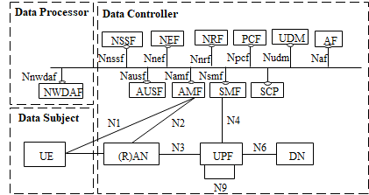
5A.1.2-1 Individual Architecture for data analytics
The UE related data is derived from the UE.
The NFs, for example, AMF, SMF, OAM, AF, etc., collect and store UE related data derived from the UE. Thus, the legal entity of those network entities is data controller. In case that the AF is outside of 3GPP network, the legal entity of the AF is another data controller.
The NWDAF collects UE related data from the NFs, and processes data for UE related analytics to provide UE related analytics services. Thus, the legal entity of the NWDAF is data processor. In case that the NWDAF is NF of data controller, the legal entity of the NWDAF is also data controller.
NOTE: Roaming architecture for NWDAF is not considered in R17.

5.2 Use Cases #2: UE Information Exposure for Mobile Edge Computing

5.2.1 Use Case details
An edge enabler server (EES) of the edge data network caters to the edge applications running at an edge data network. The EES is configured to expose APIs (e.g. location service, UE identifier (GPSI)) to the edge application server (EAS), and the PLMN NFs are also configured to expose the relevant APIs to the EES.
The EAS collects the UE information via the EES’s APIs to provide specific services, e.g. collect GPSI and related GPS to provide accurate location service, and the EES may collect the UE information via the PLMN NFs’ APIs.
The EAS can process UE information as the following:
- Collect UE information to provide specific services, e.g. collect UE location to provide accurate location service.
The EES can process UE information as following:
- Collect and store UE information.
- Share UE information to EAS.
The NFs in PLMN can process UE information as following:
- Collect and store UE information.
- Share UE information to EES.
The MEC service is provided by stakeholder of the EAS (e.g. 3rd party) to a specific subscriber. The key point is that the EAS in the 3rd party can identify the specific user who is using the MEC application. If the EAS requests for the user’s sensitive information from PLMN, e.g. location, GPSI, etc., user consent from the user may be needed because the user’s sensitive information is transferred between different data controllers, i.e. PLMN and 3rd party. Thus, for this use case, since the service is provided to the specific user, user consent should be collected from user.

5.2.2 Individual Architecture
For this use case, the architecture and framework as specified in TS 23.558 [2], TS 23.501 [5] are regarded as the baseline. The solutions shall build on the 5G System architectural principles as in TS 23.501 [5], including flexibility and modularity for newly introduced functionalities.
Moreover, the individual architecture is shown in figure 5.2.2-1.
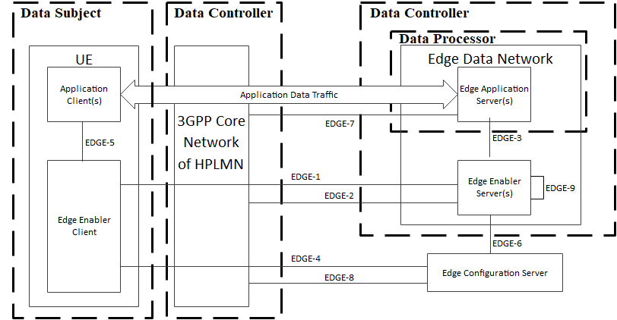
5.2.2-1 Individual architecture for data analytics
The UE information is derived from the UE, which may include UE static ID, UE location, etc.
The home PLMN NFs in 3GPP core network store UE information. Thus, the legal entity of those network entities is data controller. In addition, the EES also collects and stores UE information from the 3GPP core network. Thus the legal entity of the EES is also data controller.
The EAS collects UE information from the the EES, and processes the UE information to provide specific services. Thus, the legal entity of the EAS is data processor. The legal entity of the EAS is also data controller.

5A.X Use case #X

5A.X.1 Use Case details
Editor’s Note: This clause will capture the use case when the user consent is needed.

5A.X.2 Individual architecture
Editor’s Note: This clause is used to show the individual architecture of each use case. The architecture may show the legal entities that is relevant to user consent. Different individual architectures will be used together to generate a common architecture for user consent in 5G system..

5B Common architecture
Editor’s Note: This clause will capture the common architecture for user consent in 5G system. Common architecture could be derived from different individual architectures for user consent in 5G system.

6 Key issues
Editor’s Note: This clause will contain the agreed key issues.
NOTE: Key issues should align with the background/analysis done in clause 4 and 5 above.
Editor’s Note: The clear split between user consent aspects studied in eNA study and UC3S study need to be clarified.
Editor’s Note: Below a generic template of headings for a key issue is provided and need to be deleted before the TR goes for approval. The subclauses may not necessarily be needed as part of a KI

6.1 Key Issue #1: User's consent for exposure of information to Edge Applications

6.1.0 Use case mapping
As defined in clause 6.6 and 8.6 in TS 23.558 [2], the EES can expose some service capability APIs to the EAS(s). The exposed service capability APIs include EES capabilities and exposed 3GPP Core Network capabilities. Some APIs provided by the EES are related to user's consent such as UE location API specified in clause 8.6.2 in TS 23.558 [2] and UE Identifier API specified in clause 8.6.5 in TS 23.558 [2].

6.1.1 Key issue details
The EES exposes UE Identifier API to the EAS in order to provide an identifier uniquely identifying a UE. Further, the EES exposes the UE location API to the EAS in order to support tracking or checking the valid location of the UE. In order to expose such user related private information to the Edge Application servers, consent from the user is needed.
EES capability exposure to the EAS as defined in TS 23.558 [2], mandates the end user's consent for reporting UE's information, particularly for UE Identifier API and UE location API. Also as suggested in TS 23.558 [2], whether and how user's consent is obtained to share the UE identifier with a particular EAS is covered in this key issue.

6.1.2 Security threats
Use of user’s information to identify and track the user or user’s behavior without the permission or knowledge of the user, poses huge threat to user’s privacy.

6.1.3 Potential security requirements
Architecture for enabling edge applications shall support a mechanism for Edge Application Servers to obtain user's authorization, in order to access to and/or to expose the user's sensitive information (e.g. user's location).
Editor’s Note: the security requirements are TBA.
Editor’s Note: When defining any procedures obtaining user's consent, it is needed to clarify “when” user’s consent is obtained, on “what” information it is obtained and provide details on “why” user’s consent is obtained (e.g. for what purposes the user consented information will be used).

6.2 Key Issue #2 User consent for UE data collection

6.2.1 Key issue details
5GS NFs will collect data about the UE being served. The NFs keep privacy related sensitive data such as profiling information, location information, etc. UE related data may also need to be transferred to another NF to fulfil a service request or, e.g., for analytics purposes. For example, the NWDAF shares the analytics results to the consumer NF which may be an internal NF or a 3rd party and exposes the UE Identifier, UE location in order to support tracking or checking the valid location of the UE.
In order to meet related private information requirements stated above, user consent is needed.

6.2.2 Security threats
If the 5G NFs are not aware of the current status of user consent for a specific service, they may share information with other NF’s that are not essential for 5G communication that could lead to a compromise in the users privacy. For example, sharing location, timings and device ID with a third party service or with a NF from an operator that is neither the home or visited network.

6.2.3 Potential security requirements
The 3GPP system shall provide a means for an NF to authenticate a request for information that may compromise a user’s privacy.
The 5GS shall provide a means for an NF to verify the status of user consent for a request for information that may compromise a user’s privacy.
The 5GS shall specify where an NF can find the status of user consent for service that it delivers.
The 5GSshall specify a means that allows a user to change or add consent for a service.
5G NFs shall provide protect potential privacy related information both in transit and in storage.
Editor's Note: the key issue needs to cover also user consent not based on privacy regulation.

6.3 Key Issue #3: Modification or revocation of user consent

6.3.1 Introduction
UDR (via UDM services) holds the user consent for user related data which is provisioned by MNO as a user subscription information. A service provider (external to MNO domain) can use Nnef_parameterProvision_Update service to update or to revoke the user consent to the UDM/UDR (when applicable).

6.3.2 Security threats
If user consent modification or revocation is done by an unauthorized party, a service to a consumer can be denied; or service might be granted to the consumer that should not have access to the user data.

6.3.3 Potential security requirements
Editor's Note: Requirements to handle revocation and modification of user consent are FFS.

6.4 Key Issue #4: KI on relationship between the subscriber and the end-users

6.4.1 Key issue details
Based on the discussion over the past meetings, companies had different perspective over the consent provided by the users or the subscriber. As the end-users of the subscription may not be the subscriber, for example, employee may use the subscription of the employer for business proposes. In such scenarios, the user consent can be provided either by the user(s) (employee(s)) or by the subscriber (employer) based on the use cases. For e.g., in the case where PLMN provides service for a subscription, the user consent can be collected from subscriber and for the case where 3rd party provides service for the user, the user consent can be collected from the users (end-users), as subscriber may not be involved or it is irrelevant for the subscriber.
As an outcome of the discussion, it is decided that, the user consent is obtained from the end-user(s) and the consent obtained from the end-users (subscriber and/or users) of the subscription is considered as valid for that subscription.
NOTE: The term end-user defined in TR 21.905 [1].

6.4.2 Security Threats
Not applicable.

6.4.3 Potential Requirements
Not applicable.

6.X Key issue #X: <Key issue name>

6.X.0 Use case mapping
Editor’s Note: If the key issue is relevant with a use case, then the clause number of the use case should be given here. Otherwise, descriptions of key issue scenario should be given here.

6.X.1 Key issue details
Editor’s Note: This clause provides details of the key issue

6.X.2 Security threats
Editor’s Note: This clause list the threats derived from the key issue details

6.X.3 Potential security requirements
Editor’s Note: This clause list the potential security requirements derived from the threats

7 Potential solutions
Editor’s Note: This clause will contain the proposed solutions
Editor’s Note: Solutions are only to be provided, when common understanding of user consent topic (clause 4) is reached and the system architecture (clause 5) clearly stated.

7.0 Mapping of solutions to key issues
Table 6.0-1: Mapping of Solutions to Key Issues
Solutions | Key Issues
 | 1 | 2
#1: User Consent for Exposure of information to Edge Applications in Real Time | X
#2: User Consent for UE Related Analytics of NWDAF |  | X

Editor’s Note: This clause provides the mapping of Solutions to Key Issues.

Editor’s Note: Below a generic template of headings for a new solution is provided and need to be deleted before the TR goes for approval

7.1 Solution #1: User Consent for Exposure of information to Edge Applications in Real Time

7.1.1 Solution overview
The solution addresses key issue #1 “User Consent for Exposure of information to Edge Applications”.
The solution introduces a new function user consent function (UCF), the UCF can collect and maintain user consent from user in real time. The UCF is operator’s internal AF which can be merged with other internal AF, and can communicate with user.
Editor’s Note: how would the UCF know from what user it collected the user consent form is ffs.
Editor’s Note: It is FFS if UCF should communicate with user.
Editor’s Note: If UCF communicates with user, it is FFS how. It is also FFS how UCF can determine the user.

7.1.2 Solution details
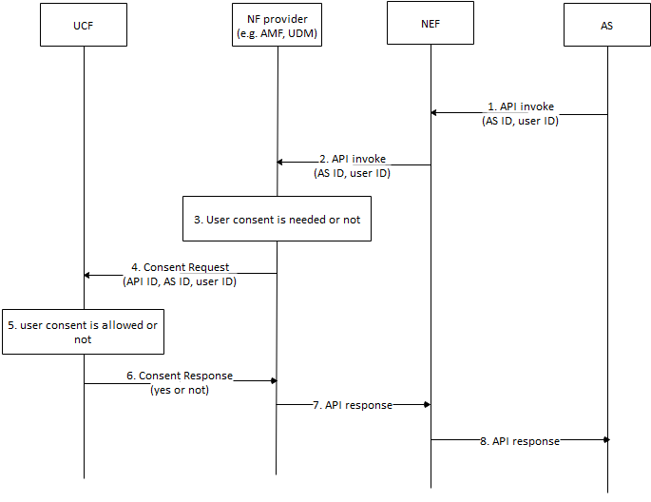
Figure 7.1.2.1 Authorization based on User Consent
- AS sends API invocation to NEF, requesting for user’s sensitive information, e.g. location. The invocation includes AS ID and user ID. The user ID is associated to specific user.
- The NEF sends the API invocation with the AS ID and the user ID to NF provider to retrieve the information.
- The NF provider checks whether authorization of user consent is needed or not based on the invocated API according to local policy, e.g. regulation, if the invocation requests the user’s sensitive data, the NF provider may check whether user is allowed based on local policy. Otherwise, if the invocation requests non-user information or policy is not needed, the NF provider may not check the consent.
- If check of consent is needed, the NF provider sends Consent Request message with the API ID, the AS ID and the user ID to the UCF.
- The UCF checks whether consent is allowed. The UCF may push application request to the user for consent via application layer, the UCF may also push SMS to the user assocated with the MISDN. The request shows that user consent is needed for sharing your sensitive information to 3rd party. If consent is received or rejected, the UCF replies result to the NF provider. The UCF may store the consent for future use.
- The UCF sends Consent Response to the NF provider with the result.
- If the result shows that consent is allowed, the NF provider response to the API invocation, otherwise, the invocation is cancelled.
Editor’s Note: How AS’s purpose for data processing is determined is FFS.
Editor’s Note: How to track where data has been communicated to in case of a requirement for later deletion is FFS.

7.1.3 Solution evaluation
TBA

7.2 Solution #2: User Consent for UE Related Analytics of NWDAF

7.2.1 Solution overview
The solution addresses key issue #2.
The solution gives an overview for user consent on services provided by NWDAF.

7.2.2 Solution details

7.2.2.1 NF Authorization based on User Consent
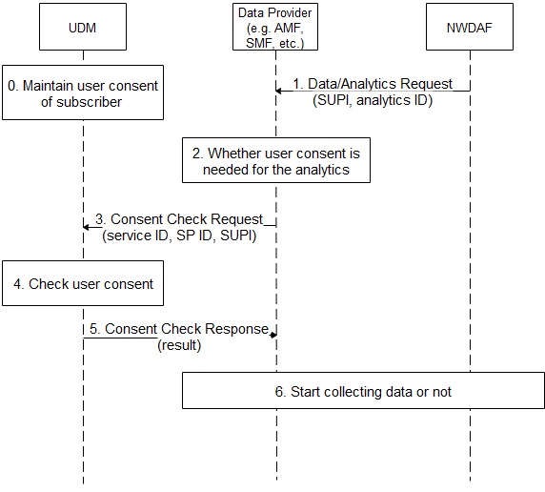
Figure 7.2.2.1-1 NF Authorization based on User Consent for NWDAF
- The UDM maintains user consent for the subscriber.
- The NWDAF sends Data/Analytics Request to Data Provider, the request includes SUPI and analytics ID.
- If the request is for specific analytics, e.g. may collect UE’s information for UE related analytics, the Data provider checks whether user consent is needed for the analytics according to local policy, e.g. regulation.
- The Data Provider sends Consent Check Request message to the UDM. The message includes the service ID, the Service Provider ID and the SUPI. The service ID is associated with the analytics ID.
- The UDM checks user consent according to the maintained user consent.
- The UDM sends Consent Check Response message to the Data Provider. The message includes the result, i.e. permission granted or denied.
- The Data Provider starts to collect the requested data based on the result.
Editor’s Note: It is FFS if step 2 is done in another place like in NWDAF or UDM.
Editor’s Note: It is FFS when UDM itself is data provider.

7.2.2.2 User Consent Format
The UDM maintains the following parameters for user consent for services provided by NWDAF:
- UE ID: refers to a subscriber, can be SUPI.
- Service Provider ID: refers to a service provider who provides data analytics service for the UE, can be PLMN ID.
- Service ID: refers to a data analytics service, can be analytics ID.
Those parameters are combined to indicate that a specific subscriber has user consent to consume specific network analytics service provided by the specific service provider.

7.2.2.3 Obtain of User Consent
The subscriber may give its consent to operator when the subscriber signs service contract with the operator.

7.2.3 Solution evaluation

TBA.

7.Y Solution #Y: <Solution name>

7.Y.1 Solution overview
Editor’s Note: This clause starts with the (part of) the key issue(s) addressed and is followed with a brief overview of the solution

7.Y.2 Solution details
Editor’s Note: This clause provides the details of the solution

7.Y.3 Solution evaluation
Editor’s Note: This clause provides the evaluation of the solution

8 Conclusions
Editor’s Note: This clause will contain the conclusion, principle and guidelines of user consent in 5G

8.1 Conclusion on KI #4
For the KI #4 on relation between the subscriber and the end-users, it is concluded that:
The user consent is obtained from the end-users. The end-users may be the subscriber or may authorize the subscriber to provide consent on behalf of the end-users or the end-users are authorized by the subscriber to provide the consent. How authorization is provided between the subscriber and the users is out-of-scope of 3GPP.
End-users cannot retroactively make the user consent setting more permissive.

Annex A (Informative):
Observations related to regulations
NOTE: There are many regional privacy regulations. In this clause specific ones like GDPR are considered for guidance only.
The European General Data Protection Regulation (GDPR) can be considered one of the leading privacy regulations as other countries (such as India) are using it as a blueprint to update their own privacy regulations. It defines that consent must be freely given, specific, informed, and unambiguous. It also means that, for users in the European Union, if consent is chosen as the legal basis for processing, users have to agree actively through an affirmative action (opt in). Other legislations such as Brazil’s Lei Geral de Proteção de Dados Pessoais (LGPD) from August 2020 and the upcoming Indian privacy law both use similar guidelines for obtaining consent. Jurisdictions such as California and their Consumer Privacy Act (CCPA), while not having limitations on the initial collection of personal data, do have updated consent controls regarding the selling and onward transfer of personal data. Thus, there could be different views around the world how user consent should be handled as there are different laws and principles around privacy in the different countries/regions.
Under the GDPR, while most of the interest revolves around the legal basis of consent for processing personal data, it forms only one of six legal bases. The other five (contract, legal obligations, vital interests of the data subject, public interest, and legitimate interest) are all used as well. Thus, there could be other legal bases for processing personal data than consent.

Consent can be obtained through a variety of methods and techniques, as long as the action is an affirmative one by the data subject and matches the GDPR requirements of being freely given, specific, informed, and unambiguous. This can be from ticking a box on a website to writing a letter confirming everything. Thus, how consent can be given depends on the concrete use case and also on the laws of the jurisdictions which govern the use case.

Annex <A>:
<Informative annex title for a Technical Report>

Annex <X> (informative):
Change history
Change history
Date | Meeting | TDoc | CR | Rev | Cat | Subject/Comment | New version
2020.10 | SA3#100bis-e | S3- 202785 |  |  |  | S3-202622,S3-202338, S3-202589r2, | 0.1.0
2020.11 | SA3#101-e | S3-203458 |  |  |  | S3-203451 | 0.2.0
2021.1 | SA3#102-e | S3-210671 |  |  |  | S3-210227, S3-210275, S3-210324r3 | 0.3.0
2021.3 | SA3#102bis-e | S3-211332 |  |  |  | S3-210873, S3-210901, S3-210902, S3-210903, S3-210904, S3-210993r2, S3-211136, S3-211193, S3-211214, S3-211267, S3-211300 | 0.4.0

