3GPP TSG-SA3 Meeting #102-e draft_S3-211166-r2

e-meeting, 1 – 5 March 2021 Revision of S3-21xxxx

Source: Nokia, Nokia Shanghai Bell

Title: KI on SCP deployment models

Document for: Approval
Agenda Item: 5.20

1 Decision/action requested
KI added according to objectives of the SID added.

2 References
[1] 3GPP TS

3 Rationale
KI added according to objectives, i.e. copy from SID justification of the objective.

4 Detailed proposal

********* START OF CHANGES

5.2 Key issue #2: SCP security domains

5.2.1 Key issue details
Editor’s note: SCP security domains to be defined.
TS 23.501 [X] addresses the aspects of handling multiple SCPs in indirect communication without and with delegated discovery and introduced SCP domains, which comprises multiple SCPs. NF Service Consumers or/and SCPs need to request NRF to discover the next hop SCP to route a service request from the NF Service Consumer to a NF Service Producer via multiple SCPs. 23.502 describes in the SCP profile SCP domain registration details about interconnected SCPs to and thus also identifies SCPs that interconnect domains.
The primary purpose of SCP domains is to describe the connectivity topology within a network. All SCPs within an SCP domain can directly interconnect. One SCP can be part of multiple SCP domains. In fact, the primary purpose of intermediate SCPs in the path is to interconnect SCP domains, thus, there are boundaries between SCP domains at each SCP in the path.
PLMN-wide trust between NFs and SCPs is an option, but more restrictions could be desirable in complex networks with SCP domains, e.g. if SCPs are operated in different regions/provinces. There can be several technical domains within a PLMN, where equipment with different capabilities is deployed and signalling also varies in some respects, e.g., if equipment upgrade is performed in a stepwise manner. Such technical domains can be defined based on computer centre boundaries, based on operators of subnetworks, based on regions/provinces, etc.

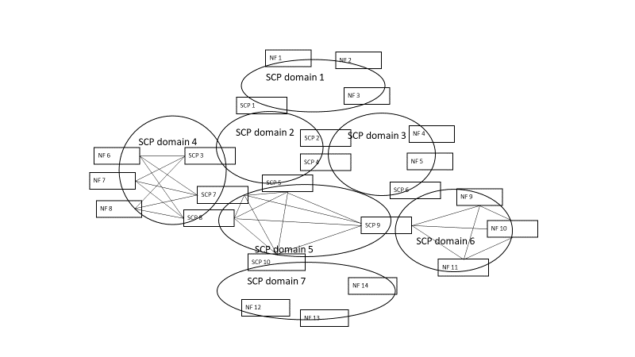
Figure 5.2.1-1: Illustration of SCP domains connecting via dedicated SPCs
This key issue is to study whether there is a need of one or several SCP domains becoming regions of trust of finer granularity than PLMN and whether there is a necessity of trust and policing of communication within or among such domains, i.e. for the case that request messages traverse a boundary between trust domains.

5.2.2 Security threats
Editor's Note: FFS. Maybe not applicable if only architectural security requirements are specified.
5.2.3 Potential security requirements
Editor's Note: FFS. Maybe not applicable if only architectural security requirements are specified.

********* END OF CHANGES

