3GPP TSG SA WG3 Meeting #102bis-e S3-210993

e-meeting, 1 – 5 March 2021 revision S3-20abcd

Source: China Unicom

Title: New Solution for User Consent for Exposure of information to Edge Applications in Real Time

Document for: Approval
Agenda Item: 2.14

Decision/action requested
This contribution proposes to add a new solution for TR 33.867

References

Rational
The contribution proposes to add a new solution for key issue #1 “User Consent for Exposure of information to Edge Applications”.

Detailed proposal
*************** Start of 1st Change ****************

7.Y Solution #Y: User Consent for Exposure of information to Edge Applications in Real Time

7.Y.1 Solution overview
The solution addresses key issue #1 “User Consent for Exposure of information to Edge Applications”.
The solution introduces a new function user consent function (UCF), the UCF can collect and maintain user consent from user in real time. The UCF is operator’s internal AF which can be merged with other internal AF, and can communicate with user.
Editor’s Note: how would the UCF know from what user it collected the user consent form is ffs.
Editor’s Note: It is FFS if UCF should communicate with user.
Editor’s Note: If UCF communicates with user, it is FFS how. It is also FFS how UCF can determine the user.

7.Y.2 Solution details
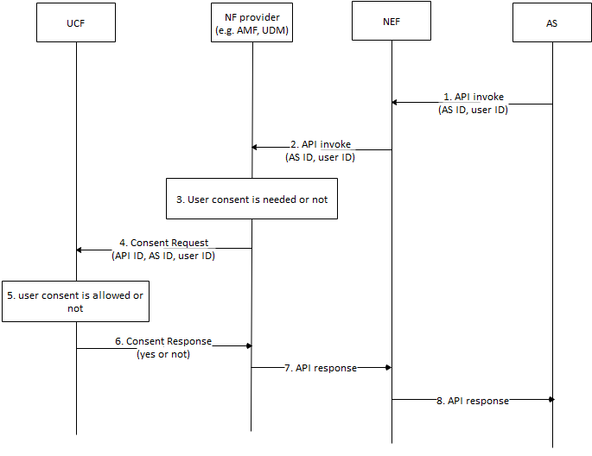
Figure 7.Y.2.1 Authorization based on User Consent
- AS sends API invocation to NEF, requesting for user’s sensitive information, e.g. location. The invocation includes AS ID and user ID. The user ID is associated to specific user.
- The NEF sends the API invocation with the AS ID and the user ID to NF provider to retrieve the information.
- The NF provider checks whether authorization of user consent is needed or not based on the invocated API according to local policy, e.g. regulation, if the invocation requests the user’s sensitive data, the NF provider may check whether user is allowed based on local policy. Otherwise, if the invocation requests non-user information or policy is not needed, the NF provider may not check the consent.
- If check of consent is needed, the NF provider sends Consent Request message with the API ID, the AS ID and the user ID to the UCF.
- The UCF checks whether consent is allowed. The UCF may push application request to the user for consent via application layer, the UCF may also push SMS to the user assocated with the MISDN. The request shows that user consent is needed for sharing your sensitive information to 3rd party. If consent is received or rejected, the UCF replies result to the NF provider. The UCF may store the consent for future use.
- The UCF sends Consent Response to the NF provider with the result.
- If the result shows that consent is allowed, the NF provider response to the API invocation, otherwise, the invocation is cancelled.
Editor’s Note: How AS’s purpose for data processing is determined is FFS.
Editor’s Note: How to track where data has been communicated to in case of a requirement for later deletion is FFS.

7.Y.3 Solution evaluation
TBA
*************** End of 1st Change ****************

