3GPP TSG-SA3 Meeting #102-e S3-210992

e-meeting, 18 - 29 January 2021 Revision of S3-20xxxx

Source: NEC

Title: SUCI Linkability attack

Document for: Approval
Agenda Item: 2.5

1 Decision/action requested
The objective of this pCR is to provide solution to key issue 2.2

2 References
(Reference - in list form - should be made to previous related SA5/3GPP/etc. documents.)
(For changes against a draft TS/TR, a pseudo CR - a.k.a. pCR - will be provided using this Tdoc template. In this case, the number, name and version of the draft TS/TR used as base must be provided and the version must be the latest available version of the draft TS/TR.)
[1] 3GPP TR 33.846 v0.9.0
[2] 3GPP TS 33.501
[3] 3GPP TS 33.303

3 Rationale
Facts and observations:
1) When a UE includes a SUCI in the registration procedure or in the Identity Response as message in response to the identity request message with Identity Type = SUCI the AMF initiates authentication procedure.
2) The UE runs T3519 timer with timer value (60 seconds) when it sends a SUCI in a registration request message or Identity response message. The UE will send same the SUCI till the timer T3519 is running in the registration request message or Identity response message. After the expiry of the T3519 timers the UE calculate a new SUCI and sends in the Registration Request message ot Identity response message.
Therefore, a SUCI is valid till timer T3519 is running i.e. for 60 seconds.
3) According to the key issue, when a UE registers to a PLMN using SUCI, the Man In The Middle (MITM) can capture the SUCI of the UE. The MITM can replay this SUCI later.
4) The MITM will replay same SUCI for all the UEs at the location to identify a presence of the user. It is easy to identify the attack in the UDM then.

4 Detailed proposal
It is proposed that SA3 include the below pCR for inclusion into the TR [1].

**** START OF CHANGES ****

6.X Solution to Key Issue #2.2: SUCI replay.

6.X.1 Introduction
The solution is proposed to solve Key Issue #2.2: SUCI replay.

6.x.1.1 Solution detalis
When a UDM receives a SUCI from the AUSF, the UDM de-conceals the SUCI to SUPI. The UDM starts a timer T equivalent T3519 and stores the SUC corresponding to the SUPI. The UDM initiates the authentication procedure.
When the UDM receives the SUCI again, then it determines if the timer T is running. if the timer T is running then the UDM shall initiate authentication procedure otherwiset the UDM determines either the UE is fake or there is man in the middle on receiving SUCI 1 after the timer T expires and the UDM rejects the authentication procedure as SUCI retransmission is not expected after T3519. The UDM stores the SUCI per SUPI for period of time (e.g. 24 hours or 48hours or longer).
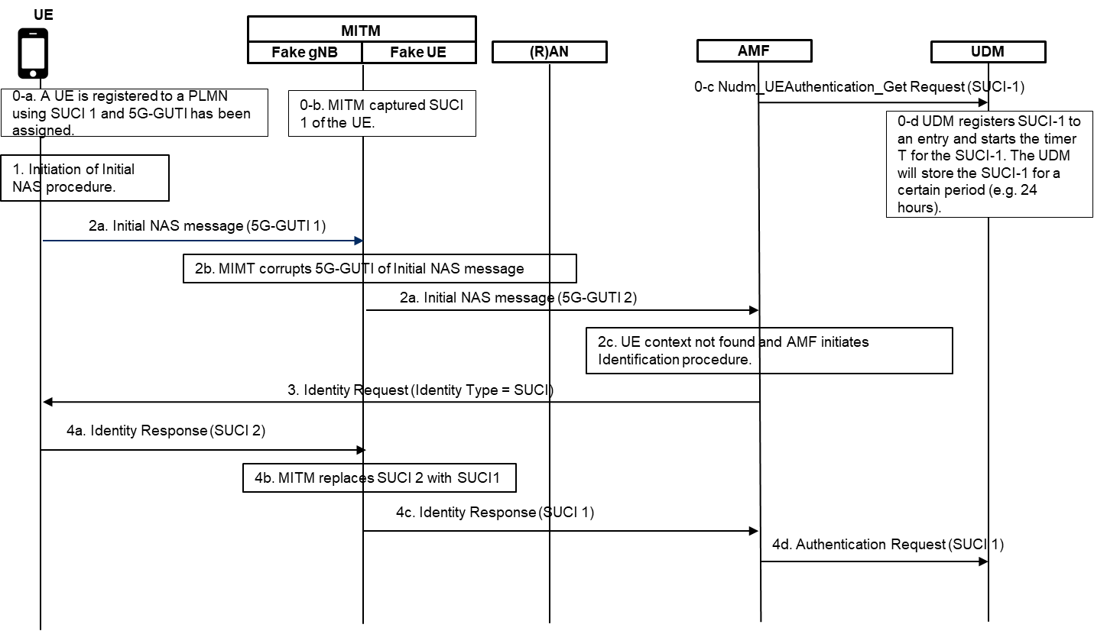
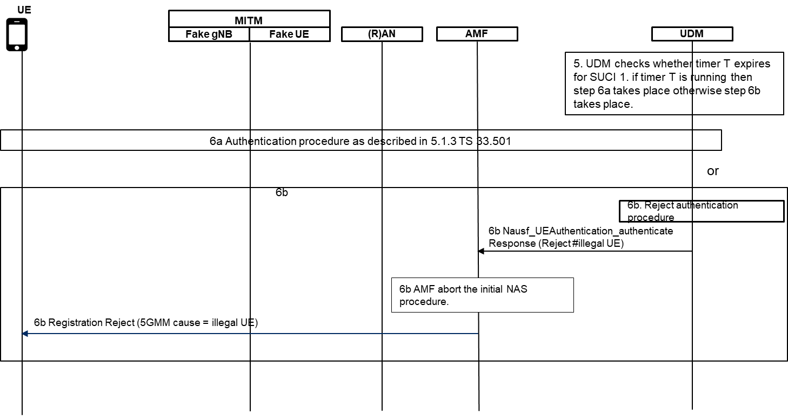
Figure 1: Procedure to handle SUCI parameter in the UDM

The detailed steps of the solution is as described below.
1. The UE is registered to the network for the first time by sending SUCI-1 in the registration procedure. The UE has been assigned 5G-GUTI 1. The UDM stores the SUCI 1 and start a timer T equivalent to T3519. The UDM stores the SUCI per SUPI for period of time (e.g. 24 hours or 48hours or longer). TheUE also starts timer T3519.
2-3. The UE initiates an initial NAS procedure including the 5G-GUTI 1 in an initial NAS message. The MITM corrupts the 5G-GUTI 1. The context is not found in the AMF and the AMF initiates the identification procedure requeting SUCI.
4. Upon receiving the identity request message with identity type = SUCI, the UE calculates a new SUCI, SUCI 2, as the timer T3519 expires in the UE and sends SUCI 2 in the identity response message. The MITM replaces SUCI 2 with SUCI 1. The AMF on receiving the identity response message initiate authentication procedure towards the UDM for SUCI 1.
5. The UDM deconceals the SUCI 1 to SUPI and verify whether the timer T is running for the SUCI 1. The UDM will executes either 6a or 6b depending on whether timer T is running for SUCI 1 or not.
6a. If the timer T is running for the SUCI 1 then the UDM initiates authentication procedure as described in sub clause 6.1.3 of 3GPP TS 33.501. After successful registration procedure, the UDM shall stop the timer T.
6b If the timer T has expired then the UDM rejects the authentication procedure as SUCI retransmission is not expected after T3519.
Editor’s Note: It is FFS how the UDM avoid replay attack when the UDM deletes the SUCI and replay attack is mounted when the MO signalling is initiated by the target UE within 60 seconds of initiation of replay attack.
Editor’s Note: It is FFS whether the proposed method is subject to the poisoning attack

6.x.1.2 Evaluation
The solution is very simple which has no UE, AMF, SEAF, AUSF impact. A minor change in the UDM as proposed in the UDM can easily and effectively solves this issue.
The UDM needs to run a timer T and to store the SUCI for a certain period. These will consume network resources.

**** END OF CHANGES ****

