3GPP TSG-SA3 Meeting #102bis-e draft_S3-210929-r1

e-meeting, 1 - 5 March 2021 Revision of S3-20xxxx

Source: Huawei, HiSilicon

Title: Address the remaining ENs in solution 15

Document for: Approval
Agenda Item: 2.9

1 Decision/action requested
This contribution proposes to resolve the remaing ENs in solution 15.

2 References
[1] 3GPP TR 33.847 "Study on Security Aspects of Enhancement for Proximity Based Services in 5GS".

3 Rationale
This contribution proposed to address the following Editor’s Notes in solution 15.
Editor’s note: whether this solution supporting out of coverage being FFS.
Considering the solution is based on the primary authentication procedure, the remote UE shall first access the network and perform the mutual authentication before the UE determines to use UE-to-network relay. After the remote UE and network have shared the Kausf, the remote UE can move out of the coverage. Therefore, this solution can be used in the case where remote UE has registered in the 5GC network and has obtained the provisioning parameters such as relay service code before the UE moves out of the coverage. And the solution cannot be used if the remote UE is out of coverage and has never accessed the network before.
Editor’s note: The generation of the P-KID in AUSF is FFS.
The AUSF derives the P-KID using the similar mechanism as the A-KID defined in 33.535, the details is specified in 6.15.2.2.
Editor’s note: how the procedure (i.e step 1~6 ) works in Kausf change (e.g., due to reauthentication) is FFS.
If the reauthentication procedure is performed, the UE initiates step 1~6 to trigger the AUSF to derive the new P-KID(s) and stores the new P-KID(s) in the UDM, then the UDM will request the old AUSF to delete the previous P-KID(s). If there is a UE-to-network relay connection established, the remote UE keep it unchanged. And the remote UE will establish new UE-to-network relay connection based on the reauthenticaiton.
Editor’s note: The retrieval of the P-KID in UE is FFS.
The UE derives the P-KID using the same mechanism as the AUSF.
Editor’s note: It’s FFS whether P-KID or other user ID e.g. SUCI should be used in PC5.
In this solution, only P-KID is used.
Editor’s note: The parameters included in Direct Security Mode Command message are FFS.
In this solution, we defines the parameters which are used for deriving the shared root key between the remote UE and relay UE. The other related parameters used to establish PC5 security based on the shared root key refers to one to one communication procedure.

4 Detailed proposal
*************** Start of 1st Change ****************

6.15 Solution #15: Key management in UE-to-Network Relay based on primary authentication

6.15.1 Introduction
This solution addresses the KI #3, KI#4 and KI#9. This solution provides a mechanism setup a PC5 link security between a remote UE and UE-to-network relay based on primary authentication.

NOTE: Remote UE needs to be in coverage to request relay key from AUSF (i.e. NAS messages step1-6).

6.15.2 Solution details

6.15.2.1 Procedure
The procedure for key management in UE-to-Network relay using primary authentication is depicted in Figure 6.15.2-1.

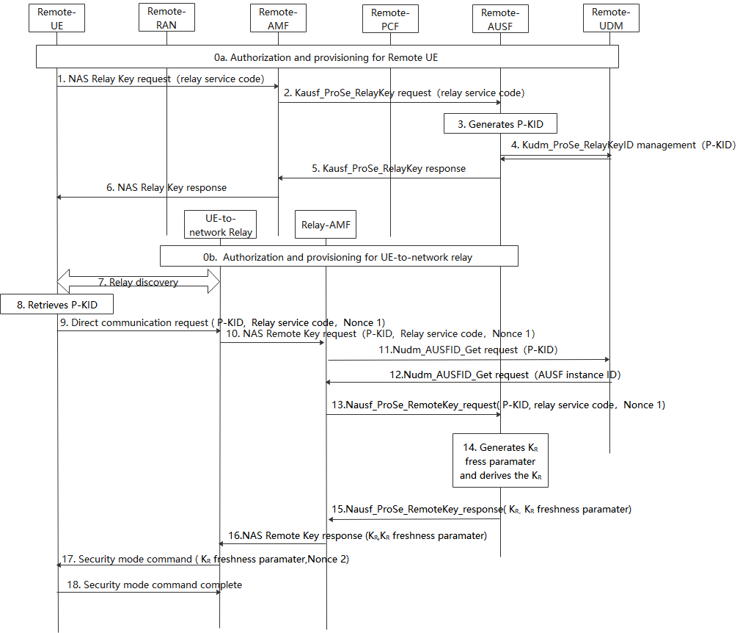
Figure 6.15.2-1: Procedures for key management in ProSe UE-to-Network Relay based on primary authentication
0. During Registration procedure, authorization and provisioning is performed for the Remote UE (0a) and ProSe UE-to-NW relay (0b).
1. The Remote UE sends a NAS relay Key request message with relay service code for PC5 communication with a UE-to-network relay.
2. After receiving the NAS relay key request from UE, the Remote AMF that serves the remote UE first checks whether the UE is authorized to be as a remote UE. If it is authorized, the Remote AMF further sends Nausf_ProSe_RelayKey request with relay service code.
3. The Remote AUSF that serves the remote UE generates P-KID for the relay service code in the Nausf_ProSe_RelayKey request.
P-KID is in NAI format as specified in clause 2.2 of IETF RFC 7542 [6], i.e. username@realm. The username part includes the Routing Identifier and the P-TID (ProSe Temporary UE Identifier), and the realm part includes Home Network Identifier.
The P-TID is derived from K_{AUSF} as specified in 6.15.2.2.

4. The Remote AUSF further stores P-KID in UDM via Kudm_ProSe_RelayKey service.
5. The Remote AUSF sends Nausf_ProSe_RelayKey response to the AMF.
6. The Remote AMF sends NAS relay Key response to the UE.

Note: If the Kausf changes, the UE initiates step 1~6 to trigger the AUSF to derive the new P-KID and stores the new P-KID in the UDM.
7. The Remote UE discovers the UE-to-network Relay using either model A or model B discovery.
8. The Remote UE derives P-KID based on the relay service code the Remote UE would like to access using the same method as the remote AUSF.

9. The Remote UE sends a Direct Communication Request. The Direct Communication Request contains the Relay Service Code, P-KID and Nonce1.

10. The UE-to-Network relay triggers the PC5 root key (i.e PC5 root key for communicating with the remote UE) retrival procedure. The Relay sends NAS remote Key request with P-KID, Relay service code, Nonce 1.
11. The relay AMF that serves the relay UE first check whether the relay UE is authorized to be a relay. If authorized, The AMF discovers the UDM based on the P-KID, the relay AMF sends Nudm_AUSFID_Get request with P-KID to the UDM.
12. UDM response to relay AMF via Nudm_AUSFID_Get with AUSF instance ID of the AUSF serving remote UE.
13. AMF further sends Nausf_ProSe_RemoteKey request with P-KID, Relay service code, Nonce 1 to the remote AUSF.
14. The remote AUSF generates K_{R} freshness parameter and derives K_{R} using at least Kausf, relay service code,K_{R} freshness parameter and Nonce 1 as input.
15. The remote AUSF sends Nausf_ProSe_RemoteKey response with K_{R}, K_{R} freshness parameter to the relay AMF.
16. The relay AMF sends NAS remote Key response K_{R}, K_{R} freshness parameter to the UE-to-network relay.
17. The UE-to-network relay sends a Direct Security Mode Command message to the Remote UE, K_{R} freshness parameter and Nonce 2 are included in the message.

18. The Remote UE derives K_{R} key in the same way as the remote AUSF in step 14. The DSMC message is integrity and confidentiality protected as in TS 33.536[8].

6.15.2.2 Derivation of P-TID
When deriving the P-TID from K_{AUSF}, the following parameters are used to form the input S to the KDF:
- FC = xxxx(to be allocated by 3GPP);
- P0 = SUPI;
- L0 = length of SUPI.
- P1 = relay service code;
- L1 = length of relay service code.
The input key KEY is K_{AUSF}.
SUPI has the same value as parameter P0 in Annex A.7.0 of TS 33.501 [2].

6.15.3 Solution Evaluation
TBD.

*************** End of 1st Change ****************

