3GPP TSG-SA3 Meeting #102bis-e draft_S3-210918-r1

e-meeting, 1 – 5 March 2021

Source: Huawei, Hisilicon

Title: New solution to update the keys used to protect the MBS traffic

Document for: Approval
Agenda Item: 2.11

1 Decision/action requested
This contribution proposes to add the solution for TR 33.850.

2 References
[1]

3 Rationale
The solution proposes to use the signalling messages to update the keys to protect the MBS traffic. The MBS traffic is protected between MBSF-U and UEs.

4 Detailed proposal
It is proposed to approve the following changes in TR 33.850.
*** BEGIN OF 1st CHANGE ***

6.X Solution #X: Update the keys used to protect the MBS traffic

6.X.1 Introduction
This solution addresses Key issue #2 to update the keys to protect the MBS traffic. The MBS traffic is protected between MBSF-U and UEs. The basic idea is to use the signalling messages for the key update procedure. The UEs, which belong to a multicast group, acquire the same group keys as in the MBSF-U. The security protection is enabled in service layer.

6.X.2 Solution details

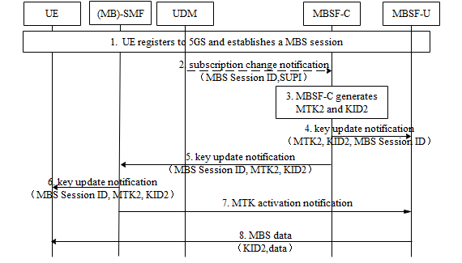
Figure 6.X.2 -1: Procedure for MTK update
1. The UE registers to 5GS and establishes a MBS session, during which MBSF-C generates MTK1&KID1 and distributes them to MBSF-U and UEs. MTK1&KID1 are used to protect the MBS traffic. Details can be found in solution 3 or solution 8.
2. MBSF-C subscribes to the UDM/UDR on the changes of the multicast information including the authorization information. The UDM/UDR notifies the MBSF-C when the authorization for a UE to join the multicast service/application is revoked. The MBS Session ID and UE identifier (i.e. SUPI) is included in the notification. The MBS Session ID may be a Temporary Mobile Group Identifier (TMGI) or a multicast address.
If UE identifier is sensitive, the number of UEs, whose authorization is revoked, is included in the notification instead of UE identifier.
3. MBSF-C triggers the MTK update based on the changes of authorization info or the key lifetime of MTK1. MBSF-C generates MTK2 and KID2 for this MBS session.
4-5. MBSF-C distributes MTK2, KID2 and MBS Session ID to (MB)-SMF and MBSF-U respectively.
6. (MB)-SMF distributes MTK2, KID2 and MBS Session ID to the authorized UEs whose MBS sessions are not released.
7. If the procedure to update the key in UE side is finished, (MB)-SMF indicates MBSF-U to activate the MTK2 for the corresponding MBS session.
8. MBSF-U uses MTK2 and KID2 to protect the MBS traffic.
The above text describes the security handling when SMF and MB-SMF are co-located. If SMF and MB-SMF are deployed separately, MBSF-C distributes MTK2, KID2 and MBS Session ID to MB-SMF. Afterwards, MB-SMF distributes MTK2, KID2 and MBS Session ID to the authorized UEs via SMF. MB-SMF indicates MBSF-U to activate the MTK2

6.X. 3 Evaluation
This solution addresses Key issue #2 to update the key for protecting the MBS session.
MBSF-C decides to trigger the MTK update procedure. The new MTK and KID are sent to UE and MBSF-U respectively.
Editor’s Note: Further evaluation is FFS.
*** END OF 1st CHANGE ***

