3GPP TSG-SA3 Meeting #102bis-e draft_S3-210913-r1

e-meeting, 1 – 5 March 2021

Source: Huawei, Hisilicon

Title: F1 interface security for IAB in NR-DC mode

Document for: Approval
Agenda Item: 2.18

1 Decision/action requested
This contribution proposes to update KI for IAB TR 33.824.

2 References
[1] RAN3_110-e_agenda_with_Tdocs20201112_EOM.zip https://www.3gpp.org/ftp/tsg_ran/WG3_Iu/TSGR3_110-e/Inbox/Chairmans_Notes/RAN3_110-e_agenda_with_Tdocs20201112_EOM.zip

3 Rationale
In RAN WG, there is an ongoing WID on IAB in R17. In RAN3, it’s agreed to define the CP-UP separation via separate NR access link. This enhancement defines the analogue of F1 routing for standalone, i.e., for IAB-nodes that use NR-DC instead of EN-DC. The IAB-donor could be Master Node or Secondary node. The following context in the chairman note are agreed:
In Rel-17 eIAB, the following two scenarios are supported for CP-UP separation:
- Scenario 1: F1-C uses NR access link via M-NG-RAN node (non-donor node) + F1-U uses backhaul link via S-NG-RAN node (donor node)
- Scenario 2: F1-U uses backhaul link via M-NG-RAN node (donor node) + F1-C uses NR access link via S-NG-RAN node (non-donor node)

In SA3, security mechanisms for F1 interface between the IAB-node (gNB-DU) and the IAB-donor-CU is already defined for SA mode and EN-DC mode. It’s needed to study the security features for NR-DC mode.

4 Detailed proposal
It is proposed to approve the following changes in IAB TR.
*** BEGIN OF 1st CHANGE ***

5.3.X Key issue #3.X: F1 interface security for IAB in NR-DC mode

5.3.X.1 Key Issue details
The IAB realized in SA mode or EN-DC is already supported as descripted in clause 5.3.1.1. An IAB donor node has gNB-CU functionality and another IAB node has gNB-DU functionality. Each IAB node is connected to the IAB-donor node either directly (i.e., a single hop) or via another IAB node (i.e., multiples hops).
In addition, NR-DC is also specified to support the CP-UP separation via separate NR access link. The following two scenarios as shown in Fig. 5.3.X.1 (a) and (b) are supported for CP-UP separation:
- Scenario 1: F1-C uses NR access link via M-NG-RAN node (non-donor node) + F1-U uses backhaul link via S-NG-RAN node (donor node)
- Scenario 2: F1-U uses backhaul link via M-NG-RAN node (donor node) + F1-C uses NR access link via S-NG-RAN node (non-donor node)

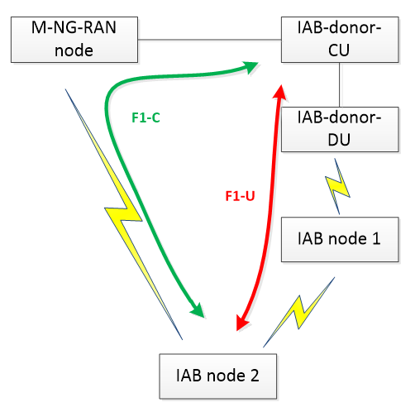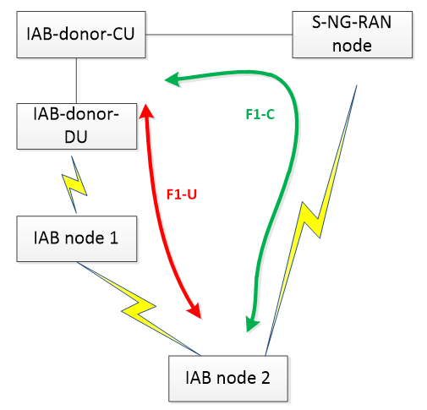
(a) Scenario 1 (b) Scenario 2
Figure 5.3.X.1: Scenarios for CP-UP separation
F1 interface security for the wireline link between CU and DU is specified in TS 33.501[5]. Dynamic PSK computation for IKEv2 PSK authentication may also be supported. When dynamic PSK is used, the IAB-node and the IAB-donor need to calculate the PSK (K_{IAB}). However, the K_{IAB} generation function is only defined for SA mode and EN-DC mode. The K_{IAB} generation function for NR-DC mode is not clear. IAB-donor could be Master Node or Secondary Node. The input key to generate K_{IAB} needs to be defined to keep consistency between IAB node and IAB-donor.
This key issue is to study potential solutions for F1 interface security for IAB in NR-DC mode.

5.3.X.2 Security threats
If the input key to generate K_{IAB} is not well-defined, the Kiab may mismatch between IAB node and IAB donor, which leads to the failure of F1 interface protection when K_{IAB} is used in IKEv2 PSK authentication.

5.3.X.3 Potential security requirements

The K_{IAB} in IAB-node and IAB-donor shall be consistent if K_{IAB} is used in IKEv2 PSK authentication for IAB in NR-DC mode.
*** END OF 1st CHANGE ***

