3GPP TSG SA WG3 Meeting #102bis-e S3-210905

e-meeting, 1 – 5 March 2021 revision S3-21abcd

Source: Huawei, HiSilicon

Title: New Solution for UE Related Analytics of NWDAF

Document for: Approval
Agenda Item: 2.14

Decision/action requested
This contribution proposes to add a new solution for TR 33.867

References

Rational
The contribution proposes to add a new solution for eNA.

Detailed proposal
*************** Start of 1st Change ****************

7.Y Solution #Y: User Consent for UE Related Analytics of NWDAF

7.Y.1 Solution overview
The solution addresses key issue #X.
The solution gives an overview for user consent on services provided by NWDAF.

7.Y.2 Solution details

7.Y.2.1 NF Authorization based on User Consent
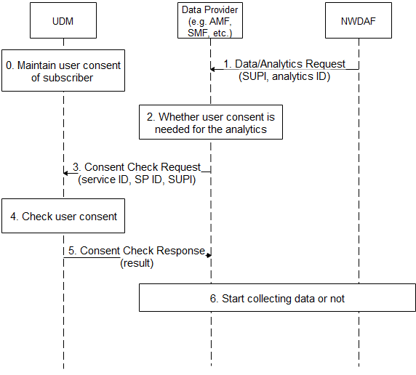
Figure 7.Y.2.1-1 NF Authorization based on User Consent for NWDAF
- The UDM maintains user consent for the subscriber.
- The NWDAF sends Data/Analytics Request to Data Provider, the request includes SUPI and analytics ID.
- If the request is for specific analytics, e.g. may collect UE’s information for UE related analytics, the Data provider checks whether user consent is needed for the analytics according to local policy, e.g. regulation.
- The Data Provider sends Consent Check Request message to the UDM. The message includes the service ID, the Service Provider ID and the SUPI. The service ID is associated with the analytics ID.
- The UDM checks user consent according to the maintained user consent.
- The UDM sends Consent Check Response message to the Data Provider. The message includes the result, i.e. permission granted or denied.
- The Data Provider starts to collect the requested data based on the result.
Editor’s Note: It is FFS if step 2 is done in another place like in NWDAF or UDM.
Editor’s Note: It is FFS when UDM itself is data provider.

7.Y.2.2 User Consent Format
The UDM maintains the following parameters for user consent for services provided by NWDAF:
- UE ID: refers to a subscriber, can be SUPI.
- Service Provider ID: refers to a service provider who provides data analytics service for the UE, can be PLMN ID.
- Service ID: refers to a data analytics service, can be analytics ID.
Those parameters are combined to indicate that a specific subscriber has user consent to consume specific network analytics service provided by the specific service provider.

7.Y.2.3 Obtain of User Consent
The subscriber may give its consent to operator when the subscriber signs service contract with the operator.

7.Y.3 Solution evaluation
TBA.
*************** End of 1st Change ****************

