3GPP TSG-SA3 Meeting #102Bis-e draft_S3-210848-r2

e-meeting, 1 – 5 March 2021 Revision of S3-210848-r1

Source: Nokia, Nokia Shanghai Bell

Title: MAC, SYNCH failure cause concealment solution

Document for: Approval
Agenda Item: 2.5

1 Decision/action requested
Approval for new solution to prevent linkability attack for Key issue #2.1

2 References
[1] TR 33.846

3 Rationale
Solution to conceal MAC, SYNCH failure cause to prevent linkability attack for Key issue #2.1 Mitigation against the Linkability attack.

4 Detailed proposal
************ START OF CHANGES

6.0 Mapping of solutions to key issues
Table 6.0-1: Mapping of solutions to key issues
 | Key Issues
Solutions | #1.X | #2.1 | #2.2 | #3.1 | #3.2 | #4.1
Solutions for anchor keys security
No solution so far
Solutions for resilience against identifier linkability
#2.1: Handling of Sync failure by AUTS encryption |  | x |  |  |  | x
#2.2: Encryption of authentication failure message types by UE with new keys derived from K_AUSF |  | x |  |  |  | x
#2.3: Unified authentication response message by UE |  | x
#2.4: MAC-S based solution |  | x |  |  |  | x
#2.5: Encryption of authentication failure message with SUCI method |  |  | x
#2.6: Certificate based encryption of unicast NAS message |  | x |  |  |  | x
#2.X: MAC, SYNCH failure cause concealment |  | x
Solutions for availability aspects of SUCI usage
No solution so far
Solutions on re-synchronisation in AKA
#4.1: Using MACS as freshness in the calculation of AK |  |  |  |  |  | x
#4.2: Using symmetric encryption function to protect SQN during a re-synchronisation procedure in AKA |  |  |  |  |  | x
#4.3: SQN protection by concealment with SUPI in USIM |  | x | x |  |  | x
#4.4: SQN protection during re-synchronisation procedure in AKA |  |  |  |  |  | x
#4.5: AUTS SQN_{MS} solution for 5GS |  |  |  |  |  | x
#4.7: SQN protection by concealment with SUPI with f5* |  | x | x |  |  | x

************ NEXT CHANGE

6.2.X Solution #2.X: MAC, SYNCH failure cause concealment

6.2.X.1 Introduction
This solution addresses Key Issue #2.1: Mitigation against the linkability attack
In TR 33.846[1], there are many solutions available like solution#4.3, solution #4.5, solution #4.7, solution#3.1 for study to prevent SQN leakage (Key Issue#4.1) by sharing the SQNMS value in various forms in Registration request message to UDM. This removes the necessity of sending SQNMS value in AUTS during synch failure or MAC failure cause in Authentication failure message.
This solution proposes to conceal the failure cause to avoid the linkability attack.

6.2.X.2 Solution details
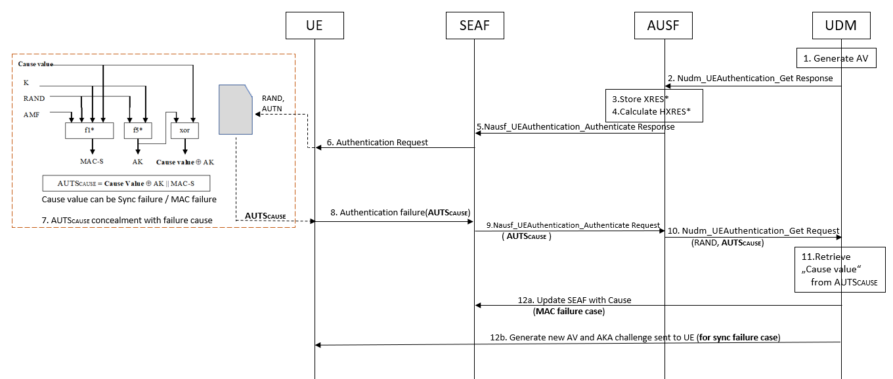
Figure 6.2.X.2.1: Cause concealment (5GS) in case of authentication failure
The initial Registration procedure is triggered from UE and the procedure is the same as described in clause 6.1.2 of 3GPP TS 33.501 [V]. Only step 7 varies by creating a new 5GMM cause value.

Step 1: UDM generates authentication vector, derives KAUSF and calculates XRES*. UDM/ARPF will create 5G HE AV from RAND, AUTN, XRES* and KAUSF.
Step 2: UDM will return 5G HE authentication vector to AUSF to be used for 5G AKA in Nudm_UEAuthentication_Get Response. UDM will include SUPI in the SUPI in the Nudm_UEAuthentication_Get Response after deconcealment of SUCI by SIDF.
Step 3: AUSF will store the XRES* temporarily together with the received SUCI or SUPI.
Step 4: AUSF will then generate 5G authentication vector from the 5G HE authentication vector received from the UDM/ARPF by computing the HXRES* from XRES* and KSEAF from KAUSF, and replacing the XRES* with the HXRES* and KAUSF with KSEAF in the 5G.
Step 5: AUSF will remove the K_{SEAF} and return the 5G SE authentication vector (RAND, AUTN, HXRES*) to the SEAF in a Nausf_UEAuthentication_Authenticate Response.
Step 6: SEAF will send RAND, AUTN to the UE in a NAS message Authentication Request. This message will also include ngKSI that will be used by UE and AMF to identify the KAMF and the partial native security context that is created if the authentication is successful. This message will also include the ABBA parameter. ME will forward the RAND and AUTN received in NAS message Authentication Request to the USIM.
Step 7: These three steps are followed at USIM after reception of RAND and AUTN.
7.1. USIM computes XMAC and compares this with received MAC from AUTN. If they are different, then it results in MAC failure. If it is same, then it continues to step 7.2.
7.2. USIM verifies if the received sequence number SQN is in correct range or not. If it is not in correct range, then it results in Synchronisation failure. If it is in correct range, then it continues to step 7.3.
7.3. As MAC verification and sequence number range is verified, USIM computes RES to be included in authentication response.
For MAC failure or Synchronisation failure, the cause value is taken as input for concealment in AUTSCAUSE.
The generation of MAC-S, AK and Cause concealment is shown below.
MAC-S = f1*K(Cause value || RAND || AMF)
AK = f5*K(RAND)
Conc(Cause value) = Cause value ⊕ AK
AUTSCAUSE = Conc(Cause value ) || MAC-S
NOTE: AUTSCAUSE containing cause value will be sent for both MAC and Synch failure. USIM conceals the cause values in AUTSCAUSE and forwards it to ME.
Step 8: Authentication failure message is sent from UE to SEAF with new 5GMM cause value as generic "authentication failure cause" along with AUTSCAUSE.
Step 9: Upon receiving an authentication failure message with AUTSCAUSE from the UE, the SEAF sends a Nausf_UEAuthentication_Authenticate Request message with a "synchronisation failure indication" to the AUSF.
Step 10: AUSF sends a Nudm_UEAuthentication_Get Request message to the UDM/ARPF, together with the following parameters:
- RAND sent to the UE in the preceding Authentication Request, and
- AUTSCAUSE received by the SEAF in the response from the UE to that request.
Step 11: UDM retrieves cause value from AUTS_{CAUSE} using RAND value.
Step 12: In case of MAC failure cause value, UDM updates SEAF with MAC failure for the Authentication procedure. Rest of the procedures of how MAC failure is treated remains the same (as described in TS 33.501[V] & TS 24.501[W] 5.4.1.3.6 & 5.4.1.3.7 item c.).
In case of Synch failure, a new Authentication vector is generated in UDM and the AKA challenge is sent to UE. Below figure 6.2 shows the concealed cause value in AUTS_{CAUSE} generation at step 7 in USIM and related 5GS procedures.
NOTE: In order to handle the attack scenario, where the attacker repeats the same RAND and AUTN in 5G AKA challenge and retrieves the "cause value", which is concealed (similar to SQN leakage key issue), USIM generated 128 bits of RAND (RAND_{MS} / RAND_{SQN} as described in solution #4.5 or #4.7) is used in initial registration request message to conceal the SQNMS at UE / UDM.
When registration request is sent with RAND_{MS} / RAND_{SQN}, USIM stores only LSB of 128 bits for future verification purposes and UDM uses received RAND (RAND_{MS} / RAND_{SQN}) to concatenate with newly generated random value at UDM (Note, only LSB of 128 bits RAND_{MS} / RAND_{SQN} is concatenated). AKA challenge is sent with concatenated RAND, so USIM can verify the received RAND by checking the LSB from stored RAND_{MS}/RAND_{SQN}. After verification, USIM deletes previously stored RAND_{MS} / RANDSQN. An attacker cannot repeat the same RAND and AUTN, as LSB of random number does not exist in USIM and verification of RAND fails.

Editor note: It is FFS, if failure cause sent in AUTSCAUSE is vulnerable (similar to SQN recovery attack).

6.2.X.3 Evaluation

The USIM needs to conceal a MAC or Sync cause value.
Solution works only when SQNms is already shared in Registration request message.
Solution has an impact of serving network (AMF) as home network decrypts cause value and updates serving network, in case of MAC failure.

************ NEXT CHANGE

7.0.2 Impact of solutions
Table: Comparison table of UE and network impacts per solution
 | UE impacts | Network impacts |  | comments
Solutions |  | AMF/  SEAF | UDM/  ARPF
Solutions for resilience against identifier linkability
#2.1: Handling of Sync failure by AUTS encryption | ME | X | X
#2.2: Encryption of authentication failure message types by UE with new keys derived from K_AUSF | Probably ME | X | X
#2.3: Unified authentication response message by UE | USIM | X | X
#2.4: MAC-S based solution | USIM | X | X
#2.5: Encryption of authentication failure message with SUCI method | USIM or ME | X | X
#2.6: Certificate based encryption of unicast NAS message | USIM and ME | X | X
#2.X: MAC, SYNCH failure cause concealment | USIM |  | X
Solutions on re-synchronisation in AKA
#4.1: Using MACS as freshness in the calculation of AK | USIM |  | X
#4.2: Using symmetric encryption function to protect SQN during a re-synchronisation procedure in AKA | USIM |  | X
#4.3: SQN protection by concealment with SUPI in USIM | USIM |  | X
#4.4: SQN protection during re-synchronisation procedure in AKA | USIM and ME |  | X

NOTE: A mapping table on which solution is addressing which key issue is provided in clause 6.0.

************ END OF CHANGES

