3GPP TSG-SA3 Meeting #102Bis-e draft_S3-210843-r6

e-meeting, 1 – 5 March 2021 Revision of S3-210843

Source: Nokia, Nokia Shanghai Bell

Title: Assuring SUCI generation by Legitimate SUPI owner using KSUCI

Document for: Approval
Agenda Item: 2.5

1 Decision/action requested
Assuring SUCI generation by legitimate SUPI owner using KSUCI solution approval request

2 References
[1] TR 33.846

3 Rationale
Solution on Assuring SUCI generation by legitimate SUPI owner for Key Issue #2.2: SUCI based attacks (Linkability by generation of different SUCIs).

4 Detailed proposal
************ START OF CHANGES

6.0 Mapping of solutions to key issues
Table 6.0-1: Mapping of solutions to key issues
 | Key Issues
Solutions | #1.X | #2.1 | #2.2 | #3.1 | #3.2 | #4.1
Solutions for anchor keys security
No solution so far
Solutions for resilience against identifier linkability
#2.1: Handling of Sync failure by AUTS encryption |  | x |  |  |  | x
#2.2: Encryption of authentication failure message types by UE with new keys derived from K_AUSF |  | x |  |  |  | x
#2.3: Unified authentication response message by UE |  | x
#2.4: MAC-S based solution |  | x |  |  |  | x
#2.5: Encryption of authentication failure message with SUCI method |  |  | x
#2.6: Certificate based encryption of unicast NAS message |  | x |  |  |  | x
#2.X: Assuring SUCI generation by Legitimate SUPI owner using KSUCI |  |  | x
Solutions for availability aspects of SUCI usage
No solution so far
Solutions on re-synchronisation in AKA
#4.1: Using MACS as freshness in the calculation of AK |  |  |  |  |  | x
#4.2: Using symmetric encryption function to protect SQN during a re-synchronisation procedure in AKA |  |  |  |  |  | x
#4.3: SQN protection by concealment with SUPI in USIM |  | x | x |  |  | x
#4.4: SQN protection during re-synchronisation procedure in AKA |  |  |  |  |  | x
#4.5: AUTS SQN_{MS} solution for 5GS |  |  |  |  |  | x
#4.7: SQN protection by concealment with SUPI with f5* |  | x | x |  |  | x

************ NEXT CHANGE

6.2.X Solution #2.X: Assuring SUCI generation by Legitimate SUPI owner using K_{SUCI}

6.2.X.1 Introduction
This solution addresses Key Issue #2.2: SUCI based attacks (Linkability by generation of different SUCIs).
This solution proposed to use a specific key, called K_{SUCI} when generating the SUCI. By this it is assured that the generated SUCI can only be created by the user to whom the long-term key K belongs to.

6.2.X.2 Solution details
The solution follows the SUCI generation scheme, but the MAC tag is generated out of a new MAC key, which is the result of an additionally introduced one-time function taking the Ephemeral MAC key and K_{SUCI} as input. The rest of the known SUCI generation scheme is not touched.
KSUCI is generated by considering long term key K, FC and newly generated RAND_{SUCI}. UE can share the scheme output of SUCI to UDM as "Final output = Eph. public key || RAND_{SUCI} || Ciphertext || MAC tag [|| any other parameter]".
During SUCI generation, after the Ephemeral MAC key has been generated (according to the scheme described in Annex A of TS 33.501), a new one-way function f is applied. f is using the generated KSUCI as additional input to the ephemeral MAC key. The result is used as the new MAC key: MAC key ← f (K_{SUCI}, Ephemeral MAC key). The USIM always performs the computation of the key K_{SUCI}, even in case of SUCI calculation in the ME.
With the new MAC key, the computation of the SUCI is continued as specified in 3GPP TS 33.501 [V].

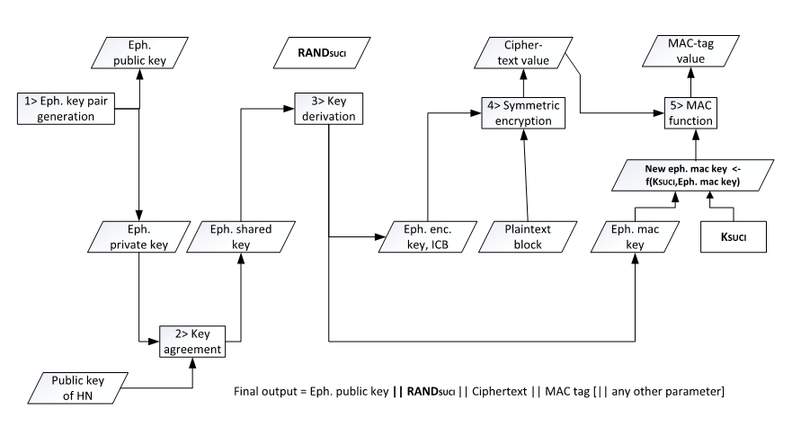
Figure 6.2.X.2-1 SUCI derivation using K_{SUCI}

6.2.X.3 Evaluation
This solution works for calculation of SUCI at both USIM and ME.
This new MAC key cannot be generated by an attacker, unless he would be in possession of the individual long-term key K and its derivative K_{SUCI} of the subscriber. The USIM always performs the computation of the key K_{SUCI}, even in case of SUCI calculation in the ME.Thus, it is assured that only the UE/UICC where the long-term key K is stored can create SUCI, which renders the attack of linkability creating different SUCIs out of a known SUPI.

Editor´s Note: The security risk to derive new key from long term key for any new purposes (example: during KSUCI derivation) different from the ones already specified for AKA procedure needs to be evaluated by ETSI SAGE.

************ END OF CHANGES

