|  |  |
| --- | --- |
| 3GPP TR 23.700-05 V0.1.0 (2022-02) | |
| Technical Report | |
| 3rd Generation Partnership Project;  Technical Specification Group Services and System Aspects;  Study on architecture enhancements for vehicle-mounted relays;  (Release 18) | |
|  | |
|  |  |
|  | |
| The present document has been developed within the 3rd Generation Partnership Project (3GPP TM) and may be further elaborated for the purposes of 3GPP. The present document has not been subject to any approval process by the 3GPPOrganizational Partners and shall not be implemented. This Specification is provided for future development work within 3GPPonly. The Organizational Partners accept no liability for any use of this Specification. Specifications and Reports for implementation of the 3GPP TM system should be obtained via the 3GPP Organizational Partners' Publications Offices. | |

|  |
| --- |
|  |
| ***3GPP***  Postal address  3GPP support office address  650 Route des Lucioles - Sophia Antipolis  Valbonne - FRANCE  Tel.: +33 4 92 94 42 00 Fax: +33 4 93 65 47 16  Internet  http://www.3gpp.org |
| ***Copyright Notification***  No part may be reproduced except as authorized by written permission. The copyright and the foregoing restriction extend to reproduction in all media.  © 2021, 3GPP Organizational Partners (ARIB, ATIS, CCSA, ETSI, TSDSI, TTA, TTC).  All rights reserved.  UMTS™ is a Trade Mark of ETSI registered for the benefit of its members  3GPP™ is a Trade Mark of ETSI registered for the benefit of its Members and of the 3GPP Organizational Partners LTE™ is a Trade Mark of ETSI registered for the benefit of its Members and of the 3GPP Organizational Partners  GSM® and the GSM logo are registered and owned by the GSM Association |

Contents

Foreword 4

1 Scope 6

2 References 6

3 Definitions of terms and abbreviations 6

3.1 Terms 6

3.2 Abbreviations 7

4 Architecture assumptions and requirements 7

4.1 Architecture assumptions 7

4.2 Architecture requirements 7

5 Key Issues 8

5.1 Key Issue #1: Mobile base station relay configuration support in 5GC 8

5.1.1 Description 8

5.2 Key Issue #2: Efficient mobility for UEs connecting to/disconnecting from VMR 8

5.2.1 Description 8

5.3 Key Issue #3: Efficient mobility and service continuity when served by VMR 9

5.3.1 General description 9

5.4 Key Issue #4: Support of roaming of mobile base station relays 10

5.5 Key Issue #5: Support of location services for UEs accessing via a mobile base station relay 10

5.6 Key Issue #6: Provide cell ID/TAC of mobile base station relay for services 10

6 Solutions 11

6.0 Mapping of solutions to key issues 11

6.1 Solution #x: title of the solution 11

6.1.1 General 11

6.1.2 Functional descriptions 11

6.1.3 Procedures 11

6.1.4 Impacts on services, entities, and interfaces 11

7 Evaluation 11

8 Conclusions 11

Annex A (informative): Change history 13

# Foreword

This Technical Report has been produced by the 3rd Generation Partnership Project (3GPP).

The contents of the present document are subject to continuing work within the TSG and may change following formal TSG approval. Should the TSG modify the contents of the present document, it will be re-released by the TSG with an identifying change of release date and an increase in version number as follows:

Version x.y.z

where:

x the first digit:

1 presented to TSG for information;

2 presented to TSG for approval;

3 or greater indicates TSG approved document under change control.

y the second digit is incremented for all changes of substance, i.e. technical enhancements, corrections, updates, etc.

z the third digit is incremented when editorial only changes have been incorporated in the document.

In the present document, modal verbs have the following meanings:

**shall** indicates a mandatory requirement to do something

**shall not** indicates an interdiction (prohibition) to do something

The constructions "shall" and "shall not" are confined to the context of normative provisions, and do not appear in Technical Reports.

The constructions "must" and "must not" are not used as substitutes for "shall" and "shall not". Their use is avoided insofar as possible, and they are not used in a normative context except in a direct citation from an external, referenced, non-3GPP document, or so as to maintain continuity of style when extending or modifying the provisions of such a referenced document.

**should** indicates a recommendation to do something

**should not** indicates a recommendation not to do something

**may** indicates permission to do something

**need not** indicates permission not to do something

The construction "may not" is ambiguous and is not used in normative elements. The unambiguous constructions "might not" or "shall not" are used instead, depending upon the meaning intended.

**can** indicates that something is possible

**cannot** indicates that something is impossible

The constructions "can" and "cannot" are not substitutes for "may" and "need not".

**will** indicates that something is certain or expected to happen as a result of action taken by an agency the behaviour of which is outside the scope of the present document

**will not** indicates that something is certain or expected not to happen as a result of action taken by an agency the behaviour of which is outside the scope of the present document

**might** indicates a likelihood that something will happen as a result of action taken by some agency the behaviour of which is outside the scope of the present document

**might not** indicates a likelihood that something will not happen as a result of action taken by some agency the behaviour of which is outside the scope of the present document

In addition:

**is** (or any other verb in the indicative mood) indicates a statement of fact

**is not** (or any other negative verb in the indicative mood) indicates a statement of fact

The constructions "is" and "is not" do not indicate requirements.

# 1 Scope

The scope of this Technical Report is to study and identify potential architecture and system level enhancements for the 5G system to support the operation of base station relays mounted on vehicles, using NR for wireless access toward the UE and for wireless access through an IAB-donor toward the 5GC, i.e. in this release only IAB type relays are studied i.e., relays based on the IAB architecture and functionalities specified in TS 23.501 [2]. The study addresses the service requirements documented in TS 22.261 [3] for the mobile base station relays, and focuses on the following aspects:

- efficient mobility and service continuity for UE or a group of UEs to efficiently deliver data during different mobility scenarios (including mobility of the mobile base station relays);

- provisioning, policies and mechanisms to e.g. manage relay configuration, geographic restrictions, QoS, authorization and control of UEs' access via the mobile base station relay, etc.;

- support for roaming of mobile base station relay (including the roaming of the IAB-UE and gNB-DUin IAB-node), support for regulatory requirements (e.g. emergency, priority services, public safety), and support for location services for UEs accessing a mobile base station relay.

# 2 References

The following documents contain provisions which, through reference in this text, constitute provisions of the present document.

- References are either specific (identified by date of publication, edition number, version number, etc.) or non‑specific.

- For a specific reference, subsequent revisions do not apply.

- For a non-specific reference, the latest version applies. In the case of a reference to a 3GPP document (including a GSM document), a non-specific reference implicitly refers to the latest version of that document *in the same Release as the present document*.

[1] 3GPP TR 21.905: "Vocabulary for 3GPP Specifications".

[2] 3GPP TS 23.501: “System architecture for the 5G System (5GS); Stage 2”.

[3] 3GPP TS 22.261: "Service requirements for the 5G system; Stage 1".

[4] 3GPP TS 23.273: "5G System (5GS) Location Services (LCS); Stage 2"

# 3 Definitions of terms and abbreviations

## 3.1 Terms

For the purposes of the present document, the terms given in 3GPP TR 21.905 [1] and the following apply. A term defined in the present document takes precedence over the definition of the same term, if any, in 3GPP TR 21.905 [1].

**mobile base station relay:** A mobile base station acts as a relay between a UE and the 5G network, i.e. providing a NR access link to UEs and connected wirelessly (using NR) through a IAB-donor to the 5G Core. Such mobile base station relay is assumed to be mounted on a moving vehicle and serve UEs that can be located inside or outside the vehicle (or entering/leaving the vehicle).

## 3.2 Abbreviations

For the purposes of the present document, the abbreviations given in 3GPP TR 21.905 [1] and the following apply. An abbreviation defined in the present document takes precedence over the definition of the same abbreviation, if any, in 3GPP TR 21.905 [1].

VMR Vehicle Mounted Relay

# 4 Architecture assumptions and requirements

## 4.1 Architecture assumptions

The study should be based on the following architecture assumptions:

- the mobile base station relays uses the IAB architecture as defined in TS 23.501 [2] clause 5.35;

NOTE: Any other alternative of base station relay architecture depends on the RAN study output if any and should be discussed with relevant RAN WGs.

- the mobile base station relay has a single hop to the IAB-donor node;

- the mobile base station relay may serve UEs located inside or outside the vehicle mounted with the relay;

- NR Uu is used for the radio link between a mobile base station relay and served UEs, and between mobile base station relay and IAB-donor node. However, optimization solutions can also consider combining other functionalities, e.g. using PC5 for discovery and mobility assistance/control amongst relays;

- LCS framework as defined in TS 23.273 [4] is used for providing the location service to the served UEs;

- the mobile base station may connect to an IAB-donor node of a PLMN or an SNPN.

## 4.2 Architecture requirements

Solutions of the study should provide architecture and system level enhancements to the 5G system to support the operation of base station relays to satisfy the normative requirements in TS 22.261 [3]. Specifically, the enhanced system needs to:

- support legacy UE(s) to connect via base station relays, but can consider optimizations involving UE changes;

- support end-to-end service continuity, in the presence of mobile base station relays, including when the mobile base station relays change the IAB-donor nodes;

- support the mobile network operator to configure, provision and control the operation of a mobile base station relay;

NOTE: Charging support will be coordinated with SA5, and if needed later handled as alignment work in SA2.

- support of regulatory requirements (e.g. for support of emergency services, priority services) when UEs access 5GS via a mobile base station relay;

- support roaming of the mobile base station relay from its HPLMN into a VPLMN.

# 5 Key Issues

## 5.1 Key Issue #1: Mobile base station relay configuration support in 5GC

### 5.1.1 Description

Mobile base station relays may attach or detach to a mobile network depending on its location and movement. When a mobile base station relay just attaches to the network, it may lack the authorization policy and configuration data to serve as a mobile relay. Therefore dynamic provisioning mechanism is needed to configure the mobile base station relay in such cases.

This key issue should investigate the enhancements needed in 5GC for the configuration of the mobile base station relay to be operational and for the access management of the mobile based station relay.

The following aspects shall be studied:

* What authorization policies and configuration data are needed for the mobile base station relay's operation.
* Whether and what is needed in 5GC to support the configuration of a mobile base station relay, besides the existing configuration methods for IAB-node.
* Whether and what is needed in 5GC for managing mobile base station relay’s access to 5GS, besides the existing IAB-UE management.

NOTE: Aspects of RAN specific configuration need to be coordinated with RAN WGs.

## 5.2 Key Issue #2: Efficient mobility for UEs connecting to/disconnecting from VMR

### 5.2.1 Description

During the mobility of the mobile base station relay, a UE or a group of UEs served by the mobile base station relay will move together with the mobile base station relay, and when the mobile base station relay is, e.g., out of service area, or out of service time, the group of UEs will be served by macro base station or another mobile base station relay nearby.

In addition, when a UE is connected to a macro base station and the vehicle is moving to an area in the vicinity of the UE, the surrounding UEs (i.e. outside the vehicle) may profit of a better communication link through the mobile base station relay requiring efficient mobility from the macro base station to the mobile base station relay and back to the macro base station.

Hence, following aspects need to be studied for UEs moving to/from mobile base station relay:

- How to support efficient mobility for a UE or a group of UEs between mobile base station relays.

- How to support efficient mobility for a UE or a group of UEs between mobile base station relay and macro base stations.

NOTE: This KI has RAN dependency and should align with the progress of RAN WGs.

## 5.3 Key Issue #3: Efficient mobility and service continuity when served by VMR

### 5.3.1 General description

When the moving vehicles are equipped with mobile base station relays, the mobile base station relays can provide 5G coverage and communication to UEs (inside the vehicle and/or in its vicinity), and connected wirelessly to the 5G network via RAN (donor) nodes. When one or a group of UEs are already served by the mobile base station relay, there are two mobility scenarios to be studied as the following:

* Scenario A (mobility within the same donor): When the UEs are continuously served by a mobile base station relay (e.g. inside the vehicle and/or in its vicinity), this mobile base station relay within the vehicle is moving around within a limited geographical area while keeping connecting with the same donor RAN node. In this case, the UE keeps the connection with the same mobile base station relay (i.e. IAB node), and there is no change of the donor RAN node.
* Scenario B (mobility between different donors): When the UEs are continuously served by a mobile base station relay (e.g. inside the vehicle and/or in its vicinity), this mobile base station relay within the vehicle is moving around over a long distance. The mobile base station relay node connects with a different donor RAN node if the vehicle keeps moving. In this case, the UE keeps the connection with the same mobile base station relay (i.e. IAB node), but there is change of the donor RAN node.

NOTE 1: For the above scenarios, whether the cell information in the System Information Broadcast (e.g. Cell ID, TAC) changes has RAN dependency.

NOTE 2: For the above scenarios, whether UE needs to perform the legacy handover procedures has RAN dependency.

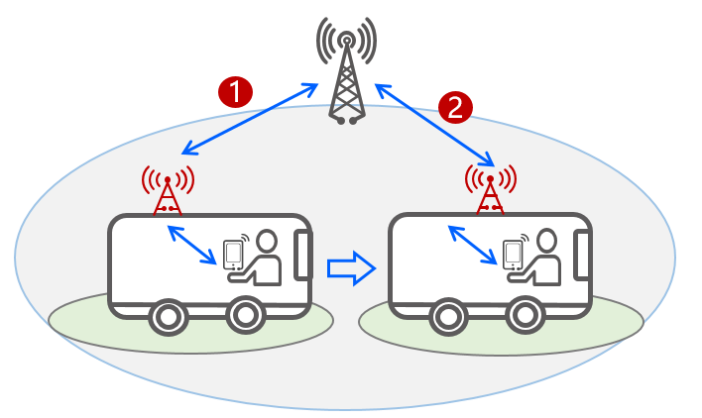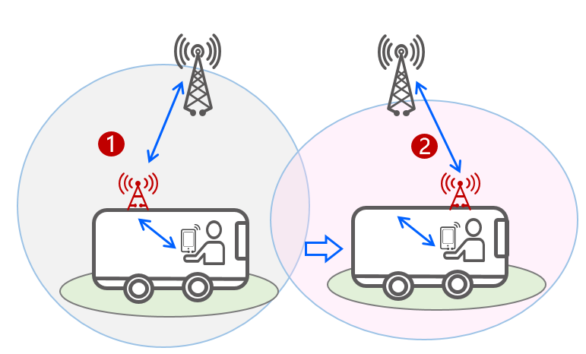

1) Scenario A 2) Scenario B

**Figure 5.3.1-1: Scenarios for efficient mobility and service continuity**

The following aspects need to be studied for UEs served by the mobile base station relay in the case of mobility within the same donor RAN node and mobility between different donors RAN node:

- Whether and how to enhance current procedures of mobility and service continuity for a UE or a group of UEs, to efficiently deliver the data. Following aspects need to be considered in potential solutions:

- If the TAC in the System Information Broadcast changes, whether and how to enhance the NAS mobility procedure.

- If the handover is needed due to cell changes, whether and how to enhance the mobility for group UEs (e.g., during handover).

NOTE 3: Mechanisms related to mobility management and service continuity have RAN dependency and should align with the progress of RAN WGs.

## 5.4 Key Issue #4: Support of roaming of mobile base station relays

Based on the requirements of TS 22.261 [3], the 5G system shall support the mobile base station relay having a subscription with a HPLMN and roaming from its HPLMN into a VPLMN.

When using the IAB architecture, a mobile base station relay consists of a gNB-DU and an IAB-UE, as defined in TS 23.501 [2] clause 5.35. For roaming, the IAB-UE behaves as a UE, and thus may be able to access a VPLMN reusing UE procedures. However, in order to support the gNB-DU component of the mobile base station to operate properly in the VPLMN, additional support may need to be defined. This key issue addresses the following aspects of the mobile base station relay when it connects to a VPLMN:

- Study the PLMN (i.e., HPLMN or VPLMN) to be presented to UE by mobile base station relay in case of roaming. And how to support access and communication from/to UEs via mobile base station relays.

- Whether and how to support the controlling of a mobile base station relay, e.g., enable/disable mobile relay operation if the relay is roaming in a VPLMN.

NOTE: coordination between the RAN WGs and SA2 is needed.

## 5.5 Key Issue #5: Support of location services for UEs accessing via a mobile base station relay

Based on the requirements of TS 22.261 [3], the 5G system shall be able to support location services for the UEs accessing 5GS via a mobile base station relay. However, when the mobile base station relay is present, the location of the cell/IAB-node serving the UEs may change, and this may affect not only positioning procedures but also regulatory services needs UE location. Therefore, this key issue needs to address:

- how to support location services for the UEs served by a mobile base station relay that moves (with or without changing IAB-donor nodes); or roams to VPLMN;

NOTE : For this key issue, this study should not seek to change the LCS framework, and the coordination with the study on FS_eLCS_PH3 may be needed.

## 5.6 Key Issue #6: Provide cell ID/TAC of mobile base station relay for services

When the mobile base station relay is present, the physical location of the cell/IAB-node serving the UEs may change even without changing its IAB-donor node. Therefore, the serving cell ID/TAC of the UE may not always accurately reflect the location of the UE. This may affect services, e.g. regulatory services, tariff notifications, and etc., that rely on cell ID/TAC as location reference. Therefore, this key issue needs to address:

- How to provide appropriate cell ID/TACs information (and possible its corresponding geographic area) of mobile base station relay that moves when such cell ID/TACs are needed, e.g. to assist route an emergency call to the correct PSAP, to assist to handle Lawful Interception, to assist the Public Warning System, and etc.

NOTE 1: For mobile base station relay that moves, whether its cell information in the System Information Broadcast (e.g. Cell ID, TAC) changes or not due to its movement has RAN dependency.

NOTE 2: For mobile base station relay that moves, even the cell information in the System Information Broadcast (e.g. Cell ID, TAC) does not change, it may represents different geographic area due to the movement.

# 6 Solutions

## 6.0 Mapping of solutions to key issues

Editor's note: This clause describes the mapping between solutions and key issues.

|  |  |  |  |  |
| --- | --- | --- | --- | --- |
|  | Key Issues | | | |
| Solutions |  |  |  |  |
|  |  |  |  |  |
|  |  |  |  |  |
|  |  |  |  |  |
|  |  |  |  |  |
|  |  |  |  |  |

## 6.1 Solution #x: title of the solution

Editor's note: This clause describes a solution addressing one or more key issues identified in clause 5. The structure of the subclauses can be adjusted.

### 6.1.1 General

### 6.1.2 Functional descriptions

### 6.1.3 Procedures

### 6.1.4 Impacts on services, entities, and interfaces

# 7 Evaluation

Editor's note: This clause provides the evaluations of the solutions of clause 6.

# 8 Conclusions

Editor's note: This clause provides the conclusions for the study.

## 

Annex A (informative):  
Change history

|  |  |  |  |  |  |  |  |
| --- | --- | --- | --- | --- | --- | --- | --- |
| **Change history** | | | | | | | |
| **Date** | **Meeting** | **TDoc** | **CR** | **Rev** | **Cat** | **Subject/Comment** | **New version** |
| 2022-02 | SA2#149e | S2-2201574 | - | - | - | TR skeleton | 0.0.0 |
| 2022-02 | SA2#149e | S2-2201575 | - | - | - | Scope for FS_VMR | 0.1.0 |
| S2-2201576 | - | - | - | Architecture assumptions and requirements for FS_VMR |
| S2-2201577 | - | - | - | Key issue on "Mobile base station relay configuration support in 5GC" |
| S2-2201579 | - | - | - | Key issue on "Efficient mobility for UEs connecting to/disconnecting from VMR" |
| S2-2201580 | - | - | - | Key issue on "Efficient mobility and service continuity when served by VMR" |
| S2-2201581 | - | - | - | Key issue on "Support of roaming of mobile base station relays" |
| S2-2201582 | - | - | - | Key issue on "Support of location services for UEs accessing via a mobile base station relay" and "Provide cell ID/TAC of mobile base station relay for services" |
|  |  |  |  |  |  |  |  |
|  |  |  |  |  |  |  |  |