SA WG2 Meeting #140e(e-meeting) S2-2005586
Elbonia, August 19 – September 01, 2020 (XXXXXX)

Source: Alibaba Group
Title: Solution for the KI#3: Edge NEF based Network Information Provisioning
Document for: Approval
Agenda Item: 8.3
Work Item / Release: FS_enh_EC / Rel-17
Abstract: This contribution introduces a solution for addressing the KI#3 on the Efficient Network Information Provisioning to Local Applications.

1. Discussion
Edge NEF is an effective way to solve the issue of efficient network information provisioning to local applications in the edge environment. It can be deployed at the edge for reducing the latency of network information provisioning. However, the relationship between central NEF and edge NEF is not clearly described. Serveral issues illustrated below has to be addressed:
- How to insert/remove edge NEF with the support of the central NEF?
- How to notify the existance of edge NEF to the NF within the 5GC?
- How to authorize the edge NEF to obtain the network information for certain AF with the support of the central NEF?
In order to shorten the path between NF(e.g. SMF) which can provide the network information and the AF, the edge NEF can be deployed either within the Operator domain but near the edge (e.g. near or within the UPF) or within the domain of ECSP. No matter where the edge NEF locates, the Operator has the full control over the edge NEF. The insertion of edge NEF should be awared by the NF within the 5GC so that the NF can send the network information directly to the edge NEF. Since the edge server belonging to different ECSP may be deployed within a same edge area. The edge NEF need to know which edge server needs to be provisioned. In addition, different edge server may require service from edge NEF regarding different type of network information. The differentiation of network information provisioning also needs to be implemented.
In order to solve the aforementioned issue, this contribution proposes a solution for the management of edge NEF.

2. Text Proposal
It is proposed to capture the following changes in TR 23.748.

* * * * Start of the change (all new texts) * * * *

6.XX Solution #XX: Edge NEF based Network Information Provisioning
This solution is for Key Issue #3 on Efficient Network Information Provisioning to Local Applications.

6.XX.1 Description
Edge NEF is an effective way to solve the issue of efficient network information provisioning to local applications in the edge environment. It can be deployed at the edge for reducing the latency of network information provisioning. However, the relationship between central NEF and edge NEF is not clearly described. Serveral issues illustrated below has to be addressed:
- How to insert/remove edge NEF with the support of the central NEF?
- How to notify the existance of edge NEF to the NF within the 5GC?
- How to authorize the edge NEF to obtain the network information for certain AF with the support of the central NEF?
In order to shorten the path between NF(e.g. SMF) which can provide the network information and the AF, the edge NEF can be deployed either within the Operator domain but near the edge (e.g. near or within the UPF) or within the domain of ECSP. No matter where the edge NEF locates, the Operator has the full control over the edge NEF. The insertion of edge NEF should be awared by the NF within the 5GC so that the NF can send the network information directly to the edge NEF. Since the edge server belonging to different ECSP may be deployed within a same edge area. The edge NEF need to know which edge server needs to be provisioned. In addition, different edge server may require service from edge NEF regarding different type of network information. The differentiation of network information provisioning also needs to be implemented.
In order to solve the aforementioned issue, this contribution proposes a solution for the management of edge NEF.

6.XX.2 Procedures

6.XX.2.1 Edge NEF-based Network Information Provisioning
Figure 6.XX.2.1-1 illustrates the procedure for edge NEF-based network information provisioning. The central NEF can have the functionality of the configuration of edge NEF and the authorization of certain network information provisioning type data which can be directly delivered to the edge NEF.
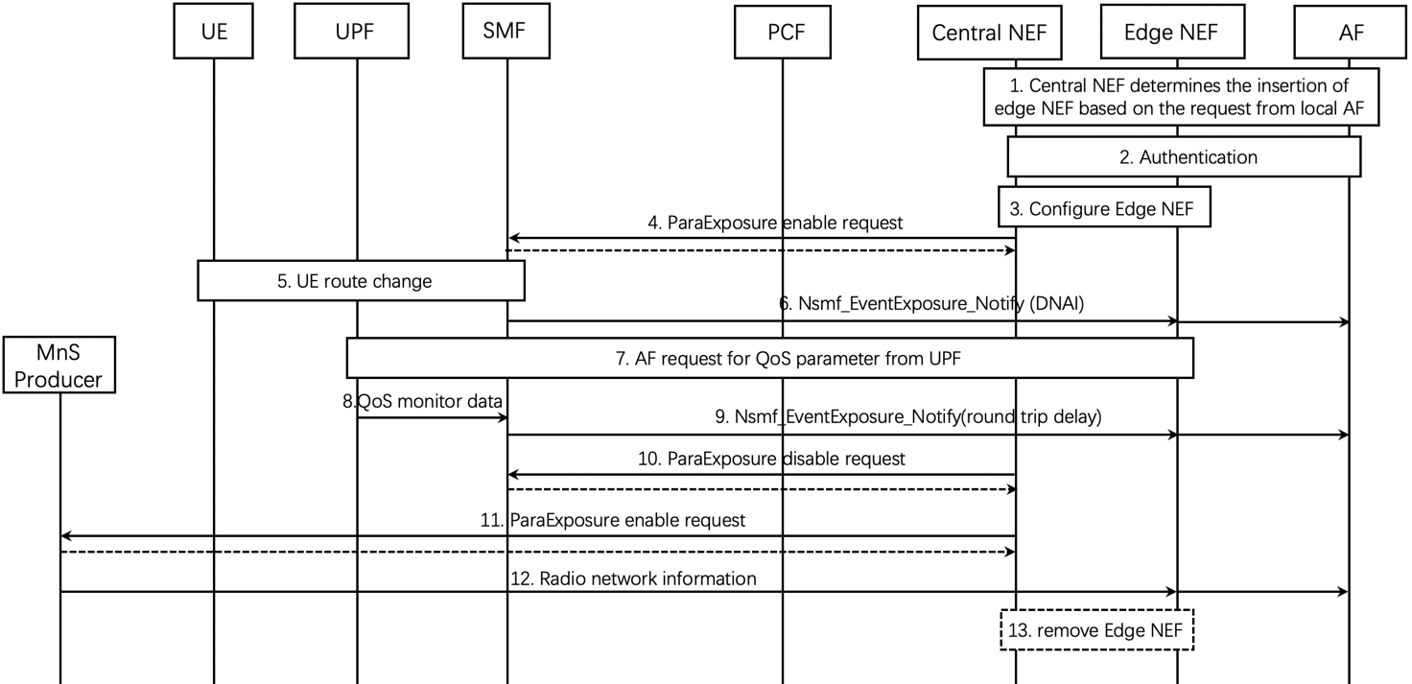
Figure 6.XX.2.1-1: Edge NEF based Network Information Provisioning
- Upon the request of a local AF (using e.g. the DNAI), the Central NEF determines whether to insert an edge NEF. Alternatively, the Central NEF sends notification regarding the insertion of edge NEF to the local AF. Local AF can decide whether to use the edge NEF via sending a response to the Central NEF.
2. The edge NEF can be inserted either within the MNO domain (e.g. near the UPF) or within the 3rd party domain. If inserted in the 3rd party domain, the Central NEF needs to conduct authentication with the AF before the insertion. The edge NEF is always owned/operated by the Operator.
3. The Central NEF configures the edge NEF either within the MNO domain or within the 3rd party domain.
4. The Central NEF send parameterExposure enable request (e.g. Nsmf_EventExposure_Subscribe through UDM) to SMF. The request information contains edge NEF ID, AF ID and Network information provisioning type, for example, UE route change information, etc.
NOTE: To support the SMF send network information directly to edge NEF, it is required that SMF is deployed near the edge area.
5. SMF conducts route change for the UE by modifying the UPF.
6. SMF sends Nsmf_EventExposure_notify including DNAI and N6 routing information to the edge NEF. Upon the receipt of the message, the edge NEF forwards the information to the corresponding AF using Nnef_EventExposure_Notify.
7. AF requests for QoS related parameter from the 5GC. This triggers QoS monitoring for specific UE per R16 specifications.
8. UPF sends QoS-related data (e.g. round-trip delay) to the SMF via the N4 report message.
9. SMF sends Nsmf_EventExposure_Notify including the QoS-related data to the edge NEF. Upon the receipt of the message, the edge NEF forwards the information to the corresponding AF using Nnef_EventExposure_Notify.
10. The central NEF can optionally sends parameterExposure disable request (e.g. Nsmf_EventExposure_Unsubscribe through UDM) to SMF. After receiving this message, the SMF will send event exposure related message to the Central NEF.
11. The Central NEF sends parameterExposure enable request to MnS producer. The request information contains edge NEF ID, AF ID and Network information provisioning type, for example, radio network information.
12. The MnS producer send the radio network information to the edge NEF following certain radio network information exposure policy.
NOTE: The MnS server discover may need certain OAM configuration information.
13. The central NEF can remove the edge NEF.

6.39.3 Impacts on services, entities and interfaces
Central NEF:
- manages the edge NEF (i.e. insertion and removal of edge NEF)
- sends message to NF (i.e. SMF) in order to notify the NF to send network related information directly to the edge NEF
- Notify the local AF regarding the information of inserted edge NEF

* * * * end of change * * * *

