Vienna, November 7th 2000

Ladies and Gentlemen,

On behalf of SIEMENS AG Austria it is my pleasure to invite you to the

3GPP_TSG_SA_WG1 VHE ad-hoc meeting

The meeting will be hosted by SIEMENS AG and held in

Vienna, AUSTRIA
December 7th and 8th , 2000

Time:
The meeting will start at December 7th 10:00 h and finish not later than 16:00 h December 8th

Venue:
Dec. 7th : Siemens premises: Siemens Aktiengesellschaft Österreich
Autokaderstraße 29, A-1210 Vienna, Object 1, Room E03
Dec. 8th : Due to that Dec. 8th is a holiday in Austria the meeting will continue on this day in a hotel in the city centre (will be specified soon).

Find attached a list of hotels with good public transport connections to the meeting venues. To book, please call directly the Hotel of your choice.

Please complete the attached registration form and send it to:
Mrs. Andrea Handler
E-mail: andrea.handler@siemens.at
Phone: +43.1.1707.21529
Fax: +43.1.1707.51924
by November 30th at the latest.

Please note that it will be a paperless meeting. Bring diskette readers for your notebooks.

Kind regards,

Jörg Swetina
Mobile Network Solutions,
SIEMENS AG.

P.S. Vienna is quite lovely before Christmas. You might want to spend the weekend here too !
Travel information:
The following Hotels near station 'Wien Mitte' are recommended and have good public transport connections to the meeting venue.

Hotel Renaissance Penta ****  Ungargasse 60  A-1030 Vienna  Phone: +43 1 71175-0 Fax: +43 1 71175-8145  E-Mail: rhi.viese.sales@renaissancehotels.com  Internet http://www.renaissancehotels.com/viese  close to S3 station ‘Wien Mitte – City Air Terminal’ | Starlight Suiten Hotel ****  Am Heumarkt 15  A-1030 Vienna  Phone: +43 1 7107808-0 Fax: +43 1 7107808-11  E-Mai: reservations@starlighthotel.co.at  Internet: http://www.starlighthotels.com  close to S3 station ‘Wien Mitte – City Air Terminal’
Hotel Dorint Biedermeier ****  Landstrasser Hauptstrasse 28  A-1030 Vienna  Phone: +43 1 71671-507 Fax: +43 1 71671-503  E-mail: hotel.vienna@dorint.rogner.com  Internet: http://www.dorint.de/wien  close to S3 station ‘Wien Mitte – City Air Terminal’ | Hotel Hilton Vienna *****  Am Stadtpark  A-1030 Vienna  Phone: +43 1 71700-0 Fax: +43 1 7130691  E-Mail: rm_vienna@hilton.com  Internet: http://www.telecom.at/ViennaHilton  right at the S3 station ‘Wien Mitte - City Air Terminal’

Please ask for SIEMENS company rates. These are around ATS 1.400.- to 1.600.- including breakfast. For additional information on Hotels in Vienna see: http://info.wien.at/index_e.html

How to get from airport to the Siemens premises:
- By ShuttleBus and Train:
There is a ShuttleBus and Train Service from the airport to the station ‘Wien Mitte - City Air Terminal’. The ShuttleBus operates at an interval of 20 Minutes.
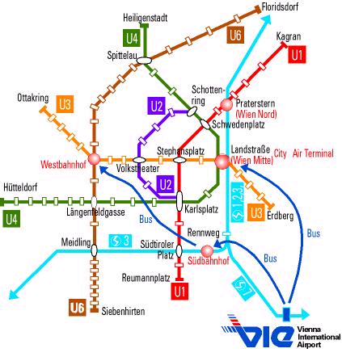

We recommend to take the ShuttleBus Service to ‘Wien Mitte – City Air Terminal’, which is quite comfortable and moderate in price - ATS 70,- (oneway) or ATS 130,- (roundtrip). From ‘Wien Mitte’ take the train S3 in the direction of ‘Floridsdorf’/‘Stockerau’ and leave the train at ‘Strebersdorf’.
S3 leaves ‘Wien Mitte’ 2 minutes before every full and half hour during the day. The train takes about ½ hour to arrive at ‘Strebersdorf’, then 5 minutes walk to the Siemens premises.

To get to the Siemens premises follow the arrow on the map below:
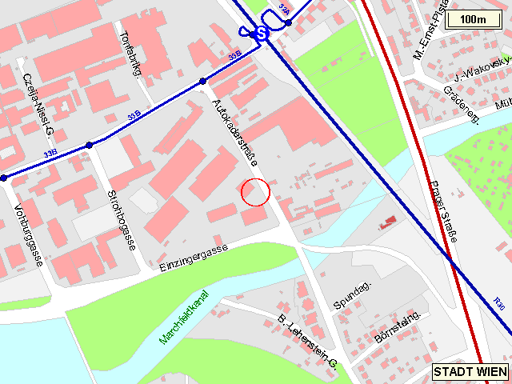
SIEMENS
S3
Strebersdorf

- By taxi:
We recommend the taxis that are those provided by the airport service. They are called "Jetbus-Taxi" and you will find their desk when you exit the luggage collection hall on the right hand side of the sliding doors. Tel. Nr.: +43 1 7007 38778

The following link provides additional information and more details on transport services in Vienna.
http://english.viennaairport.com/

If you have any questions or needs concerning the co-ordination of the meeting, please feel free to contact

Jörg Swetina | or | Ms. Andrea Handler
SIEMENS AG |  | SIEMENS AG
Autokaderstraße 29 |  | Autokaderstraße 29
1210 Wien |  | 1210 Wien
Austria |  | Austria
Tel.: +43 676 4912429 |  | Tel: +43 5 1707 21529
Fax: +43 5 1707 51924 |  | Fax: +43 5 1707 51924
E-mail: joerg.swetina@siemens.at |  | E-mail: andrea.handler@siemens.at

We are looking forward to see you in Vienna !
REGISTRATION FORM

For the 3GPP TSG SA WG1 VHE ad-hoc
December 7th and 8th 2000
Vienna, Austria
Please fill in this form and return it by November 30th 2000 to: | Mrs. Andrea Handler  E-mail: andrea.handler@siemens.at  or  Fax: +43.5.1707.51924

Title: | Ms Mrs. Mr. Dr.
Family name: | _____
First name: | _____
Postal address: | _____
Telephone: | _____
Fax: | _____
E-mail: | _____
Date and time of arrival: | _____
Date and time of departure: | _____
I will attend:
I am unable to attend on this occasion:

Status of Member Represented (tick one box in one column 1, 2 or 3):

1) Organizational Partner Representative (SDO)  (tick one box below) | 2) Individual Member Representative  (tick one box below) | 3) Market Representation Partner Representative  (tick one box below)
Representing Partner:  ARIB | Representing Partner:  ARIB | Representing Partner:  UMTS Forum
ETSI | ETSI | GSA
T1 | T1
TTA | TTA
TTC | TTC
Other: _____ | Other: _____ | Other: _____
Individual Member organization* Name:
_____
I am the voting representative for this Individual Member.

* For a list of Individual Member organizations, see: HREF="http://www.3gpp.org/Individual_Member.htm

