**3GPP TSG-SA WG1 Meeting #99e draftS1-222048r2**

**Electronic Meeting, 22 Aug – 1 Sep 2022** *(revision of S1-22xxxx)*

**Source: China Unicom, vivo, Charter Communications**

**pCR Title: Pseudo-CR on use case of mobility scenarios and Requirements**

**Draft Spec: 3GPP TR 22.851v0.0.0**

**Agenda item: 7.5**

**Document for: Approval**

**Contact: Tianqi Xing <xingtq@chinaunicom.cn>, Yanchao Kang <kangyanchao@vivo.com>**

*Abstract: introduce the mobility scenarios and potential requirements for the non-N2 shared network in TR22.851.*

**1. Introduction**

Study FS_Netshare aims to study use cases and potential requirements for the non-N2 shared network.

**2. Reason for Change**

Update the “Use Cases” section 5 of the TR 22.851V0.1.0.

This use case was provided in the last meeting, but not captured in the TR.

It is proposed to add new service flows and define new requirements. Mobility scenarios and potential requirements needs to be discussed and agreed for the indirect connection shared network.

**3. Conclusions**

none

**4. Proposal**

It is proposed to agree the following changes to 3GPP TR 22.851.

* * * First Change * * * *

# 2 References

The following documents contain provisions which, through reference in this text, constitute provisions of the present document.

* References are either specific (identified by date of publication, edition number, version number, etc.) or non‑specific.
* For a specific reference, subsequent revisions do not apply.
* For a non-specific reference, the latest version applies. In the case of a reference to a 3GPP document (including a GSM document), a non-specific reference implicitly refers to the latest version of that document *in the same Release as the present document*.

[1] 3GPP TR 21.905: "Vocabulary for 3GPP Specifications".

[x1] 3GPP TS 22.101: "Service principles".

[x2] 3GPP TS 23.122: "Non-Access-Stratum (NAS) functions related to Mobile Station (MS) in idle mode".

[x3] 3GPP TS 22.261: "Service requirements for the 5G system".

* * * Next Change * * * *

# 5 Use cases

## 5.A use case of mobility scenarios and Requirements

### 5.A.1 Description

It is worth mentioning that 5G networks have been designed to be able to provide shared facilities from the beginning. This means that in the case that the 4G network has both non-shared and shared E-UTRAN at the same time, there could be a number of different type of coverage in the same region:

- Non-shared E-UTRA coverage,

- Shared E-UTRA coverage,

- Non-shared 5G NR coverage,

- Shared 5G NR coverage.

This study introduces a new sharing method arises as without direct connection between shared NG-RAN and the core network of participating operators. Therefore, interoperability regarding mobility management needs to be considered when introducing the potential requirements of this new sharing method with existing network.

### 5.A.2 Pre-conditions

This use case will discuss how a UE with a subscription from OP2 can move between OP2’s own 4G or 5G access networks and either OP1’s or OP3’s shared 5G networks (described in scenario 1) as well how the UE from OP2 can move between OP1’s and OP3’s shared 5G networks (described in scenario 2).

1. It is assumed that OP1, OP2 and OP3’s has deployed 4G and 5G networks.

NOTE: The home 4G and 5G network of OP1, OP2 and OP3 may be deployed with non-shared and shared wireless access technology.

- Both OP1 and OP3 are Hosting RAN Operators, which shared NG-RAN with Participating OP2.

- UE subscribe to OP2’s home PLMN.

- UEs may register successfully to OP1 and OP3’s shared 5G network.

2. Both operators (i.e., OP1 and OP3) agreed to share their networks via indirect connection between the shared radio access network and the OP2’s core network.

3. Potential scenario1: The coverage of OP1 and OP3’s shared 5G network may overlap with OP2’s 4G network; may also overlap with OP2’s 5G network (i.e. at OP1 and OP2’s border, at OP3 and OP2’s border).

4. Potential scenario2: The coverage of OP1’s shared 5G network may overlap with OP3’s shared 5G network (i.e., at OP1’s and OP3’s border).

5. According to the mutual agreement of the sharing parties, UE access with one of the wireless technology, e.g. UE may access to shared 5G network, when the coverage of OP1’s shared 5G network may overlap with OP2’s 4G network.

### 5.A.3 Service Flows

Mobility scenarios are shown in the following pictures of shared network, including:

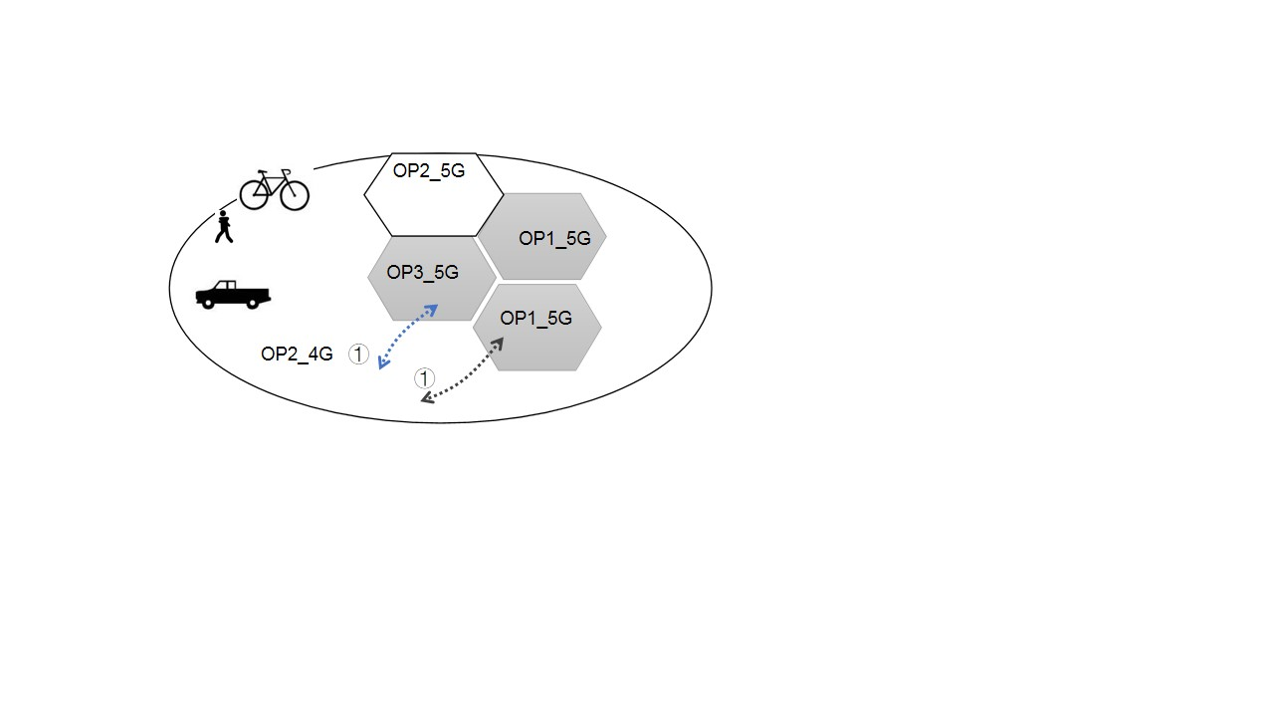

Figure 5. A.3-1a: : Scenario 1, a UE with a subscription from OP2 makes a handover between OP2’s own 4G access networks and either OP1’s or OP3’s shared 5G networks.

NOTE 1: OP1_5G/OP3_5G are OP1/OP3’s shared 5G network via indirect connection between the shared radio access network and the OP2’s core network.

NOTE 2: OP2_5G/OP2_4G is OP2’s network, may be MOCN networks or non-shared network.

1. The mobility management needs to be supported when UE crosses the border between the shared network managed by Hosting operator and the OP2’s own 4G access networks in the scenario 1 (As shown as ① in figure 5. A.3-1a).

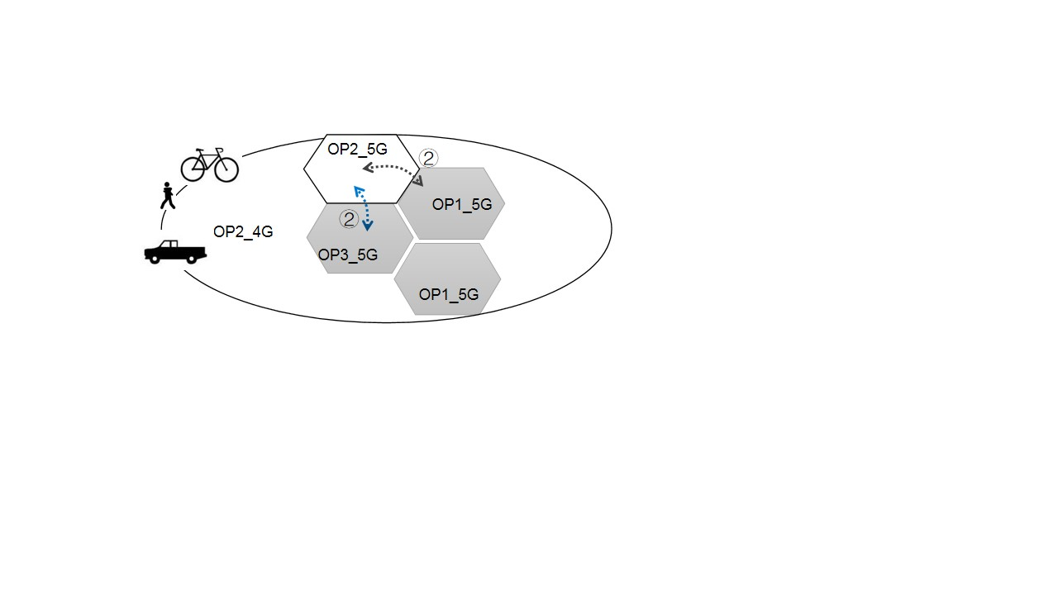

Figure 5. A.3-1b: Scenario 1, a UE with a subscription from OP2 moves between OP2’s own 5G access networks and either OP1’s or OP3’s shared 5G networks.

2. The mobility management needs to be supported when UE crosses the border between the shared network managed by Hosting operator and the OP2’s own 5G access networks in the scenario 1 (As shown as ② in figure 5. A.3-1b).

3. When the UE moves to the area of OP3_5G, As shown as ② in figure 5. A.3-1b, which has more than one operator's wireless access technologies simultaneously supported, including 5G NR of OP3_5G and E-UTRA of OP2_4G, UE accesses one of them.

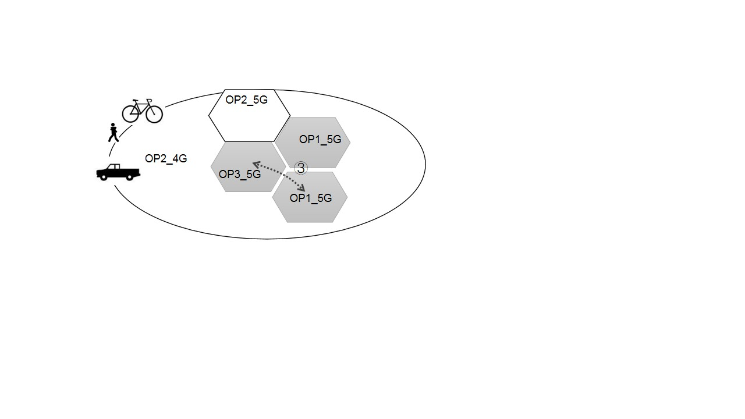

Figure 5. A.3-2: Scenatio 2, a UE with a subscription from OP2 moves between coverage of OP1’s and OP3’s shared 5G access networks

4. And the mobility management needs to be supported when UE crosses the border between the two shared networks managed by different Hosting operators in the scenario 2 (As shown as ③ in figure 5. A.3-2).

5. If the UE moves to the shared network of OP3_5G, then the network of OP2 may need to be aware of the area which is within the sharing agreement with OP3, rather than OP1_5G, although both OP1/OP3’s shared 5G network with OP2 via indirect connection between the shared radio access network and the OP2’s core network, or other non-shared area of OP3.

6. If OP1 and OP2 release the sharing agreement, the UE no longer accesses the network of OP1_5G when moving into it.

### 5.A.4 Post-conditions

All forms of mobility (i.e. between participating operators RAN and shared RAN for both CONNECTED mode and IDLE mode UE, see clause 3.1 of TS 23.122 [x2]) successfully processed in a sharing scenario without direct connections between the shared access and the core networks of the participating operator.

### 5.A.5 Existing feature partly or fully covering use case functionality

SA1 has performed various studies on mobility and network sharing in previous releases, where related normative stage 1 requirements are introduced in 3GPP TS 22.101 [x1] and 22.261[x3].

3GPP TS 22.261 [x3] introduces requirements of Diverse mobility management, stated as follows:

*The 5G system shall support inter- and/or intra- access technology mobility procedures within 5GS with minimum impact to the user experience (e.g. QoS, QoE).*

3GPP TS 22.261 [x3] describes various access related requirements, stated as follows:

*Based on operator policy, the 5G system shall support steering a UE to select certain 3GPP access network(s).*

3GPP TS 22.101 [x1] introduces requirements of mobility of network sharing, stated as follows:

*It shall be possible to support different mobility management rules, service capabilities and access rights as a function of the home PLMN of the subscribers.*

The above requriements are based on MOCN.

### 5.A.6 Potential New Requirements needed to support the use case

[PR 5.A.6-001] Mobility management shall be supported if a user crosses the border between the shared network managed by a Hosting operator and a Participating Operator.

[PR 5.A.6-002] Mobility management shall be supported if a user crosses the border between the two shared network managed by different Hosting operators.

[PR 5.A.6-003] 5G system shall support steering a UE to select certain shared network to access 5G network(s) when UE moves to network sharing area based on operator policy.

[PR 5.A.6-004] Subject to the network sharing agreement, 3GPP system shall be able to select the access technology if different 3GPP access technologies (e.g., NR or E-UTRA) co-exist in the network sharing area.

[PR 5.A.6-005] The 5G system shall support means for an operator to be aware of the area where the network sharing is applied with a certain sharing method.