|  |  |
| --- | --- |
| 3GPP TR 22.837 V0.1.0 (2022-05) | |
| Technical Report | |
| 3rd Generation Partnership Project;  Technical Specification Group TSG SA;  Feasibility Study on Integrated Sensing and Communication  (Release 19) | |
|  | |
|  |  |
| The present document has been developed within the 3rd Generation Partnership Project (3GPP TM) and may be further elaborated for the purposes of 3GPP. The present document has not been subject to any approval process by the 3GPPOrganizational Partners and shall not be implemented. This Specification is provided for future development work within 3GPPonly. The Organizational Partners accept no liability for any use of this Specification. Specifications and Reports for implementation of the 3GPP TM system should be obtained via the 3GPP Organizational Partners' Publications Offices. | |

|  |
| --- |
|  |
| ***3GPP***  Postal address  3GPP support office address  650 Route des Lucioles - Sophia Antipolis  Valbonne - FRANCE  Tel.: +33 4 92 94 42 00 Fax: +33 4 93 65 47 16  Internet  http://www.3gpp.org |
| ***Copyright Notification***  No part may be reproduced except as authorized by written permission. The copyright and the foregoing restriction extend to reproduction in all media.  © 2022, 3GPP Organizational Partners (ARIB, ATIS, CCSA, ETSI, TSDSI, TTA, TTC).  All rights reserved.  UMTS™ is a Trade Mark of ETSI registered for the benefit of its members  3GPP™ is a Trade Mark of ETSI registered for the benefit of its Members and of the 3GPP Organizational Partners LTE™ is a Trade Mark of ETSI registered for the benefit of its Members and of the 3GPP Organizational Partners  GSM® and the GSM logo are registered and owned by the GSM Association |

Contents

Foreword 6

Introduction 7

1 Scope 8

2 References 8

3 Definitions of terms, symbols and abbreviations 10

3.1 Terms 10

3.2 Symbols 10

3.3 Abbreviations 11

4 Overview 11

5 Use cases 11

5.1 Use case of intruder detection in smart home 11

5.1.1 Description 11

5.1.2 Pre-conditions 11

5.1.3 Service Flows 12

5.1.4 Post-conditions 12

5.1.5 Existing features partly or fully covering the use case functionality 12

5.1.6 Potential New Requirements needed to support the use case 12

5.2 Use case on pedestrian/animal intrusion detection on a highway 13

5.2.1 Description 13

5.2.2 Pre-conditions 14

5.2.3 Service Flows 14

5.2.4 Post-conditions 15

5.2.5 Existing features partly or fully covering the use case functionality 15

5.2.6 Potential New Requirements needed to support the use case 15

5.3 Use case on rainfall monitoring 16

5.3.1 Description 16

5.3.2 Pre-conditions 16

5.3.3 Service Flows 17

5.3.4 Post-conditions 17

5.3.5 Existing feature partly or fully covering use case functionality 17

5.3.6 Potential New Requirements needed to support the use case 17

5.4 Use Case on Transparent Sensing Use Case 18

5.4.1 Description 18

5.4.2 Pre-conditions 18

5.4.3 Service Flows 19

5.4.4 Post-conditions 19

5.4.5 Existing feature partly or fully covering use case functionality 19

5.4.6 Potential New Requirements needed to support the use case 19

5.5 Use case on sensing for flooding in smart cities 20

5.5.1 Description 20

5.5.2 Pre-conditions 20

5.5.3 Service Flows 20

5.5.4 Post-conditions 21

5.5.5 Existing features partly or fully covering the use case functionality 21

5.5.6 Potential New Requirements needed to support the use case 21

5.6 Use case on intruder detection in surroundings of smart home 21

5.6.1 Description 21

5.6.2 Pre-conditions 21

5.6.3 Service Flows 21

5.6.4 Post-conditions 22

5.6.5 Existing features partly or fully covering the use case functionality 22

5.6.6 Potential New Requirements needed to support the use case 22

5.7 Use case on sensing for railway intrusion detection 22

5.7.1 Description 22

5.7.2 Pre-conditions 23

5.7.3 Service Flows 24

5.7.4 Post-conditions 25

5.7.5 Existing feature partly or fully covering use case functionality 25

5.7.6 Potential New Requirements needed to support the use case 25

5.8 Use Case on Sensing Assisted Automotive Maneuvering and Navigation 25

5.8.1 Description 25

5.8.2 Pre-conditions 26

5.8.3 Service Flows 26

5.8.4 Post-conditions 28

5.8.5 Existing features partly or fully covering the use case functionality 28

5.8.6 Potential New Requirements needed to support the use case 28

5.9 Use case on AGV detection and tracking in factories 29

5.9.1 Description 29

5.9.2 Pre-conditions 29

5.9.3 Service Flows 30

5.9.4 Post-conditions 31

5.9.5 Existing features partly or fully covering the use case functionality 31

5.9.6 Potential New Requirements needed to support the use case 31

5.10 Use case on UAV flight trajectory tracing 31

5.10.1 Description 31

5.10.2 Pre-conditions 32

5.10.3 Service Flows 32

5.10.4 Post-conditions 33

5.10.5 Existing features partly or fully covering the use case functionality 33

5.10.6 Potential New Requirements needed to support the use case 33

5.11 Use case on sensing at crossroads with/without obstacle 34

5.11.1 Description 34

5.11.2 Pre-conditions 34

5.11.3 Service Flows 35

5.11.4 Post Conditions 35

5.11.5 Existing features partly or fully covering the use case functionality 36

5.11.6 Potential New Requirements needed to support the use case 36

5.12 Network assisted sensing to avoid UAV collision 37

5.12.1 Description 37

5.12.2 Pre-Conditions 38

5.12.3 Service Flows 38

5.12.4 Post-Conditions 39

5.12.5 Existing features partly or fully covering the use case functionality 39

5.12.6 Potential New Requirements needed to support the use case 39

5.13. Use case on sensing for UAV intrusion detection 40

5.13.1 Description 40

5.13.2 Pre-conditions 40

5.13.3 Service Flows 41

5.13.4 Post-conditions 42

5.13.5 Existing features partly or fully covering the use case functionality 42

5.13.6 Potential New Requirements needed to support the use case 42

5.14. Use case on sensing for tourist spot traffic management 43

5.14.1 Description 43

5.14.2 Pre-conditions 43

5.14.3 Service Flows 44

5.14.4 Post-conditions 44

5.14.5 Existing features partly or fully covering the use case functionality 44

5.14.6 Potential New Requirements needed to support the use case 44

5.15 Use case of contactless sleep monitoring service 45

5.15.1 Description 45

5.15.2 Pre-conditions 46

5.15.3 Service Flows 46

5.15.4 Post-conditions 46

5.15.5 Existing feature partly or fully covering use case functionality 46

5.15.6 Potential New Requirements needed to support the use case 46

5.16 Use case on Protection of Sensing Information 46

5.16.1 Description 46

5.16.2 Pre-conditions 47

5.16.3 Service Flows 47

5.16.4 Post-conditions 47

5.16.5 Existing features partly or fully covering the use case functionality 47

5.16.6 Potential New Requirements needed to support the use case 47

5.17 Use case on health monitoring at home 47

5.17.1 Description 47

5.17.2 Pre-conditions 48

5.17.3 Service Flows 48

5.17.4 Post-conditions 49

5.17.5 Existing features partly or fully covering the use case functionality 49

5.17.6 Potential New Requirements needed to support the use case 49

5.18 Use case on service continuity of unobtrusive health monitoring. 49

5.18.1 Description 49

5.18.2 Pre-conditions 50

5.18.3 Service Flows 50

5.18.4 Post-conditions 51

Robert’s vital signs are monitored without interruption independently of his location. 51

5.18.5 Existing features partly or fully covering the use case functionality 51

5.18.6 Potential New Requirements needed to support the use case 51

6 Considerations 51

6.1 Considerations on confidentiality and integrity, 51

6.1.1 General 51

6.1.2 Potential New Requirements 51

6.2 Privacy 52

6.3 Mission Critical and other priority services 52

7 Consolidated potential requirements and KPIs 52

7.1 Consolidated potential requirements 52

7.2 Consolidated potential KPIs 52

8 Conclusion and recommendations 52

Annex <Z> (informative): Change history 53

# Foreword

This Technical Report has been produced by the 3rd Generation Partnership Project (3GPP).

The contents of the present document are subject to continuing work within the TSG and may change following formal TSG approval. Should the TSG modify the contents of the present document, it will be re-released by the TSG with an identifying change of release date and an increase in version number as follows:

Version x.y.z

where:

x the first digit:

1 presented to TSG for information;

2 presented to TSG for approval;

3 or greater indicates TSG approved document under change control.

y the second digit is incremented for all changes of substance, i.e. technical enhancements, corrections, updates, etc.

z the third digit is incremented when editorial only changes have been incorporated in the document.

In the present document, modal verbs have the following meanings:

**shall** indicates a mandatory requirement to do something

**shall not** indicates an interdiction (prohibition) to do something

The constructions "shall" and "shall not" are confined to the context of normative provisions, and do not appear in Technical Reports.

The constructions "must" and "must not" are not used as substitutes for "shall" and "shall not". Their use is avoided insofar as possible, and they are not used in a normative context except in a direct citation from an external, referenced, non-3GPP document, or so as to maintain continuity of style when extending or modifying the provisions of such a referenced document.

**should** indicates a recommendation to do something

**should not** indicates a recommendation not to do something

**may** indicates permission to do something

**need not** indicates permission not to do something

The construction "may not" is ambiguous and is not used in normative elements. The unambiguous constructions "might not" or "shall not" are used instead, depending upon the meaning intended.

**can** indicates that something is possible

**cannot** indicates that something is impossible

The constructions "can" and "cannot" are not substitutes for "may" and "need not".

**will** indicates that something is certain or expected to happen as a result of action taken by an agency the behaviour of which is outside the scope of the present document

**will not** indicates that something is certain or expected not to happen as a result of action taken by an agency the behaviour of which is outside the scope of the present document

**might** indicates a likelihood that something will happen as a result of action taken by some agency the behaviour of which is outside the scope of the present document

**might not** indicates a likelihood that something will not happen as a result of action taken by some agency the behaviour of which is outside the scope of the present document

In addition:

**is** (or any other verb in the indicative mood) indicates a statement of fact

**is not** (or any other negative verb in the indicative mood) indicates a statement of fact

The constructions "is" and "is not" do not indicate requirements.

# Introduction

Wireless sensing technologies aim at acquiring information about a remote object or environment and its characteristics without physically contacting it. The perception data of the object and its surrounding can be utilized for analysis, so that meaningful information about the object or environment and its characteristics can be obtained.

1 Scope

The present document describes use cases and potential requirements for enhancement of the 5G system to provide sensing services addressing different target verticals/applications, e.g. autonomous/assisted driving, V2X, UAVs, 3D map reconstruction, smart city, smart home, factories, healthcare, maritime sector.

Use cases focus on NR-based sensing, while some use cases might make use of information already available in EPC and E-UTRA (e.g. cell/UE measurements, location updates). This study will not lead to impacts on EPC and E-UTRA. Some use cases could also include non-3GPP type sensors (e.g. Radar, camera).

The aspects addressed in the present document include collecting and reporting of sensing information, sensing related KPIs. Security, privacy, regulation and charging are additional topics of concern.

# 2 References

The following documents contain provisions which, through reference in this text, constitute provisions of the present document.

- References are either specific (identified by date of publication, edition number, version number, etc.) or non‑specific.

- For a specific reference, subsequent revisions do not apply.

- For a non-specific reference, the latest version applies. In the case of a reference to a 3GPP document (including a GSM document), a non-specific reference implicitly refers to the latest version of that document *in the same Release as the present document*.

[1] 3GPP TR 21.905: "Vocabulary for 3GPP Specifications".

[2] W. Favoreel, "Pedestrian sensing for increased traffic safety and efficiency at signalized intersections," 2011 8th IEEE International Conference on Advanced Video and Signal Based Surveillance (AVSS), 2011, pp. 539-542, doi: 10.1109/AVSS.2011.6027406.

[3] Advances in Wildlife Crossing Technologies: <https://highways.dot.gov/public-roads/septoct-2009/advances-wildlife-crossing-technologies>.

[4] Protection Detection: Making Roads Safe for Drivers and Wildlife: <https://onlinepubs.trb.org/onlinepubs/webinars/201118.pdf>.

[5] F. Liu et al., "Integrated Sensing and Communications: Towards Dual-functional Wireless Networks for 6G and Beyond," in IEEE Journal on Selected Areas in Communications, doi: 10.1109/JSAC.2022.3156632.

[6] T. S. Rappaport, G. R. MacCartney, M. K. Samimi and S. Sun, "Wideband Millimeter-Wave Propagation Measurements and Channel Models for Future Wireless Communication System Design," in IEEE Transactions on Communications, vol. 63, no. 9, pp. 3029-3056, Sept. 2015, doi: 10.1109/TCOMM.2015.2434384.

[7] C. Han, Y. Bi, S. Duan and G. Lu, "Rain Rate Retrieval Test From 25-GHz, 28-GHz, and 38-GHz Millimeter-Wave Link Measurement in Beijing," in IEEE Journal of Selected Topics in Applied Earth Observations and Remote Sensing, vol. 12, no. 8, pp. 2835-2847, Aug. 2019, doi: 10.1109/JSTARS.2019.2918507.

[8] IEEE 802.11-18/0611r16: “Wireless LANs, WiFi Sensing Uses Cases”

[9] TEM STANDARDS TEM STANDARDS AND RECOMMENDED PRACTICE: [https://unece.org/fileadmin/DAM/trans/main/tem/temdocs/TEM-Std-Ed3.pdf](javascript:;)

[10] ETSI TS 103 300-2: "Intelligent Transport Systems (ITS); Vulnerable Road Users (VRU) awareness; Part 2: Functional Architecture and Requirements definition; Release 2".

[11] 3GPP TR 22.856, "Localized Mobile Metaverse Services".

[12] 3GPP TR 29.238, "Uplink Streaming".

[13] “Velodyne™ LiDAR VPL-16 User Manual,” 63-9243 Rev. E, Velodyne™ LiDAR, https://velodynelidar.com/wp-content/uploads/2019/12/63-9243-Rev-E-VLP-16-User-Manual.pdf <accessed 9.8.22>

[14] Liu, A., Huang, Z., Li, M., Wan, Y., Li, W., Han, T.X., Liu, C., Du, R., Tan, D.K.P., Lu, J. and Shen, Y., 2022. A survey on fundamental limits of integrated sensing and communication. *IEEE Communications Surveys & Tutorials*, *24*(2), pp.994-1034.

[15] <https://medium.com/desn325-emergentdesign/s-l-a-m-and-optical-tracking-for-xr-cfabb7dd536f>

[16] Dwivedi, S., Shreevastav, R., Munier, F., Nygren, J., Siomina, I., Lyazidi, Y., Shrestha, D., Lindmark, G., Ernström, P., Stare, E. and Razavi, S.M., 2021. Positioning in 5G networks. *IEEE Communications Magazine*, *59*(11), pp.38-44.

[17] T. Murakami et al, “Wildlife Detection System Using Wireless LAN Signal,” in NTT Technical Review vol.17, No.6, pp. 45-48, June 20019, <https://www.ntt-review.jp/archive/ntttechnical.php?contents=ntr201906fa13.pdf&mode=show_pdf>

[18] Eradication of elephant mortality and injury due to railway accidents through automatic tracking and alert system in IEEE Conference Publication, IEEE Xplore

[19] Impact of wild animals (deer and bears) on train operations 210616_KO_Animal2.pdf (jrhokkaido.co.jp) (in Japanese) [z] Rail Industry Safety Induction Handbook: https://railsafe.org.au/__data/assets/pdf_file/0009/32022/Rail-Industry-Safety-Induction-RISI-Handbook-V5.1.pdf

[20] Rail Industry Safety Induction Handbook: https://railsafe.org.au/__data/assets/pdf_file/0009/32022/Rail-Industry-Safety-Induction-RISI-Handbook-V5.1.pdf

[21] Society of Automotive Engineers (SAE), “Taxonomy and definition for terms related to Driving automation systems for on-Road Motor Vehicles”, <https://www.sae.org/standards/content/j3016_202104/>

[22] Census of Fatal Occupational Injuries Summary, 2020 https://www.bls.gov/news.release/cfoi.nr0.htm

[23] Javed MA, Muram FU, Hansson H, Punnekkat S, Thane H. Towards dynamic safety assurance for Industry 4.0. Journal of Systems Architecture. 2021 Mar 1; 114:101914.

[24] American National Standards Institute/Industrial Truck Safety Development Foundation, Safety standard for driverless, automatic guided industrial vehicles and automated functions of manned industrial vehicles, December 2019, 2019, [Online] <http://www.itsdf.org>.

[25] Moore, Erik George, "Radar Detection, Tracking and Identification for UAV Sense and Avoid Applications" (2019). Electronic Theses and Dissertations. 1544.

[26] I. Sobron, I. Landa, I. Eizmendi and M. Velez, "Adaptive TOA Estimation with Imperfect LOS and NLOS Knowledge in UWB Positioning Systems," 2020 IEEE SENSORS, 2020, pp. 1-4. available at: <https://sci-hub.wf/10.1109/sensors47125.2020.9278589>

[27] L. Wang, Z. Zhang, X. Di and J. Tian, "A Roadside Camera-Radar Sensing Fusion System for Intelligent Transportation," 2020 17th European Radar Conference (EuRAD), 2021, pp. 282-285.

[28] 5GAA_White_Paper_C-V2X Use Cases Volume II: Examples and Service Level Requirements

[29] Moore, Erik George, "Radar Detection, Tracking and Identification for U AV Sense and Avoid Applications" (2019). Electronic Theses and Dissertations. 1544.

[30] Moore, Erik George, "Radar Detection, Tracking and Identification for U AV Sense and Avoid Applications" (2019). Electronic Theses and Dissertations. 1544

[31] X. Liu, J. Cao, S. Tang and J. Wen, "Wi-Sleep: Contactless Sleep Monitoring via WiFi Signals," 2014 IEEE Real-Time Systems Symposium, 2014, pp. 346-355, doi: 10.1109/RTSS.2014.30.

[32] Chen V C. The micro-Doppler effect in radar. Artech house, 2019.

[33] 3GPP TS 22.261: “Service requirements for the 5G system”.

[34] A. Chebrolu, "FallWatch: A Novel Approach for Through-Wall Fall Detection in Real-Time for the Elderly Using Artificial Intelligence", 2021 Third International Conference on Transdisciplinary AI (TransAI), 2021, pp. 57-63, doi: 10.1109/TransAI51903.2021.00018, <https://ieeexplore.ieee.org/document/9565618>

[35] B. A. Alsaify et al., “A CSI-Based Multi-Environment Human Activity Recognition Framework” Applied Sciences12*,* no. 2: 930, 2022. <https://doi.org/10.3390/app12020930>

[36] U. Saeed U et al., "Discrete Human Activity Recognition and Fall Detection by Combining FMCW RADAR Data of Heterogeneous Environments for Independent Assistive Living", Electronics 10(18):2237, 2021. <https://doi.org/10.3390/electronics10182237>

[37] C. Dou, H. Huan, "Full Respiration Rate Monitoring Exploiting Doppler Information with Commodity Wi-Fi Devices". Sensors 21, 3505, 2021. <https://doi.org/10.3390/s21103505>

[38] J. Pu, H. Zhang, "RF-Heartbeat: Robust and Contactless Heartbeat Monitoring Based on FMCW Radar", 2021. TechRxiv Preprint. https://doi.org/10.36227/techrxiv.15021645.v2

# 3 Definitions of terms, symbols and abbreviations

## 3.1 Terms

For the purposes of the present document, the terms given in 3GPP TR 21.905 [1] and the following apply. A term defined in the present document takes precedence over the definition of the same term, if any, in 3GPP TR 21.905 [1].

**sensing measurement data**: data collected about radio/wireless signals impacted (e.g. reflected, refracted, diffracted) by an object or environment of interest for sensing purposes.

**sensing measurement process**: process of collecting sensing measurement data.

**sensing result**: the information derived from processing sensing measurement data.

NOTE: Examples of sensing result are characteristics of an object or environment, etc.

**Sensing service area location:** an area location whether with or without obstacle, the 5G system can provide sensing service with certain quality.

**transparent sensing**: sensing measurements are communicated such that they can be discerned and interpreted by the 5GS, e.g. the data is communicated using a standard protocol to an interface defined by the 5GS.

## 3.2 Symbols

For the purposes of the present document, the following symbols apply:

<symbol> <Explanation>

## 3.3 Abbreviations

For the purposes of the present document, the abbreviations given in 3GPP TR 21.905 [1] and the following apply. An abbreviation defined in the present document takes precedence over the definition of the same abbreviation, if any, in 3GPP TR 21.905 [1].

<ABBREVIATION> <Expansion>

# 4 Overview

# 5 Use cases

## 5.1 Use case of intruder detection in smart home

### 5.1.1 Description

Sensing in smart home is a kind of the typical scenarios of indoor/local-area sensing. Considering people spends most of lifetime indoor, how to improve the user experience for indoor scenario is important. Nowadays, various 5G UEs, e.g. wearable device, sensor, smart phone and customer premise equipment (CPE), are deployed at home. In order to enjoy more comfortable and convenient indoor life, various devices are connected via wireless signals to build a smart home platform.

In addition to communication purposes, wireless signals can also be used for sensing, e.g., monitoring the home environment continuously.

For intruder detection in smart home scenario, due to the activities of indoor object or human, the 3GPP signal measured by UE or network would be influenced. By analysing and collecting the sensing information such as Doppler frequency shift, amplitude change and phase change, the behaviour of indoor object or human could be detected as shown in following figure 5.1.1-1 which takes sensing entity that trasceives (transmits and receives) the signal case as example.

. 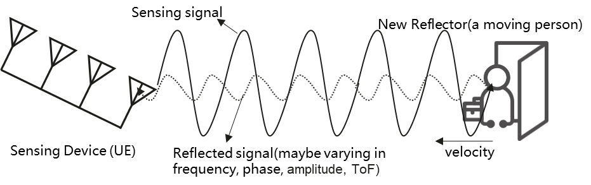

Fig. 5.1.1-1 An example of sensing operation of UE

### 5.1.2 Pre-conditions

Mary and her husband Tom live in a house with little daughter Alice.

On every working day, Mary and Tom have to leave home to work, and Alice needs to go to school. Since the community where the house is located is not stable, Mary and Tom have concern on the safety of their property.

In order to address their concerns, considering protecting the personal privacy and save family cost, Mary sets up some 5G CPEs (i.e. UE) in each room at home, which support sensing functionalities.

### 5.1.3 Service Flows

Mary and her all family members travel to Hawaii in a holiday. At this time, her house is empty. Since she worries about the safety of property, she enables the sensing service on intruder detection of the 5G CPEs (i.e. UE) at home.

Mary’s CPE (i.e. UE) in the living room is activated to perform the sensing operation. While the 5G CPE transmit 5G signals to provide communication services at home, the reflected signals are also be received and measured at the CPE as sensing information. The CPE reports the sensing information to 5G network or further process locally. Via the analysing the differences between the 5G signals and the received reflected signals provided by sensing service performed by 5G system, any potential intruder will not be missed.

Also, Mary’s CPE in the living room can work with other 5G UEs in other rooms. The CPE discovers that the living room has another 5G device (i.e. UE) which could assist the sensing service as secondary device via direct device connection. The connectivity used in this case is direct device connection, and CPE and this 5G device play as the role of transmitter and receiver, respectively. The receiver measures the 5G signal (e.g., number of detected transmission paths), then provides sensing information to 5G network or further process locally. Via the analysing the differences between the 5G signals and the received reflected signals provided by sensing service performed by 5G system, any potential intruder will not be missed.

An intruder breaks into Mary’s house someday. The sensing service provided by 5G network system assists detecting that the presence of an intruder based on analysing the change of collected signals is aligned with the known feature of the activities of indoor human, and the alarm of intruder is sent to Mary’s smart phone. Mary calls the police for help, and the property is protected.

### 5.1.4 Post-conditions

Thanks to the sensing service provided by 5G UE and network, an intruder is found when Mary is out of home.

### 5.1.5 Existing features partly or fully covering the use case functionality

None.

### 5.1.6 Potential New Requirements needed to support the use case

[P.R.5.1.6-1] The 5G system shall provide a mechanism for an operator to authorize a UE for sensing, e.g., based on location.

Editor's Note: it is FFS whether base station needs to be added into [P.R.5.1.6-1].

[P.R.5.1.6-2] The 5G system shall support a UE to perform sensing measurement process based on the trusted 3rd party’s request.

[P.R.5.1.6-3] The 5G system shall provide mechanisms for an operator to only collect or expose the sensing information requested by a trusted 3rd party according to agreement.

[P.R.5.1.6-4] The 5G system shall support UE to perform sensing measurement process using signals received from other UE(s).

[P.R.5.1.6-5] The 5G system shall support UE to perform sensing measurement process in licensed or unlicensed band.

[P.R.5.1.6-6] The 5G system shall be able to provide the sensing service with following KPIs:

Table 5.1.6-1: Performance requirements for intruder detection in smart home

|  |  |  |  |  |  |  |  |  |  |  |  |
| --- | --- | --- | --- | --- | --- | --- | --- | --- | --- | --- | --- |
| **Scenario** | **Sensing Distance** | | | **Sensing Angle** | | | **Sensing Velocity** | | | **Confidence level** | **Latency** |
| **Accuracy** | **Resolution** | **Effective Sensing Distance** | **Accuracy** | **Resolution** | **FOV (Field of View)** | **Accuracy** | **Resolution** | **Effective Sensing Velocity** |
| Intruder detection in smart home | 0.5-2 m | - | 10 m | - | - | - | 0.1-0.3 m/s | - | 3 m/s | Probability of missed detection < 5%  Probability of false alarm < 2% | < 1 s |
| Note 1: The KPIs are taken the requirement of IEEE 802.11bf WiFi sensing use case as the baseline [8]. | | | | | | | | | | | |

Editor’s Note: the KPI table will be updated when the common KPI table is ready, and it is FFS to identify the potential KPIs.

Editor's Note: it is FFS whether other potential requirements will be identified.

## 5.2 Use case on pedestrian/animal intrusion detection on a highway

### 5.2.1 Description

Transportation as a basic and essential industry plays one of the important roles in a human’s life. Making transportation smarter can make life more convenient and benefit economic development. Highways are an important part of smart transportation. Due to the strong road safety demand on smart transportation, it is necessary to monitor the road situation so as to make appropriate management of road traffic, give guidance or assistance information to vehicles and/or highway traffic safety administration [2].

For example, major accidents caused by pedestrians or animals crossing highways occur frequently [3] [4]. Currently, the highway supervision systems are mainly based on traditional sensors (e.g. radars, cameras) equipped in the roadside infrastructure, but there are still many problems in road supervision system, e.g. it only has partial coverage along the roadside, and the radar may be dedicated for a single usage which requires deploying different types of transportation radars in the same place to satisfy the respective sense use cases and requirements in the area of interest.

Base stations on the roadside are already used to provide 5G coverage for communication, and the radio signals can also be used to sense the environment for object detection.

The assumption of this use case is the following:

- There is at least 10km long and 33m wide dual three-lane carriageway, which has a central reservation to separate the carriageways, six 3.75m wide lanes and two 3.00m wide shoulders to permit emergency stops [9].

- The size and typical velocity of traffic participant is described in the Table 5.2.2-1.

Table 5.2.1-1

|  |  |  |
| --- | --- | --- |
|  | Size  (Length x Width x Height) | Typical velocity |
| Pedestrian  (Adult) | 0.5m x 0.5m x 1.75m | 5km/h [9] |
| Animal  (Sheep/deer) | 1.5m x 0.5m x 1 m | 5km/h [9] |
| Vehicle | 4m x 1.75m x 1.5m | 60km/h - 120km/h |

As described in the figure 5.2.1-1, when the pedestrian/animal standing at the outermost side of the shoulder starts walking on the traffic lane, it means the highway intrusion happens. The distance that pedestrian/animal move perpendicular to the traffic lane ( i.e. y direction in the figure 5.2.1-1) is more sensitive for road safety, compared to the distance parallel to the traffic lane ( i.e. x direction in the figure 5.2.1-1).

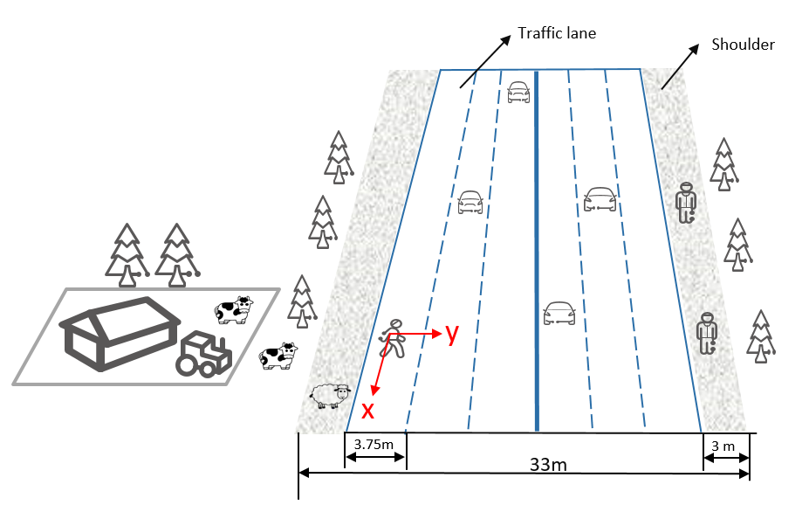

**Figure 5.2.1-1: Intrusion detection on a dual three-lane carriageway**

### 5.2.2 Pre-conditions

Good partnership and cooperation are established between the road supervision department and Mobile Operator#A in City#B. Requested by the supervision departments for the sensing service, the suitable base stations around/along a highway are selected, which enable Mobile Operator#A to constantly sense the road situation including moving objects (e.g. vehicles and pedestrians). The sensing signal emitted from the base station arrives at vehicles/pedestrians/objects on the road and is bounced (reflected) back to the transmitting base station.

### 5.2.3 Service Flows

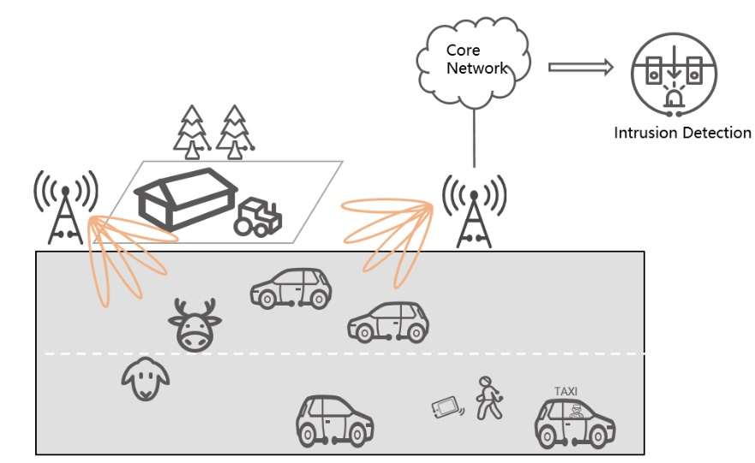

**Figure 5.2.3-1: Pedestrian/animal intrusion detection**

1. Fei is a tourist, who is taking a taxi to enjoy the view around the highway in City#B. The base stations around/along the highway constantly sense the road situation. While the taxi is driving on the highway, Fei rolls down the window to take some pictures. Suddenly his mobile phone falls out the window.
2. Fei tells the driver to stop and cautiously gets out of the taxi. He crosses the highway and wants to find his mobile phone. Meanwhile, some animals (e.g. sheep and deer) from a farm near the highway approach the road. More and more surrounding vehicles are passing at very high speed. The pedestrian and animals are detected and closely tracked with sufficient accuracy in the sensing area of a base station, and then the sensing measurement is transferred to the core network from the base station and further processed into the sensing results in the core network.
3. The sensing results are exposed by the Mobile Operator#A to the road supervision departments and map provider. The map provider adds the position of the vulnerable pedestrian and animals into the HD dynamic maps and transmits warning messages to the vehicles approaching them. Alternatively, RSUs are connected to the traffic control centre for management and control purposes. RSUs transmit warning messages to the vehicles approaching them.The staff working for supervision departments immediately responds to the emergency, launching temporary traffic management, and rushes to the emergency site to fetch the mobile phone for Fei and drive the animals away from the highway.
4. Finally, Fei and animals leaves the highway safely. Potential road accident(s) caused by the pedestrian/animal intrusion are avoided.

### 5.2.4 Post-conditions

Thanks to the area-coverage, long-distance sensing capability of the base station (which provides a bird’s-eye-view for monitoring the highway environment) the precision and efficiency of highway management and safety supervision is improved. The network-based sensing can provide timely, continuous, accurate, and comprehensive sensing results, which is a reliable basis for highway safety services.

### 5.2.5 Existing features partly or fully covering the use case functionality

None.

### 5.2.6 Potential New Requirements needed to support the use case

[PR 5.2.6-1] The 5G system shall be able to support a base station to perform sensing.

[PR 5.2.6-2] The 5G system shall be able to support means to select suitable base station(s) to perform sensing, e.g. based on the base station’s location, sensing capability, and the sensing service information requested by trusted third party application.

[PR 5.2.6-3] The 5G system shall be able to support means to configure the sensing operation of a base station(e.g. authorization, sensing activation and/or deactivation, sensing duration, sensing accuracy, target sensing location area).

[PR 5.2.6-4] The 5G system shall be able to support means to enable a base station to transfer sensing measurement data to the core network.

[PR 5.2.6-5] The 5G system shall be able to support means to enable the core network to process sensing measurement data for obtaining sensing results.

[PR 5.2.6-6] Based on operator’s policy, the 5G system shall expose a suitable API to a trusted third party to provide the information regarding sensing results.

[PR 5.2.6-7] The 5G system shall be able to support charging data collection for the sensing services (e.g. considering service type, sensing accuracy, target area, duration) requested by a trusted third party application.

[PR 5.2.6-8] The 5G system shall be able to support the following KPIs:

**Table 5.2.6-1: Performance requirements for pedestrian/animal intrusion detection**

|  |  |  |  |  |  |  |  |  |
| --- | --- | --- | --- | --- | --- | --- | --- | --- |
| **Scenario** | **Distance Accuracy**  **([95%] confidence level)** | | **Velocity Accuracy**  **([95%] confidence level)** | | **Resolution** | | **Max allowed Sensing service latency** | **Refreshing rate** |
| Horizontal Accuracy | Vertical Accuracy | **Horizontal Accuracy** | **Vertical Accuracy** | **Horizontal Resolution** | **Vertical Resolution** |
| Pedestrian/animal intrusion detection on a highway  (Note 1) | ≤1m  (Note 2) | - | - | - | - | - | ˂5s  (Note 3) | ≥10Hz  (Note 4) |
| Note 1: the typical size (Length x Width x Height) of pedestrian is 0.5m x 0.5m x 1.75m and the typical size of animal is 1.5m x 0.5m x 1 m.  Note 2: the safe distance between pedestrian/animal and road is 2m[10].  Note 3: the sensing time needed to warn/act on the traffic participants is 5s[10].  Note 4: for collision avoidance purposes, the typical sufficient data sampling rate is 10 Hz[10]. | | | | | | | | |

Editor’s note: The KPIs for this use case is FFS.

## 5.3 Use case on rainfall monitoring

### 5.3.1 Description

Rainfall monitoring is a topic of great importance for several application contexts: hydraulic structure design, agriculture, weather forecasting, climate modelling, etc. At present, the most widely used measurement method is rain gauge.

Traditional rainfall monitoring use rain gauges, which are located at a particular location. Wide-area rainfall monitoring using traditional rain gauges would be costly. The base stations are deployed by the operators with radio cell planning that could cover a wider area. With base stations monitoring the rainfall, for example rain rate (mm/h), it could obtain a horizontally wider-area measurement.

Radio signals, as they propagate through the atmosphere, are reduced in intensity by constituents of the atmosphere. Oxygen and water vapor are the two major components which are responsible for the signal absorption. If it is a rainy day, an additional attenuation caused by rain further increases the propagation path loss. [7] The rain attenuation depends on the size and distribution of the water droplets, hence, by quantifying and modelling the base station signal measurements, we are able to know the rain rate.

The mmWave bands, such as 28GHz and 38GHz have been used to assess coverage, large-scale path loss, and fading and multipath effects [6]. Since the 28 GHz and 38 GHz bands are also licensed for wireless backhaul communications, these frequencies can used for rainfall monitoring [7].

The granularity of the rainfall monitoring could be smaller than the traditional measurements.

### 5.3.2 Pre-conditions

Peter is a farmer who takes care of a big farm that grows different crops. Peter needs to monitor the rainfall of his farm to manage reasonable irrigation, drainage and fertilizer. When there is less rainfall, Peter can select reasonable irrigation plans to improve the farmland water content condition. When there is high rainfall, Peter should improve the drainage system and fertilize the crops to avoid crop losses.

### 5.3.3 Service Flows

1. Peter has a subscription for the premium service of rainfall monitoring for a more granular location.
2. Peter is at daily working routine and wants to check the timely rainfall information from the weather application on his phone.
3. The base station obtains the NR based sensing measurement data every hour and the 5G system processes the sensing measurement data to obtain sensing results and exposes the NR based sensing results to the weather application via the core network.
4. Based on the sensing results above, the application server obtains the rainfall associated with location information.
5. Peter obtains timely rainfall information from weather application on his phone.

### 5.3.4 Post-conditions

Peter could check the rainfall information at any time on his phone. Based on the timely rainfall information, Peter could plan the irrigation, drainage and fertilizer for the crops in his farm.

### 5.3.5 Existing feature partly or fully covering use case functionality

None

### 5.3.6 Potential New Requirements needed to support the use case

[PR. 5.3.6 - 001] The 5G system shall support collection of the NR based sensing measurement data from the base station.

[PR. 5.3.6 - 002] Based on operator’s policy, the 5G system shall support mechanisms to process the sensing measurement data to derive the sensing results.

[PR. 5.3.6 - 003] Based on operator’s policy, the 5G system shall provide mechanisms to expose NR based sensing results with assisted information, e.g. location, to a trusted 3rd party application via the core network.

[PR. 5.3.6 – 004] The 5G system shall support sensing services with KPIs as given Table 5.3.6-1.

Table 5.3.6-1: Performance requirements for the use case of rainfall monitoring

|  |  |  |
| --- | --- | --- |
| **Scenario** | **Sensing Range** | **Sensing Frequency** |
| Rainfall monitoring | 200m  (Note 1) | [1/1min-1/15min]  (Note 2) |
| Note 1: The sensing range for rainfall monitoring refers to the reference [5].  Note 2: The sensing frequency should be adjustable and depends on the requirement of the weather application. | | |

Editor’s Note: The KPI table should be aligned with the agreed common KPI table format.

## 5.4 Use Case on Transparent Sensing Use Case

### 5.4.1 Description

In general, a UE senses using either or combination of the sensors such as camera, NR-based sensing and Lidars, Radars. In NR-based sensing, the UE and BS senses for stationary and moving Objects around UE – using time-difference-of-arrival (TDoA), angle-of-arrival (AoA), angle-of-departure (AoD) measurements, RSSI etc. as shown in Figure 5.Q.1-1 [14]Transparent sensing is a use case in which sensing data is captured by the UE and communicated so that the 5GS is aware of the sensing information. From this information, service enablers can be defined. One example of such information is location data, whose corresponding service enabler is Location Based Services.

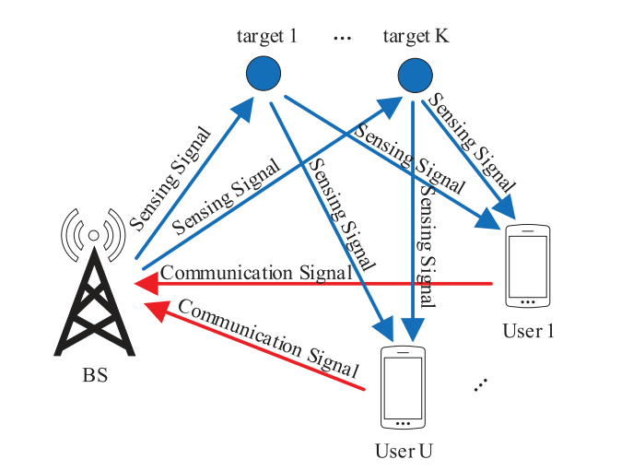

Figure 5.Q.1-1: BS and UE sensing Objects

In this use case, sensing data is made available to the 5GS, and the requirements for this exposure are considered. The data so obtained can be used for diverse purposes. One such purpose is Localization (identifying both a three dimensional position and orientation.) Transparent Sensing data used for Localization is described in TR 22.856 [11]

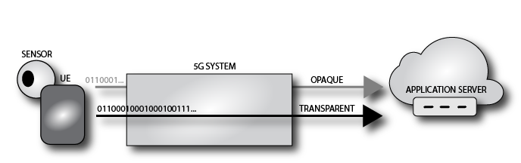

Figure 5.Q.1-2: Opaque and Transparent Sensing Data

The distinguishing characteristic of this use case is that the sensing data is provided to the 5GS itself, not merely by the 5GS to an AF out of scope of 3GPP standardization.

### 5.4.2 Pre-conditions

A UE has access to one or more sensors. In this use case. the UE has access to four sensors: NR-based sensing, 3D LiDAR, an RGB Camera and a Smart Phone Camera. The sensors' physical configuration is known (e.g. the cameras are 10 cm apart). The NR-based sensing capabilities of the UE and its connected BS are used to capture information about the nearby environment by the UE.

A mobile network MN supports the acquisition of sensing data. We term this support by the network a 'sensing data sink.'

Editor's Note: A sensing data sink is a stage 2 notion. What can we instead write? The 5GS supports a service that acquires sensing data to either process it and expose the processed information?

### 5.4.3 Service Flows

The user U activates a mechanism to enable NR-based sensing at UE and MN and provide sensing measurement data to the 5GS. This process is analogous to activating or enabling a location tracking service.

MN acquires sensing measurement data provided by U's UE, for a period of time.

The user U deactivates the mechanism to provide sensing measurement to the 5GS.

Editor's Note: Additional details on the use of LiDAR, cameras and/or spatial localization need to be added.

### 5.4.4 Post-conditions

The sensing data acquired by the 5GS is processed in order to enable other services. The processed information can for example provide 'Spatial Localization' information that can be exposed to authorized third parties, as discussed in 22.856 [11]. "Spatial Localization Use Case".

### 5.4.5 Existing feature partly or fully covering use case functionality

Positioning in 5G Networks been proposed in 3GPP release-16, it specifies positioning signals and measurements for the 5G NR. In release-16, 5G Positioning architecture extends 4G positioning architecture by adding Location Management Function (LMF) and Transmission reception points (TRP). 5GS provides new positioning methods based on multi-cell round-trip time measurements, multiple antenna beam measurements, multiple to enable downlink angle of departure (DL-AoD) and uplink angle of arrival (UL-AoA) [15][16]. The Rel-17 5G system supports positioning of the device-based but not device-free – objects that do not radiate EM signals. [14][15][16]

The 5GS already supports transport of sensor data. The table below provides indicative performance requirements for media used for sensor information communication.

|  |  |  |
| --- | --- | --- |
| **Sensor Type** | **Uplink KPI** | **Remarks** |
| 3D Lidar | 30 Mbps | An example 3D LiDAR: 16 channel, 0.3M data points, dual return mode  2 bytes distance, 1byte [13] |
| Industrial RGB Camera | 16 ~ 800 Mbps | 2,592 x 2,048 x 10bits x 2.5 Hz x 6 EA, compression ratio 2% |
| Smart Phone Camera | 4 ~ 200 Mbps | 2,160 x 2,880 x 8bits x 1 Hz x 4 EA, compression ratio 2% |

Figure 5.4.5-1: Performance Requirements (already possible to fulfill with the 5GS)

### 5.4.6 Potential New Requirements needed to support the use case

[PR.5.4.6 - 001] Subject to user consent and national or regional regulation, based on operator policy, the 5GS shall support a mechanism to receive uplink sensing measurements from a UE that is authorized to provide uplink sensing measurements to the network.

NOTE: This requirement assumes there is some functionality in the 5GS to discern and interpret the acquired sensing measurements.

[PR.5.4.6 - 002] Subject to user consent and national or regional regulation, based on operator policy, the 5GS shall support a mechanism to expose sensing result to authorized third parties.

[PR.5.4.6 - 003] Subject to user consent, network operator policy and national or regional regulation, the 5GS shall support a mechanism to enable RAN entities and UEs to acquire NR-based sensing measurement data to capture information about the nearby environment.

Editor's Note: It is FFS if explicit requirements for LiDAR, cameras and other sensors need to be added.Editor's Note: Using existing E-UTRA measurements is FFS.

## 5.5 Use case on sensing for flooding in smart cities

### 5.5.1 Description

Due to the climate change in recent years, a larger amount of rain sometimes falls within a short duration of time inside a small area. This result, in particular in urban areas, in inundation and flooding even in areas where these did not happen in the past. When flooding is about to happen on roads, people might enter areas getting in danger without knowing it. Once flooding really happens there, this might result in loss of human life. At places where flooding is expected to occur, monitoring of flooding is performed using cameras and other sensors. However, due to the recent climate change, it may be difficult to recognize places where flooding is expected to occur. Using radio waves, it is possible to recognize places where flooding occurs in an efficient way.

### 5.5.2 Pre-conditions

Good partnership and cooperation are established between Mobile Operator #A and administrators of roads such as a local government in City #B. Mobile Operator #A constantly senses the surface of the road and informs results of sensing to the administrator of the road.

### 5.5.3 Service Flows

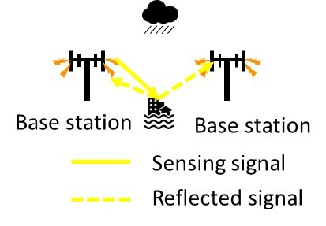

Figure 5.5.3-1: Sensing for flooding in smart cities

1. Base stations owned by Mobile Operator #A are deployed around the road. Mobile Operator #A carries out sensing of the surface of the road in City #B. This sensing is performed using radio wave. Results of sensing information, incl. whether flooding occurs on the road, are informed to the administrator of the road in City #B.
2. The administrator of the road usually monitors the state of flooding on the road using information from sensors including information from Mobile Operator #A. In addition, in the case of heavy rain, the administrator may request Mobile Operator #A to increase frequency of monitoring of situation of roads and Mobile Operator #A monitors the situation more frequently responding to this request.
3. If there is information received that flooding occurs, the administrator advises people in the areas concerned to evacuate the areas. The administrator advises via mobile networks.
4. People who received the advice evacuate the areas or do not enter such areas.
5. Now City #B trusts Mobile Operator #A and allows it to advise people about evacuation without City #B's intervention in case of flooding. Next time a similar flooding occurs, Mobile Operator #A sends advice for evacuation directly to people.

### 5.5.4 Post-conditions

Damage of the flooding has been kept at minimum.

### 5.5.5 Existing features partly or fully covering the use case functionality

TBD.

### 5.5.6 Potential New Requirements needed to support the use case

[PR. 5.5.6 - 001] Subject to operator policy, the 5G system shall be able to provide sensing result indicating disasters or other emergencies (e.g., flooding) in a given geographic area to authorized third parties in a timely manner.

[PR. 5.5.6 - 002] Subject to regional or national regulatory requirements and operator policy, the 5G system shall be able to provide its public warning system with a warning notification based on sensing result indicating disasters or other emergencies (e.g., flooding) in a given geographic area in a timely manner.

## 5.6 Use case on intruder detection in surroundings of smart home

### 5.6.1 Description

Detection of an intruder including a person or a harmful animal into a private property is an important piece to ensure residents at home in the private property feel comfortable and secure. For the surroundings monitoring, various technologies, such as cameras, infrared cameras, and microwave radars are being used. However, these technologies require line-of-sight, and therefore locations which can be monitored may be limited.

Wireless signals make it possible to monitor locations without line-of-sight and to monitor wider areas [17]. Sensing by wireless signals can complement the afore-mentioned technologies and can improve accuracy of the detection. Sensing by wireless signals gives residents time to prepare against intruders or to drive them away.

### 5.6.2 Pre-conditions

UEs such as smart phones and consumer premise equipment are installed inside a house, in particular, near a wall or a window. Residents have a contract with a mobile operator for the UEs.

### 5.6.3 Service Flows

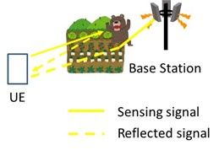

Figure 5.6.3-1: Intruder detection in surroundings of smart home

1. The UEs such as smart phones and CPE communicate with base stations in the outdoor or in the indoor and monitor 3GPP signals which are influenced by outdoor objects such as humans and animals. In addition, the UEs communicate with base stations of the mobile operator and monitor the radio wave state between the UEs and the base stations.
2. When an intruder enters the site, the radio signals are changed. The core network processes the data and yields sensing result indicating detection of the intruder.

NOTE: Cases that such an intruder or an animal is already indoor are addressed in the use case in clause 5.1.

1. The residents are informed of detection of the intruder.

### 5.6.4 Post-conditions

The residents report to the police or the security service and request them to take an appropriate action.

### 5.6.5 Existing features partly or fully covering the use case functionality

TBD.

### 5.6.6 Potential New Requirements needed to support the use case

[PR. 5.6.6 - 001] Subject to operator policy, the 5G system shall be able to collect sensing measurement data and yield sensing result from the data for detection of outdoor objects.

## 5.7 Use case on sensing for railway intrusion detection

### 5.7.1 Description

Extensive railway deployment and the changing wildlife habitat area due to the changing global environment has led to increase of crash of wildlife to trains. Once a crush happens, its recovery costs, takes time, and impairs convenience [x, y]. Such a crush should be avoided, but it appears difficult to proactively predict wildlife's intrusion onto railway track. It's different from e.g., weather forecast. Passively detecting wildlife's intrusion onto railway track appears an option to take. Monitoring with cameras serves the same purpose. However, this requires LOS (i.e., line of sight) and a dense deployment of cameras, which is not necessarily efficient. Another traditional mechanism using fibre optic sensing techniques is costly and requires manual intervention, making it very difficult to meet the increasing demand for railway monitoring. Thanks to the 5G NR based sensing, the base station as transmitter and receiver along the railway can constantly sense the railway situation such as railway intrusion.

The assumption of this use case is the following:

- There is at least 300km train line as depicted in the figure 5.x.1-1[20] owned by railway operator. The safe place is a place where a person and their equipment cannot be struck by rail traffic, which is used for minimizing damage caused by possible railway accident or crash and for ensuring safe operation of railway. The danger zone is anywhere within 3m horizontally from the nearest track.

- The typical size and velocity of intruder and train in this use case are described in the Table 5.7.1-1.

**Table 5.7.1-1**

|  |  |  |
| --- | --- | --- |
|  | Size  (Length x Width x Height) | Velocity |
| Intruder | Pedestrian(Adult):  0.5m x 0.5m x 1.75m | 5km/h |
| Animal(Sheep/deer):  1.5m x 0.5m x 1 m | 5km/h |
| Trains | 24m x 3.5m x 3 m | 100km/h - 350km/h |

When the intruder standing at the outermost side of safe place starts walking on the danger zone, it means the intrusion happens. The distance that intruder move perpendicular to the railway track is more sensitive for road safety, compared to the distance parallel to the railway track.

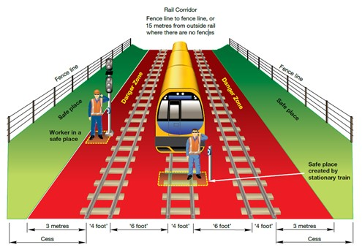

**Figure 5.x.1-1**

### 5.7.2 Pre-conditions

Base stations are deployed near and along a railway track which enable the mobile operator to constantly sense the railway including intruder (e.g., pedestrians and animal). For sensing, signaling transmitted by a base station is influenced or bounced by objects around the railway and then monitored by the base station and other base stations. Sensing result is being notified to a railway operator by the mobile operator. The railway operator knows locations of trains.

### 5.7.3 Service Flows

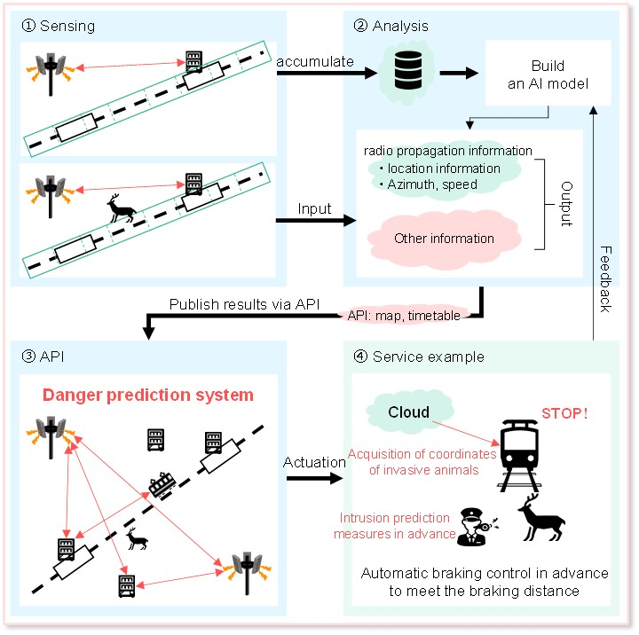

Figure 5.x.3-1 Railway intrusion detection

1. Base stations are deployed near and along a railway track. In order to acquire the sensing information of railway, railway operator requests sensing service from mobile operator. The mobile operator configures the base stations along the train line to perform sensing. Suddenly, an intruder (e.g. pedestrian or animal) is walking on the danger zone.
2. The sensing measurement data is reported from base stations and further processed into the sensing results by the core network. The mobile operator exposes the sensing results to the railway operator. Based on the sensing results, the location of the intruder can be estimated.

3. Trains running on the railway track measure their own location and velocity. These trains inform that information to a controller of the railway operator.

4. The controller identifies a train that is affected by an intruder based on the sensing results from mobile operator and train's location and velocity.

5. The controller orders the train to slow down or stop. In addition, the staff working for railway operator immediately responds to the emergency. The intruder leaves the danger zone safely.

### 5.7.4 Post-conditions

The controller judges the intruder is gone and safety can be ensured. The controller permits the train to start again or speed up.

### 5.7.5 Existing feature partly or fully covering use case functionality

TBD.

### 5.7.6 Potential New Requirements needed to support the use case

[PR. 5.7.6 - 001] Subject to operator policy, the 5G system shall enable the core network to collect and aggregate sensing measurement data from base stations.

[PR. 5.7.6 - 002] Subject to operator policy, the 5G system shall enable the core network to expose a suitable API to provide the information regarding sensing results to authorized third parties.

[PR. 5.7.6 - 002] The 5G system shall be able to support the following KPIs:

Table 5.x.6-1: Performance requirements for railway intrusion detection

|  |  |  |  |  |  |  |  |  |
| --- | --- | --- | --- | --- | --- | --- | --- | --- |
| **Scenario** | **Distance Accuracy**  **([95%] confidence level)** | | **Velocity Accuracy**  **([95%] confidence level)** | | **Resolution** | | **Max allowed Sensing service latency** | **Refreshing rate** |
| Horizontal Accuracy | Vertical Accuracy | **Horizontal Accuracy** | **Vertical Accuracy** | **Horizontal Resolution** | **Vertical Resolution** |
| Intrusion detection on a railway (Note 1) | ≤1.5m  (Note 2) | - | - | - | - | - | ˂1.5s  (Note 3) | ≥10Hz |
| Note 1: the typical size (Length x Width x Height) of pedestrian is 0.5m x 0.5m x 1.75m and the typical size of animal is 1.5m x 0.5m x 1 m. The length of railway depends on the real environment.  Note 2: the width of the danger zone horizontally from the nearest track is within 3m [20].  Note 3: in order to ensure passenger safety if any hazardous situation is detected, this is the latency for 5G system to sense the intrusion and report the sensing information on the presence of an intrusion (e.g. pedestrian/animal) to railway management departments. | | | | | | | | |

## 5.8 Use Case on Sensing Assisted Automotive Maneuvering and Navigation

### 5.8.1 Description

To support smart transportation and autonomous driving, more vehicle and devices are equipped with sensing technologies. For example, cameras, Radar, and Lidar systems are the most used sensors by the automotive industry to maintain the perception for autonomous vehicles at various levels of autonomy. Accurate sensing results are crucial to enable the safe and reliable control of the vehicles.

Due to the mounting position of the sensors (e.g., NR-based sensors) information collected from a single vehicle's sensors may not be sufficient or accurate enough to satisfy the advanced automotive use cases, e.g., autonomous driving, coordinated manoeuvre, etc. Therefore, the 5G system could coordinate sensing to enable the vehicles derive NR sensing inputs (i.e., sensing measurement data or sensing results) which could be consumed at the vehicle and used for the vehicular control and driver assistance, e.g., feed into the Automated Driving System (ADS) in the car [21]. Alternatively, the NR sensing measurement data or sensing results collected by the UE can be sent alongside relevant sensing information to other sensing entities (including other vehicles, roadside units, and network) for further processing (if required) before sharing with a 3rd party application as shown in Figure 5.8.1-1.

The network facilitated NR based sensing described above could significantly improve the sensing reliability and quality, enabling new and advanced automotive use cases.



Figure 5.8.1-1: 5G System Assisted Automotive maneuvering and navigation

### 5.8.2 Pre-conditions

In this use case, Joe and Bob’s vehicles are equipped with NR-based sensing technology. Non-3GPP-based sensors like radar, camera and Lidar sensors could also be available in the vehicles. Additionally, the vehicles are capable of 5G communications, including direct communication with other vehicles, communication with 5G system via RAN entities.

### 5.8.3 Service Flows

**5G system assisted coordination of sensing service**

Step 1 (**Network provides configurations and policies**): When Bob’s car registers for NR sensing service, the network provides policies and configurations to enable UEs take appropriate actions during sensing e.g., obtaining sensing inputs from another UEs/RAN entities. For example, the policies provided by network could provide guidance for the discovery UEs/RAN entities with appropriate NR RF sensing capabilities, when to trigger requests, when to stop sending requests, messaging formats, the communication configurations (such as which 5G communication mode to use and under which conditions), etc. These polices and configurations could be updated frequently as determined by the network.

Step 2 (**Bob determines his sensors are blocked**): Bob's sensor(s) is(are) blocked by Joe's vehicle, and cannot adequately detect its surroundings (e.g., detect if there is another vehicle in front). This could result in the vehicle miscalculating the needed distance to stop before a traffic light. In other cases, Joe's vehicle could also reduce the valid sensing region and result in misdetection of incoming vehicles size or shape, especially near intersections. The sensing results cannot fully satisfy the autonomous driving needs and requirement.

Step 3 (**Bob recognizes need for sensing inputs**): Due to unsatisfactory autonomous driving needs and requirements, the UE in Bob's vehicle is notified that its sensors are blocked and needs 5G System assistance for coordination of the sensing service.

Step 4 (**Bob’s vehicle discovers Joe’s vehicle**): With the policies and configurations provided by the 5G system, Bob’s vehicle can search for neighbouring UEs/RAN entities or ask the network to provide recommendations for UEs/RAN entities and their NR RF sensing capabilities (e.g., if UE/RAN entity supports sensing service). This information would be used to discover other vehicles and RAN entities with NR RF sensors that can support sensing in the area. In this example, Bob's vehicle discovered Joe's vehicle could be useful in providing sensing inputs.

Step 5 (**Bob’s vehicle connects to Joe’s vehicle**): Bob's vehicle then establishes 5G communication connection with Joe's vehicle and/or RAN entities as shown in Figure 5.y.3-1. The most suitable 5G communication mode (e.g., broadcast, unicast, etc) is determined by the Bob’s vehicle based on 5G system configuration and policies.

Step 6 (**Bob's vehicle requests sensing info from Joe’s vehicle).** The request could indicate the information needed to perform sensing, e.g., the additional region to be covered, additional sensing target, synchronization info, etc.

Step 7 (**Joe sends sensing results/sensing measurement data to Bob’s vehicle**) Based on the information provided by Bob’s vehicle; Joe sends Bob sensing results identifying objects in its surroundings. Joe’s car also supports the capability to forward sensor measurement data so it forwards that also to Bob’s car.

Step 8a (**Bob processes sensing data locally**) Based on the fact that Bob’s has non-NR sensors (e.g., camera, Lidar), Bob’s car combines the sensing measurement data from Joe’s vehicle with other sensors and displays the sensing results on the application in its autonomous driving application in his car.

Step 8b (**Bob sends NR and non-NR sensing results to 3rd party application)** Alternatively, Bob sends NR sensing results and results from the camera and Lidar to a 3rd party application server (through the network) for fusion of the sensing results from NR and non-NR sensors.



Figure 5.8.3-1: 5G system assisted automotive maneuvering and navigation

With the sensing information provided by Joe's vehicle and/or the network, Bob's vehicle obtains a full map of the region. The autonomous driving algorithm can make corresponding decisions reliably.

### 5.8.4 Post-conditions

Using 5G system assistance, Bob's vehicle would be able to achieve highly reliable and accurate sensing results, by coordinating the operation with other vehicles to collaborate with other sensing devices to improve quality. With this high-quality sensing results, advanced smart transportation use cases and autonomous driving could be achieved.

### 5.8.5 Existing features partly or fully covering the use case functionality

V2X communication supports the information exchange among the vehicles, between vehicle and infrastructure or network.

Editor’s note: Further gap analysis is FFS.

### 5.8.6 Potential New Requirements needed to support the use case

[PR 5.8.6-1] The 5G system shall be able to support mechanisms to control UEs and RAN entities for a sensing service.

NOTE1: In the requirement above, control may include configuration such as sensing specific policies and settings (e.g., conditions for triggering sensing requests, location, etc.) coordinated amongst UE and RAN entities.

[PR 5.8.6-2] For a sensing service, the 5G system shall be able to support mechanisms for the UEs and RAN entities to provide sensing measurement data.

NOTE2: This requirement can cover scenarios making use of information already available in the EPC and E-UTRA (assuming no new functionalities are required in the EPC and E-UTRA).

[PR 5.8.6-3] The 5G system shall be able to support an authorized UE in the discovery of UEs and RAN entities with the required NR RF sensing capabilities for the sensing service.

[PR 5.8.6-4] The 5G system shall be able to provide means to authorize and configure a UE for sensing operation (e.g., based on location, time, etc) and for establishing the communication connection needed to assist the sensing service.

NOTE3: The above requirement assumes that the communication connection used for sensing service can include direct network communication, direct device connection and indirect network connection.

[PR 5.8.6-5] The 5G system shall be able to support exposure of UEs' sensing results, capabilities, and configurations to a trusted 3rd-party application, e.g., to facilitate 3rd-party control and coordination of sensing inputs from one or more sensing UEs.

## 5.9 Use case on AGV detection and tracking in factories

### 5.9.1 Description

Improving safety and work conditions in factories and industrial environments is a critical component for industry 4.0. Replacing communication cables with wireless connections has already positively changed the factory environment, by providing reliable ethernet-like communications, and enabling time-sensitive networking over the air. Nevertheless, despite automation and improvement, accidents in factories still occur, leaving room for improvement. Indeed, 5250 fatal work injuries were recorded in the US only in 2018, according to the Bureau of Labour Statistics [22], a 2% increase from 2017.

Automated Guided Vehicles (AGVs) are key components of the new smart factories, used for a variety of tasks such as heavy or hazardous materials transportation and distribution. Simultaneous presence of AGVs and human workers at the industrial side creates safety challenges and calls for stringent safety requirements [[23](https://www.sciencedirect.com/science/article/pii/S1383762120301788)]. For example, the driverless, automated guided industrial vehicles ANSI/ITSDF B56.5 [24] safety standard requires that “the AGV shall detect and avoid both static and dynamic obstacles appearing in the path of travel direction”. Reliable detection of AGV/human presence or proximity is therefore an important safety criterion.

5G system can be deployed in a factory which uses RAN entities and/or UEs to measure sensing measurement data, that are made available to sensing management entities in order to derive sensing results such as the detection of the presence or proximity of AGVs and humans. This use case assumes support of NR-based RF sensing.

### 5.9.2 Pre-conditions

Company #A operates multiple AGV in its factory. Each AGV is programmed to perform certain tasks, such as transporting large containers from point #B to point #C following a programmed route. AGVs can be of various sizes and operate at different speeds and locations. In a factory, workers are dispersed throughout the area, performing different tasks. Workers-AGVs interactions are a source of potential injuries, and extra care needs to be taken to avoid any harm.

The factory deploys 5G based integrated communication and sensing system with RAN entities and UEs throughout the factory floor. The RAN entities deployment is done to optimize communication, positioning, and sensing.

The RAN entities and/or UEs perform sensing operations over certain target areas throughout the factory. The deployed RAN entities (or a subset of the RAN entities) transmit sensing reference signals, which are received by a subset of RAN entities and/or selected UEs. Some UEs are authorized and configured to monitor the sensing reference signals and report sensing measurement data to a sensing entity in the 5G system. The sensing entity can be deployed either locally in the factory or in the cloud/edge.

In this use case it is important to note that AGVs do not actively participate in the sensing signals transmission or reception, and hence it is more applicable to AGVs which are not equipped with UEs, e.g., legacy AGVs. For those AGVs with UEs, the UEs can be helpful in sensing and tracking humans on the factory floor.

### 5.9.3 Service Flows

Figure 5.9.3-1: AGV presence and proximity detection

1. Alex is working in his section of the factory (shown in the lower left area in Figure 1), performing regular maintenance work around a conveyor belt.
2. An AGV, AGV#1, is approaching the area where Alex is working, carrying a heavy load to be placed at a designated location next to the conveyor belt.
3. Using the sensing measurement data from the RAN entities and the UE carried by Alex, the sensing entity processes the data to obtain sensing results and detects the proximity of the AGV1 to Alex. The sensing results is shared with a safety monitoring application of the factory, and a notification is sent to Alex to warn him of the approaching AGV.
4. Another AGV, AGV#2, enters an area (lower right area in Figure 1) with increased risk for workers due to higher workers presence and higher equipment and machines density. Based on the sensing measurement data from RAN entities, the sensing entity processes the data to obtain sensing results and detects the presence of AGV#2 and exposes the detection event to the factory safety monitoring application. The safety monitoring application triggers a warning sound to warn the workers (e.g., John and Emma) in that area of the approaching AGV.   
   Note that, in this scenario, none of the UEs was involved in the sensing session. However, the sensing entity can use sensing measurements from UEs in the area (e.g., UE carried by Emma) in its sensing processing if available.
5. In another scenario, John (lower right area in Figure 1), working on his section, not having a UE, is being tracked using radio sensing measurements from RAN entities and/or UEs. When John comes in proximity with an AGV, which has or does not have a UE, a warning message is sounded to alert John.

### 5.9.4 Post-conditions

Thanks to the warning messages, workers are safe and potential accidents caused by workers-AGVs interactions are avoided. By leveraging the sensing capability of the 5G based integrated communication and sensing system, the factory safety supervision is upgraded, and workers safety is enhanced.

### 5.9.5 Existing features partly or fully covering the use case functionality

Editor’s note: Gap analysis for this use case is FFS.

### 5.9.6 Potential New Requirements needed to support the use case

NOTE1: The following requirements apply to networks managed by PLMN or NPN.

[PR 5.9.6-1] The 5G system shall be able to provide means to support NR-based sensing in a certain area or location.

[PR 5.9.6-2] Based on operator policy and location area, the 5G system shall be able to provide means to support per-UE authorization for NR-based sensing.

[PR 5.9.6-3] The 5G system shall be able to support means to enable RAN entities and UEs to transfer sensing measurement data to sensing processing entities in the 5G system responsible for processing and aggregation of the sensing measurement data.

NOTE2: The “Sensing processing entities” in the above requirement refer to one or more entities in the 5G system responsible for aggregating and processing of sensing measurement data (e.g., core network).

[PR 5.9.6-4] Based on operator’s policy, the 5G system shall be able to support means to expose sensing results to a trusted 3rd-party application.

Editor’s note: The KPIs for this use case are FFS.

## 5.10 Use case on UAV flight trajectory tracing

### 5.10.1 Description

With the development of UAV technologies and the increase of demands on rapid logistics, aerial photographing, environmental monitoring and public security, a variety of commercial UAV services gradually become reality.

Normally the commercial UAVs fly based on predetermined flight routes, following regulated positions, heights, speeds, and directions. E.g., a package-delivery UAV flies from the package sender to the package recipient; a task-execution (such as environmental monitoring) UAV flies from the UAV airport to the target area.

On-route flying is important for these commercial UAVs. Their flight routes are optimized and permitted by UAV service operators, UAV management department, or USS (Uncrewed Aerial System Service Supplier)/UTM (Uncrewed Aerial System Traffic Management). Usually, they have the shortest flight distance, avoid no-fly zone, and keep safe distance from obstacles (e.g., building, trees, hills) and other commercial UAVs.

Although a UAV is equipped with sensors to keep itself along the flight route, the external UAV flight trajectory tracing function is still necessary because these sensors sometimes are restricted. E.g., the camera is impacted by light situation; the UAV-borne radar is impacted by rainfall or snowfall, etc. If these events occur, UAV cannot correctly decide its own position, height or speed, and thus cannot follow the traced route.

Although there exist dedicated UAV surveillance equipment and radar, their large-scale deployment has great challenges due to lack of available sites and high installation and maintenance cost.

In comparison, using the 5G system can provide a cost-effective way to trace these UAVs, e.g., 5G network infrastructures with ubiquitous coverage can better trace the flight trajectory of each UAV.

Specifically, 5G RAN entities can relies on radio sensing to obtain the information on UAV position and motion (e.g., distance, angle) and send sensing measurement data to a sensing processing entity located in the 5G system.

As shown in Figure 5.10.3-1, the UEs that are connected to the 5G RAN entities can be configured to assist in the sensing operations, which can increase the sensing coverage, provide more positioning reference points, and improve sensing result accuracy and robustness. This improvement is a result of higher density of UEs compared to the base stations, which increases the probability that some UEs are located in positions that have shorter distance away from UAV than 5G RAN entities (e.g., UAV located in the middle of two 5G RAN entities while UE locates under UAV), or some UEs are located in the reflection directions that have larger radar cross section (RCS) than 5G RAN entities considering the UAV RCS variation in different reflection directions.

The 5Gsensing processing entity can collect the sensing data from one or multiple network infrastructures.

The 5G network operator can provide the UAV flight trajectory tracing service to a trusted 3rd party application (e.g., UAV service operator, UAV management department, USS/UTM) as requested.

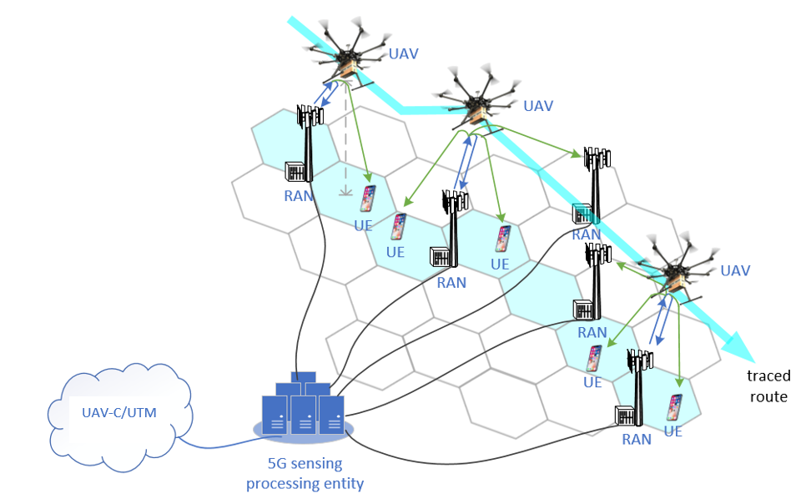

Figure 5.10.1-1: UAV flight trajectory tracing by 5G system

### 5.10.2 Pre-conditions

A UAV operator/UTM provides package delivery service in an area which is covered by 5G network. The UAV operator/UTM subscribes to the UAV flight trajectory tracing service from the 5G network operator.

The UAV operator/UTM provides the 5G network operator the characteristics of the UAV to be sensed, time and space (covering the regulated UAV flight routes and possible off-route locations) of the UAV flight trajectory tracing service.

### 5.10.3 Service Flows

When the appointed time starts, 5G network operator activates the UAV flight trajectory tracing function at the appointed space until the appointed time ends.

The UAV operator controls UAV#1 to take off from package delivery source and fly toward package delivery destination along a regulated flight route.

By radio sensing, a set of 5G base stations and UEs detect UAV#1, and then estimate the position and motion related metrics (e.g., distance, angle) as well as the target object is in coverage, resulting in sensing measurement data. The 5G base stations and UEs then send the sensing measurement data to the 5Gsensing processing entity.

In certain cases, during the flying course, based on sensing and location information, if it is detected that UAV#1 has left the coverage of an old base station and entered the coverage of a new base station, the old base station could stop radio sensing and operate in a power saving mode. The new base station starts and keeps on sensing UAV#1 until it is out of coverage. Note that the determination that the UAV#1 has left the coverage of a base station or not could be determined based on the UAV positions and velocities estimated at the 5G sensing processing entity. Therefore, the network could then decide to activate and deactivate sensing in certain base stations based on this information. In other cases, the network could configure a start and stop of sensing operations for a base station based on a specified time period.

The 5G sensing processing entity collects the UAV sensing measurement data from one or multiple base stations and UEs, and estimates the positions and velocities, and sends in real time the sensing results (e.g., UAV positions, velocities) to the UAV operator and/or UTM.

Based on the received sensing results, the UAV operator and/or UTM traces the flight trajectory of UAV#1. Once the UAV operator and/or UTM detects an off-route event, it further steers UAV#1.

### 5.10.4 Post-conditions

UAV#1 delivers package to the destination along the traced flight route or its off-route behavior is sensed.

### 5.10.5 Existing features partly or fully covering the use case functionality

Editor’s note: Further gap analysis is FFS.

### 5.10.6 Potential New Requirements needed to support the use case

[P.R 5.10.6-1] Based on operator policy, request from UTM and sensing configuration (e.g. sensing area), the 5G system shall be able to support RAN entities and UEs in sensing the characteristics of an airborne object of interest (e.g., UAV), including generating sensing measurement data related to the object’s location and motion metrics (see examples in Table 5.10.6-1).

[P.R 5.10.6-2] The 5G system shall be able to support means to authorize RAN entities and UEs in certain location area generating and reporting sensing measurement data (e.g., related to a UAV position, velocity) to a 5G sensing processing entity.

NOTE: The requirement above assumes that the sensing measurement data is post-processed in 5G sensing processing entity which is located within the 5G system.

[P.R 5.10.6-3] The 5G system shall be able to support means to process the sensing measurement data and expose in real time the sensing results (e.g., related to a UAV position, velocity) from a 5G sensing processing entity to a trusted 3rd party application.

[P.R 5.10.6-4] The 5G system shall support energy efficient sensing operations.

[P.R 5.10.6-5] The 5G system shall support sensing services with KPIs as given in Table 5.10.6-1.

Table 5.10.6-1: UAV Flight Trajectory Tracing KPI Requirements

|  |  |  |  |  |  |  |  |  |  |  |  |
| --- | --- | --- | --- | --- | --- | --- | --- | --- | --- | --- | --- |
| **Scenario** | **Sensing Distance** | | | **Sensing Angle/direction** | | | **Sensing Speed** | | | **Interval between two consecutive sensing fixes** | **Latency** |
| **Accuracy** | **Resolution** | **Distance Range** | **Accuracy** | **Resolution** | **Angle range** | **Accuracy** | **Resolution** | **Speed range** |
| Remote Sensing (e.g., Drone monitoring, detection and/or management) | FFS | 0.5 - 1m,  (note 1) | <500m  (note 1) | FFS | FFS | FFS | FFS | 0.5 - 5m/s  (note 1) | FFS | FFS | FSS |
| NOTE 1: KPIs were obtained from [25] | | | | | | | | | | | |

Editor’s note: This KPI table will be updated when the format is finalized.

## 5.11 Use case on sensing at crossroads with/without obstacle

### 5.11.1 Description

The various ways of transportation (e.g. vehicles, walking people, motor vehicle, non-motor vehicle) and the dense buildings make the traffic condition complicated. Typically, traffic accidents often happen at the crossroads for example the pedestrians suddenly rush to the road from the invisible place (e.g., behind the high buildings, behind the tall trees), which cause an urgent need to monitor the real-time road status for all days, thus with the collaboration of trusted 3rd party e.g. map service provider or ITS management platform, driving warning or assistant driving information can be provide timely to vehicles.

The road status includes vehicle moving information, VRU(Vulnerable road user) information (e.g. VRU location, VRU moving direction, VRU moving speed, etc.), abnormal vehicle behaviour, road obstacles and road condition.

The road status information can be sensed by the cameras and radars on RSU (Road Side Unit). But considering the crossroad condition is very complicated, there are always some blind points. 5G based sensing can provide sensing information to fill these gaps.

For example, it is expected that the base station can sense the surrounding environment e.g. the road, and send the sensing measurement data to the core network. The core network can carry out systematic calculation and analysis of the sensing measurement data for outputting the sensing result. Such sensing result can be sent to a trusted 3rd party e.g. map service provider for combination with navigation map data, so as to make the driver aware of the congestion and traffic accidents in advance, and effectively increase the comfort and safety of driving. The base station sensing operations could improve the real-time map service with high reliability and quality.

But in some cases of above, the obstacles (e.g., high buildings or trees) block the transmission of radio signals. The availability and accuracy of the sensing service for the target objects which are located in the area will be greatly impacted.

To guarantee sensing service in this area, multiple 5G system sensing entities can work together.

### 5.11.2 Pre-conditions

Network operator “VV” has released a sensing service for road status sensing, and has deployed base stations especially at multiple crossroads to continuously sense the road status.

Due to the high buildings (e.g. Building A) near the crossroads, there are some areas with obstacles for 5G base stations. Some 5G system sensing entities are further deployed by the network operator ‘VV’ to help radio signal transmission and collect sensing measurement data.

Network operator “VV” has a collaboration with the ITS management department that the user who has registered the Network operator “VV”’s “road status sensing service” can receive real-time road status information, driving warning or assistant driving information from ITS management platform.

Bob has registered the road status sensing service from Network operator “VV”.

Network operator “VV” can also deliver the real-time road information and the real time location/ trajectory of vehicles to a map service provider. The map service provider can provide “assisted driving service” based on these information.

Tom has a vehicle with the “assisted driving service” provided by the map service provider.

Tom drives the vehicle from home to the company in the morning of a working day.

### 5.11.3 Service Flows

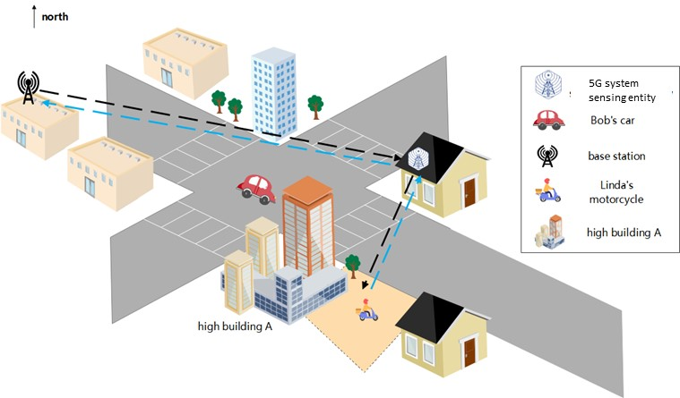

Figure 5.11.3-1. sensing at crossroads with/without obstacle

1. The 5G base station continuously collects sensing measurement data of the road status and the sensing result is continuously reported to the trusted 3rd party (e.g. the map service provider or ITS management platform) by 5G network according to the preconfigured refresh rate (e.g. in the midnight, it uses slow refresh rate with 0.2Hz, and in the working day morning, it uses fast refresh rate with 10Hz). The refresh rate can be adjusted according to the trusted 3rd party demand and network operator’s policy.
2. In the working day morning, Bob has started his road status sensing service when he begins driving his vehicle to his office.
3. Tom drives his vehicle from home to his office and started assisted driving service. The map service provider sends the road sensing request to the 3GPP core network.
4. In the crossroad, there are some higher buildings. It is difficult for Tom and Bob to timely detect other vehicles and VRUs in the area. As example in figure 5.x.3.1, Bob is driving his vehicle and crossing the crossroad toward the southeast of the crossroad. Linda is driving her motorcycle on a side road toward the main road which is also the southeast of the crossroad. The line of sight between Bob and Linda is blocked by the high building A which is at a corner of the intersection.
5. Linda’s motorcycle activity is continuously sensed by the base station under the help of other 5G system sensing entities.
6. The motorcycle sensing result which includes the motorcycles moving speed, moving direction, position etc. is periodically reported to the the map service provider and ITS management platform.
7. The other vehicles in the crossroad have been sensed and related sensing result are also reported to the map service provider and ITS management platform.
8. The map service provider fuses the sensing result with the map and then sends to the Tom’s vehicle.
9. According to the continuously received motorcycle sensing results, the ITS management platform can analyze and identify that there will be a potential collision risk between Bob and Linda. The collision warning then is sent to Bob.

### 5.11.4 Post Conditions

Tom’s vehicle receives the real-time map information which warns Tom that there is another cross-direction motorcycle driving towards his vehicle. Tom stops his vehicle before the crossroad to avoid a potential collision. With the assistance of RAN sensing, Tom arrives in the company safely and easily. Tom starts the daily work in the office.

Bob receives the warning and drives safely through the crossroads.

Linda can also ride safely to the crossroad. The potential risk of collision is avoided.

### 5.11.5 Existing features partly or fully covering the use case functionality

None.

### 5.11.6 Potential New Requirements needed to support the use case

[PR 5.11.6-1] The 5G system shall be able to support a mechanism to provide available sensing service in a sensing service area location.

[PR 5.11.6-2] The 5G base station shall be able to collect sensing measurement data from requested sensing service area location according to the operator’s policy.

NOTE 1: The operator policy means to configure the sensing service area location, real time sensing measurement data collection or periodic collection etc.

[PR 5.11.6-3] The 5G system shall be able to report the sensing result to the trusted 3rd party with refresh rate which is requested by the trusted 3rd party e.g. a map service provider, and controllable by the operator, according to a business agreement.

NOTE 2: The sensing result can be the target object’s size, shape, position, moving direction, moving speed, etc.

[PR 5.11.6-4] The 5G system shall support means for a trusted 3rd party application, e.g. a map service provider to configure sensing per location.

[PR. 5.11.6-5] The 5G system shall be able to support the sensing service with given KPIs in Table 5.11.6-1.

Table 5.11.6-1 KPI Table of Sensing

|  |  |  |  |  |  |  |  |  |  |  |  |  |
| --- | --- | --- | --- | --- | --- | --- | --- | --- | --- | --- | --- | --- |
| **Scenario** | **Sensing Distance** | | | **Sensing Angle/direction** | | | **Moving Speed of target object** | | | **Interval between two consecutive sensing fixes** | **Latency**  **(ms)** | **Service Availability (%)** |
| **Accuracy(m)** | **Resolution(cm)** | **Distance Range (m)** | **Accuracy** | **Resolution** | **Angle range** | **Accuracy** | **Resolution(m/s)** | **Speed range(km/h)** |
| sensing at crossroads with/without obstacle | [2]  (note 1) | [36.6]  (note 2) | [500]  (note 3) | FFS | FFS | FFS | FFS | [0.52]  (note 2) | [<=70]  (note3) | FFS | [<100]  (note3) | [99.9]  (note3) |
| NOTE 1: The value is sourced from [26].  NOTE 2: The value is sourced from [27]  NOTE 3: The values are sourced from [28] | | | | | | | | | | | | |

Editor’s Note: Other KPIs are FFS.

Editor’s Note: The KPI term and table format will be updated.

## 5.12 Network assisted sensing to avoid UAV collision

### 5.12.1 Description

With the help of current 5G networks, the commercialization of low-altitude UAV has entered a new stage. UAV can perform surveillance, early warning for many scenarios, and other tasks in low altitude airspace below commercial flights such as delivery. In the logistics industry, UAV delivery is developed very quickly and is estimated to become a nearly 10-billion-euro market. UAV delivery can be widely used in food distribution, retail commodity delivery, postal delivery, provision of medical aids, precision agriculture delivery, industrial delivery, etc.

While the UAV is applied in so many industries, how to avoid collision and effectively manage the UAV traffic are key challenges. In general, the UAV can provide its moving information and surrounding dynamic environment sensed by its own sensors to UTM (Uncrewed Aerial System Traffic Management), then the UTM controls the flight trajectory of the UAV accordingly. But the sensing range of a single UAV is limited and during a UAV flying, the UAV surrounding environment status will not be detected in time which will cause the UAV deviation or collision.

Using the wide coverage of 5G network, a UE on boarding UAV can be a subscriber of the 5G network and connect with UTM via the 5G network.

As shown in figure 5.x.1-1, through the communication connection between the 5G base station and the UE on boarding UAV, the UE can provide its positioning information and UE ID to 5G network. The 5G network and UTM can corelate the UE positioning information, UE ID with UAV ID.  Based on it, on one hand, the 5G RAN nodes can work together to send sensing signal toward specific direction, angle, area to track the flight of the UAV.  On the other hand, the UE can collect the reflection signals from its environments and send this information associated with the UE ID to 5G network via the communication connection.  Some sensing information of the UAV flying environment, e.g. higher building, obstacles and other UAVs nearby, which will impact its safe flying can be collected by UE on barding a UAV and then reported to the UTM.

The UTM is using different inputs like classic radar, via systems currently used in general aviation like FLARM or ADS-B. In this sense, UTM already combines different sources of location information and could further use 5G sensing as additional source for the specific UAV to avoid it deviating from course and collision. When multiple UAVs appear in the same area, the base station also can sense them at the same time.

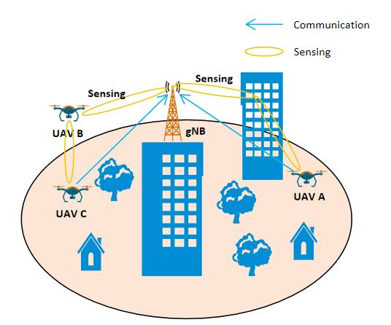

Figure 5.12.1-1 Network assisted collision avoidance for the UAVs

The following service flow gives an example of UAV delivery in retail goods delivery.

### 5.12.2 Pre-Conditions

Network Operator ‘MM’ provides a new 5G service named ‘5G Sensing Service’.

The UAV City Express ‘SS’ uses a specific UTM to assist its retail goods UAV delivery.

This UTM uses ‘5G Sensing Service’ provided by 5G network Operator ‘MM’ as additional source of information and navigate the UAVs.

Tom has ordered online daily necessities from a supermarket. Tom is living in downtown.

Jerry has also ordered online some food from a supermarket. Jerry is living in countryside.

The supermarket prepares the goods in packages and asks City Express ‘SS’ to deliver them to Tom and Jerry.

City Express ‘SS’ dispatches UAV A for Tom, and UAV B for Jerry.

UE A is on board UAV A and UE B is on board UAV B. Both UE A and UE B are subscribed to the 5G network of Operator ‘MM’.

Through the communication connections between the 5G base station and the UE A/ UE B, the UE provides its positioning information and UE ID. The 5G network and UTM corelate the UE positioning information, UE ID with associated UAV ID.

### 5.12.3 Service Flows

The UAV A and UAV B are flying to their destinations under the guidance of UTM with the assistance of the ‘5G Sensing Service’ provided by network Operator ‘MM’.

Considering that UAV A will fly to downtown, the UTM asks network Operator ‘MM’’s ‘5G Sensing Service’ to provide sensing service for UAV A, and the required sensing result includes the flying environment along its trajectory, e.g. altitude of the buildings, obstacles and other UAVs nearby.

Considering UAV B will fly to the countryside, the UTM asks network Operator ‘MM’’s ‘5G Sensing Service’ to provide sensing service for UAV B, and the required sensing result includes the flying environment along its trajectory e.g. obstacles, and other UAVs nearby.

The UTM requests the report period about UAV A and UAV B.

Each base station continuously sends sensing signaling along the UAV A’s trajectory, and the UE A on board of the UAV A can send the sensing measurement data which it collects for its surrounding environment back to the base station using the 5G communication connection. Then, the 5G network can obtain a comprehensive UAV A’s flying environment sensing result e.g. building position, altitude, other nearby moving objects e.g. other UAV’s relative position, altitude, degree of moving angle, moving speed etc. to UTM.

Same sensing operation is also for UAV B.

The 5G network reports the sensing result periodically according to UTM’s request.

The UTM adjusts and guides the UAV flying trajectories considering the received sensing result and input from other sources (e.g. FLARM, ADS-B).

Considering UAV A is flying toward downtown, both the flying environment (e.g. many buildings) and wireless environment are complex compared with UAV B and its environment in countryside, the 5G network need to configure different sensing operation for UAV A and UAV B to guarantee required sensing service quality, for example to operate sensing with shorter period, sensing KPI, and report sensing result with higher refresh rate for UAV A.

### 5.12.4 Post-Conditions

The UAV A successfully delivers package to Tom and UAV B successfully delivers package to Jerry and return safely.

### 5.12.5 Existing features partly or fully covering the use case functionality

None.

### 5.12.6 Potential New Requirements needed to support the use case

Editor's Note: It is FFS if to use target or UAV in these requirements.

[PR 5.12.6 -1] The 5G system shall be able to provide a sensing service to track one or more specific target object and the environment around the target object/s with the assistant information provided by the UE on board the specific target object or authorized 3rd party.

NOTE 1: The assistant information for example can be UE position, UE ID.

[PR 5.12.6 -2] The base stations shall be able to sense multiple specific target objects and their environments at the same time.

Editor's Note: The environment in this requirement is FFS.

[PR 5.12.6 -3] The 5G system shall be able to provide a mechanism controllable by the operator, according to a business agreement, for a trusted 3rd party to request the sensing service related with a certain target object or multiple target objects of a certain location area.

[PR 5.12.6 -4] Based on operator policy, the 5G system shall be able to provide a mechanism for a trusted 3rd party to request per location area different sensing services configuration (e.g. sensing KPI, report refresh rate etc.).

[PR 5.12.6 -5] The 5G system shall be able to report sensing result of the environment around a specific target object to a trusted 3rd party.

NOTE 2: The sensing result of the environment for example can be its position, the size of obstacles around, and other moving objects nearby.

Editor's Note: This environment in this requirement is FFS.

[PR 5.12.6 -6] The 5G system shall be able to provide sensing service with follow KPIs.

Table 5.12.6-1 Sensing KPI for Network Assisted sensing

|  |  |  |  |  |  |  |  |  |  |  |  |  |  |  |  |
| --- | --- | --- | --- | --- | --- | --- | --- | --- | --- | --- | --- | --- | --- | --- | --- |
| **Scenario** | **Sensing Distance** | | | | | **Sensing Angle/direction** | | | **Sensing Speed** | | | | | **Interval between two consecutive sensing fixes** | **Latency** |
| **Accuracy** | **Resolution(m)** | **Distance(m)**  **Range** | **Vertical accuracy** | **Horizontal l accuracy** | **Accuracy** | **Resolution** | **Angle range** | **Vertical Accuracy** | **Horizontal accuracy** | **Resolution(m/s)** | **Vertical Speed range(m/s)** | **horizontal Speed range(m/s)** |
| Network assisted sensing to avoid UAV collision | FFS | <1  (Note 3) | FFS | FFS | FFS | FFS | FFS | FFS | FFS | FFS | 1  (Note 3) | <= 90  (Note 3) | FFS | FFS  (Note 1) | FFS  (Note 2) |
| NOTE 1: Time intervals between successive sensing result reports to a trusted third-party application.  NOTE 2: Latency from the gNB to the application server via core network.  NOTE 3: the KPI values are sourced from [29] | | | | | | | | | | | | | | | |

Editor's Note: The KPI term and table format will be updated.

Editor's Note: Other potential new requirements are FFS.

## 5.13. Use case on sensing for UAV intrusion detection

### 5.13.1 Description

UAV industry is developing quickly around the world with the widely usages in various scenarios such as aerial photography, police force, urban management, agriculture, geology, meteorology, electric power, emergency rescue and disaster relief, etc. Especially for the smart city in future, a large number of UAVs will be used to improve the quality of our daily life including industrial inspection, public security patrol, cargo transportation, live broadcast and so on. However, this also brings big challenges on UAV supervision due to the following reasons:

1) Low-altitude UAVs have characteristics as large number, small size, wide flying zone, widely used to execute complex and diverse tasks, which makes UAV supervision very difficult if only using the traditional radar system.

2) Non-cooperative UAVs could intrude some no-fly zone (e.g. airport, [military](C:/Users/cmcc/AppData/Local/Youdao/dict/Application/8.10.3.0/resultui/html/index.html#/javascript:;) [base](C:/Users/cmcc/AppData/Local/Youdao/dict/Application/8.10.3.0/resultui/html/index.html#/javascript:;)) intentionally or unintentionally which would lead to serious consequences, e.g. exposing private information using the camera, blocking other UAV traffic on the flying route..

5G radio signals can be used to provide wireless access for communication, meanwhile the 5G radio signals can also be used to generate sensing data for object detection e.g. sense presence or proximity of UAVs illegal flying in a specific area. 5GS could provide sensing service by processing sensing data and output sensing information (e.g. relative position, altitude, distance, velocity, direction). In this case, 5GS could be used for sensing the UAV intrusion in the scenarios of UAV illegal flying in restricted area include light rail, airports, government facilities, research institutes, high-speed railway stations, temporary performance venue and other permanent or temporary restricted areas.

Furthermore, considering that the UAV entering the restricted area is illegal and the UAV itself even could be illegal, this kind of sensing operation doesn’t require the cooperation of the UAV. That means the UAV may be unaware of the sensing operation. When multiple UAVs appear in the same restricted area, the 5G system can sense presence or proximity of multiple UAVs illegal flying at the same time.

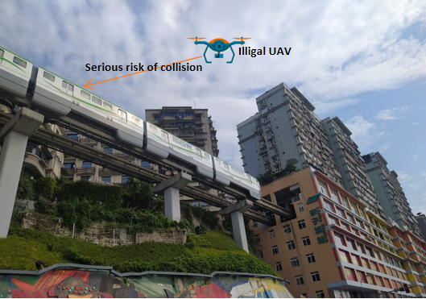

Figure 5.13.1-1 UAV collision risks at light rail

### 5.13.2 Pre-conditions

Network operator ‘MM’ provides 5G sensing service for the park and the light rail area with its 5G network covering the park and the light rail track. ‘MM’ can make use of wireless base stations to sense the airspace within their coverage area and report the sensing information to the USS/UTM as defined in TS 23.256 [Y] clause 3.1.

The Light rail operator ‘XX’ uses a UTM to management potential UAV illegal intrusion along the light rail tracks. ‘XX’ has provided its restricted area information to the UTM.

There is a need to hold a ceremony with high security requirement in the park temporarily, turning the park in a restricted area where UAVs are not allowed to enter. The administrator has a subscription for UAV prevention service from the USS/UTM.

The UTM uses ‘5G Sensing Service’ provided by 5G network Operator ‘MM’ to detect potential UAV illegal intrusion for above scenarios.

The UTM requests that once a UAV is detected that its distance from the border of the restricted area is less than 10m, the 5G system should report the event to the UTM.

The Network operator ‘MM’ can configure energy consumption sensing mode with different sensing period, e.g. operate sensing one time per 50 seconds, per 10 seconds, per second etc. And in emergency condition, the 5G system can provide continuously sensing service according to the UTM’s request.

The light rail works from 5:30 am to 23:00 pm every day.

### 5.13.3 Service Flows

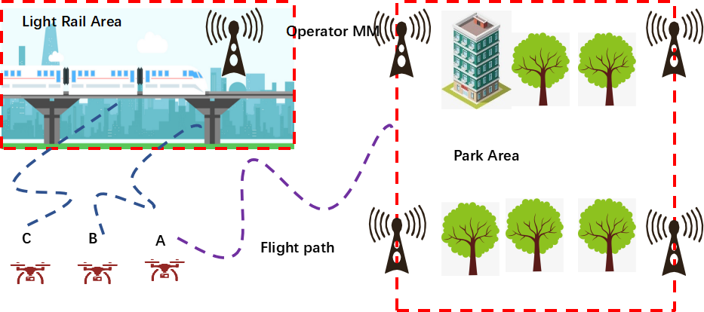

Figure 5.13.3-1: Sensing for UAV intrusion detection

The 5G system periodically senses the restricted area whether there are UAVs flying into the restricted area border for both the Park and the light rail area.

There are three UAVs(A,B,C) flying around the restricted areas.

When UAV C flying near the Park is detected and closely tracked with required accuracy in the sensing area, the 5G system reports the sensing results to the UTM in real time and begins continuously sensing.

When UAV B and UAV C flying near the light rail are detected, and closely tracked with required accuracy in the sensing area, the 5G system reports the sensing results to the UTM in real time and continuously senses.

To reduce energy consumption, the 5G system will notify the UTM that the 5G system cannot detect any UAVs illegal flying after a time period which is requested by the UTM. After that, the 5G system stops continuously sensing and begins periodically sensing operation according to the Network Operator’s policy.

The USS/UTM could trigger to send warning messages/notices to UAV controller based on analytical results based on the sensing information from the mobile network. Alternatively, the USS/UTM will trigger UAV countermeasures to prevent the UAV from flying in the no-fly area.

When the ceremony has been finished, the 5G system would stop sensing operation based on the request from UTM. And when the light rail stops operation between 23:00 pm to 5:00am next morning, the 5G system stops sensing operation to save energy.

### 5.13.4 Post-conditions

The mobile network can provide sensing service for UAV intrusion detection with high quality and continuity, to improve the accuracy and efficiency of public safety supervision and management.

USS/UTM interacts with the mobile network for sensing service and perform UAV intrusion detection based on the sensing information exposed by network.

### 5.13.5 Existing features partly or fully covering the use case functionality

None.

### 5.13.6 Potential New Requirements needed to support the use case

[P.R 5.13.6-001] The 5G system shall be able to provide a sensing service by using base stations to collect sensing measurements.

[P.R 5.13.6-002] The base station shall be able to sense a target object by obtaining sensing measurement without active involvement of the target object.

[P.R 5.13.6-003] The 5G system shall provide mechanisms for an operator to transport sensing data from base station towards the core network.

[P.R 5.13.6-004] Based on operator’s policy and subject to regulatory requirements, the 5G system shall be able to provide a mechanism for a trusted 3rd party to request the sensing service and based on the request, the base station shall be able to operate sensing periodically or continuously in certain location area for a certain amount of time.

[P.R 5.13.6-005] Based on operator’s policy and subject to regulatory requirements, the 5G system shall be able to periodically expose sensing results to a trusted 3rd party application.

[P.R 5.13.6-006] The 5G system shall provide a mechanism controllable by the operator, according to a business agreement, to report sensing result to a trusted 3rd party about a target object and multiple target objects when specific conditions are met.

Note: These conditions could be the target object distance from the restricted area border less than 10m or entering restricted area.

[P.R 5.13.6-007] The 5G system shall be able to support the activation and deactivation of the sensing service according to operator’s policy.

[P.R 5.13.6-008] The 5G system shall be able to provide a mechanism for network operator to configure and adjust sensing operation (e.g. authorization, sensing area, sensing operation period and sensing operation time window etc.).

Editor’ Note: Capturing 3rd party request is FFS.

[P.R 5.13.6-009] The 5G system shall be able to provide sensing with following KPIs.

Table 5.13.6-1 KPI Table of UAV intrusion detection

|  |  |  |  |  |  |  |  |  |  |  |  |  |
| --- | --- | --- | --- | --- | --- | --- | --- | --- | --- | --- | --- | --- |
| **Scenario** | **Sensing Distance** | | | **Sensing Angle/direction** | | | **Moving Speed of target object** | | | **altitude** | **Interval between two consecutive sensing fixes** | **Latency** |
| **Accuracy** | **Resolution(m)** | **Distance Range(Km)** | **Accuracy** | **Resolution** | **Angle range** | **Accuracy** | **Resolution(m/s)** | **Speed range(km/h)** | **(m)** |  | **(ms)** |
| Sensing for UAV intrusion detection | FFS | 10 | 1 | FFS | FFS | FFS | FFS | 10 | ≤90 | <300 | FFS | FFS |
| NOTE: The KPI values are sourced from [30] | | | | | | | | | | | | |

Editor’ Note: The KPI requirements for UAV intrusion detection are FFS.

## 5.14. Use case on sensing for tourist spot traffic management

### 5.14.1 Description

In order to ensure the sustainable development of tourist spots, the traffic flow management of tourist attractions should fully consider the space-carrying capacity, facility-carrying capacity, ecological-carrying capacity and other factors that may induce disasters within the area.

The scenic area controls the traffic flow through real-time monitoring, diversion of traffic and early warning and reporting. The flow control of tourist spots includes two aspects: passenger-flow management and vehicle-flow management.

Traffic data collection is an important part of traffic management. Base stations in tourist area can provide 5G communication service and also can sense the passenger and the vehicle in its coverage at gates or per unit area that are set with a finer granularity. For tourist spots with a large area, it will be convenient to use base station to have the traffic sensing data sources when it's difficult to deploy equipment like camera and other sensors.

### 5.14.2 Pre-conditions

Network Operator A provides 5G services for a famous tourist spot.

The management department of the tourist spot has subscribed the sensing service provided by 5G network Operator A. And the base stations in the tourist area can be used to sense the traffic flow and the crowd density (for both including the vehicles and passengers) constantly.

Jim is the worker of the tourist spot and responsible for traffic management.

### 5.14.3 Service Flows

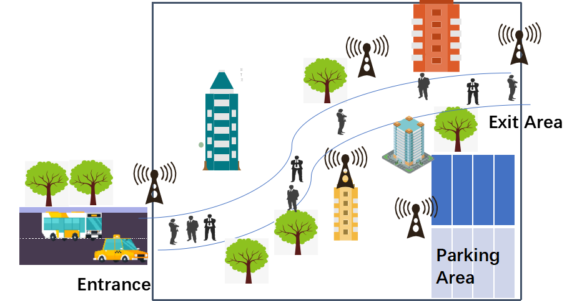

Figure 5.14.3-1: Sensing for tourist spot traffic management

1. When the scenic area begins to open. Jim will operate the scenic area traffic monitoring system to start real-time traffic control.

2. The traffic management system of the scenic spot will send a service request to the operator network to start sensing the people and vehicles in the scenic spot.

3. The base station at the entrance and exit of the scenic spot can sense the people and vehicles those will enter or leave the place, and the base stations in the scenic spot can sense the people and vehicles for certain area (e.g. walkway, parking area).

4. Operator A reports the traffic sensing information from the base stations in the scenic spot to the traffic monitoring system. Based on the sense information, the traffic management system could analyse the traffic status and decides whether the traffic in the area is congested.

5. If the congestion exceeds the threshold, the management system would notice Jim about the detail, and Jim would trigger to limit traffic to avoid traffic overload in the scenic spot.

### 5.14.4 Post-conditions

With 5GS support to the traffic management system, the vehicles and tourists are controlled within a reasonable range, and the spot can operate normally during business hours.

### 5.14.5 Existing features partly or fully covering the use case functionality

None.

### 5.14.6 Potential New Requirements needed to support the use case

[P.R 5.14.6-001] The 5G system shall be able to provide means to use base stations to perform sensing in certain area.

Editor's Note: This requirement is FFS.

[P.R 5.14.6-002] Subject to regulatory requirements and operator policy, the 5G system shall be able to expose sensing results to a trusted 3rd party application.

[P.R 5.14.6-003] Subject to regulatory requirements and operator policy, the 5G system shall be able to support the activation and deactivation of the sensing service based on location.

[P.R 5.14.6-004] The 5G system shall be able to provide sensing service with KPIs given in Table 5.14.6-1.

Table 5.14.6-1 KPI Table of tourist spot traffic management

|  |  |  |  |  |  |  |  |  |  |  |  |
| --- | --- | --- | --- | --- | --- | --- | --- | --- | --- | --- | --- |
| **Scenario** | **Sensing Distance** | | | **Sensing Angle/direction** | | | **Moving Speed of target object** | | | **Interval between two consecutive sensing fixes** | **Latency** |
| **Accuracy** | **Resolution(m)** | **Distance Range (Km)** | **Accuracy** | **Resolution** | **Angle range** | **Accuracy** | **Resolution(m/s)** | **Speed range(km/h)** |  | **(ms)** |
| Sensing for tourist spot traffic management | FFS | FFS | FFS | FFS | FFS | FFS | FFS | FFS | FFS | FFS | FFS |

Editor's Note: The KPI requirements for tourist spot traffic management are FFS.

## 5.15 Use case of contactless sleep monitoring service

### 5.15.1 Description

Compared with wearable devices, contactless sensing technologies have more advantages in health status detection. With more room has reserved for un-intrusion, contactless sensing-based health monitoring gives people, especially who view object contact as uncomfortable, more options. 3GPP system are designed for catering people’s communication purpose, whose wireless signals are very rich and can be accessible ubiquitously. With additional processing, 3GPP system will breed new opportunities with contactless sensing technologies applied, such as smart health, smart home, smart city and even smart space.

Sleep Monitoring application describes the case that a human’s sleep situation is monitored without any wearable device [31]. Instead of utilizing capacitors as propagation medium, Sleep Monitoring application effectively reuses the current ubiquitously accessible medium, that is wireless signals to realize the sensing purpose. People’s presence, movement and even respiration will affect the wireless signal propagation, which on the receiving side will be presented as the fluctuation of waveform’s intensity, phase shift and etc.

Figure 5.15.1-1 describes how the wireless signals that propagated via the established direct network connection (i.e. between the radio access network and 5G UE) will be affected and distorted by the target sensing object. Generally, when people is sleeping, regular chest rise and fall will cause additional vibration of the target object when detecting the doppler, this is defined as the **micro doppler effect** in radar [32]. By observing the micro doppler effect, people’s respiration rate per minute can be counted.

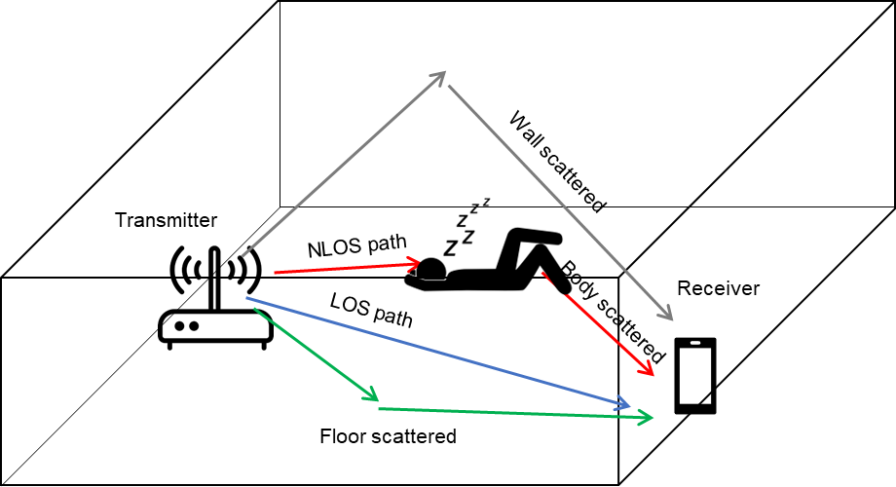

Figure 5.15.1-1: People’s respiration affected 3GPP wireless signal propagation in an indoor environment

NOTE 1: The transmitter as shown in Figure 5.15.1-1 is an indoor small base station as described in TS22.261 [33].

NOTE 2: The transmitter as shown in Figure 5.15.1-1 can also be a CPE that is used for this service.

### 5.15.2 Pre-conditions

The device installing this sleep monitoring application is 5G UE.

There is a service agreement between MNO and sleep monitoring operator. The MNO can also be the sleep monitoring application provider.

### 5.15.3 Service Flows

1. The application user Bob triggers the sleep monitoring application on the 5G UE. When the application server receives the request, the application server contacts the 5G system to trigger the sensing service.

2. 5G system discovers a base station (or CPE) to start the sleep monitoring sensing service.

3. The base station (or CPE) coordinates with Bob’s phone (5G UE) to perform the sensing measurement. The base station and the 5G UE can be transmitter and receiver or vice versa. The receiver measures the 5G wireless signals (e.g., number of detected transmission paths, micro doppler shift, etc.) and collects them as the sensing measurement data.

4. Sensing measurement data is processed to derive the sensing results (e.g. respiration rate) locally or is provided to the 5G network: 5G network processes the sensing measurement data to derive the sensing results and exposes the sensing results to the sleep monitoring application server.

5. The 5G UE receives the sleep monitoring feedback from the application server and shows it to the application user Bob.

### 5.15.4 Post-conditions

The user experiences the sleep monitoring application enabled by the 5G network.

### 5.15.5 Existing feature partly or fully covering use case functionality

None

### 5.15.6 Potential New Requirements needed to support the use case

Editor’s Note: it is FFS of whether there are or what additional requirements are needed to support this use case.

[PR.5.15.6-1] The 5G system shall support mechanisms to discover and configure a UE and a base station to perform sensing measurements in a certain sensing location area.

Editor’s Note: This requirement is FFS.

[PR.5.15.6-2] The 5G system shall support mechanisms to derive and expose sensing results to a trusted 3rd party.

## 5.16 Use case on Protection of Sensing Information

### 5.16.1 Description

This use case re-uses the scenario where a UE performs sensing to detect intruders in the home, as per use case 5.1 (intruder detection in smart home). The additional aspect introduced in this use case is that there is an unauthorised user that is attempting to collect sensing information from Mary's home.

### 5.16.2 Pre-conditions

Refer to use case 5.1 where 5G CPEs (i.e. UEs) are set up to detect intruders when Mary's home is vacant as her family is on holiday.

### 5.16.3 Service Flows

An unauthorised user is in the vicinity of Mary's home.

In Mary's home, the 5G CPE transmits 5G signals, and the reflected signals are used by the unauthorised user's device to collect sensing information.

As the 5G signals from the CPEs in Mary's home are protected, the unauthorised user's device fails to derive any sensing information.

### 5.16.4 Post-conditions

The privacy of sensing information in Mary's home is preserved.

The unauthorised user cannot use the 5G signals to detect that the family is not at home.

### 5.16.5 Existing features partly or fully covering the use case functionality

None

### 5.16.6 Potential New Requirements needed to support the use case

[PR 5.16.6-1] The 5G system shall provide a mechanism to protect identifiable information that can be derived from the sensing measurements data from eavesdropping.

## 5.17 Use case on health monitoring at home

### 5.17.1 Description

Tom is an elderly person living in his house. Since he has become weaker, he has subscribed to a wireless sensing service of his MNO so that his health state (including e.g. lack of movement, detection of falls, breathing rate) can be monitored 24/7 when he is at his home. Wireless sensing is a promising technology for health monitoring [34] [35] [36] [37] that does not require a person to wear a health monitoring device on his/her body (which people may forget, requires recharging, and can be uncomfortable to wear over long periods of time).

A single base station is not capable of covering Tom’s home with good coverage. Thus, multiple base stations capable of acting as wireless transmitters and/or receivers cooperate to ensure excellent coverage. Furthermore, the received reflected radar signal is sometimes weak, and thus, the MNO offers the possibility of using a phone with wireless sensing receiving capabilities. The usage of the phone also allows more accurate measurements of certain vital signs (e.g. breathing rate) since the phone is close to Tom. The usage of the phone also allows the MNO to offload the workload from the base station to the phone. Also other UEs in vicinity of Tom could take part in the sensing.

Fig. 5.x.1.1 shows a schematic illustration of how such system could look like, whereby the blue arrow indicates transmitted wireless sensing signals from Base Station A, and the green dashed arrows indicate reflected wireless sensing signals received by Base Station B and Tom’s phone.

Figure 5.17.1-1: Example of a distributed sensing system (incl. two base stations, a UE and a Sensing function).

### 5.17.2 Pre-conditions

1. Tom has subscribed to the sensing service offered by an MNO.

2. The MNO has deployed two RAN entities (e.g. base station A and base station B) that are capable of wireless communication and sensing. The base stations can act as wireless sensing transmitters and/or wireless sensing receivers. These two base stations are sufficiently close to Tom's house to provide good coverage in and around Tom's house in the frequency bands used for wireless sensing. Tom’s subscription includes a phone with wireless sensing capabilities for more accurate sensing.

3. Tom has a mobile phone that is capable of detecting wireless sensing signals. Tom can use it to directly and/or more accurately sense his health state.

4. The sensing measurement data from the base stations and UEs is collected and processed by a sensing function that can be deployed in the 5GS or provided by an external application or a combination thereof. The exact separation of functionalities between those entities is not explored further in this use case. The sensing function is assumed to be capable of extracting health state information, e.g. lack of movement, detection of falls, breathing rate from these sensing measurements, determine the sensing requirements (e.g. accuracy), and determine the criteria/thresholds (e.g. lack of movement) on when to create an alert.

### 5.17.3 Service Flows

1. Based on Tom’s sensing subscription, information about a user (in this case Tom) is obtained including information about where he lives and sensing requirements that are needed (e.g. sensing of movements which can be used to detect falls or sufficient activity of Tom).

2. Base station A starts transmitting the wireless sensing signal.

3. Tom is currently located in the living room. If Tom is at this location, base station A can hardly receive the reflection of its transmitted sensing signal. However, base station B can receive a strong reflection of that sensing signal. Base station A and B coordinate with each other so that Base Station B is capable of processing the received reflected wireless sensing signal, generating sensing measurement and/or sensing results that are sent to a sensing function for further processing. In this manner, movements of Tom in and around the house can be monitored, and it can be detected if Tom falls.

4. Tom feels a bit weak today and decides to measure his health state in more detail. Tom was told that he needs to carry his phone to enable this. Tom picks up his phone and uses it as a wireless sensing receiver capable of picking up and processing the reflected wireless sensing signal transmitted by Base station A. This requires the phone to coordinate wireless sensing with Base station A, which includes for example exchanging of capabilities (since the sensing capabilities can differ per phone) and coordinating of timing/frequencies of sensing signals. Since Tom’s phone is very close to Tom, Tom can use his phone for more accurate sensing of certain vital signs, such as breathing rate and heart rate. The phone sends measurements to a sensing function for further processing. When Tom goes to sleep, he puts his phone next to him to monitor his vital signs also during the night.

5. When Tom’s health state is determined to be in danger, e.g., when Tom falls or stops moving, the family or emergency services gets alerted of such event.

### 5.17.4 Post-conditions

The sensing service/application receives accurate sensing measurements about Tom and can generate alerts if an adverse event happens to Tom.

### 5.17.5 Existing features partly or fully covering the use case functionality

None

### 5.17.6 Potential New Requirements needed to support the use case

[PR 5.17.6-1] The 5G system shall be able to coordinate wireless sensing among a set of RAN entities and UEs.

[PR 5.17.6-2] The 5G system shall support a mechanism for the 5G network to retrieve the wireless sensing capabilities from UEs and RAN entities, and for the UEs and RAN entities to exchange capabilities amongst each other.

[PR 5.17.6-3] The 5G system shall support a mechanism for two or more authorized UEs and/or RAN entities to take part in the wireless sensing of a target, whereby the authorization may be provided based on location.

[PR 5.17.6-4] The 5G system shall support a mechanism to provide wireless sensing capable UEs and RAN entities with information of which network entity or destination server to send the sensing measurement data to.

## 5.18 Use case on service continuity of unobtrusive health monitoring.

### 5.18.1 Description

An elderly home has installed a new 5G system capable of providing communication and sensing capabilities through the facilities as illustrated in Figure 5.18.1-1. The deployed 5G system includes multiple sensing devices, e.g., base stations, providing connectivity and sensing capabilities. These sensing devices can perform wireless sensing of a target, in this case, health monitoring (e.g. fall/activity detection [34][35][36] or wireless sensing of vital signs such as heart rate [38] or breathing rate [37] of one or more persons). Since elderly people move through the facilities, it is important to provide health monitoring independently of the base station used for sensing. The staff of the elderly home really likes this new 5G wireless sensing feature because it is unobtrusive and offers various advantages over the old system that they use with body worn sensors. For example, they don’t need to recharge or replace the batteries of body worn sensors anymore and remind people or help people to wear them after they took them off (for example to take a shower). The elderly people themselves also like it more, since the body worn sensors often made them feel uncomfortable, especially during sleep or during hot days. Installing cameras was not seen as a good alternative because of the privacy concerns.

In the provided use case, base stations cooperate with each other to ensure service continuity for sensing of a ‘target’ user. In this particular scenario, a user, Robert, is considered who moves through the facilities. Robert's health is quite frail and requires continuous monitoring of his health state *without interruption*. Robert is currently sensed by means of (indoor) base station A located near his room and is moving out of the sensing area of base station A and approaching the sensing area of base station B covering the recreation/eating area and part of the hallway. Base station A and base station B cooperate in such a way that it is ensured that base station B has started wireless sensing of Robert before base station A stops its wireless sensing of Robert. When Robert is in range of both base station A and B, both base stations can cooperate to perform simultaneous wireless sensing. Similarly, when Robert decides to go for a walk to the garden that is covered by Base Station C, the sensing of Robert is seamlessly continued by Base Station C. The sensing measurement data is collected and processed by the 5G system (e.g. to detect certain movement patterns) and then exposed to a sensing application that is automatically monitoring health anomalies. If a health anomaly is detected (e.g. Robert falls down), an alarm is triggered indicating the health condition as well as the location of the monitored user.

Figure 5.18.1-1: Example of service continuity between Base stations A, B and C.

### 5.18.2 Pre-conditions

1. MNO operates a 5GS providing wireless sensing capabilities through a set of base stations installed in the elderly home and its garden, as illustrated in Figure 5.x.1-1.

2. Robert has subscribed to the wireless sensing service offered by the 5GS in cooperation with an external application provider. Robert provided some identification information, e.g. which room he resides in, the identity of his mobile phone and/or some physical characteristics (e.g. length). The application provider has no knowledge of the RAN infrastructure operated by the MNO.

### 5.18.3 Service Flows

1. Robert is currently located in his room in the elderly home. The closest nearby base station, i.e. base station A infers, based on the identification information provided by Robert, that Robert is in his room. Base station A starts wireless sensing of Robert, whereby it sends the sensing measurements to the 5GC for further processing, after which the sensing results are sent to a sensing application to detect health anomalies

2. Robert starts moving toward the garden.

3. When leaving his room and entering the hallway, the wireless sensing signal conditions of base station B become better than those of base station A.

4. The 5G system coordinates the responsibility of sensing Robert from base station A to base station B. During this time, both base station A and B might sense Robert.

5. Base station B is used for sensing Robert

6. Base station A can stop sensing Robert.

7. When leaving the elderly home and entering the garden, Base Station C continues the sensing of Robert.

### 5.18.4 Post-conditions

### Robert’s vital signs are monitored without interruption independently of his location.

### 5.18.5 Existing features partly or fully covering the use case functionality

None

### 5.18.6 Potential New Requirements needed to support the use case

[PR 5.18.6.1] The 5G system shall support service continuity for wireless sensing of a target between different sensing devices.

Editor’s Note: It is FFS if [PR 5.18.6.1] can be solved at application layer.

[PR 5.18.6.2] The 5G system shall support simultaneous wireless sensing of a target by means of multiple sensing devices.

# 6 Considerations

Editor's Note: This clause can capture privacy, charging, public safety considerations.

Editor’s note: This chapter is FFS

## 6.1 Considerations on confidentiality and integrity,

### 6.1.1 General

When introducing sensing technology, new aspects on confidentiality, integrity, and availability need to be considered, to ensure that these aspects are considered already when proposing service requirements.

For instance, with sensing technology by-standers can be affected in a completely new way, previously only UEs have been able to be tracked but now sensing capabilities may enable tracing and potentially identification of anything in the environment, including humans that do not carry a UE, or any objects. This has implications for privacy. Obviously humans should have a right to privacy.

Of course, factors such as resolution, updating frequency, and type of application influence the security implications.

Requirements to minimize the risk of unwanted usage and awareness of the usage needs to be considered in stage 1. These are captured in the next chapter.

### 6.1.2 Potential New Requirements

A set of general new requirements can be identified:

[P.R.6.1.2-1] The 5G system shall limit the sensing information to users authorized to receive that information.

[P.R.6.1.2-2] The 5G system shall support encryption and integrity protection of the sensing result, to protect the data inside the 5G system and when used.

[P.R.6.1.2-3] The 5G system shall support appropriate level of sensing for both situations where consent can be obtained from the sensing targets, and where it cannot.

## 6.2 Privacy

Since Sensing is almost for the whole environment under the RF signal coverage, the privacy of sensing operation is an important consideration factor for real deployment.

For the private area, the private permission is required for sensing operation from such as the homeowner for in-home sensing or the building management for the in-building sensing.

For the public area, such as the public road, park and airport, it is required to obtain the permission of the public area management.

For the specific object (e.g. rain), the content of the sensing result report is limited according to the authority of the sensing requester, for example, the climate and rainfall detection can be reported to the Meteorological Bureau.

For the sensed object that supports 3GPP UE capability, the 5GS should notify the UE about the sensing event and request consent of the user before sensing the object.

These privacy policies need to be configured on the 5GS and can be flexible modified by the related parties under the operator control.

## 6.3 Mission Critical and other priority services

The sensing operation in 5GS shall support commercial services (e.g. driving assistance), Mission Critical services (e.g. public safety, Utilities, Railways) and other priority services (e.g. MPS) with requirements for priority treatment.

The 5G system should allow flexible means to provide relative priority treatment among the sensing services (e.g. driving assistance, Mission Critical, MPS) and among the users of these services subject to regional/national regulatory rules and operator policy.

# 7 Consolidated potential requirements and KPIs

## 7.1 Consolidated potential requirements

## 7.2 Consolidated potential KPIs

# 8 Conclusion and recommendations

# 

Annex <Z> (informative):  
Change history

|  |  |  |  |  |  |  |  |
| --- | --- | --- | --- | --- | --- | --- | --- |
| **Change history** | | | | | | | |
| **Date** | **Meeting** | **TDoc** | **CR** | **Rev** | **Cat** | **Subject/Comment** | **New version** |
| 5.2022 | SA1#98e | S1-221249 | - | - | - | Initial Skeleton | 0.0.0 |
| 5.2022 | SA1#98e | S1-221250  S1-221251  S1-221252 | - | - | - | Output of approved pCRs from SA1 #98e | 0.1.0 |
| 9.2022 | SA1#99e | S1-222300  S1-222301  S1-222302  S1-222303  S1-222304  S1-222305  S1-222306  S1-222307  S1-222308  S1-222309  S1-222310  S1-222311  S1-222312  S1-222313  S1-222314  S1-222315  S1-222316  S1-222317  S1-222318  S1-222319  S1-222320  S1-222321  S1-222322 | - | - | - | Output of approved pCRs from SA1 #99e | 0.2.0 |