3GPP TR 22.876 V0.1.0 (2022-09)
Technical Report
3rd Generation Partnership Project;
Technical Specification Group Services and System Aspects;
Study on AI/ML Model Transfer-Phase 2
(Release 19)



The present document has been developed within the 3rd Generation Partnership Project (3GPP TM) and may be further elaborated for the purposes of 3GPP.
The present document has not been subject to any approval process by the 3GPP Organizational Partners and shall not be implemented.
This Report is provided for future development work within 3GPP only. The Organizational Partners accept no liability for any use of this Specification.
Specifications and Reports for implementation of the 3GPP TM system should be obtained via the 3GPP Organizational Partners' Publications Offices.
Keywords
AmbientIoT
3GPP
Postal address

3GPP support office address
650 Route des Lucioles - Sophia Antipolis
Valbonne - FRANCE
Tel.: +33 4 92 94 42 00 Fax: +33 4 93 65 47 16
Internet
http://www.3gpp.org
Copyright Notification
No part may be reproduced except as authorized by written permission.
The copyright and the foregoing restriction extend to reproduction in all media.

© 2017, 3GPP Organizational Partners (ARIB, ATIS, CCSA, ETSI, TSDSI, TTA, TTC).
All rights reserved.

UMTS™ is a Trade Mark of ETSI registered for the benefit of its members
3GPP™ is a Trade Mark of ETSI registered for the benefit of its Members and of the 3GPP Organizational Partners
LTE™ is a Trade Mark of ETSI registered for the benefit of its Members and of the 3GPP Organizational Partners
GSM® and the GSM logo are registered and owned by the GSM Association
Contents
Foreword 4
Introduction 4
1 Scope 5
2 References 5
3 Definitions, symbols and abbreviations 5
3.1 Definitions 5
3.2 Symbols 5
3.3 Abbreviations 5
4 Overview 5
5 Use cases 6
5.1 Use case 1 6
5.1.1 Description 6
5.1.2 Pre-conditions 6
5.1.3 Service Flows 6
5.1.4 Post-conditions 6
5.1.5 Existing features partly or fully covering the use case functionality 6
5.1.6 Potential New Requirements needed to support the use case 6
7 Consolidated potential requirements and KPIs 7
7.1 Consolidated potential requirements 7
7.2 Consolidated potential KPIs 7
8 Conclusion and recommendations 7
Annex <A>: <Annex title> 8
A.1 x 8
Annex <X>: Change history 9

Foreword
This Technical Report has been produced by the 3rd Generation Partnership Project (3GPP).
The contents of the present document are subject to continuing work within the TSG and may change following formal TSG approval. Should the TSG modify the contents of the present document, it will be re-released by the TSG with an identifying change of release date and an increase in version number as follows:
Version x.y.z
where:
x the first digit:
1 presented to TSG for information;
2 presented to TSG for approval;
3 or greater indicates TSG approved document under change control.
y the second digit is incremented for all changes of substance, i.e. technical enhancements, corrections, updates, etc.
z the third digit is incremented when editorial only changes have been incorporated in the document.

Introduction
This document identifies use cases with functional and performance requirements for 5G system support of AI/ML training and inference using direct device connection. By using direct device connection, it can provide a communication capacity and coverage, more work task offloading choice to achieve an efficient AIML training and inference.

1 Scope

The objective of this document is to study the use cases with potential functional and performance requirements to support efficient AI/ML operations using direct device connection for various applications e.g. auto-driving, robot remote control, video recognition, etc.
The aspects addressed in the document includes:
- Identify the use cases for distributed AI inference;
- Identify the use cases for distributed/decentralized model training;
- Gap analysis to existing 5GS mechanism to support the distributed AI inference and model training.

2 References
The following documents contain provisions which, through reference in this text, constitute provisions of the present document.
- References are either specific (identified by date of publication, edition number, version number, etc.) or non-specific.
- For a specific reference, subsequent revisions do not apply.
- For a non-specific reference, the latest version applies. In the case of a reference to a 3GPP document (including a GSM document), a non-specific reference implicitly refers to the latest version of that document in the same Release as the present document.
[1] 3GPP TR 21.905: "Vocabulary for 3GPP Specifications".
[2] 3GPP TR 22.874, Study on traffic characteristics and performance requirements for AI/ML model transfer in 5GS (Release 18)
[3] 3GPP TS 22.104, Service requirements for cyber-physical control applications in vertical domains
[4] Huaijiang Zhu, Manali Sharma, Kai Pfeiffer, Marco Mezzavilla, Jia Shen, Sundeep Rangan, and Ludovic Righetti, “Enabling Remote Whole-body Control with 5G Edge Computing”, to appear, in Proc. 2020 IEEE/RSJ International Conference on Intelligent Robots and Systems. Available at: https://arxiv.org/pdf/2008.08243.pdf
[5] B. Kehoe, S. Patil, P. Abbeel, and K. Goldberg, “A survey of research on cloud robotics and automation,” IEEE Transactions on automation science and engineering, vol. 12, no. 2, pp. 398–409, 2015.
[6] M. Chen, K. Huang, W. Saad, M. Bennis, A. V. Feljan, and H. V. Poor, “Distributed Learning in Wireless Networks: Recent Progress and Future Challenges”IEEE JOURNAL ON SELECTED AREAS IN COMMUNICATIONS, VOL. 39, NO. 12, DECEMBER 2021
[7] M. Chen, H. V. Poor, W. Saad, and S. Cui, “Wireless communications for collaborative federated learning,” IEEE Commun. Mag., vol. 58, no. 12, pp. 48–54, Dec. 2020

…
[x] <doctype> <#>[ ([up to and including]{yyyy[-mm]|V<a[.b[.c]]>}[onwards])]: "<Title>".

3 Definitions, symbols and abbreviations

3.1 Definitions
For the purposes of the present document, the terms and definitions given in 3GPP TR 21.905 [1] and the following apply. A term defined in the present document takes precedence over the definition of the same term, if any, in 3GPP TR 21.905 [1].
example: text used to clarify abstract rules by applying them literally.
Proximity-based work task offloading: based on 3rd party’s request, a relay UE receives data from a remote UE via direct device connection and performs calculation of a work task for the remote UE.

3.2 Symbols
For the purposes of the present document, the following symbols apply:
<symbol> <Explanation>

3.3 Abbreviations
For the purposes of the present document, the abbreviations given in 3GPP TR 21.905 [1] and the following apply. An abbreviation defined in the present document takes precedence over the definition of the same abbreviation, if any, in 3GPP TR 21.905 [1].
<ACRONYM> <Explanation>

4 Overview
In TR 22.874, three types of AIML operations as below has been described
- AI/ML operation splitting between AI/ML endpoints;
- AI/ML model/data distribution and sharing over 5G system;
- Distributed/Federated Learning over 5G system.
For the phase-2 study, it continues to study how the 5GS can have more gains for each type of AIML operations when leveraging direct device connection. Thus, the following clause 5, 6, and 7 is to capture use cases corresponding to the three types of AIML operations considering the assistance of direct device connection.

5 Split AI/ML operation between AI/ML endpoints for AI inference by leveraging direct device connection connection

5.1 Proximity based work task offloading for AI/ML inference

5.1.1 Description

The model splitting is the most significant feature for AI inference. As some R18 use cases in TR 22.874[3] shows, the number of terminal computing layers and the amount of data transmission are corresponding to different model spliting points. For example, as figure x.1-1 shows, the general trend is that the more layers the UE calculated, the less intermediate data needs to be transmitted to application server. In another word, when UE has low computation capacity (e.g. due to low battery), the application can change the splitting point to let UE calaulate fewer layers while increasing the data rate in Uu for tranmistting a higher load of intermediate data to network.
However, sometimes the data rate cannot be increased due to radio resource limitation, in such circumstances, UE with low computation capacity needs to offload the computation task to a proximity UE (likely a relay UE) but still keeping the computation service and let the proximity UE to send the calculated data to network. Thus, by offloading the work task using direct device connection, the orginal UE’s computation load will be released while the data rate in Uu interface will not necessarily be increased either, which leads to a more ideal performance.
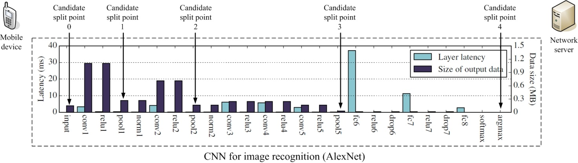
Figure 5.1-1. Layer-level computation/communication resource evaluation for an AlexNet model (abstracted from subclause 5.1.1 in TR 22.874)

5.1.2 Pre-conditions

A UE uses the AI model (AlexNet) for image recognition. As predetermined by application, there are 5 alternative spliting points which are corresponding to intermediate data size and data rate [13-14], while fewer the layers being calculated implies fewer the work load being performed by UE. The specific values are shown in the table below (it is abstracted from clause 5.1 Split AI/ML image recognition in TR22.874).
Table 5.1-1: Required UL data rate for different split points of AlexNet model for video recognition @30FPS (Frame Per Second)
Split point | Approximate output data size (MByte) | Required UL data rate (Mbit/s)
Candidate split point 0  (Cloud-based inference) | 0.15 | 36
Candidate split point 1  (after pool1 layer) | 0.27 | 65
Candidate split point 2  (after pool2 layer) | 0.17 | 41
Candidate split point 3  (after pool5 layer) | 0.02 | 4.8
Candidate split point 4  (Device-based inference) | N/A | N/A

5.1.3 Service Flows

- no task offloading (b) task offloading by UE-B
Figure 5.1-3: Using direct device connection (sidelink) to realize the proximity-based work task offloading. In this case, the data rate on Uu need not be increased while the original UE’s computation load is offloaded
- As shown in left(a) of Figure x.1-2, UE-A is doing image recognition using Alexnet Model as described in clause 5.4.2. It selects splitting point-3 for the AI inference.
The E2E service latency (including image recognition latency and imtermediate data transmission latency) is 1 second.
- When the UE-A’s battery becomes low, it cannot afford the heavy work task for the AlexNet model (i.e. calculating layer 1-15 for AlexNet model in local side).
- The UE-A discovers UE-B (a Costomized Premise Equirement, CPE) which has installed the same model and is willing to take the offloading task from UE-A.
Then UE-A established the sidelink (direct device connection) to UE-B. During the sidelink establishment, the UE-B also get the information of the total service latency (including the image recognition latency and intermediate data transmission latency) and the processing time consumed by UE-A for computing layer 1-4. Since the UE-B has acquired the E2E service latency and the processing time consumed by UE-A, and also it knows its own processing time for computing layer 5-15, the UE-B can determine the QoS parameters applied to both Uu and Sidelink while keeping the E2E service latency same as the E2E service latency described in step-1.
NOTE: It is assuming the UE-A and UE-B have the same computation capacity, i.e. the time used for computing the certain AlexNet model layers are the same for UE-A and UE-B. Otherwise, the data rate on Uu and Sidelink may be changed accordingly.
- The UE-A sends the intermediate data (data after calculating layer 1-4) to UE-B via sidelink and let UE-B makes further processing then transmit the intermediate data (data after calculating layer 5-15) to application server via Uu. The specific model layers being computed by UE-A and UE-B are shown in the right(b) in figure x.1-3.
- UE-A continues to perform image recognition by leveraging sidelink and UE-B’s computation capacity while the source and destination IP address and the E2E service latency for the image recognition service is unchanged.

5.1.4 Post-conditions

Thanks to UE-B’s help, the proximity-based work task offloading is performed. By doing so,
- it decreased the UE-A’s work task by letting UE-A to compute fewer layers of AlexNet model, which helps to meet the low battery condition happened to UE-A;
- The UE-B computes the rest of layers which is originally from the UE-A’s work task;
- the mobile network does not need to increase the QoS parameters such as guaranteed data rate because the intermediate data rate transmitted by UE-B is unchanged.

5.1.5 Existing features partly or fully covering the use case functionality

In TS 22.261 clause 6.9, the description about the direct network connection mode and the indirect network connection mode as well as the service continuity for switching between the two modes have been described. They are summarized as below:
The UE (remote UE) can connect to the network directly (direct network connection), connect using another UE as a relay UE (indirect network connection), or connect using both direct and indirect connections.
The 5G system shall support different traffic flows of a remote UE to be relayed via different indirect network connection paths.
The 5G system shall be able to maintain service continuity of indirect network connection for a remote UE when
However, there is no proximity-based work task offloading which means that the “relay UE” not only performs the indirect network communication but also performs task computation for the “remote UE”. This may impact the current discovery mechanism, QoS determination on Uu and PC5, and charging aspect.

5.1.6 Potential New Requirements needed to support the use case

5.1.6.1 Potential Functionality Requirements

5.1.6.2 Potential KPI Requirements
Considering the widely-used AlexNet and VGG-16 model for proximity-based work task offloading, the following KPIs need to be supported:
Table 5.1-2 KPI requiremnts for proximity-based work task offloading
 | UL data size  (for sidelink) | UL data rate  (for sidelink) | Intermediate data uploading latency (including sidelink+Uu) | Image recognition latency
AlexNet model with 30FPS (NOTE 1) | 0.15 - 0.02 Mbyte for each frame | 4.8 – 65 Mbit/s | - 2ms for Rmote driving, AR displaying/gaming, and remote-controlled robotics;  - 10ms for video recognition;  - 100ms for One-shot object recognition, Person identification, or photo enhancement in smart phone | 1s
VGG-16 model with 30FPS | - - 1.5 Mbyte for each frame | 24 - 720 Mbit/s |  | 1s
NOTE 1: FPS stands for Frame Per Second

6 AI/ML model/data distribution and sharing by leveraging direct device connection

6.1 AI Model Transfer Management through Direct Device Connection

6.1.1 Description

Based on the earlier study in phase one[2], operators can provide services to help manage and distribute the AI/ML models especially in the edge server so that the UE can acquire a proper model immediately. However, when a lot of UEs requesting for the same model at the same time or the UE is blocked by barriers with poor connection with the base station, the model transfer process will become longer than expected.
To overcome this difficulty, as shown in Fig.1, a volunteer UE which is well connected to the base station can help receive and store AI/ML models first. Then, the other UEs can download AI/ML models from the volunteer UE through direct device connection. In this way, all UE can have a stable and reliable model transfer process while the radio resource of the base station can be saved. Besides, the volunteer UE can transfer the stored models to other volunteer UEs under operator’s control.
The selection of volunteer UE can be realized by local network policies and strategies. And it also can be exposed as a capability to the 3rd party company when the company wants to choose one or a few certain UEs to be volunteer UEs in an activity. For example, a travel company may assign the tour guides’ Augmented Reality (AR) headsets as volunteer UEs in a carnival through the operator’s network exposure. The travel company may sign a higher quality plan for tourist guides’ devices to provide better user experience for following tourists. Meanwhile, operator can benefit from the alternative open service based on AI/ML model management capabilities and may avoid low Quality of Service due to crowding direct connections to base stations during the carnival.
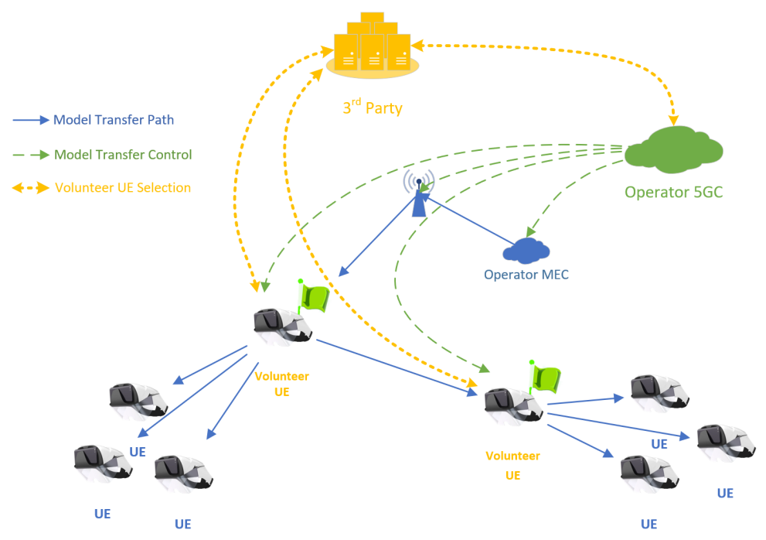
Fig.1 AI/ML Model management through direct device connection

6.1.2 Pre-conditions

The operator’s MEC near the Jurassic Park stores a variety of AI/ML models according to the the park company’s requirements. And it is capable to transfer the stored model to the device such as AR headset.
The operator rolls out a new high quality plan which can allow the user customizes own Service Level Agreement (SLA) for specific network address access and data (e.g. AI/ML Models) download. As a trade-off, the user’s device will help transfer the same data through direct device connection to nearby devices sharing common aspiration.
The AR headset can transfer the stored AI/ML model to the other AR headsets. However, the AR headset cannot store all models for different scenarios due to limited storage. Indeed, a model needs to be downloaded when or a few seconds before the UE first appears in the certain area.
Alice and Bob are tour guide hired by Jurassic Park and their real-time positions can be acquired when they are in the park based on signed agreements.
All of AR headsets should in the coverage of the base stations serving for the Jurassic Park.

6.1.3 Service Flows

1. Jurassic Park provides panorama AR tour guide services in a commercial area and a tropical rainforest area. AR headsets need to download Model A and B (both are 32 bits VGGnet, 536MByte) respectively.
2. To provide high quality user experience, Jurassic Park company indicates to the operator that AR headsets require to download model A in area A and model B in area B.
3. The Jurassic Park company signs a high quality plan for tour guide Alice and Bob’s AR Headsets for providing better service to the tour group using direct device connection.
4. When Bob and his tour group enter area A, their headsets request for the Model A. The operator network finds they requested the same model and Bob is a signed volunteer UE, then triggers to establish a QoS acceleration for Bob’s model downloading timely. Meanwhile, Jurassic Park requests the operator network to inform Bob to help transfer the model to all other UE near Bob. Also, the operator network informs all other UE near Bob that Bob can provide the model as well. The UE which is a little far from Bob (e.g. out of Bob’s coverage) will still download the model through the base station directly.
5. Alice and her group are 10 meters far from Bob and also move towards to area A. Jurrassic Park predicts their desire model based on their movement and finds Bob has already downloaded it based on the model transferring records. Jurassic Park requests operator network to inform Alice that she can request model from Bob. Meanwhile, the operator network indicates all other UE near Alice to download the model from Alice.
6. For Alice and Bob, they can see the status of all direct device connections to themselves through network exposures providing by operators (e.g. monitored bandwidth and latency of each direct device connection)
7. When Alice and Bob notice that their groups have a poor QoS of model transfer through direct device connection, they can send a request to the park company for promoting the performance of their direct device connections and the park company will send a similar message to the operator through network exposure to active a temporary acceleration of these direct device connections (e.g. expand the bandwidth of each direct device connection).

6.1.4 Post-conditions

1. The tourists can enjoy the continuous AR services with smooth model switchover when their location and responding models change.
2. Tour group’s AR headsets provides user experience of the panorama AR tour guide services that can help retrain and improve AI/ML models in operator’s MEC by Jurassic Park company (e.g. Federated/Distributed Learning).
3. the operator network performs analytics, based on network statistics and quality of experience reported by Jurassic Park company, to improve and optimized the model transfer process (e.g. setting constraints for maximum direct device connection for one volunteer UE and choose a temporary volunteer UE for sharing model transfer task).

6.1.5 Existing features partly or fully covering the use case functionality

22.261 v18.6.0 6.27
The 5G system shall be able to make the position-related data available to an application or to an application server existing within the PLMN, external to the PLMN, or in the User Equipment.
Editor's Note: it is FFS whether other existing features will be identified.

6.1.6 Potential New Requirements needed to support the use case

[P.R.x.y-001] Subject to user consent, operator policies and regional or national regulatory requirements, the 5G system shall support means to monitor a direct device connection and expose corresponding monitoring information (e.g. experienced data rate, latency) to an authorized 3rd party.
NOTE: The monitoring information in [P.R.x.y-001] doesn’t include any user position-related data.
Editor's Note: it is FFS whether other potential new requirements or corresponding KPIs can be identified.

7 Distributed/Federated Learning by leveraging direct device connection

7.1 Direct device connection assisted Federated Learning

7.1.1 Description

In many circumstances, an application server holding a Federated Learning (FL) task has a transmission delay requirement and limited FL coverage. An FL coverage means an area in which UEs the Application server can organize for federated learning.
An Application server has a transmission delay requirement for each FL member (UE). Some of UEs are actually holding valuable dataset but cannot fulfil transmission delay requirement, which leads to a decreasing of FL performance. However, if a UE’s direct network connection cannot fulfil the transmission delay requirement (i.e. an QoS on Uu), leveraging the devices with direct connections helps to involve more UEs holding valuable dataset for the FL task with the following case study:
A UE-A with bad transmission condition sends a UE’s training result to UE-B via direct device connection. In such case, a UE-B aggregates the training result locally and provides to UEs an update of training model for next round.
Some research e.g. in [6][7] have illustrated the increasing performance in subcase-B (we call it “decentralized averaging methods”). In order to include more devices to participate in FL and to reduce the devices’ reliance on the PS, the authors in [7] uses decentralized averaging methods to update the local ML model of each device. In particularly, using the decentralized averaging methods, each device only needs to transmit its local ML parameters to its neighboring devices. And the neighboring devices can use the acquired ML parameters to estimate the global ML model. Therefore, using the decentralized averaging methods can reduce the communication overhead of FL parameter transmission.
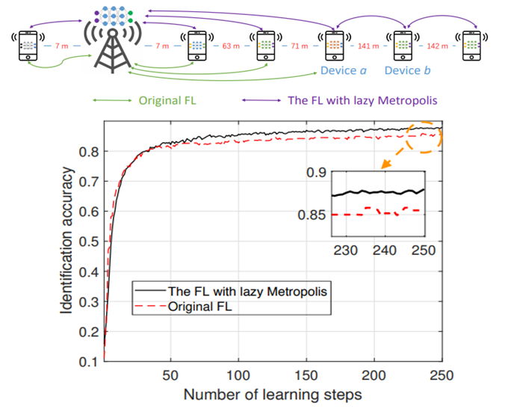
Figure-1 FL with decentralized averaging method outperforms the original FL
To show the performance of decentralized averaging method, the [6] implemented a preliminary simulation for a network that consists of one BS that is acted as an application server and six devices, as shown in Figure-1. In Figure-1, the green and purple lines respectively represent the local ML parameter transmission of original FL and the FL with decentralized averaging methods. Due to the transmission latency requirement, only 4 devices can participate in original FL. For the FL with the decentralized averaging update method, 6 devices can participate in the FL training process since the devices which are out of coverage can connect to their neighbouring devices (i.e. Device a and Device b) for model updating.
From Figure-1, we can see that the FL with decentralized averaging method outperforms the original FL in terms of identification accuracy. Specifically, the original FL (without using direct device connection) has an upper limit of identification accuracy to about 0.85, while using direct device connection for decentralized averaging method helps to increase the identification accuracy to about 0.88 which is actually a big optimization since the line already goes smoothly after 200 round of FL training.
Besides, the FL leveraging direct device connection can also reduce the energy consumption for some devices since it only needs to transmit its ML model parameters to device instead of the BS.

7.1.2 Pre-conditions

Figure-2 two UEs performs decentralized FL using Direct Device connection)
As depicted in Figure-2, there is an Application server for federated learning which needs to communicate with the UEs in a FL coverage for FL task.
To achieve an ideal performance (i.e. fast convergence and high model accuracy), there is a transmission latency requirement to each FL member UE’s data transmission.
Alice and Bob are FL members but their cell phones sometimes have bad signal condition which cannot transmit data to FL service directly. Meanwhile, Bob is willing to support the “decentralized averaging method” (as described in clause 5.x.1) service for its neighbouring cell phones.
Alice, Bob are neighbouring to each other within a FL coverage.

7.1.3 Service Flows

- Alice is a FL member and already acquires the global AI/ML model from the Application server for FL task, later on when Alice moves to a tunnel with bad signal condition, Alice cell phone’s with direct device connection with her neighboring cell phonese cannot transmit model data to its Application server anymore.
- In the tunnel, Alice discovers Bob, who is neighbouring to Alice, a FL member and willing to activate the “decentralized averaging method” service. Thus, Alice requests Bob to establish a direct device connection so that Alice can transmit the AI/ML model training result to Bob.
- Bob updates the AI/ML model based on Alice’s training result and Bob’s local training result. And Bob sends the updated AI/ML model to Alice for further training.
When Bob moves to a good coverage and is able to transmit the AIML training model (e.g. after several rounds of AIML model parameters exchange between Alice and Bob have been done), Bob transmits the training result to Application server to assist the Application server to perform a global model updating.

7.1.4 Post-conditions

By leveraging direct device connection, Alice and Bob can keep the model training of a FL task even when they are under a bad network coverage. And the training result between Alice and Bob can be further uploaded to Application server for global model updating.
Thanks to leveraging direct device connection, it helps FL to be performed even when no communication availability to FL server. Such use case helps to optimize the FL performance.

7.1.5 Existing features partly or fully covering the use case functionality

TS22.261 v18.6.0 6.40.2
Based on operator policy, the 5G system shall be able to provide means to allow an authorized third-party to monitor the resource utilisation of the network service that is associated with the third-party.
NOTE 1: Resource utilization in the preceding requirement refers to measurements relevant to the UE’s performance such as the data throughput provided to the UE.
Based on operator policy, the 5G system shall be able to provide an indication about a planned change of bitrate, latency, or reliability for a QoS flow to an authorized 3rd party so that the 3rd party AI/ML application is able to adjust the application layer behaviour if time allows. The indication shall provide the anticipated time and location of the change, as well as the target QoS parameters.
Based on operator policy, 5G system shall be able to provide means to predict and expose predicted network condition changes (i.e. bitrate, latency, reliability) per UE, to an authorized third party.
Subject to user consent, operator policy and regulatory constraints, the 5G system shall be able to support a mechanism to expose monitoring and status information of an AI-ML session to a 3rd party AI/ML application.
NOTE 2: Such mechanism is needed for AI/ML application to determine an in-time transfer of AI/ML model.
Subject to user consent, operator policy and regulatory requirements, the 5G system shall be able to expose information (e.g. candidate UEs) to an authorized 3rd party to assist the 3rd party to determine member(s) of a group of UEs (e.g. UEs of a FL group).

7.1.6 Potential New Requirements needed to support the use case

Functionality Requirements:
[P.R.7.x-001] Based on user consent and operator policies, the 5G system shall support to discover a suitable UE who participates in the same service group (e.g. for the same FL task) when direct network connection is not available for the service.
Editors note: this requirement is FFS
KPI requirement for direct device communication
The 5G system shall support the following KPI on direct device connection as defined in Table 5.x.6-1
NOTE: The table refers to a typical AI/ML model for image recognition i.e. a 7-bit CNN model VGG16_BN using 224×224×3 images as training data).
Table 5.x.6-1: Latency and user experienced UL/DL data rates for uncompressed Federated Learning
Mini-batch size  (images) | Maximum latency for trained gradient uploading and global model distribution (see note 1) | User experienced UL/DL data rate for trained gradient uploading and global model distribution (see note 2)
64 | 3.24s | 325Mbit/s
32 | 1.9s | 55Mbit/s
16 | 1.3s | 810Mbit/s
8 | 1.1s | 960Mbit/s
4 | 1.04s | 1.0Gbit/s

8 Consolidated potential requirements and KPIs

8.1 Consolidated potential requirements

8.2 Consolidated potential KPIs

9 Conclusion and recommendations

Annex <A>:
<Annex title>

A.1 x
Heading levels within an annex are used as in the main document, but for Heading level selection, the "A.", "B.", etc. are ignored. e.g. A.1.2 is formatted using Heading 2 style.

Annex <X>:
Change history
Change history
Date | Meeting | TDoc | CR | Rev | Cat | Subject/Comment | New version
2022.05 | SA1#98e | S1-221010 | - | - | - | Initial Skeleton | 0.0.0
2022.09 |  | S1-222397 | - | - | - | Introduction of TR 22.876 on study of AI/ML Model Transfer Phase 2 | 0.1.0
2022.09 |  | S1-222158 | - | - | - | Scope of TR 22.876 on study of AI/ML Model Transfer Phase 2 | 0.1.0
2022.09 |  | S1-222398 | - | - | - | Adding description in overview and updating the TR structure | 0.1.0
2022.09 |  | S1-222399 | - | - | - | Use Case of AI model transfer management through direct device connection | 0.1.0
2022.09 |  | S1-222400 | - | - | - | Proximity based work task offloading for AIML inference | 0.1.0
2022.09 |  | S1-222401 | - | - | - | Direct device connection assisted Federated Learning | 0.1.0

