**3GPP TSG-SA WG1 Meeting #96-e S1-21xxxx**

**Electronic Meeting, 08-18 Nov 2021** *(revision of S1-21xxxx)*

**Source: Huawei**

**pCR Title: FS\_TACMM multi-modality vs. multi-modal**

**Draft Spec: 3GPP TR 22.847 V18.0.0**

**Agenda item: 7.11.1**

**Document for: Approval**

**Contact: Alice Li, alice.li1@huawei.com**

*Abstract: There are mixed uses of multi-modal and multi-modality in the current TR 22.847. This document discusses the way forward to align the terminology, and provides a CR accordingly.*

**Discussion**

Both multi-modal and multi-modality are used in the current TR, which need to be aligned to avoid any confusion.

modal vs. modality

C:\Users\awx957877\AppData\Roaming\eSpace_Desktop\UserData\awx957877\imagefiles\5D8BB1B9-321D-4D09-B1FE-201D289F5E42.png

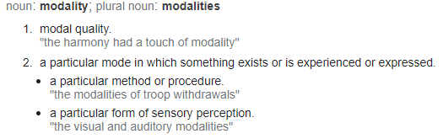

**Observation:** generally modal is used as an adjective while modality a noun.

In the context of describing a (communication) service or an application or a system, multi-modal should be used instead of multi-modality, i.e.

* tactile and ***multi-modal*** communication services
* ***multi-modal*** service
* ***multi-modal*** interactive system
* ***multi-modal*** application
* tactile and ***multi-modal*** interactions
* multiple ***modal*** representations
* ***multi-modal*** data and ***single-modal*** data
* ***multi-modal*** outputs

**Proposal: To replace multi-modality with multi-modal when it is intended to be used as an adjective.**

A CR is provided to update the TR accordingly.