**3GPP TSG-SA1 Meeting #94e-bis *S1-21xxxx***

**Electronic Meeting, 5 – xx July 2021** *(revision of S1-21xxxx)*

|  |  |  |  |  |  |  |  |  |
| --- | --- | --- | --- | --- | --- | --- | --- | --- |
| *CR-Form-v12.1* | | | | | | | | |
| **CHANGE REQUEST** | | | | | | | | |
|  | | | | | | | | |
|  | **22.261** | **CR** |  | **rev** | **<Rev#>** | **Current version:** |  |  |
|  | | | | | | | | |
| *For* [***HE******LP***](http://www.3gpp.org/3G_Specs/CRs.htm#_blank)*on using this form: comprehensive instructions can be found at* [*http://www.3gpp.org/Change-Requests*](http://www.3gpp.org/Change-Requests)*.* | | | | | | | | |
|  | | | | | | | | |

|  |  |  |  |  |  |  |  |  |
| --- | --- | --- | --- | --- | --- | --- | --- | --- |
| ***Proposed change affects:*** | UICC apps |  | ME |  | Radio Access Network |  | Core Network |  |

|  |  |  |  |  |  |  |  |  |  |  |
| --- | --- | --- | --- | --- | --- | --- | --- | --- | --- | --- |
|  | | | | | | | | | | |
| ***Title:*** | Consolidated Requirements | | | | | | | | | |
|  |  | | | | | | | | | |
| ***Source to WG:*** | vivo | | | | | | | | | |
| ***Source to TSG:*** | 3GPP SA1 | | | | | | | | | |
|  |  | | | | | | | | | |
| ***Work item code:*** | FS_PIN | | | | |  | ***Date:*** | | | Rel-18 |
|  |  | | | |  | |  | | |  |
| ***Category:*** | B |  | | | | | ***Release:*** | | |  |
|  | *Use one of the following categories:* ***F*** *(correction)* ***A*** *(mirror corresponding to a change in an earlier release)* ***B*** *(addition of feature),* ***C*** *(functional modification of feature)* ***D*** *(editorial modification)*  Detailed explanations of the above categories can be found in 3GPP [TR 21.900](http://www.3gpp.org/ftp/Specs/html-info/21900.htm). | | | | | | | | *Use one of the following releases: Rel-8 (Release 8) Rel-9 (Release 9) Rel-10 (Release 10) Rel-11 (Release 11) … Rel-15 (Release 15) Rel-16 (Release 16) Rel-17 (Release 17) Rel-18 (Release 18)* | |
|  |  | | | | | | | | | |
| ***Reason for change:*** | | Add consolidated requirements that are missing. | | | | | | | | |
|  | |  | | | | | | | | |
| ***Summary of change:*** | | Add consolidated requirements. | | | | | | | | |
|  | |  | | | | | | | | |
| ***Consequences if not approved:*** | | No consolidated requirements | | | | | | | | |
|  | |  | | | | | | | | |
| ***Clauses affected:*** | | TBD | | | | | | | | |
|  | |  | | | | | | | | |
|  | | **Y** | **N** |  | | | |  | | |
| ***Other specs*** | |  | **X** | Other core specifications | | | | TS/TR ... CR ... | | |
| ***affected:*** | |  | **X** | Test specifications | | | | TS/TR ... CR ... | | |
| ***(show related CRs)*** | |  | **X** | O&M Specifications | | | | TS/TR ... CR ... | | |
|  | |  | | | | | | | | |
| ***Other comments:*** | |  | | | | | | | | |
|  | |  | | | | | | | | |
| ***This CR's revision history:*** | |  | | | | | | | | |

****Start changes****

# 7 Potential Consolidated Requirements

This section provides Consolidated Potential Requirements for consideration to include in the normative specifications. The CPR’s have been grouped into different functional categories, each category contains a table that lists the original PR and any relationship to 3GPP TR 22.858 [6].

## 7.0 PIN Element Requirements

Table 7.0-1 – PIN Element Consolidated Requirements

| CPR No. | Potential Requirement | |
| --- | --- | --- |
|  | Original Potential requirement  No. | Potential requirement text |
|  | PR.5.1.5-7 | PIN Elements shall be able to communicate when there is no connectivity between a PIN Element with Gateway Capability and a 5G network.  NOTE 1: In this case, PIN Elements can only use non operator managed spectrum for communications and authentication mechanisms that do not require 5CN and or internet connectivity i.e. PIN Elements that are managed locally. |
|  | PR 5.2.6-1 & PR 5.7.6-1 | A PIN Element shall be authorized for more than one PIN. |
|  | PR 5.3.6-1 | A PIN Element shall be able to support simultaneous transmissions to multiple PIN Elements when a PIN Element is in the same PIN or another PIN. |
|  | PR 5.1.5-2 | A PIN Element shall be able to support both delay and non-delay tolerant services. |
|  | PR 5.1.5-3 | A PIN Element shall be able to support fault tolerant operations. |

## 7.1 Gateway

Table 7.1-1 – PIN Gateway Consolidated Requirements

| CPR No. | Potential Requirement | |
| --- | --- | --- |
|  | Original Potential requirement  No. | Potential requirement text |
| TBD | PR 5.3.6-3 | A PIN may include one or more PIN Elements with Gateway Capability |
|  | PR 5.10.6-2 | A PIN Element shall be able to detect loss of connectivity to the 5G network. |
|  | PR 5.9.6-1, PR 5.13.6-3 | The 5G system shall support access to the 5G network and its services for an authorized PIN Element (linked to a 3GPP subscription and provisioned with credentials) via one or more PIN Elements with gateway capability or directly. |
|  | PR 5.8.6-2 | A PIN Element with Gateway Capability shall support optimization of PIN Element service discovery (e.g., reducing the frequency of service discovery messages). |

## 7.2 PIN Element and Service Discovery

Table 7.2-1– PIN Service Discovery Consolidated Requirements

| CPR No. | Potential Requirement | |
| --- | --- | --- |
|  | Original Potential requirement  No. | Potential requirement text |
| TBD | PR.5.1.5-10, PR 5.6.6-1, PR 5.13.6-1, PR 5.8.6-1, PR 5.10.6-6, PR-5.10.6-2 | A PIN Element may support a service discovery mechanism for other authenticated/authorized PIN Elements to discover, for example:   * PIN Element capabilities and status (e.g., relay, PEMC, PEGC) * Whether a PEGC has external data network connectivity   NOTE 1: external connectivity could be local break out or via the 5G core network.   * Expected availability of Power (e.g., how long is remaining battery life) * Supported applications/service (e.g., UPNP) * Device manufacturer * Security/encryption mechanisms available * PIN Network topology * connection types support by other PIN Elements (e.g. licensed spectrum PIN direct connection, non-licensed spectrum PIN direct connection)   NOTE 2: Any of the above may be done directly (depending on the discovery capabilities of the PIN elements) or via a PIN element with gateway capability or via a PIN with management capability e.g. when a PIN Element acting as a UE in the 5GS needs to discover a PIN Element or service behind a PEGC. |

## 7.3 Service Hosting

Table 7.3-1 – PIN Service Hosting Consolidated Requirements

| CPR No. | Potential Requirement | |
| --- | --- | --- |
|  | Original Potential requirement  No. | Potential requirement text |
| TBD | TBD | TBD |

## 7.4 Privacy & Security

Table 7.4-1 – PIN Privacy Consolidated Requirements

| CPR No. | Potential Requirement | |
| --- | --- | --- |
|  | Original Potential requirement  No. | Potential requirement text |
|  |  |  |
|  | PR 5.7.6-7 | The 5G system shall be able to provide secure communications between PIN Elements in a PIN.  NOTE: secure communications between PIN Elements can be provided when a PIN Element is acting as a UE in the 5GS. |
|  | PR 5.8.6-3, PR 5.8.6-4 | The PEMC, PEMG and 5G system shall support a mechanism to mitigate repeated and unauthorized attempts to access PIN Elements (e.g. mitigate a malicious flood of messages). |
|  | PR 5.1.5.-6 | The 5G system shall support a PIN Element using non operator managed credentials (e.g. provided by a third party) for performing communications within the PIN when those communications use PIN direct connections. |
|  |  | A PIN shall be able to use credentials that are created in the PIN to allow for the PIN to operate when the PIN has no external connectivity.  NOTE: external connectivity could be local break out or via the 5G core network. |
|  | PR 5.10.6-3 | The 5G system shall support a PIN Element to be configured with credentials of multiple user identities. |
|  | PR-5.11.6-3 | 5G system shall be able to support authentication and authorization of PIN elements whose subscriptions can belong to different operators to access the PIN. |

## 7.5 Direct Communications

Table 7.5-1 – PIN Direct Communications Consolidated Requirements

| CPR No. | Potential Requirement | |
| --- | --- | --- |
|  | Original Potential requirement  No. | Potential requirement text |
| TBD | TBD | TBD |
|  | PR 5.2.6-3 & PR 5.7.6-3 | The 5G system shall support mechanisms to provision a PIN Element to use either licensed or unlicensed spectrum (e.g., when it has no connectivity to the 5G system). |
|  | PR 5.4.6-1 | A PIN Element shall be able to act upon user and operator preferences to aggregate, switch or split the service between non-3GPP RAT and operator managed PIN direct connections. |
|  | PR 5.7.6-5 | The 5G system shall be able to support a PIN Element shall be able to concurrently use both operator managed and non-operator managed PIN direct connectivity with another PIN Element. |
|  | PR 5.3.6-2 | A PIN Element shall support service continuity when a PIN Element changes the communication path from one PIN Element to another PIN Element. The communication path between PIN devices may include both 3GPP and non-3GPP access. |

## 7.6 Connectivity - QoS

Table 7.6-1 – PIN Connectivity, QoS and Charging Consolidated Requirements

| CPR No. | Potential Requirement | |
| --- | --- | --- |
|  | Original Potential requirement  No. | Potential requirement text |
| TBD | TBD | TBD |
|  | PR 5.6.6-2&  PR 5.6.6-3 | The 5G system shall support a mechanism to manage QoS for communications between PIN Elements when using 3GPP access.  NOTE: the above mechanism to manage QoS can be used when a PIN Element is acting as a UE in the 5GS. |

## 7.7 PIN Management

Table 7.7-1 – PIN Provisioning Consolidated Requirements

| CPR No. | Potential Requirement | |
| --- | --- | --- |
|  | Original Potential requirement  No. | Potential requirement text |
| TBD | PR.5.1.5-8 | A PIN may contain one or more PIN Elements with Management Capability |
|  | PR 5.1.5-1, PR 5.8.6-1a, PR 5.10.6-1 | The PEMC, 5GS and xxxx shall support mechanisms for a network operator or authorized 3rd party to create and manage a PIN, including:   * Authorizing/deauthorizing PIN Elements * Authorizing/deauthorizing PIN Elements with Management Capability * Authorizing/deauthorizing PIN Elements with Gateway Capability * Establishing duration of the PIN * Configure PIN Elements to enable service discovery of other PIN Elements * Authorize/deauthorise if a PIN Element can use a PEGC to communicate with the 5GS. * Authorize/deauthorise which PIN Element another PIN Element may communicate with or use as relay PIN Element. * Authorize/deauthorise which PIN Element when using the 5GS can perform service discovery of other PIN Elements in the PIN. |
|  | PR.5.1.5-9 | The 5G network shall be able to provide backup of management data for a PEMC based on operator’s policy and local regulations. |

## 7.8 Positioning

Table 7.8-1 – PIN Positioning Consolidated Requirements

| CPR No. | Potential Requirement | |
| --- | --- | --- |
|  | Original Potential requirement  No. | Potential requirement text |
| TBD | TBD | TBD |

## 7.8A Charging

Table 7.8A-1 – Charging Consolidated Requirements

| CPR No. | Potential Requirement | |
| --- | --- | --- |
|  | Original Potential requirement  No. | Potential requirement text |
| TBD | PR.5.1.5-5 | The 5G system shall support mechanisms to collect charging information on PIN Element communications (e.g., start and stop of communications, amount of data transmitted, radio resources used) when 3GPP access is used. |

## 7.9 KPIs

Editor’s note: KPI still need to be completed at SA1#95e, this section will be updated then.

# 8 Conclusions and Recommendations

[Editor’s note: Text to be provided at the end of study.]

Appendix A Connectivity models

## A.1 General

This annex provides a diagrammatic view of the types of connectivity models that are supported in a PIN. Each diagram will contain 2 types of lines, one that shows a PIN Element to PIN Element transport and a second line that shows the end to end communication. In both diagrams PIN Elements use PIN direct connections, however PIN Element to PIN Element end to end communication may require a relay.

A PIN Element may support more than one form of connectivity but this is not shown in the diagrams.

## A.2 PIN direct connectivity with no relay

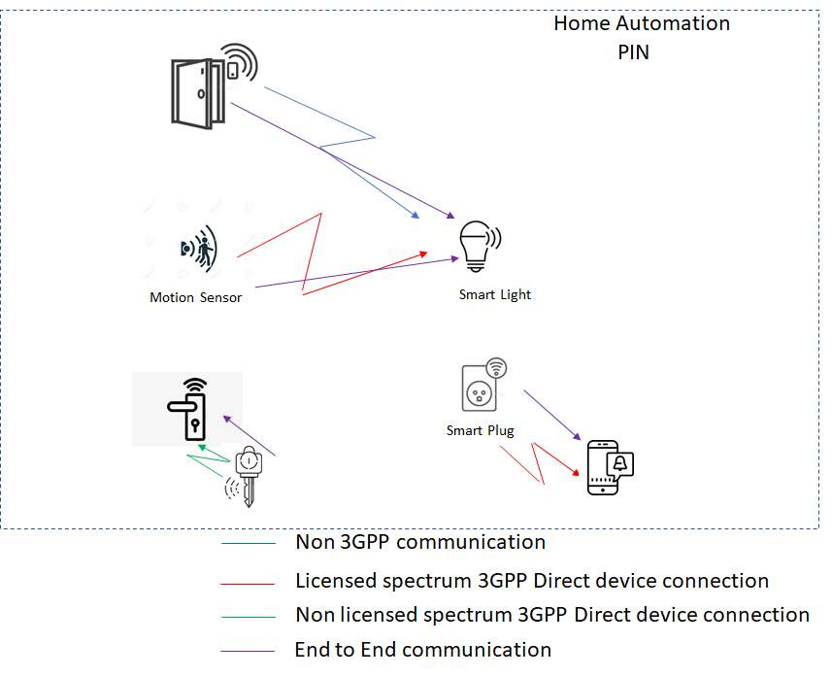

Figure A2-1: Examples PIN direct connectivity in a PIN

Figure A2-1 shows PIN Elements that communicate directly, without any relay elements to another PIN Element, this is collectively known as PIN direct connection. PIN direct connection can encompass different types of direct connection as show in Figure A2-1:

a) Door sensor (a device PIN Element) uses PIN direct connection (e.g. WLAN) to communicate with a light bulb (e.g. door opens and the light turns on).

b) Motion sensor (UE PIN Element) uses PIN direct connection in licensed spectrum to communicate with the light bulb (e.g. motion is detected in the room and the light bulb turns on).

NOTE PIN direct connection in 3GPP licensed spectrum is direct device connection as defined in TS 22.261 [2].

c) The key uses PIN direct connection in non licensed spectrum to communicate with the door lock (e.g. key opens the door).

d) The smart plug (UE PIN Element) uses PIN direct connection in licensed spectrum to communicate with the smartphone (e.g. notification that it is using 60 watts of energy).

## A.3 PIN direct connection using a relay.

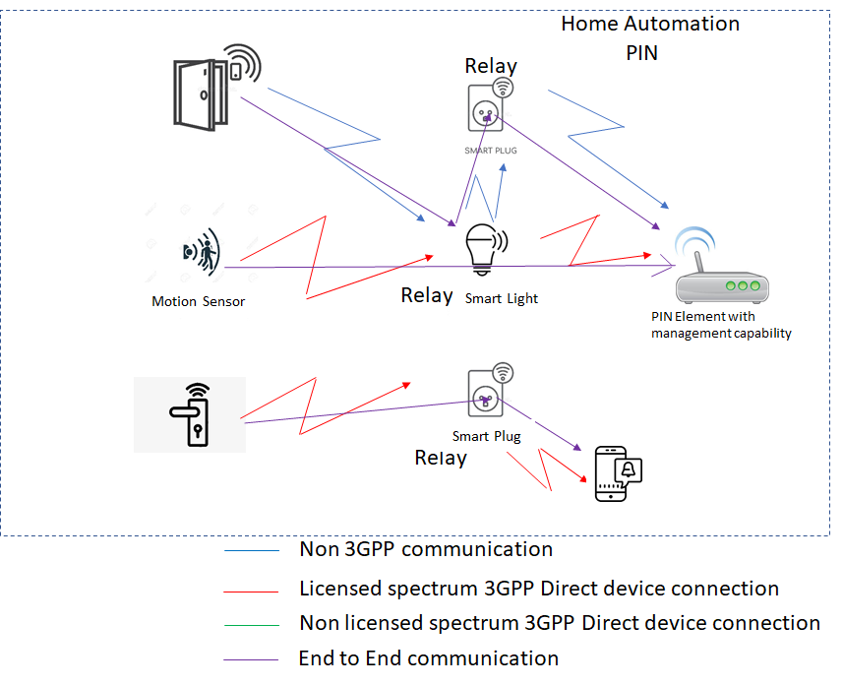

Figure A3-1: Examples PIN direct connection using a relay in a PIN

Figure A3-1 shows PIN Elements that communicate directly but there is a relay in the communication path. Figure A3-1 shows the following:

a) Door sensor (device PIN Element) uses PIN direct connection (Non 3GPP communication) to communicate with a PIN Element with management capability via 2 relays (light bulb and smart switch).

b) Motion sensor (UE PIN Element) uses PIN direct connection in licensed spectrum to communicate with the a PIN Element with management capability via a relays (light bulb) (e.g. to configure the motion sensor to turn the light bulb on or off).

c) The door lock (UE PIN Element) uses PIN direct connection in licensed spectrum to communicate with the smartphone (e.g. notification that it opened) via a relay (smart socket).

Annex A:  
Change history

|  |  |  |  |  |  |  |  |
| --- | --- | --- | --- | --- | --- | --- | --- |
| **Change history** | | | | | | | |
| **Date** | **Meeting** | **TDoc** | **CR** | **Rev** | **Cat** | **Subject/Comment** | **New version** |
| 2020-08 | SA1#91e | S1-203283 |  |  |  | TR Skeleton | 0.0.0 |
| 2020-09 | SA1#91e | S1-203390 |  |  |  | Incorporated the following PCRs into TR:  S1-203422, S1-203418, S1-203419, S1-203420, S1-203371, S1-203421 | 0.1.0 |
| 2020-11 | SA1#92e | S1-204360 |  |  |  | Incorporated the following PCRs into TR:  S1-204443, S1-204334, S1-204331, S1-204333, S1-204438, S1-204439, S1-204063, S1-204440, S1-204445, S1-204441, S1-204444, S1-204442, S1-204332, S1-204066 | 0.2.0 |
| 2021-03 | SA1#93e | S1-210314 |  |  |  | Incorporated the following PCRs into TR:S1-210486, S1-210487, S1-210488, S1-210489, S1-210490, S1-210491, S1-210492, S1-210493, S1-210494, S1-210495, S1-210496, S1-210497 | 0.3.0 |
| 2021-03 | SA#91e | SP-210208 |  |  |  | Presented for information, MCC clean-up | 1.0.0 |
| 2021-05 | SA1#94e | S1-211309 |  |  |  | S1-211457, S1-211458, S1-211459, S1-211460, S1-211461, S1-211469, S1-211092, S1-211508, S1-211464, S1-211157, S1-211158, S1-211465, S1-211467, S1-211468, S1-211466 | 1.1.0 |
| 2021-06 | SA#92e | SP-210513 |  |  |  | Raised to v.2.0.0 by MCC for SA approval | 2.0.0 |