**3GPP TSG-SA WG1 Meeting #92e S1-204058**

**Electronic Meeting, 11-20 November** *(revision of S1-20xxxx)*

Title: FS_PINs Overview

Agenda Item: 7.12.1 - FS_PINs

Source: vivo Mobile Communications Ltd,

Contact: Adrian Buckley <adrian.buckley@vivo.com>

*Abstract: This contribution proposes to add the overview.*

# 4 Overview

[Editor’s Note: This clause provides a high-level overview of the feature. This section will be updated based on the study outcome.]

IoT capabilities have been designed for devices that communicate using the traditional cellular network, including battery constrained devices where it is expected that the battery should last in the order of years. Recently standards have been extended to support more vertical IoT devices for factory based, audio visual, medical, mission critical and vehicular solutions. In some contexts e.g. factory based solutions the concept of a private network has been introduced, this has the added benefit for devices that generate very little user plane traffic (e.g. sensors etc) the traditional cellular operator might not have to dedicate resources to them in the network and the traffic can stay within the local “factory (private network) environment”. There are 2 consumer segments that have similar traffic characteristics where private networks provide an advantage, where communications are predominately within the constraints of a localized IoT network:

i) Wearable devices;

ii) Home automation

For the purpose of this discussion these will be called “Personal IoT networks” (PINs). These types of networks are very different to commercial IoT device, they are usually less rugged, most highly battery constrained and lifespan of the battery typically a couple of years. User plane traffic typically stays with a constrained environment, around the body or in the home i.e. within the PIN.

PINs have been around for a long time using others standards however their take up / adoption rate has been low compared to the general smartphone UE.

a) Home automation there are multitude of standards, some require hubs, configuration is a barrier to entry for adaption and usability is plain awful. Reliability of the networks built with these standards can be questionable at times.

b) Wearables can use a multitude of different access technologies, battery life can in some situations be severely constrained just by the physical dimension limitations e.g. glasses frames, earbuds and rings. Space is also at a premium, capabilities are limited (memory, processing power, even USIM functionality might not be available). Location requirements on wearable devices, especially those with Uu interfaces can contribute to battery drain. Earbuds / Rings are very small, even an ESIM chip takes up valuable space, battery consumption and adds weight to the device.

Figure 4-1 and figure 4-2 show 2 forms of PINs, however the figures are not exhaustive, they can be combined or others can be created.

The blue lines between the PIN devices represent direct device connections that can use operator managed or non-operator managed spectrum. The green lines represent direct network connections. The red lines represent how PIN devices could communicate with each other.

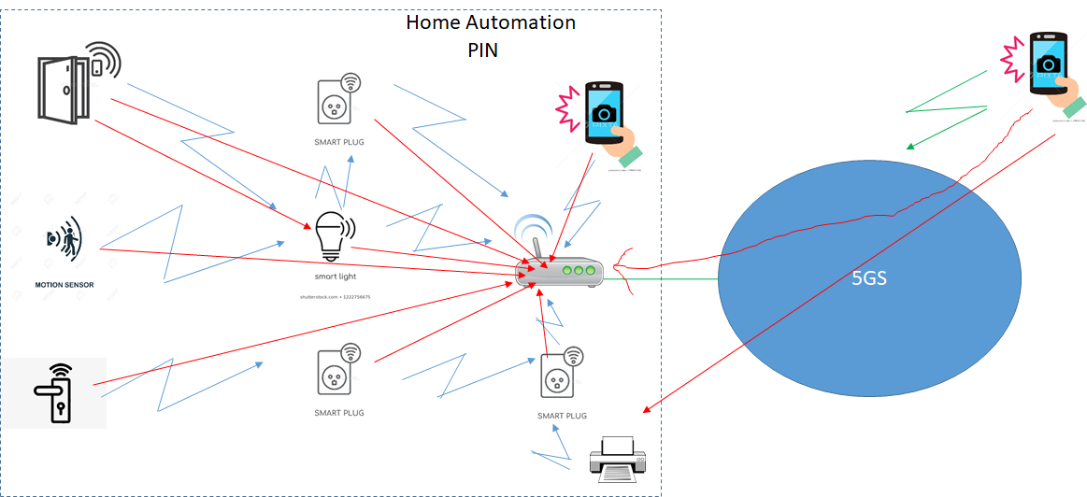

Figure 4-1: Home Automation PIN example

Figure 4-1. shows a PIN device e.g. door motion sensor communicating with an another PIN device acting as a gateway. That same door sensor also communicates with the PIN device that is a light bulb. A smartphone that is connected to the 5GS using direct network connection communicates with a PIN device, a printer, in the home.

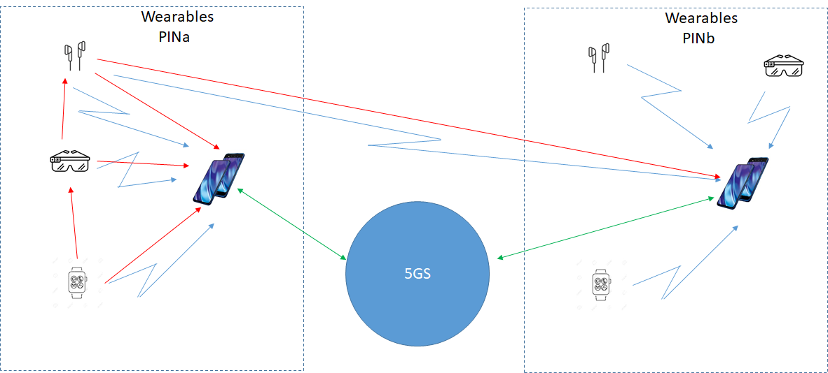

Figure 4-2: Wearables PIN examples

Figure 4-2. shows a wearables network where PIN devices mainly communicate with the PIN device that is a smartphone. There is also a set of earbuds that communicates with 2 smartphones, each smartphone being in a different PIN. The 2nd PIN in this example is providing an audio service e.g. tour guide.

In summary, it is considered beneficial for 3GPP specification to address 5G system support of different use cases for PINs.