3GPP TSG-SA WG1 Meeting #64 S1-135054
San Francisco, USA, 11thNov – 15th Nov, 2013

Title: CSIPTO On-Demand Dual PDN Connection
Agenda Item: 9.4 FS_CSIPTO: Co-ordinated P-GW change for CSIPTO (SP 130417)
Source: Samsung Electronics, Intel, NEC, Acer, ITRI
Contact: Alper Yegin (alper.yegin@partner.samsung.com)

Introduction
This contribution proposes a use case for study in FS_CSIPTO

Proposal
It is proposed to add the following to TR 22.828 (FS_CSIPTO)

4.X CSIPTO On-Demand Dual PDN Connection Use Case

4.X.1 Description

There is a trade-off between data-path optimization and IP address preservation (a.k.a. IP session continuity) when it comes to using SIPTO at the Local Network (LN). Using SIPTO at LN provides a more direct data-path between the UE and its communicating Remote Ends compared using a PGW in the core network. On the other hand, UE handovers are more likely to break the IP session as the UE may end up changing IP subnets when changing LGW with SIPTO at LN.
The choice between data-path optimization and IP address preservation depends on the applications. Certain applications prefer data-path optimization because either their flows are short-lived and they do not need any IP session continuity (e.g., DNS lookups), or they handle session continuity at a higher layer (e.g., Instant Messengers). Certain other applications prefer IP address preservation because an IP session break yields unacceptable user experience (e.g., live video streaming).
When the UE establishes a single PDN connection for a given PDN, it runs the risk of causing suboptimal results and/or disruption for its running applications. If the PDN connection is established with a PGW in the core network, it causes unnecessary transmission delay and core network load for the applications that are not in need of IP address preservation. On the other hand, if the PDN connection is established with an LGW, this causes disruption for the applications that require IP address preservation when the UE changes LGW.
This contribution suggests a use case for establishing a PDN connection with one type of GW by default (using an LGW when it’s available, a PGW otherwise), establishing an additional PDN connection to the same PDN using the other type of GW when required by the applications, and performing PDN connection selection on a per-application/flow basis.
4.X.2 Pre-conditions
Operator X has deployed SIPTO at the LN in its network.
LGW may be available to the UE depending on the location of the UE.

4.X.3 Service Flows

UE establishes the default PDN connection with an LGW, when an LGW is available. If an LGW is not available, then the default PDN connection is established with a PGW.
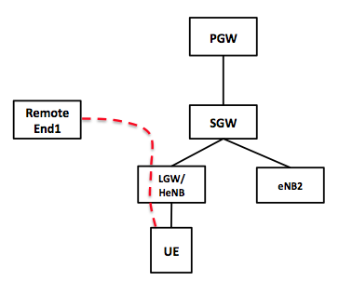
Figure 4.x.3-1: Default PDN Connection with an LGW.
When the UE attempts to initiate a flow that does not require IP address preservation, that flow can be carried over the PDN connection with the LGW (see the red dotted-line in Figure 4.x.3-1).
When the UE attempts to initiate a flow that requires IP address preservation, that flow shall not be carried over the SIPTO at LN PDN connection as that connection cannot ensure preservation of the IP address. So, the UE establishes an additional PDN connection with the same PDN but using a PGW this time. The new flow is carried over this new PDN connection (see the blue dotted-line Figure 4.x.3-2).

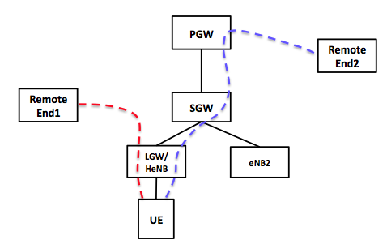
Figure 4.x.3-2: Dual PDN Connection.
The second PDN connection stays on as long as there is an active flow that requires IP address preservation. It can be terminated after the last flow that required IP address preservation has terminated (plus some grace period).
When the UE is attached to an eNB where there is no LGW available, then the default PDN connection is established with the PGW. The single PDN connection is used whether the flows require IP address preservation or not (see Figure 4.x.3-3). UE can resume using dual PDN connections as soon as an LGW becomes available.
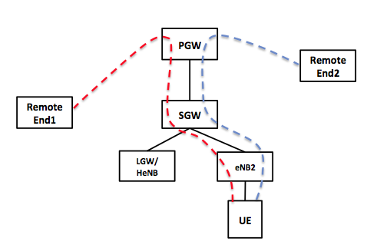
Figure 4.x.3-2: Falling Back to Single PDN Connection in the Absence of an LGW.
The aforementioned use case prefers LGW as the default GW when available. This preference is based on the assumption that most of the flows would not need IP address preservation. This preference can be reversed based on the operator policy and UE type.

4.X.4 Post-conditions

The network was able to improve network efficiency by dynamically establishing additional PDN connection and selectively utilizing SIPTO at the LN without penalizing flows that required IP address preservation.

4.X.5 Potential Requirements

The requirements derived from this use case are:
- The system shall be able to establish a default PDN connection either with or without IP address preservation. Default preference is PDN connection with no IP address preservation.
- The system shall be able to establish an additional PDN connection for the same service type when a flow requires IP address preservation, but the only available PDN connection at the time is a PDN connection with no IP address preservation.
- The system shall be able to bind a flow to the PDN connection with no IP address preservation, if such a PDN connection is available and the flow does not require IP address preservation.
- The system shall be able to bind a flow to the PDN connection with IP address preservation, if the flow requires IP address preservation or that PDN connection is the only available one at that time.
- The system shall be able to terminate the additional PDN connection with IP address preservation if there are no flows using that connection anymore.

4.X.6 Potential Impacts or Interactions with Existing Services/ Features

This scenario requires ability to establish and simultaneously use two PDN connections with the same PDN (i.e., using the same APN). This is the basic impact of CSIPTO feature on the 3GPP system.
The IP stack on the UE shall be able to bind each UE-initiated flow to one of the two PDN connections. The determination of the target PDN connection is outside the scope of this contribution.

