3GPP TSG SA WG 1 Meeting #104 S1-23xxxx
Chicago, USA, 13 - 17 November 2023 (revision of S1-23xxxx)

Source: ZTE, Deutsche Telekom AG
pCR Title: Pseudo-CR on update of 4.2 Sensing Operation
Draft Spec: 3GPP TS 22.137
Agenda item: x.x
Document for: Approval
Contact: xu.ling@zte.com.cn

Abstract: This document is to update the description of 4.2 in TS 22.137.
1. Introduction
This pCR is to update description of section 4.2.
2. Reason for Change
(1) “5G Wireless sensing is a technology enabler to acquire information about characteristics of the environment and/or objects within the environment, that uses NR radio waves to determine the distance (range), angle, or instantaneous linear velocity of objects, etc.” It is duplicated with first sentence in section 4.1. It is suggested to remove it.
(2) “For example, measuring parameters such as Doppler shift of the received signal, the velocity of the sensed object can be estimated” It is also duplicated with sentence in section 4.1, so it is suggested to remove it.
(3) “Below is a schematic picture showing the different parts of the sensing operation and the nomenclature used in this specification.” It is not clear what is the below picture. It is suggested to add figure 4.2-1 and figure 4.2-2 as examples to make it more clear.
(4) Alignment the “sensing service ” with “5G Wireless sensing service” which is already used in section 4.1.
(5) “Operating frequencies and used bandwidth, typically higher resolution is achieved with higher bandwidth and higher frequency.” When we say higher frequency here, it applies to range or velocity, not angle. So, it is suggested to add “for range or velocity” to make it more accurate.

3. Proposal
It is proposed to agree the following changes to 3GPP TS 22.137.

* * * First Change * * * *

4.2 Sensing operation
The operation of the 5G wireless sensing service, a.k.a. sensing operation, relies on processing the transmissions, reflections, and scattering of wireless sensing signals.
5G wireless sensing, therefore, has the opportunity to enhance the 5G system from a communication network to a wireless communication and sensing network, where it uses 5G entities to sense objects and the environment in its surroundings.
Sensing operation can be implemented in a couple of different ways, from radar like sensing where the sensing transmitter and sensing receiver are co-located in the same entity (figure 4.2-1), called Monostatic sensing, to have the sensing receiver and sensing transmitter in different entities (figure 4.2-2), also called Bistatic sensing. A more advanced scenario with multiple sensing transmitters and receivers is also possible, called Multistatic sensing. The reflections of the sensing signal sent from the sensing transmitter are received by the sensing receiver and processed to obtain characteristics of the sensed object and its environment (e.g., location). Below figure 4.2-1 and figure 4.2-2 show the examples of the sensing operation and the nomenclature used in this specification.
Non-3GPP based sensing is when information from non-3GPP sensors is used to determine characteristics of objects and their environment. These non-3GPP sensors could include radar camera or Wi-Fi sensing. While the mechanism of these types of sensing is not considered in this specification, non-3GPP sensing data from these non-3GPP sensors, if available, can be used in 5G wireless sensing to achieve improved sensing result, or in any other way to enhance the sensing service.
Th 5G wireless sensing services could be consumed by either the 3GPP system or trusted third-party.
It is expected that the 5G wireless sensing service will work independently of positioning service.
There are some factors affecting what resolution/granularity the 5G wireless sensing service can achieve e.g.,
- Operating frequencies and used bandwidth, typically higher resolution for range or velocity is achieved with higher bandwidth and higher frequency.
- The propagation environment also plays an important role. Environments with many objects that can block radio signals, leading to interruption of the Line of Sight (LOS) path and reflections/scattering can increase the number of interfering signal paths, as well as clutter and thus make it harder to reach higher resolutions.
Sensing operations, such as authorization, and parameters such as sensing area, sensing operation period and sensing operation time window etc., could be configured and adjusted for efficient use of all kinds of resources, such as energy and radio spectrum, etc.
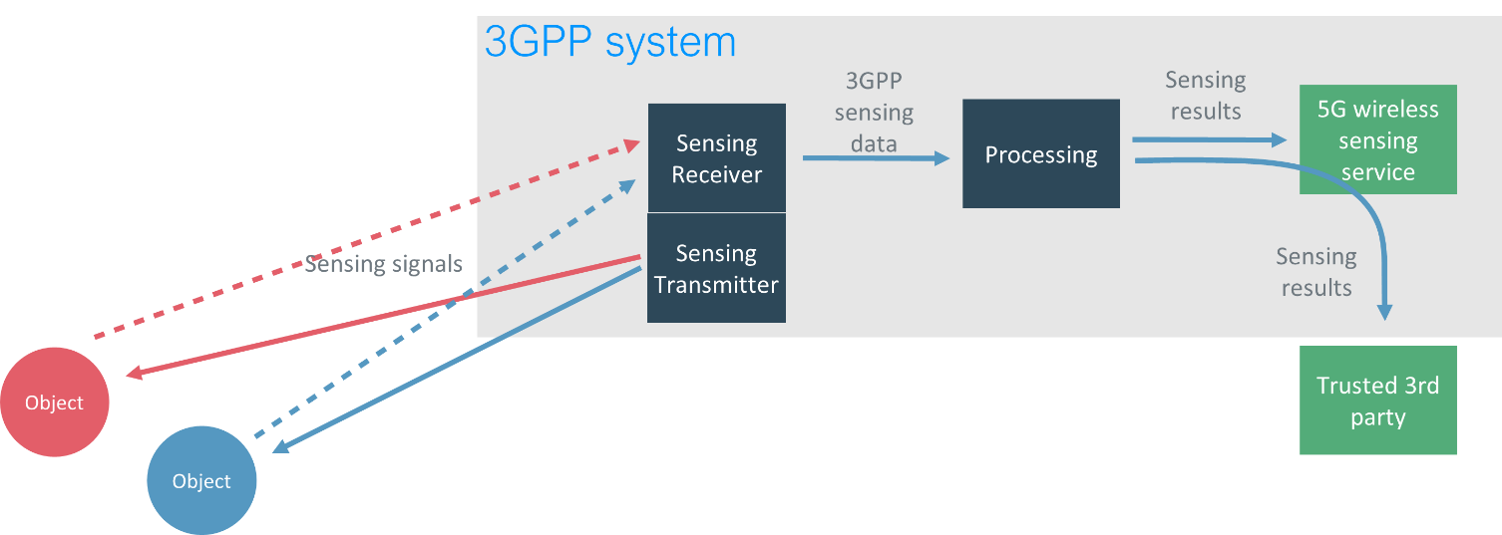
Figure 4.2-1: Example of sensing with co-located sensing receiver and sensing transmitter
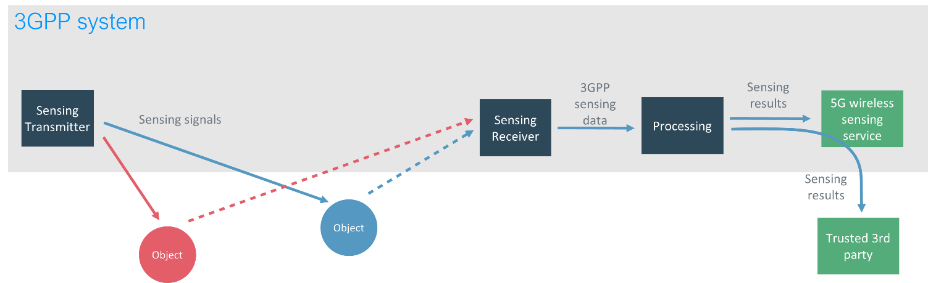
Figure 4.2-2: Example of sensing with separated sensing receiver and sensing transmitter

* * * End of Change * * * *

