3GPP SA1
Guidelines for Delegates v.1.0

Contents
1 Scope 3
2 Overview of SA1 work flow 3
3 Submit contribution to a meeting 4
4 Deadlines for contributions to a meeting 4
5 Reserve contribution number 4
5.1 Before the number-request deadline 4
5.2 After the number-request deadline 6
5.2.1 Authorised late documents 6
5.2.2 Other documents 6
5.3 At the meeting 6
6 Upload contribution to the 3GPP server 7
6.1 Before the contribution-submission deadline 7
6.2 After the contribution-submission deadline 7
6.3 At the meeting 8
7 Revisions of contributions before the meeting 8
8 Handling of revisions of contributions during the meeting 9
9 Access to the local ftp server 9
10 Agenda, Schedule and Document Status Information 10
11 Templates for contributions 12
12 Mailing list 12
13 Email discussions between meetings 13
14 Email approval 13
15 Change Request creation guidelines 13
15.1 What is a Change Request? 13
15.2 CR cover sheet 14
15.2.1 Cover sheet example 14
15.2.2 SpecNumber 14
15.2.3 CRNum 14
15.2.4 rev 15
15.2.5 Current version 15
15.2.6 Work item code 15
15.2.7 Titles 16
15.2.8 Date 16
15.2.9 Category 16
16 CR common errors 16
16.1 Incorrect specification version 16
16.2 Incorrect Work Item Code 16
16.3 CR clashes 16
16.4 Incomplete/incorrect list of clauses affected 16
16.5 Changes on changes 17
16.6 Ticking of boxes 17
A.1 Links 18

1 Scope
3GPP Working Groups are driven by documents contributed by 3GPP Individual Member Companies. Therefore, the process of submitting documents to a Working Group meeting and handling documents in a Working Group meeting is key.
This document describes the management of documents ("contributions") in 3GPP SA Working Group 1 (SA1). Its purpose is to provide an overview of the working procedures in SA1 and be used as a reference for processes to be followed. Procedures during the meeting may differ slightly from this guide.
Procedures in other 3GPP Working Groups may be different from the SA1 process described in this document.
The terms "document" and "contribution" are used interchangeably in these guidelines.

2 Overview of SA1 work flow
To assist in the understanding of the work done in SA1, an overview of a typical SA1 work flow is shown below. This shows how a new idea triggers development of work via:
- a Work Item Description (WID), which leads to the creation/update of a 3GPP Technical Specification (TS), a 3GPP deliverable containing normative provisions;
- a Study Item SID (SID), which leads to the creation of a 3GPP Technical Report (TR), a 3GPP deliverable containing only informative elements.
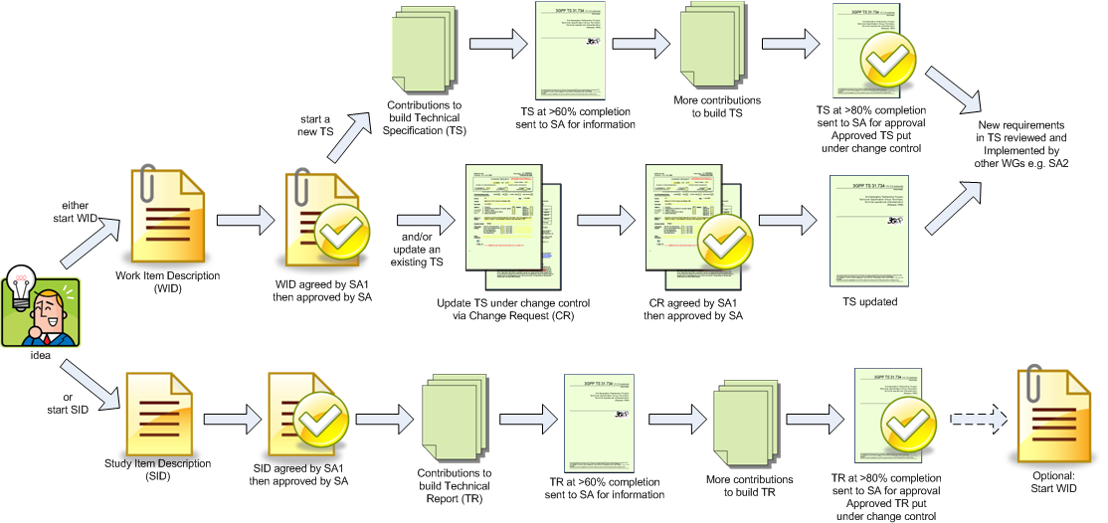
Figure 2.1: Overview of SA1 work flow
Contributions to a 3GPP working group include:
- WIDs/SIDs that proposes new features/functionalities
- discussion papers that explain e.g. new concepts, proposal justification
- Change Requests (CRs) that propose specific text updates to a TR/TS under change control
- "Pseudo" CRs that propose specific text updates to a draft TR/TS
- draft outgoing Liaison Statements (LSs)
- a direct response to another contribution that e.g. provide comments, suggest revisions

3 Submit contribution to a meeting
Contributions may be submitted either before the meeting or during the meeting. Each contribution submitted is assigned a unique document number. Assigned document numbers are never reused. When revising a contribution a new unique document number is allocated.
Contribution templates are posted prior to the meeting, see clause 11 for further details.
In order to submit a contribution, it is necessary to follow the steps below:
- Reserve a contribution number before the document number request deadline. See clause 5 "Reserve contribution number" for further details.
- If the contribution is a CR, in addition to a contribution number, a CR number needs to be reserved. The same deadline mentioned above applies. See clause 15.2.3.1 "Before the meeting" for instructions on how to obtain a CR number.
- Submit/upload the numbered contribution before the document submission deadline. See clause 6 "Upload contribution to the 3GPP server" for further details.
See clause 4 for additional information on the deadlines.
Contributions that miss either deadline will be considered LATE and will likely not be treated in the meeting.
Different rules apply for contributions to be submitted during the meeting. These rules are detailed in clause 5.3 "At the meeting" for requesting document numbers, and clause 6.3 "At the meeting" for uploading document.

4 Deadlines for contributions to a meeting
There are two deadlines:
- document number request deadline
- document submission deadline, typically at the same time as the document number request deadline
Both deadlines are announced on the SA1 reflector several weeks prior to the meeting by the SA1 chairman/secretary, along with a draft agenda for the meeting.
A contribution that misses either deadline is considered late. A late contribution will be handled as a low priority contribution at the discretion of the Chairman. It is likely that late contributions will not be handled at the meeting.
After the contribution number request deadline has passed, the SA1 secretary will provide a link to the folder on the 3GPP server containing all the contributions submitted on time. The SA1 secretary will also provide a document that lists all the numbered contributions with their title, source companies and initial associated agenda item (the "Tdoc list"). The SA1 chairman will then submit a revision of the agenda, allocating the contributions per agenda item, with possible re-allocation of contributions to different agenda items.

5 Reserve contribution number

5.1 Before the number-request deadline
Document numbers are reserved via 3GU.
The 3GPP Ultimate portal can be found at:
http://portal.3gpp.org

A brief tutorial for delegates on the general facilities provided by 3GU can be found here:
http://www.3gpp.org/ftp/webExtensions/3GU/3GU_instructions_for_delegates/ats-sld-00000.htm

You will need an ETSI-On-Line (EOL) account to be able to allocate tdoc numbers. If you do not already have an EOL account, then use the links at the top right of the 3GU page to sign up for one. (Ignore the warning that EOL accounts are only available to representatives of ETSI member organizations!) Click on “apply for an account” on bullet point 2 of the landing page. When you have your EOL account credentials, use them to log in to the 3GPP Ultimate portal.

Registering your intention to participate in the meeting
Do this in the way you have done so in the past, or via the meetings tab on the portal following the instructions starting at slide 8 of the tutorial page.

Reserving a tdoc number
Follow the instructions starting at page 9 of the tutorial. The instructions show you how to create a new tdoc and, in subsequent slides, how to make a revision to an existing tdoc.
Please be sure to follow the revision instructions if this is what you are doing, and not to create a brand new tdoc. This will save you time and will give a logical link from the original tdoc to the revised one!
If you have a number of tdoc numbers to reserve, refer to the instructions for bulk allocation starting at slide 16 of the tutorial. (You cannot use the bulk allocate feature for revisions to tdocs.) Note that for tdocs of type Change Request, 3GU will allocate CR numbers for you as well as the tdoc number.
Make a careful note of the allocated tdoc and CR numbers! You will need to show them in the documents themselves.

5.2 After the number-request deadline

5.2.1 Authorised late documents
After the document number request deadline, no new document numbers will be assigned until Monday morning of the meeting. The exceptions are for:
- new incoming liaison statements (LSs);
- draft answers to incoming LSs; or
- discussion papers/CRs associated with incoming LSs.
For these exceptions:
- Send an email to the SA1 Secretary requesting a new document number and include the following information:
- incoming LS document number;
- new document title;
- sourcing company(ies); and
- agenda item.
- If the document is a CR, provide the impacted specification number
- SA1 Secretary response to late document number requests is best effort
- The author is responsible for late document handling. See section 6.2 "After the contribution-submission deadline".

5.2.2 Other documents
New document numbers for new documents, revision or merge of on-time documents prepared after the document number request deadline can only be requested from the Monday of the meeting.
The author is responsible for document handling in this case. See section 6.2 "After the contribution-submission deadline".

5.3 At the meeting
To submit a new contribution or a revision of an existing contribution at the meeting, delegates shall contact the SA1 secretary to get a document number. New contributions are only allowed for the following cases:
- new incoming liaison statements (LSs)
- draft answers to incoming LSs
- associated discussion papers/CRs associated with to incoming LSs
- revisions of existing contributions
- when SA1 agrees a new contribution is needed to capture an agreement at the meeting (e.g. outgoing liaison statements)
For drafting sessions, a series of numbers may have been pre-allocated to the session. In this case, delegates shall contact the drafting session convenor for a new document number.

6 Upload contribution to the 3GPP server

6.1 Before the contribution-submission deadline
Before the meeting, all documents will be placed in the respective meeting folder on the 3GPP Web site.
Example: SA1#58 documents are available at http://www.3gpp.org/ftp/tsg_sa/WG1_Serv/TSGS1_58_Seville/docs/
To upload a document, you can:
- Either upload it at the time you request a tdoc number on 3GU. There is an explicit “upload” button when you request your number.
- If your document is not ready at the time you request for your tdoc number, you can do it at any time by clicking the “upload Tdocs” button on 3GU and follow the instructions, as shown in the next figure:
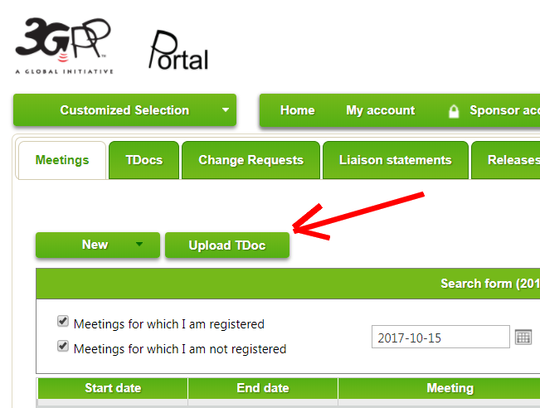
Figure 6.1
Delegates shall use the file name convention "S1-YYxyzw.zip", where YY is the current year (e.g. 12 for 2012), when uploading documents. Within the zip file, Word documents shall use the Word 2003 file format (*.doc), and not Word 2007/2010 file format (*.docx). Powerpoint documents shall use the 2003 file format (*.ppt) and not 2007/2010 format (*.pptx).
In case assistance is needed, Delegates should contact the SA1 Secretary.

6.2 After the contribution-submission deadline
After the contribution-submission deadline, documents not uploaded are considered late documents.
The author of a late document shall:
- send the late documents to the SA1 reflector as soon as they are available
- upload late documents in the "Inbox" folder of the local server on Monday morning of the meeting (see clause 9 "Access to the local ftp server" on how to upload documents to the "Inbox" folder)
Submission of late documents or Revision/Merge of on-time documents after the contribution submission deadline:
- New document numbers for revision/merge of on-time documents will only be available from Monday morning of the meeting
- The author must send the revised/merged documents (without document number) to the SA1 reflector as soon as they are available
- The author shall obtain a document number from the SA1 Secretary on Monday morning
- The author shall upload revised/merged documents with the correct document number in the "Inbox" folder of the local server on Monday morning of the meeting (see the following clause 6.3 "At the meeting")
It cannot be assumed that SA1 delegates will have knowledge of a document sent on the email reflector after the contribution-submission deadline.

6.3 At the meeting
Late contributions and contributions created at the meeting shall be uploaded to the "Inbox" folder of the local server by the delegates, following the file naming convention of: S1-YYxyzw.zip, where YY is the current year (e.g. 12 for 2012). See also clause 9 "Access to the local ftp server" on how to upload documents to the "Inbox" folder.

7 Revisions of contributions before the meeting
Revisions of documents already submitted are allowed before the meeting. These revisions should be submitted using a new document number.
Revisions can be done for the following reasons:
- to correct mistakes in the original contribution;
- to take into account comments received from other delegates; or
- to merge the contribution with another contribution dealing with the same topic.
On occasion, the SA1 chairman may provide some comments/corrections for a contribution in the Chairman's document (see clause 9 "Agenda, Schedule and Document Allocation Document Status Information").
For example, for the contribution listed below, the Chairman indicates that corrections are needed to the CR cover page.
If there are corrections noted against your contribution, and:
- if no other changes are needed to the contribution, wait until after the contribution is presented at the meeting before revising the document;
- if you already plan to revise your contribution before presentation at the meeting, e.g. due to comments from other delegates, then take the Chairman's comments into account.
If the revision is done before the document number request deadline, delegates should get a new document number via ADN. Delegates shall indicate the document number of both the revised and original documents to the SA1 secretary. The original document shall be marked as "withdrawn".
If the revision is done after the document number request deadline, delegates shall follow the late document submission procedures in section 5.2 "After the number-request deadline" and 6.2 "After the contribution-submission deadline". In this case, the original document shall be marked as "revised".
Revisions uploaded after the document submission deadline will NOT be considered as late contributions, as long as the original document was on time.

8 Handling of revisions of contributions during the meeting
Documents may be revised during the meeting. The revised document shall be submitted by using a new document number: to obtain a new document number during the meeting, Delegates must contact the SA1 Secretary, indicating the document number of the original document. Changes with respect to the original document should be clearly indicated on the revised document via revision marks.
Examples where document revisions are welcome are to take into account offline discussions that can help reaching agreement, or when an error is identified in the contribution. In case of addition of co-signing companies, it is recommended not to modify the already uploaded document, but ask the Secretary to add a note in the minutes.
When the need for a revision of a document is decided during its presentation, Delegates should place the revised document in the "Inbox" as soon as possible, following the file naming convention of: S1-YYxyzw.zip, where YY is the current year (e.g. 12 for 2012). See clause 9 "Access to the local ftp server" on how to upload documents to the "Inbox" folder. It is also recommended that delegates inform the SA1 reflector when the revised documents have been placed in the "Inbox".
This rule is also valid for uploading new documents.
Revisions of contributions should be uploaded as soon as possible. On the last day of the meeting, it is recommended that revisions of contributions are made available at least one hour before being presented.
If the revised document is not to be addressed again during the meeting (i.e. it is automatically agreed/approved without presentation), Delegates must upload the document to the "Inbox" before the end of the meeting. If agreed/approved documents are not available by the end of the meeting, the document status may be changed to Noted.
After the closure of the meeting, document numbers for that specific meeting can no longer be allocated unless a document has been sent for email approval. See clause 14 for details on email approval.

9 Access to the local ftp server
During the meeting, a local ftp server is provided by MCC to store documents generated at the meeting. To access this server it is necessary to connect to the local network provided by MCC (SSID: 3GPP, security:ask the secretary). Once connected, the server can be accessed at ftp://10.10.10.10 or http://10.10.10.10. Entering http://10.10.10.10 in a web browser displays the following page.
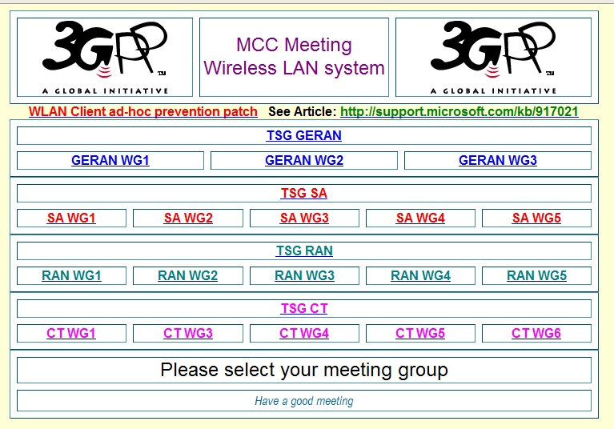
Figure 9.1
Select "SA WG1" to navigate to the SA1 page, also accessible at http://10.10.10.10/SA_WG1.htm:
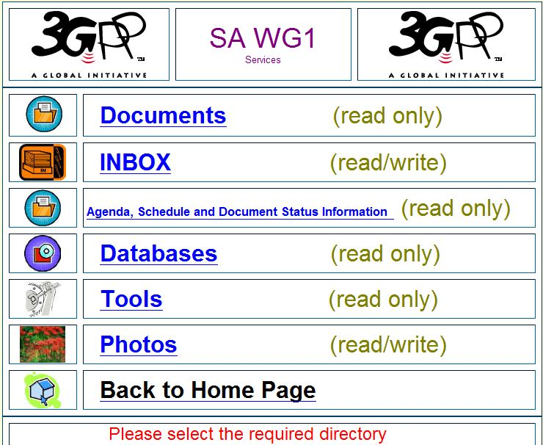
Figure 9.2
The server contains a folder that stores SA1-related documents. The "Inbox" subfolder contains the contributions and is also where new contributions are placed.
To upload files to the "Inbox", use an FTP client e.g. FileZilla to connect to the FTP server at ftp://10.10.10.10 using username "anonymous" and select remote directory /SA/SA1/Inbox. Copy the file to be uploaded from your computer to this directory.
Additional information may be found on the 3GPP Wiki:
- How do I connect to the meeting WLAN?
- Where do I find the meeting documents?
- Internet connection at the meeting

10 Agenda, Schedule and Document Status Information
The SA1 Secretary provides a working draft of the meeting minutes in a Microsoft Office Word document in tabular format. Documents can be identified by the assigned document number. This is uploaded to the local server "Inbox" at regular intervals during the week of the meeting. An updated version of this document is provided at the end of the meeting that captures the disposition for all the documents in the agenda for the meeting. The draft meeting minutes will be provided after the meeting.
The SA1 Chairman provides a working draft of the agenda, schedule and document allocation/status information in a Microsoft Office Word document. An initial version will be provided before the meeting and updated versions are uploaded to the local server "Inbox" at regular intervals during the week of the meeting. An updated version of this document is provided at the end of the meeting that captures all the agreements of the meeting.
The schedule indicates the agenda items (via agenda item number and work item acronym) to be treated within a particular time slot. Some slots are allocated to the plenary session and other slots are allocated to drafting sessions. If more than one topic is listed in a drafting session slot, this means that there are parallel drafting sessions.
Example schedule:
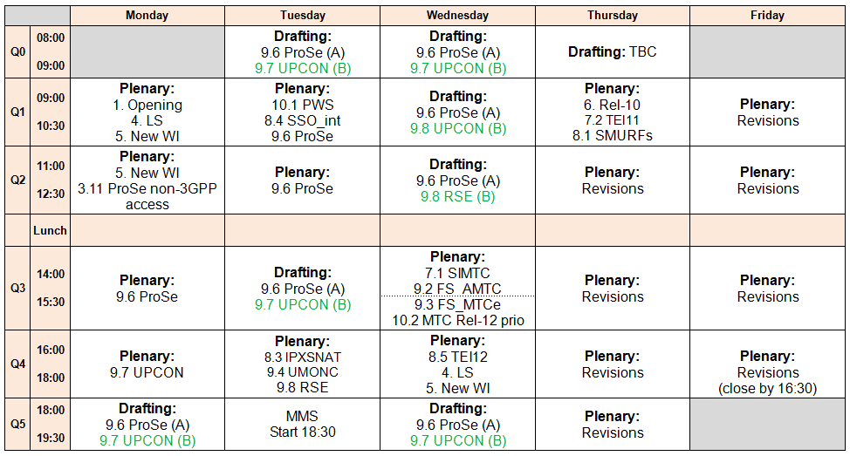
Figure 10.1
The document allocation/status information within the Chairman's document provides details of each contribution (document number, document type, sourcing company, title, status of document in the meeting and comments). If a document has been revised, the document number of the revision is provided.
A hyperlink to the document is provided – to use the hyperlinks, place the downloaded SA1 documents to "docs" sub-folder on your PC, with the Chairman's document in the parent folder.
Example document allocation/status information:
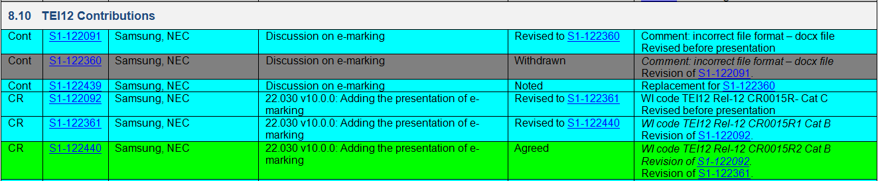
Figure 10.2
An online version of the Chairman's document in the form of a web page is also available on the local server. See clause 8 "Access to the local ftp server". Click on "Agenda, Schedule and Document Status Information" in the SA WG1 page, or go to ftp://10.10.10.10/SA/SA1/Docsstatus/Docsstatus.htm.
Figure 10.3

11 Templates for contributions
Templates for contributions are available under the respective meeting directory within the meeting folder, for example, http://www.3gpp.org/ftp/tsg_sa/WG1_Serv/TSGS1_58_Seville/templates/.
Templates are available for the following documents:
- Technical Report (TR)
- Technical Specification (TS)
- Change request (CR) cover page
- Liaison Statement (LS)
- Cover page for presentation of a TR or TS to TSG SA
- Document/Discussion paper
- Work Item Description (WID)
- Drafting session agenda/report
- Work Item (WI) status update

12 Mailing list
The SA1 mailing list is 3GPP_TSG_SA_WG1@LIST.ETSI.ORG
Delegates who have an ETSI username and password can use the list management application to subscribe to the SA1 mailing list at http://webapp.etsi.org/TBMembershipList/home.asp.
Delegates who do not have an ETSI username and password can apply for an ETSI account at: http://webapp.etsi.org/createaccount/.
If you have any problems subscribing to the lists, please send an email to the SA1 Secretary.
The SA1 email list archive is available at http://list.etsi.org/3gpp_tsg_sa_wg1.html.

13 Email discussions between meetings
Email discussions on particular topics may be held on the SA1 mailing list between meetings.
The aim of email discussions between meetings is to optimise the use of meeting time by discussing contributions in advance in order to get as much agreement as possible before the meeting.
It is the responsibility of the Rapporteur or author of the contribution to trigger the email discussion, to take into account comments made, and to summarise/conclude the discussion.
The Rapporteur/author may suggest a deadline for comments in order to incorporate all changes into the document for submission to the meeting. Even so, comments can still be made after this deadline and it is up to the Rapporteur/author whether to take the comments into account and revise the document before the meeting.
It may not be possible for all delegates to keep up with all the discussion threads due to other commitments, so it is sometimes unavoidable that comments are repeated. However, if delegates do want to comment, please check if the comment has been made and already taken into account as this will help the Rapporteur/author deal with new comments efficiently.
Participation in the email discussion is not mandatory and delegates that cannot participate in email discussions can share their views at the meeting.

14 Email approval
If agreed by the meeting, documents may be sent for email approval on the SA1 mailing list. This allows further discussion on the document. Typically this may be done if there is not enough time to complete the discussion during the meeting. A deadline for the email approval will also be defined by the meeting.
For documents revised under email approval, new document numbers shall be obtained from the SA1 Secretary.
If no modification is made to the initial document during email approval, the same document number can be used for the final agreed version.

15 Change Request creation guidelines

15.1 What is a Change Request?
According to the 3GPP Working Procedures, when a Technical Specification (TS) or Technical Report (TR) is approved by the TSG Plenary and published, the document can no longer be edited by the Rapporteur. From that moment onwards the TS or TR is under Change Control, a process managed by MCC.
It is still possible to develop the TS or TR further, for example, to add the missing parts, and to correct errors and/or omissions as the overall system becomes better defined. Such changes are conveyed through documents called Change Requests.
A Change Request contains two components. The first is a CR cover sheet (see clause 15.2) that provides e.g. the details of the impacted TS or TR, describes the proposed changes and the justification. The second component is the proposed text modification to one or more clauses of the latest version of a TS or a TR. The proposed modifications are shown using revision marks against the original text of the TS or TR.
Change Requests are submitted by Delegates to a SA1 meeting; agreed SA1 CRs are submitted by the SA1 Secretary to the TSG SA; TSG SA-approved CRs are collected by the SA1 Secretary and implemented onto the specifications.
More information about Change Requests can be found here:
http://www.3gpp.org/ftp/workshop/2009-06-16_3GPP_Methods_Seminar/3GPP_TheTrainingCourse_Module_12_CRs.pps
http://www.3gpp.org/Change-Requests-Step-by-Step

15.2 CR cover sheet

15.2.1 Cover sheet example
In the Figure below there is an example of a CR cover sheet. The following subclauses illustrate how some of the fields should be filled in. The list below is not comprehensive and its objective is to provide guidance for the avoidance of common mistakes encountered during WG meetings.
There are a number of "comments" on the cover page, illustrating how each field should be used. CR Cover sheet templates can be found within the meeting directory, for example: http://www.3gpp.org/ftp/tsg_sa/WG1_Serv/TSGS1_58_Seville/templates/.
Figure 15.1: CR cover sheet Template

15.2.2 SpecNumber
The specification or Report number should be inserted here. e.g. 22.101 ("TS" or "TR" must not appear in this field).

15.2.3 CRNum
All Change Requests submitted for an Ordinary or ad hoc WG meeting must have a CR number.
The CR number identifies a particular CR in the CR database, and is in addition to the document number S1- YYxyzw.

15.2.3.1 Before the meeting
The process of CR number allocation is as follows:
- using ADN, a Delegate obtains one or more document numbers;
- the Delegate emails the SA1 Secretary stating the document number(s) are CR(s) against particular Spec(s) number(s);
- the SA1 Secretary replies assigning the CR number;
- the Delegate fills in the CR number field (where the template indicates "CRNum") with the CR number obtained
- before the document submission deadline, the Delegate uploads the CR via ADN.
If the document number request deadline has passed, then the document is late. See clause 5.2 "After the number-request deadline" on how to get document numbers after the deadline, and clause 6.2 "After the contribution-submission deadline" on how to submit a late document.
If the document submission deadline has passed, then the document is late and late document submission process shall be followed, see clause 6.2 "After the contribution-submission deadline" on how to submit a late document.

15.2.3.2 During the meeting
Any revision of the CR during the meeting, results in incrementing the CR revision field.
Merging two or more CRs may mean that a new CR number must be obtained. There is no fixed rule on this and a decision should be taken on a case-by-case basis. In general, when the contents of the CR change significantly, a new CR number should be used.
To obtain a new CR number during the meeting, for an entirely new CR or for a case such as the one above, the Secretary must be contacted.
Use 4-digit numbers for the CR number, e.g. 0021 (do not insert "CR" in this field).

15.2.4 rev
This indicates the revision number of the CR. So, every time a CR is revised, this field needs to be incremented. For the first version of the CR, this field is labelled with a hyphen "-", and subsequent revisions are 1, 2, etc.

15.2.5 Current version
This field should contain the version number of the TS or TR which the CR uses as a basis for changes and therefore should be the latest published version of the TS or TR in the relevant Release. To identify the latest version for the relevant Release consult: http://www.3gpp.org/ftp/specs/html-info/22-series.htm and click on the specification number to be addressed. A complete list of versions per Release is available; use the latest version available for the relevant Release.
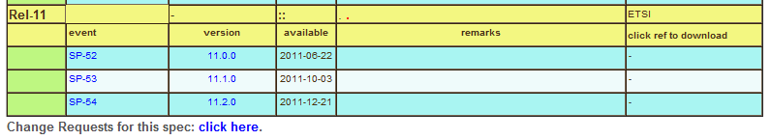
Figure 15.2: CR cover sheet Template

15.2.6 Work item code
This field should contain the acronym for the work item which is applicable to the change. A list of work item acronyms can be found here http://www.3gpp.org/ftp/Specs/html-info/WI-List.htm.
When producing a CR and one or more mirrors of the CR for different Releases, the WI of the originating CR (the only one that is not Category A) must be used.

15.2.7 Titles
The title should clearly and concisely describe the proposed changes. Specification or CR numbers should not be inserted in this field. Also, the title should give a clear but brief explanation of the change and should not be vague (e.g. "Corrections to 33.401" would not be appropriate).

15.2.8 Date
This field should contain the date of creation of the CR or the revised CR. When a CR is revised, the date should be updated. The current date format is YYYY-MM-DD.

15.2.9 Category
The correct category should be used for a CR. A full description of categories and their use can be found in TR 21.900 (refer to Table 4A).

16 CR common errors

16.1 Incorrect specification version
When the CR cover page indicates a current specification version that is not the latest one available:
- but the actual content of the CR is based on the latest version;
- and the actual content of the CR is based on this baseline.
In the first case the only correction that must be performed is a revision of the cover page to report the correct current version.
In the second case, a revision of the entire CR must be performed, retrieving the latest version of the specification as explained in clause 15.2.5 "Current version". This is important as a CR based on an outdated version of the specification is not implementable and will be rejected by the TSG.

16.2 Incorrect Work Item Code
The Work Item Code selected should reflect the purpose of the CR.
A generic WI code, such as TEI12, should only be selected for CRs that are not addressing any particular WI and are generic corrections (Category F or D).
For all other CRs, the correct WI can be selected following the procedure described in clause 15.2.6.

16.3 CR clashes
When multiple CRs are written against a specification, there can be the case where more than one CRs are modifying the same text. In this case, it is not clear how the CR implementation should take place.
This is an example of a CR clash; the two sources of the two CRs should merge the CRs in one CR, which resolves the clash to avoid that both CRs being rejected in TSG Plenary.

16.4 Incomplete/incorrect list of clauses affected
CR cover sheets must explicitly mention in the "clauses affected" (see Figure 15.1) cell each and every subclause down to the Nth degree which has a change. Even if all subclauses in a clause are mentioned, it is not sufficient to mention just the top level clause number.
EXAMPLE: In the example below the clauses affected field should not contain simply 10, which erroneously includes 10.2 in the list of clauses affected. The clauses affected field should instead contain 10.3.
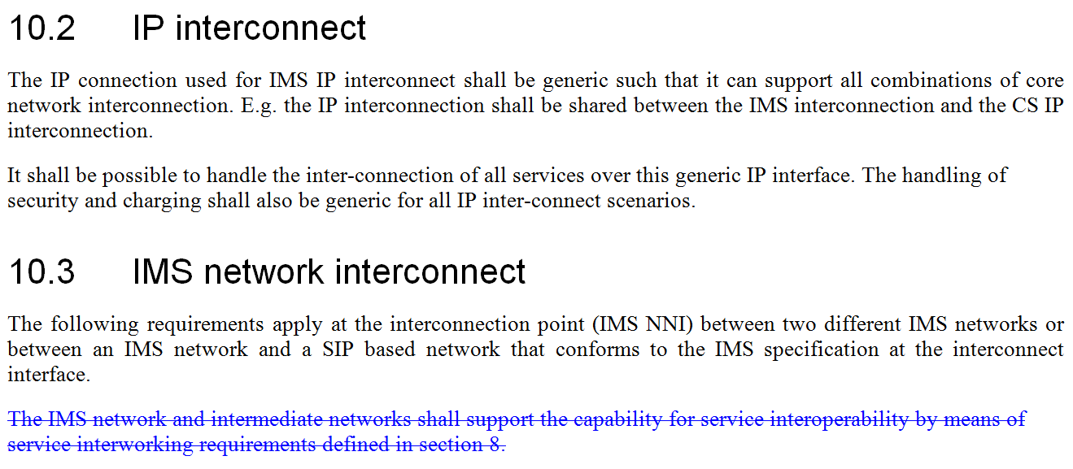
Figure 16.1: Example of clause affected

16.5 Changes on changes
It happens that when CRs are modified multiple times, some of the new text applied on the baseline is deleted. When this text is deleted, it should not result on the CR as a deletion; so-called "changes on changes" should be removed from the CR.
As a simple rule, the only changes that should appear on the CR, are all the changes that are present compared to the latest available version.
An example of changes on changes is shown on the figure below. The blue text appearing as deleted does not belong to the baseline, and should be completely removed from the CR, as such a deletion cannot be applied on the specification.
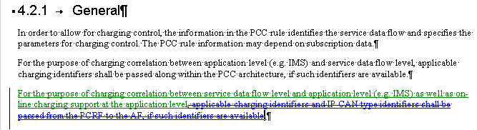
Figure 16.2: Changes on changes after updating the CR
Additional information may be found on the 3GPP Wiki: CRs - "changes on changes"

16.6 Ticking of boxes
A common mistake is forgetting to tick the appropriate boxes in "Proposed change affects" field and/or the "Other specs affected" field. If no other specification is affected, an "X" should be inserted in each box under the "N" column.

A.1 Useful Links and References
3GPP Specifications home page | http://www.3gpp.org/Specifications
3GPP Specifications | http://www.3gpp.org/ftp/Specs/
3GPP Specification latest updates | http://www.3gpp.org/ftp/Specs/latest/
3GPP Specification status | http://www.3gpp.org/ftp/Information/Databases/Spec_Status/
3GPP Specification latest drafts | http://www.3gpp.org/ftp/Specs/Latest-drafts/
3GPP Change request database | http://www.3gpp.org/ftp/Information/Databases/Change_Request/
3GPP Work plan | http://www.3gpp.org/ftp/Information/WORK_PLAN/
3GPP Meetings | http://www.3gpp.org/Meetings/meetings.htm
3GPP Meeting calendar | http://webapp.etsi.org/meetingcalendar/QueryForm.asp
3GPP Meeting invitations | http://www.3gpp.org/ftp/Invitation/
Delegate contact information (*) | http://webapp.etsi.org/teldir/TelDirectory.asp
Update contact information (*) | http://webapp.etsi.org/teldir/PersonalInfo.asp
Email list management (*) | http://webapp.etsi.org/TBMembershipList/home.asp
Info for meetings in ETSI | http://www.3gpp.org/ftp/information/ETSI_meeting_info/
SA1 Home page | http://www.3gpp.org/SA1-services
SA1 Specification list | http://www.3gpp.org/ftp/Specs/html-info/TSG-WG--S1.htm
SA1 Documents | http://www.3gpp.org/ftp/tsg_sa/WG1_Serv/
Archives of SA1 email list | http://list.etsi.org/3gpp_tsg_sa_wg1.html
(*): ETSI account required

