Vienna, October 3nd 2000

Ladies and Gentlemen,

On behalf of SIEMENS AG it is a pleasure to invite you to the

3GPP_TSG_SA_WG1 OSA ad-hoc meeting

The meeting will be hosted by SIEMENS AG and held in

Vienna, AUSTRIA

October 18th and 19th , 2000
at

Siemens Aktiengesellschaft Österreich
Autokaderstraße 29
A-1210 Vienna
Object 1, Room E03

The meeting will start at 10:00 h October 18th and finish not later than 16:00 h October 19th

The proposed agenda of the meeting will be distributed by Manfred Leitgeb (chairman).

Please find attached a list of hotels with guite good public transport connections to the meeting venue. To book, please call directly the Hotel of your choice.

Please complete the attached registration form and send it to us by
E-mail: susanne.krammel@siemens.at
Phone: +43.1.1707.21529
Fax: +43.1.1707.51924
by October 12th at the latest.

Documents for the meeting should be sent by E-mail in advance to Mr. Michael Clayton
(E-mail: michael.clayton@etsi.fr).

Please note that it will be a paperless meeting. Bring diskette readers for your notebooks.
Travel information:

The following Hotels have quite good public transport connections to the meeting venue.

Hotel Strebersdorferhof ***  Russbergstrasse 46  A-1210 Vienna  Phone: 292 57 22, 292 88 69 Fax: 292 88 69 36 E-Mail: strebersdorferhof@aon.at  Internet: http://www.strebersdorferhof.at  walking distance from the meeting venue | Hotel Hilton Vienna *****  Am Stadtpark  A-1030 Vienna  Phone: 71 700-0 Fax: 713 06 91  E-Mail: rm_vienna@hilton.com  Internet: http://www.telecom.at/ViennaHilton  right at the S3 station ‘Wien Mitte - City Air Terminal’
Hotel Lassalle ****  Engerthstrasse 173-175  A-1020 Vienna  Phone: 213 15-0 Fax: 213 15-100  E-Mail: lassalle@austria-trend.at  Internet: http://www.nethotels.com/lassalle  close to S3 station ‘Wien Nord – Praterstern’ | Hotel Inter-Continental Wien *****  Johannesgasse 28  A-1037 Vienna  Phone: 711 22-0 Fax: 713 44 89  E-Mail: vienna@interconti.com  Internet: http://www.interconti.com  close to S3 station ‘Wien Mitte – City Air Terminal’

The following link provides additional information on Hotels in Vienna.
http://info.wien.at/index_e.html

How to get from airport to the meeting venue:
- By ShuttleBus and Train:
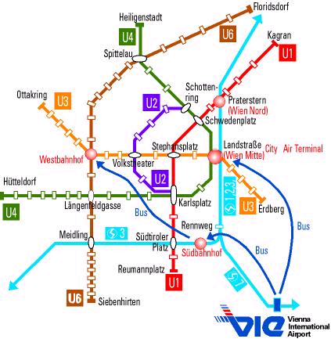
There is a ShuttleBus and Train Service from the airport to Viennas Main Stations, like ‘Südbahnhof’, ‘Westbahnhof’ and ‘Wien Mitte - City Air Terminal, Hilton’.

We recommend to take the ShuttleBus Service to ‘Wien Mitte – City Air Terminal’, which is quite comfortable and moderate in price - ATS 70,- (oneway) or ATS 130,- (roundtrip). From ‘Wien Mitte’ take the train S3 in the direction of ‘Floridsdorf’/‘Stockerau’ and leave the train at ‘Strebersdorf’. Please find below an example of the time table:

Station | Date | Arr/Platform |  |  | Dep/Platform |  |  | Train No | Comments
1. | Schwechat Flughafen (Bus) | 18.10.00 |  |  | 7:50 |  | Bus 1185 | VU
 | Wien City Air Terminal |  | 8:10 |  |  |  | on foot | 7 minutes
 | Wien Mitte |  |  |  | 8:29 | 1 | S 3 | FB K2
 | Strebersdorf |  | 8:48
Duration: 0:58; runs daily
Pricing information not available

The ShuttleBus operates in an interval of 20 Minutes.

To get to the meeting venue follow the arrow on the map below:
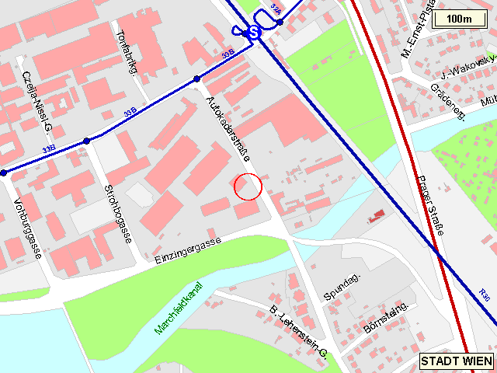
SIEMENS
S3
Strebersdorf

- By taxi:
We recommend the taxis that are those provided by the airport service. They are called "Jetbus-Taxi" and you will find their desk when you exit the luggage collection hall on the right hand side of the sliding doors. Tel. Nr.: +43 1 7007 38778

The following link provides additional information and more details on transport services in Vienna.
http://english.viennaairport.com/

If you have any questions or needs concerning the co-ordination of the meeting, please feel free to contact

Peter Markovics | or | Ms. Susanne Krammel
SIEMENS AG |  | SIEMENS AG
Autokaderstraße 29 |  | Autokaderstraße 29
1210 Wien |  | 1210 Wien
Austria |  | Austria
Tel.: +43 5 1707 21760 |  | Tel: +43 5 1707 21529
Fax: +43 5 1707 51924 |  | Fax: +43 5 1707 51924
E-mail: peter.markovics@siemens.at |  | E-mail: susanne.krammel@siemens.at

We are looking forward to meeting you in Vienna

Kind regards,

Peter Markovics
Mobile Network Solutions,
SIEMENS AG,
REGISTRATION FORM

For the 3GPP TSG SA WG1 OSA ad-hoc
October 18th and 19th 2000
Vienna, Austria
Please fill in this form and return it by October 12th 2000 to: | Mrs. Susanne Krammel  E-mail: susanne.krammel@siemens.at  or  Fax: +43.5.1707.51924

Title: | Ms Mrs. Mr. Dr.
Family name: | _____
First name: | _____
Postal address: | _____
Telephone: | _____
Fax: | _____
E-mail: | _____
Date and time of arrival: | _____
Date and time of departure: | _____
I will attend:
I am unable to attend on this occasion:

Status of Member Represented (tick one box in one column 1, 2 or 3):

1) Organizational Partner Representative (SDO)  (tick one box below) | 2) Individual Member Representative  (tick one box below) | 3) Market Representation Partner Representative  (tick one box below)
Representing Partner:  ARIB | Representing Partner:  ARIB | Representing Partner:  UMTS Forum
ETSI | ETSI | GSA
T1 | T1
TTA | TTA
TTC | TTC
Other: _____ | Other: _____ | Other: _____
Individual Member organization* Name:
_____
I am the voting representative for this Individual Member.

* For a list of Individual Member organizations, see: HREF="http://www.3gpp.org/Individual_Member.htm

